# **End of Year Reminders**

**Claims Cannot Span Years**

To prevent a delay with claim payments, please note that WPS will not process claim lines that span across calendar years unless they are Medicare crossover claims.

What does this mean?

When submitting claims to WPS for dates of service spanning 2024 into 2025, they must be submitted on two separate claim lines. Any claims submitted that span for dates of service in 2024 into 2025 will be sent back to the provider, and resubmission will be requested on individual claim lines.

Example:

Instead of billing 12/29/2024 through 01/04/2025 for the last week in December 2024 (Sunday through Saturday), you will submit two separate claim lines: one claim for dates of service 12/29/2024 through 12/31/2024, and a separate claim for 01/01/2025 – 01/04/2025.

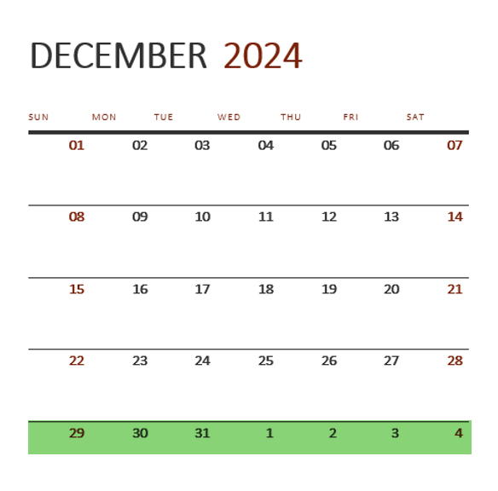

Please contact the ACS support team for your service type if you have questions. [Authorization and Claims Support Contact Information for Providers](https://www.inclusa.org/wp-content/uploads/Authorization-and-Claims-Support-Contact-Information-for-Providers-1.docx)

**1099 Reminder**

In early 2025, 1099s will go out to providers per the information identified on your organization’s W9 for all services paid by WPS within calendar year 2024.  WPS will not issue a 1099 for owner-occupied Adult Family Homes or if the total annual payout is lower than $600 as required by the IRS.

Please contact WPS at 608-977-5099 with any questions.