

Certification Handbook

1-2 Bed Adult Family Home

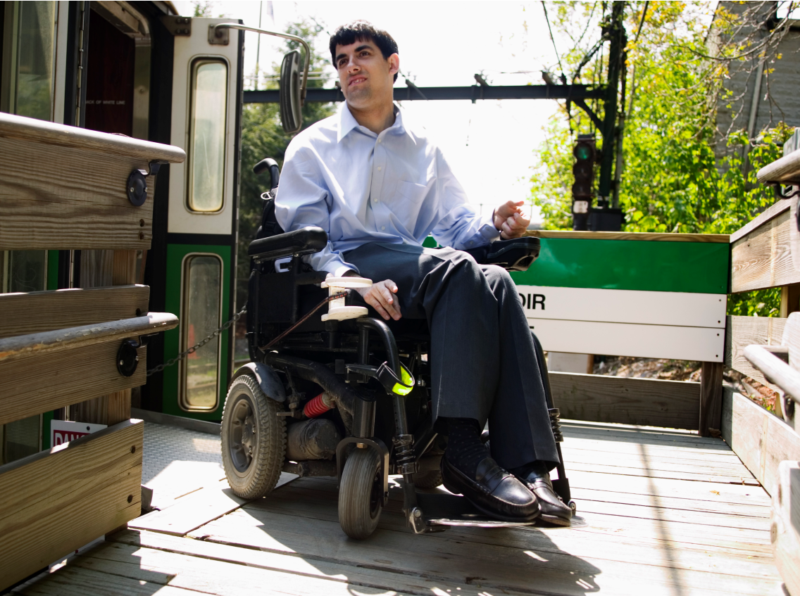

**13349 Church Street, Suite 1, Stevens Point, WI 54481**

**877-622-6700 | inclusa.org**

**•••••••••••••••••••••••••••••••••••••••**

**Issued August 2018**

Certification Handbook 1-2 Bed Adult Family Homes

**TABLE OF CONTENTS**

Definitions 1

Certification 1

Training Requirements 2

Caregiver Background Checks 2

Your Home Must: 2

Fire Safety 3

Household Pets 3

Resident Support and Services 4

Nutrition 4

Medications 4

Resident Rights 4

Reporting of Abuse/Neglect 5

Placement Process 5

Resident’s Responsibilities 6

Sponsor’s responsibilities 6

Resident Activities 7

i www.inclusa.org

# 

# DEFINITIONS

# In this handbook and in other documents, certain terms are used that you should know.

* **ADLs:** Activities of daily living that include self-care, leisure, and recreation. Self-care includes: dressing, eating, bathing, grooming, toileting, mobility transferring from one surface to another such as a bed to chair transfer, object manipulation, ambulation and rest.
* **Adult Family Home Sponsor/Provider:** The person who operates the Adult Family Home.
* **Adult Family Home:** The primary residence of the person that provides care that is above the level of room and board. This care is provided to one or two adults. Respite care may also be provided.
* **Certifying Agency:** The agency that certifies Adult Family Homes. Inclusa certifies one and two bed Adult Family Homes located in its assigned territories.
* **Community Resource Coordinator:** The person who supervises the care and services needed by the resident. This includes services inside and outside of the Adult Family
* **Guardian:** A person appointed by a court to make decisions for another adult who is incompetent or to manage the estate and money of a person who is incompetent.

Home.

* **Household Member:** Any person living in an Adult Family Home.
* **IDT:** Interdisciplinary Team: Care management team consisting of a Community Resource Coordinator and a Health & Wellness Coordinator (Nurse)
* **Resident:** The person who resides in the Adult Family Home and receives services above the level of room and board.
* **Respite Care:** Temporary care that is provided to persons with disabilities or special care needs, including individuals at risk of abuse or neglect, or in crisis situations.
* **Substitute Care:** Intended to provide Adult Family Home Sponsors time away from the stress and demands of being a Sponsor or family care-giver.
* **Substitute Provider:** A person designated by the Sponsor/Provider to take full responsibility for operating the Adult Family Home when the Sponsor/Provider is temporarily unable to provide the services.

# CERTIFICATION

* Inclusa certifies one and two bed Adult Family Homes in accordance with Wisconsin Standards for 1-2 bed Adult Family Homes.
* Certification must be renewed at least annually.
* An Adult Family Home located in Inclusa’s district may not be certified by another certifying agency unless there is a written agreement between the two agencies.
* An Adult Family Home certified by Inclusa may not take a placement from another agency or take a private pay resident without the prior approval of Inclusa.

• Non-renewal/Revocation of Certification:

If you are denied renewal of your certification or if your certification is revoked, you will receive a written notice. This notice will clearly state the reasons for not renewing or revoking your certification. It will also inform you of your right to appeal this decision by requesting an Administrative Review.

## Training Requirements

* During your first year of certification, the Sponsor/Provider must complete a minimum of ten (10) hours of approved training.
* Each year thereafter, the Sponsor/Provider must complete a minimum of eight (8) hours of approved training.
* The Sponsor/Provider may be required to obtain training beyond the minimums required.
* Substitute Providers and other household members may be required to obtain specific training.

Training opportunities that are available to you include: AFCN self-study trainings that can be completed at home, group training, and other approved training. As the Adult Family Home Sponsor/Provider, you are required to obtain and retain documentation of completed trainings.

## Caregiver Background Checks

* Completed Background Information Disclosure (BID) forms are required every four (4) years on all household members age ten (10) and older.
* Background checks are required every four (4) years on all household members age 18 and older
* Background checks are also required every four (4) years on all Substitute Providers/employees.

## Your Home Must:

* Provide physical and emotional privacy for the resident.
* Be clean, safe and free from hazards, dangerous substances, insects, and rodents.
* Provide sufficient space for household activities and comfort of all household members.
* Provide safe and functioning heat, water, and electricity.
* Have well water tested annually.
* Provide garbage removal.
* Provide laundry facilities-either in the home or arranged for.
* Have a telephone available for resident’s use.
* Not be used for any business purpose that brings customers to the home.
* Keep all weapons, including concealed carry, stored and locked. Ammunition must be stored and locked separately.

## Fire Safety

#### Fire Safety Evacuation Plan

* Develop a Fire Safety Evacuation Plan for the immediate and safe evacuation of all occupants of your home in the event of a fire. (This Evacuation Plan should be posted in a prominent place in your home)
* Review the Fire Safety Evacuation Plan with each new resident immediately following their placement in your home and annually.
* Conduct semi-annual fire drills and document on the log that you keep in you Adult Family Home binder.

#### Fire Extinguishers

* Must have a 2A, 10-B-C rating or larger.
* Are required on each floor of the home.
* Must be wall mounted.
* Are required at the head of each stairway and in or near the kitchen.
* Must be inspected annually by an authorized dealer or local fire department.
* If an extinguisher is found defective it must be replaced.

#### Smoke Detectors

* Must be located on each floor of the home.
* Should be located at the head of each open stairway, at the door leading to every enclosed stairway, on the ceiling of the living room or family room, and on the ceiling of each habitable room.
* Must be tested monthly and documented on the log that you keep in your Adult Family Home binder.

#### Carbon Monoxide Detectors

* Must be located on every floor of the home, including the basement.
* A detector should be located within ten (10) feet of each bedroom door and there should be one near or over any attached garage.
* Each detector should be replaced every five (5) to six (6) years.

**A fire that requires the assistance of the fire department must be reported to Inclusa within 24 hours.**

## Household Pets

* Rabies vaccinations are required on dogs, cats, and other pets vulnerable to rabies.
* Pens, cages, and litter boxes must be kept clean.
* Pets must be kept and handled in a manner that protects both residents and pets.
* Wishes of residents must be considered before bringing a new pet into your Adult Family Home.
* The Sponsor must assure that pets are under control and are not a danger to residents or guests.

# RESIDENT SUPPORT AND SERVICES

* The Sponsor will provide opportunities for cultural, religious, political, social, and intellectual activities. Residents do not have to participate but must be allowed to if they choose to (unless their service plan indicates otherwise).
* The Sponsor will provide those services that are identified in the resident’s Adult Family Home Service Plan. The Sponsor will assist, teach, and support the resident to promote his or her health, well-being, self-esteem, independence, and quality of life in the community.
* If needed, nursing care may be arranged for or, if qualified, provided by a Sponsor with a physician’s written authorization.

## Nutrition

* Provide a sufficient quantity and variety of foods.
* Provide or assure at least 3 meals per day.
* Prepare food in sanitary conditions.
* Residents should dine together with other household members.
* Sponsor must take into account a resident’s preferences, and special physical or religious dietary needs. Preferences are usually included in the Service Plan.

## Medications

* Safely store all medications.
* Medication containers must be labeled. Medications must be kept in original containers.
* Residents shall control and administer his/her own medications except when they are unable to do so (as directed by a physician or requested by a guardian).
* Assist the resident in taking the correct dosage at the correct time and communicate with his/her physician/pharmacist.
* Each time a medication is administered it must be recorded on the Medication Log for Resident contained in the Adult Family Home Placement Packet.

### Resident Rights

* To be treated with courtesy, respect, dignity and individuality.
* To have full physical and emotional privacy.
* To have records kept confidential.
* To be presumed mentally competent.
* To have the opportunity to make decisions.
* To manage his or her own financial affairs.
* To keep and use personal clothing and other personal possessions.
* To exercise choice of social activity.
* To exercise choice of providers.
* To exercise choice of treatment.
* To participate in religious activities of the residents choosing.
* To have a safe physical environment in which to live.
* To be free from physical, sexual, verbal or emotional abuse, and financial exploitation or misappropriation of property.
* To be free from seclusion and restraints.
* To not be required by the Sponsor to perform labor that is of financial benefit to the Sponsor.
* To receive prompt and adequate treatment.
* To receive all prescribed medication.
* To receive and send mail.
* To make and receive telephone calls.
* To have private visitors and private space for visits.
* To be fully informed in writing of all services and service charges.
* The right to file a grievance.

## Reporting of Abuse/Neglect

* A Sponsor who knows or has reasonable cause to suspect abuse or neglect must contact Inclusa & Guardian immediately.
* If a Sponsor suspects that a crime has been committed, immediately report to law enforcement, Inclusa and the Guardian within 24 hours.

# PLACEMENT PROCESS

* The IDT conducts an assessment which identifies the person’s needs, abilities, and preferences in the following areas:
  + Activities of daily living
  + Medications
  + Current health status/health maintenance needs
  + Level of supervision required
  + Behavior support needs
  + Work/vocational programming
  + Recreational and social needs
  + Transportation
* Prior to placement:
  + The person is provided information about the home.
  + The Adult Family Home Sponsor is provided with information about the person.
  + Pre-placement visit occurs so that the person has an opportunity to meet the Sponsor, other household members and get acquainted with the home.
* An Adult Family Home placement will be arranged only if the potential resident and the Adult Family Home Sponsor agree to the arrangement. Once it’s agreed that the home is a good match for the person, an Adult Family Home Service Plan is developed with resident/guardian, the IDT, and the adult family home Sponsor/provider.

# RESIDENT’S RESPONSIBILITIES

* Treat other members of the household with courtesy and respect.
* Participate in family and community activities; if the resident chooses to.
* Maintain confidentiality about the home (any information may be shared with the Case Manager and guardian).
* Is responsible for paying for clothing, personal items, and medical needs.
* Self-medicating except when they are unable to do so and in accordance to the Adult Family Home Service Plan.
* Maintain his/her bedroom (as much as possible).
* Maintain good personal care standards, with assistance if needed.
* Expenses for repair of any items they damage in the home.
* Adhere to the smoking policy of the Adult Family Home.

# SPONSOR’S RESPONSIBILITIES

* Provide room, board, and access to laundry facilities. Board means three nutritious meals a day, plus snacks. If the resident works this would include a sack lunch.
* Provide soap for laundry.
* Provide furniture, bedding, and clean linens for the resident’s bedroom.
* Provide services which may include but are not limited to: teaching and supervision of personal care and activities of daily living, health monitoring services, behavioral intervention, money management, leisure and recreational activities, and personal supervision.
* Provide/arrange transportation to medical/dental appointments, church, and social activities.
* Provide a family atmosphere that is safe, warm, stable, and accepting of the resident. This includes confidentiality regarding any information about the resident.
* Encourage the resident to assist with household tasks and participate in family and community activities.
* Provide family-based care to residents placed in the home. The resident will be treated as an adult member of the family. This includes a bedroom that provides adequate privacy. Basic care includes nutritious meals eaten with other family members; the opportunity to attend the church of his/her choice; to see the physician of his/her choice; inclusion in family activities and outings; access to all areas of the home, with the exceptions of, personal bedrooms; access to television, books and other recreational activities of the home.
* Obtain emergency care when needed. This includes calling a doctor or ambulance for serious illness or injury and the police for other serious emergencies. Adult Family Home Sponsors must contact the IDT, guardian, and /or power of attorney for health care within 24 hours (or the next working day) after emergency measures are taken.
* Whenever any event/situation occurs that creates a significant risk or serious harm to the physical, mental health, safety or well-being of the resident, or results in the death of the resident, you must complete a Critical Incident Report. This Report should be sent to the IDT immediately.
* If you are absent from the home an appropriate Substitute Provider must be utlilized to provide the supervision and services specified in the Adult Family Home Service Plan.

Background checks must be conducted every four years for the Substitute Provider.

* Provide assistance with medications, bathing, dressing, etc., as the resident may require and in accordance with the Adult Family Home Service Plan.
* Ensure that IDT & Guardian are informed of all medical appointments.

## Resident Activities

Residents must have opportunities for activities. A variety of activities will be made available to the resident including cultural, religious, political and social activities. Even if the resident functions at a reduced intellectual level or has dementia, scale the activity to the resident’s level and get them out into the community as well. Make sure some of the activities are their favorites, not yours! Residents do not have to participate, but must be allowed to, unless stated otherwise in the service plan. If Residents cannot participate they still need opportunities to observe. Note: watching TV is not an activity.