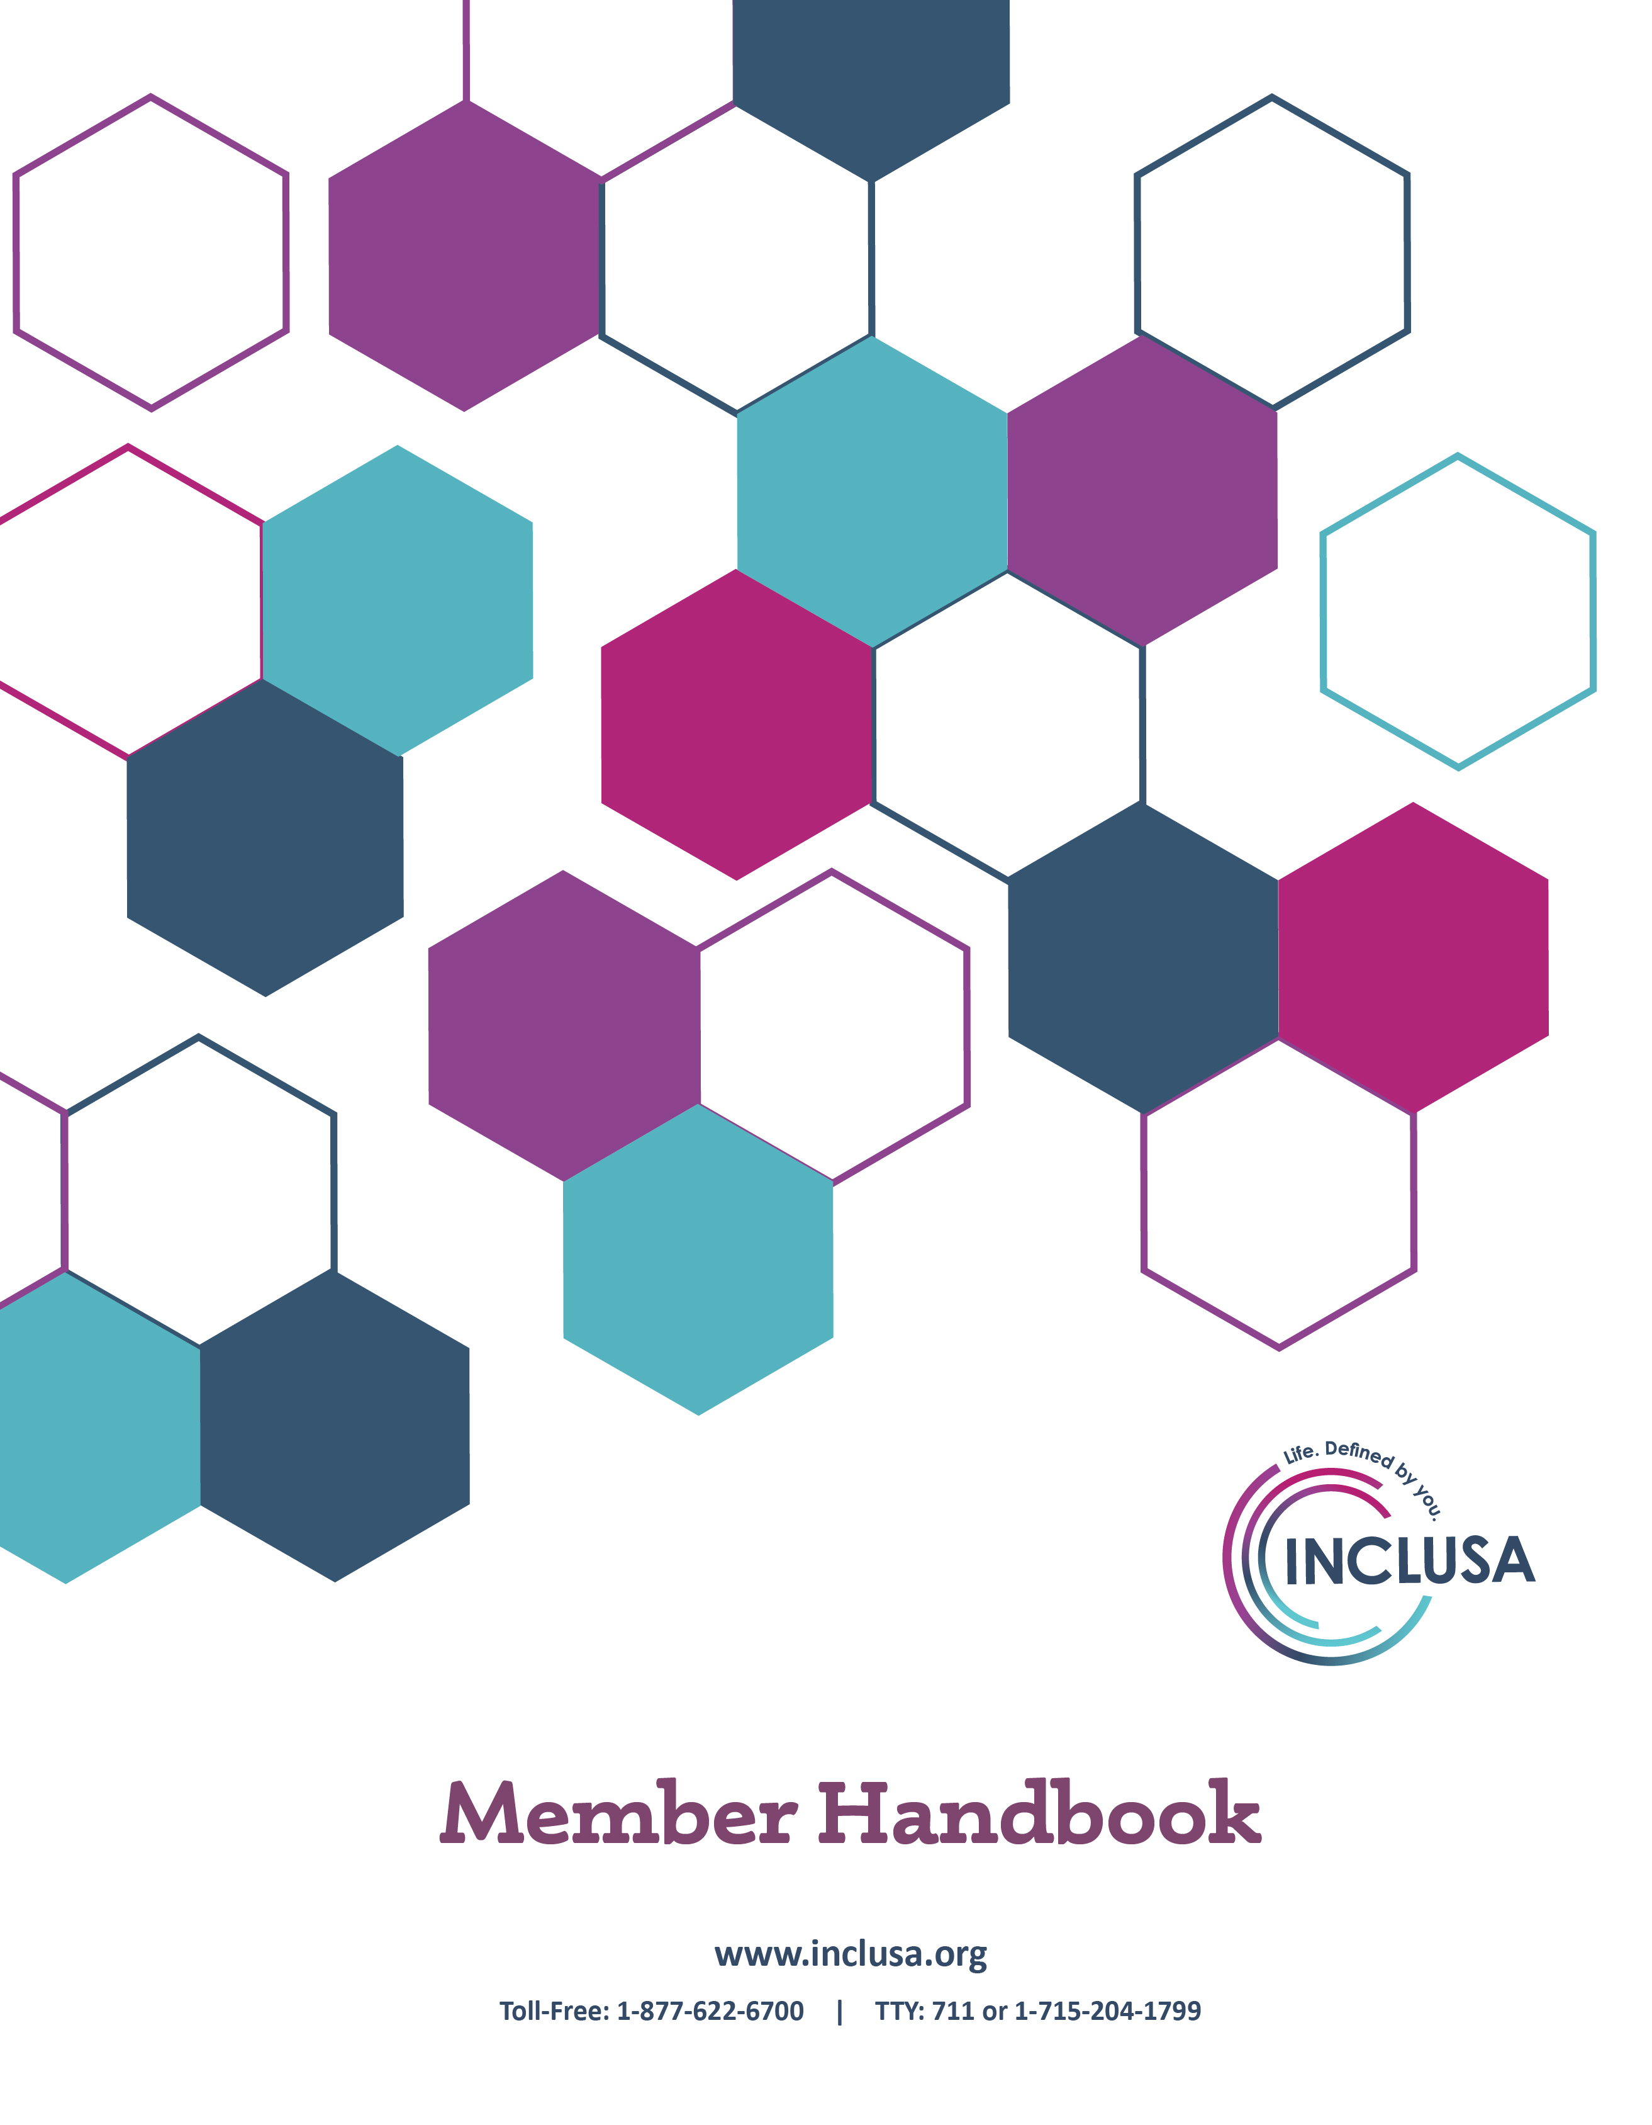
Cover Page

Family Care
Member Handbook

Template provided by the Wisconsin Department of Health Services
P-00649 (04/2021)
DHS Approval Date: 5/17/2021

Dear Partner:

Our goal is to support you and the community you call home. But we cannot do that without you! We are here to follow your lead, and help you connect to the resources you need to live the life of your choosing.

Thank you for taking the lead in this important partnership. Speaking of partnership, you have a team of people to help you succeed. They are here to support you, so make sure you write down their names and numbers so you can reach them when you need their help.

Community Resource Coordinator Phone

Health & Wellness Coordinator Phone

In addition to your team, there is an entire organization working on your behalf. We thought you might like to know more about us.

Who is Inclusa?
Inclusa is a values-based organization whose vision is to support full and meaningful lives. We do this by partnering with others to build inclusive communities focused on the whole, and we utilize a set of values to define our business practices and standards of operation. To understand Inclusa, you must first understand our Vision, Mission, and Values.
Vision is the description of what we as an organization aim to achieve, and serves as a clear guide for intentional action. This is who we are, and what we aspire to do.
The innovative leader in building vibrant and inclusive communities, INCLUSA, empowers full and meaningful lives of those we serve.
Mission is our core purpose which helps define what is important to us and provides a sense of focused direction.
We proactively partner with others to build a shared vision of long-term care that offers the people we serve choice, connections, and dignity fostering full participation in communities.
Values are a set of principles or ideals that are important, lasting, and shared by a collective.
Partnership: We work collaboratively with stakeholders to accomplish more than the sum of our parts. We team with others through shared ownership of risks and benefits.
Respect: We treat others as we wish to be treated: honoring differences, listening actively, and responding promptly and with care.
Innovation: We are forward-thinking; we search for proactive, bold, new and creative solutions. Through leadership and continuous improvement, we enhance the quality of care.
Integrity: We consistently hold ourselves accountable by doing what we say we will do when we say we will do it.
Development: We pursue continuous individual and organizational learning. We learn from experience and share new knowledge.
Excellence: We are exceptional communicators. We are responsible stewards of resources. We exceed the expectations of those we serve and our business partners.

INCLUSA:
- Provides free aids and services to people with disabilities to communicate effectively with us, such as:
  - Qualified sign language interpreters
  - Written information in other formats (large print, audio, accessible electronic formats, other formats)
- Provides free language services to people whose primary language is not English, such as:
  - Qualified interpreters
  - Information written in other languages
If you need these services, contact INCLUSA at 1-877-622-6700 or TTY 715-204-1799.

English
ATTENTION: If you speak English, language assistance services are available to you free of charge. Call 1-877-622-6700 (TTY: 1-715-204-1799).

Spanish
ATENCIÓN: Si habla español, los servicios de asistencia de idiomas están disponibles sin cargo, llame al 1-877-622-6700 (TTY: 1-715-204-1799).

Hmong
CEEB TOOM: Yog koj hais lus Hmoob, kev pab rau lwm yam lus muaj rau koj dawb xwb. Hu 1-877-622-6700 (TTY: 1-715-204-1799).

Chinese Mandarin
注意：如果您说中文，您可获得免费的语言协助服务。请致电1-877-622-6700 (TTY 文字电话: 1-715-204-1799).

Somali
DIGTOONI: Haddii aad ku hadasho afka Soomaaliha, adeegyada caawimada luqadda waxaa laguu heli karaa iyagoo bilaash ah. Wac 1-877-622-6700 (TTY: 1-715-204-1799).

Laotian
ໝາຍ​ເຫດ: ຖ້າ​ທ່ານ​ເ​ວົ້າພາສາ​ລາວ, ທ່ານ​ສາມາດ​ໃຊ້ການ​ບໍລິການ​ຊ່ວຍ​ເຫຼືອດ້ານ​ພາສາ​​ໄດ້​ໂດຍ​ບໍ່​​ເສຍ​ຄ່າ. ​ໂທ 1-877-622-6700 (TTY: 1-715-204-1799).

Russian
ВНИМАНИЕ: Если Вы говорите по-русски, Вам будут бесплатно предоставлены услуги переводчика. Позвоните по номеру: 1-877-622-6700 (TTY: 1-715-204-1799).

Burmese
1-877-622-6700 (TTY: 1-715-204-1799)

Arabic (right to left)
تنبيه: إذا كنتم تتحدثون العربية، تتوفر لكم مساعدة لغوية مجانية. اتصلوا بالرقم
.(1-877-622-6700 : هاتف نصي): 1-715-204-1799

Serbo-Croatian
PAŽNJA: Ako govorite srpsko-hrvatski imate pravo na besplatnu jezičnu pomoć. Nazovite 1-877-622-6700 (telefon za gluhe: 1-715-204-1799).

Table of Contents
Chapter 1. Important phone numbers and resources 11
Chapter 2. Welcome and introduction 28
Welcome to Inclusa 28
How can the Family Care program help me? 29
Who will help me? 30
What does it mean to be a member? 32
Who can be a member of Inclusa? 33
How do I become a member? 35
Chapter 3. Things to know about getting services 37
How does Family Care work? 37
What should be in your care plan? 39
How are services selected and authorized? 41
What if my needs change? 43
How do I use the provider network? 43
How does Family Care help you manage your own services? 45
What are self-directed supports? 46
What should I do in case of an emergency? 47
How do I receive care after normal business hours? 48
What if I need care while I am out of the area? 48
Chapter 4. The Family Care benefit package 50
What services are provided? 50
Family Care benefit package chart 52
What services are not provided? 57
Chapter 5. Understanding who pays for services and coordination of your benefits 60
Will I pay for any services? 60
How do I make a payment? 63
What if I get a bill for services? 63
Does Family Care pay for residential services or nursing homes? 64
How are Medicare and my other insurance benefits coordinated? 65
What is estate recovery? How does it apply to me? 67
Chapter 6. Your rights 68
Chapter 7. Your responsibilities 74
Chapter 8. Grievances and appeals 78
Introduction 78
Grievances 80
Appeals 86
State Fair Hearings 95
Who can help me with my grievance or appeal? 100
Chapter 9. Ending your membership in Inclusa 102
APPENDICES 105
1. Definitions of important words 105
2. Definitions of services in the Family Care benefit package 113
3. Application for Reduction of Cost Share 125
4. Sample Notice of Adverse Benefit Determination 129
5.Inclusa appeal request form 133
6. State Fair Hearing request form 135
7. Notice of privacy practices 138

Chapter 1. Important phone numbers and resources

Inclusa Contact Information
The administrative and main office for Inclusa is located in the city of Stevens Point. All of our office locations may be reached by using the toll free number below. See Inclusa website for offices open by appointment only.

Inclusa Main Office (Stevens Point)
8:00 a.m. – 4:30 p.m. Monday – Friday
Toll-Free: 1-877-622-6700
TTY: 711 or 1-715-204-1799
Fax: 1-715-345-5725
Website: www.inclusa.org

After Hours Contact Information
If you need assistance after hours or on weekends or holidays, call Inclusa’s toll-free number (listed below) and your call will be directed to an individual able to authorize urgent help or services to ensure your health, safety, or well-being. Your team will follow up with you on the next business day to determine whether the services authorized should continue. On-call staff are available 24 hours a day, seven days a week.
Toll-Free: 1-877-622-67004:30 p.m. – 8:00 a.m. on Weekdays
24 hours a day on Weekends & Holidays
Member Rights
If you are experiencing an emergency, call 911
Member Relations Managers are specialists in explaining member rights. They are available to help if you have a complaint or grievance. They can give you information or assistance if you want to appeal a decision your team made. Member Relations Managers may be reached at the contact information below.

Toll-Free: 1-877-622-6700
8:00 a.m. – 4:30 p.m. Monday-Friday

Other Important Contacts

Adult Protective Services
Every county has an agency that will look into reported incidents of abuse, neglect, financial exploitation, and self-neglect. Call your county help line if you need to talk to someone about suspected abuse of an adult-at-risk (age 18 to 59). To report abuse of an elder over the age of 60, contact your county elder adult-at-risk agency.
● Adams County (Health & Human Services Department)
Phone: 608-339-4505
● Ashland County (Health & Human Services Department)
Phone: 715-682-7004
● Barron County (Department of Health & Human Services)
Phone: 715-537-5691
● Bayfield County (Department of Human Services)
Phone: 715-373-6144
● Brown County (Human Services)
Phone: 920-448-7885
● Buffalo County (Aging and Disability Resource Center)
Phone: 866-578-2372
● Burnett County (Health & Human Services Department)
Phone: 715-349-7600
● Calumet County (Department of Health & Human Services)
Phone: 920-849-1400
● Chippewa County (Department of Human Services)
Phone: 715-726-7788
● Clark County (Department of Social Services)
Phone: 866-743-5233
● Columbia County (Aging and Disability Resource Center)
Phone: 608-742-9233
● Crawford County (Human Services Department)
Phone: 608-326-0248
● Dodge County (Aging and Disability Resource Center)
Phone: 920-386-3580
● Door County (Human Services)
Phone: 920-746-7155
● Douglas County (Department of Health & Human Services)
Phone: 715-395-1304

● Dunn County (Aging and Disability Resource Center)
Phone: 715-232-4006
● Eau Claire County (Department of Human Services)
Phone: 715-839-7118
● Fond Du Lac County (Aging and Disability Resource Center)
Phone: (920) 929-3466
● Forest County (Human Services Department)
Phone: 888-452-3296
● Florence County (Department of Human Services)
Phone: 715-478-7709
● Grant County (Department of Social Services)
Phone: 608-723-2136
● Green County (Aging and Disability Resource Center)
Phone: 608-328-9499
● Green Lake County (Health and Human Services)
Phone: 920-294-4070
● Iowa County (Aging and Disability Resource Center)
Phone: 608-930-9835
● Iron County (Human Services Department)
Phone: 715-561-3636
● Jackson County (Aging and Disability Resource Center)
Phone: 844-493-4245
● Jefferson County (Human Services)
Phone: 920-674-3105
● Juneau County (Department of Human Services)
Phone: 608-847-2400
● Kewaunee County (Human Services)
Phone: 920-338-0626
● La Crosse County (Aging and Disability Resource Center)
Phone: 800-500-3910
● Lafayette County (Human Services)
Phone: 608-776-4800
● Langlade, Lincoln, and Marathon Counties (North Central Community Services)
Phone: 855-487-3338 or 715-841-5160
● Manitowoc County (Department of Human Services)
Phone: 920-683-4230
● Marinette County (Aging and Disability Resource Center)
Phone: 715-732-3850
● Marquette County (Human Services)
Phone: 608-297-3124
● Menomonee County (Health & Human Services)
Phone: 715-799-3861
● Monroe County (Aging and Disability Resource Center)
Phone: 800-500-3910
● Oconto County (Health & Human Services)
Phone: 920-834-7000
● Oneida County (Department of Social Services)
Phone: 715-369-7499
● Outagamie County (Health and Human Services)
Phone: 920-832-5169
● Ozaukee County (Human Services)
Phone: 262-284-8200
Pepin County (Aging and Disability Resource Center)
Phone: 866-578-2372
● Pierce County (Aging and Disability Resource Center)
Phone: 715-273-6780
● Polk County (Human Services Department)
Phone: 715-485-8400
● Portage County (Health & Human Services Department)
Phone: 715-345-5350
● Price County (Health & Human Services)
Phone: 715-339-2158
● Richland County (Aging and Disability Resource Center)
Phone: 608-647-4616
● Rock County (Human Services Department – ADRC)
Phone: 608-741-3600 or 855-741-3600
● Rusk County (Department of Health & Human Services)
Phone: 715-532-2299
● St. Croix County (Department of Health and Human Services)
Phone: 715-246-8255
● Sauk County (Department of Human Services)
Phone: 608-355-4200
● Sawyer County (Health & Human Services Department)
Phone: 800-569-4162
● Shawano County (Department of Social Services)
Phone: 715-526-4700

● Sheboygan County (Aging and Disability Resource Center)
Phone: 920-467-4700
● Taylor County (Human Services Department)
Phone: 715-748-3332
● Trempealeau County (Aging and Disability Resource Center)
Phone: 800-273-2001
● Vernon County (Aging and Disability Resource Center)
Phone: 800-500-3910
● Vilas County (Department of Social Services)
Phone: 715-479-3668
● Walworth County (Department of Health & Human Services)
Phone: 262-741-3200
● Washburn County (Health & Human Services Department)
Phone: 715-468-4747
● Washington County (Aging and Disability Resource Center)
Phone: 262-335-4497
● Waukesha County (Aging and Disability Resource Center)
Phone: 262-548-7848
● Waupaca County (Health and Human Services)
Phone: 715-258-6400
● Waushara County (Department of Human Services)
Phone: 920-787-6618
● Winnebago County (Department of Human Services)
Phone: 877-886-2372
● Wood County (Department of Social Services)
Marshfield Area Phone: 715-387-6374
Wisconsin Rapids Area Phone: 715-421-8600

Aging and Disability Resource Centers
Aging and disability resource centers (ADRCs) are the first place to go to get accurate, unbiased information on all aspects of life related to aging or living with a disability. ADRCs are friendly, welcoming places where anyone—individuals, concerned families or friends, or professionals working with issues related to aging or disabilities—can go for information tailored to their situation. The ADRC provides information on programs and services, helps people understand their long-term care options, and helps them apply for programs and benefits. ADRCs in Inclusa’s service regions are:
- Aging & Disability Resource Center Serving Adams, Green Lake, Marquette, and Waushara Counties
Toll-Free: 1-877-883-5378
- ADRC of Barron, Rusk & Washburn Counties
Toll-Free: 1-888-538-3031
- ADRC of Brown County
Toll-Free: 920-448-4300
- ADRC of Buffalo and Pepin Counties
Toll-Free: 866-578-2372
- ADRC of Calumet, Outagamie and Waupaca Counties
Toll-Free: 1-883-620-2730
- ADRC of Central Wisconsin
Serves residents of Langlade, Lincoln, Marathon, and Wood Counties
Toll-Free: 1-888-486-9545
- ADRC of Chippewa County
Toll-Free: 1-888-400-6920
- ADRC of Clark County
Toll-Free: 866-743-5144
- ADRC of Columbia County
Toll-Free: 1-888-742-9233
- ADRC of Dodge County
Toll-Free: 1-800-924-6407
- ADRC of Door County
Toll-Free: 855-828-2372
- ADRC of Douglas County
Toll-Free: 1-866-946-2372
- ADRC of Dunn County
Phone: 1-715-232-4006
- ADRC of Eagle Country
Serves residents of Crawford, Juneau, Richland and Sauk Counties
Toll-Free: 1-877-794-2372
- ADRC of Eau Claire County
Toll-Free: 1-888-338-4636
- ADRC of Florence County
Toll-Free: 1-855-528-2372

- ADRC of Fond Du Lac County
Toll-Free: 1-888-435-7335
- ADRC of Jackson County
Toll-Free: 1-844-493-4245
- ADRC of Jefferson County
Toll-Free: 1-866-740-2372
- ADRC of La Crosse County
Toll-Free: 1-800-500-3910
- ADRC of the Lakeshore
Serving residents of Kewaunee and Manitowoc Counties
Toll-Free: 877-416-7083
- ADRC of Marinette County
Toll-Free: 888-442-3267
- ADRC of Monroe County
Toll-Free: 1-888-339-7854
- ADRC of the North
Serves residents of Ashland, Bayfield, Iron, Price, and Sawyer Counties
Toll-Free: 1-866-663-3607
- ADRC of Northwest Wisconsin
Serves residents of Burnett and Polk Counties and the St. Croix Chippewa Tribe
Toll-Free: 1-877-485-2372
- ADRC of the Northwoods
Serves residents of Forest, Oneida, Taylor, and Vilas Counties
Toll-Free: 1-800-699-6704
- ADRC of Ozaukee County
Toll-Free: 1-866-537-4261
- ADRC of Pierce County
Toll-Free: 1-877-273-0804
- ADRC of Portage County
Serves residents of Portage County
Toll-Free: 1-866-920-2525
- ADRC of Rock County
Phone: 1-608-741-3600 or
Toll-Free: 1-855-741-3600
- ADRC of St. Croix County
Toll-Free: 1-800-372-2333
- ADRC of Sheboygan County
Toll-Free: 800-596-1919
- ADRC of Southwest Wisconsin
Serves residents of Grant, Green, Iowa, and Lafayette Counties
Toll-Free: 1-877-794-2372
- ADRC of Trempealeau County
Phone: 1-715-538-2001 or
Toll-Free: 1-800-273-2001
- ADRC of Vernon County
Toll-Free: 1-888-637-1323
- ADRC of Walworth County
Toll-Free: 800-365-1587
- ADRC of Washington County
Toll-Free: 1-877-306-3030
- ADRC of Waukesha County
Toll-Free: 1-866-677-2372
- ADRC of Winnebago County
Toll-Free: 1-877-886-2372
- ADRC – Wolf River Region (Shawano, Oconto & Menomonee Counties)
Toll-Free: 855-492-2372

Visit www.dhs.wisconsin.gov/adrc for more information about ADRCs.

Ombudsman Programs
An ombudsman (om-budz-man) is an independent advocate or helper who does not work for Inclusa. Anyone receiving Family Care services can get free help from an ombudsman. The organization to contact depends on the member’s age.
If you are age 60 or older, contact:
The Wisconsin Board on Aging and Long Term Care
1402 Pankratz Street, Suite 111
Madison, WI 53704-4001
Toll-Free: 800-815-0015
TTY: 711
Fax: 608-246-7001
Email: BOALTC@wisconsin.gov
longtermcare.wi.gov

If you are 18 to 59 years old, contact:
Disability Rights Wisconsin
131 W. Wilson Street, Suite 700
Madison, WI 53703
Toll-free: 800-928-8778
TTY: 711
Fax: 833-635-1968
www.disabilityrightswi.org

Income Maintenance Consortiums
You must report changes in your living situation or finances within 10 days. If you move, you must report your new address. These changes can affect whether you are eligible for Medicaid and Family Care. Report these changes to your county’s income maintenance consortium and Inclusa. Consortiums in our service regions are:
Bay Lake Consortium
Serves residents of Brown, Door, Marinette, Oconto and Shawano Counties
Phone: 1-888-794-5747
Fax: 1-855-293-1822
● Capital Consortium
Serves residents of Adams, Columbia, Dane, Dodge, Juneau, Richland, Sauk, and Sheboygan Counties
Phone: 1-888-794-5556
Fax: 1-855-293-1822
● Central Consortium
Serves residents of Langlade, Marathon, Oneida, and Portage Counties
Phone: 1-888-445-1621
Fax: 1-855-293-1822
● East Central Consortium
Serves residents of Calumet, Green Lake, Kewaunee, Manitowoc, Marquette, Outagamie, Waupaca, Waushara, and Winnebago
Phone: 1-888-256-4563
Fax: 1-855-293-1822
● Great Rivers Consortium
Serves residents of Barron, Burnett, Chippewa, Douglas, Dunn, Eau Claire, Pierce, Polk, St. Croix, and Washburn Counties
Phone: 1-888-283-0012
Fax: 1-855-293-1822
● Moraine Lakes Consortium
Serves residents of Fond du Lac, Ozaukee, Walworth, Washington, and Waukesha Counties
Phone: 1-888-446-1239
Fax: 1-855-293-1822
● Northern Consortium
Serves residents of Ashland, Bayfield, Florence, Forest, Iron, Lincoln, Price, Rusk, Sawyer, Taylor, Vilas, and Wood Counties
Phone: 1-888-794-5722
Fax: 1-855-293-1822
● Southern Consortium
Serves residents of Crawford, Grant, Green, Iowa, Jefferson, Lafayette, and Rock Counties
Phone: 1-888-794-5780
Fax: 1-855-293-1822

● Western Consortium
Serves residents of Buffalo, Clark, Jackson, La Crosse, Monroe, Pepin, Trempealeau, and Vernon Counties
Phone: 1-888-627-0430
Fax: 1-855-293-1822

Wisconsin Medicaid (ForwardHealth)
If you are having problems using your ForwardHealth card for services or items not in the Family Care benefit package (such as eyeglasses, visits to your doctor, or prescriptions), call ForwardHealth Member Services toll-free at:
800-362-3002

Reporting Public Assistance Fraud
Fraud means getting coverage or payments you know you should not get or helping someone else get coverage or payments you know they should not get. Anyone who commits fraud can be prosecuted. If a court determines a person received health care benefits by committing fraud, the court will require that person to pay back the state for those benefits, in addition to other penalties.

If you suspect anyone of misuse of public assistance funds, including Family Care, call the fraud hotline or file a report online at:
877-865-3432
www.dhs.wisconsin.gov/fraud

or

Toll-Free: 1-877-622-6700
fraud@inclusa.org

Wisconsin FoodShare (QUEST Card)
If you have questions or concerns about FoodShare, or if you want to know the balance on your FoodShare/QUEST card, or to report a lost or stolen QUEST card, call the FoodShare customer service line toll-free at:
877-415-5164

Wisconsin Division of Quality Assurance
If you think a caregiver, agency, or facility has violated state or federal laws, you have the right to file a complaint with the Wisconsin Division of Quality Assurance. When filing a complaint, you may be asked for the county in which the provider is located. To file a complaint, call:
800-642-6552

Inclusa Billing Questions
If you have questions about cost share, room and board charges, or billing processes, call our main office toll free at 1-877-622-6700 during normal business hours (8:30 to 4:30, Monday – Friday) and ask to speak to a Member Liabilities Specialist. They can also help you if you are not able to pay a bill or want to set up automatic billing and payment.

1-877-622-6700

Chapter 2. Welcome and introduction

Welcome to Inclusa

Welcome to Inclusa, a managed care organization that operates the Family Care program. Family Care is a Medicaid long-term care program that helps elders and adults with physical, developmental, or intellectual disabilities. People in the program receive services to help them live in their own home whenever possible. Family Care is funded by state and federal tax dollars.

This handbook will give you the information you need to:

- Understand the basics of Family Care.
- Become familiar with the services in the benefit package.
- Understand your rights and responsibilities as a Family Care member.
- File a grievance or appeal if you have a problem or concern.

If you would like help in reviewing this handbook, please contact your care team. Your team’s contact information is provided on the business cards provided during your first meeting. You may also call our general telephone number, 1-877-622-6700, and ask to speak with a member of your team.

In general, the words “you” and “your” in this document refer to you, the member. “You” and “your” may also mean your legal decision maker, such as a legal guardian or activated power of attorney.

At the end of this handbook (page 67) are definitions of important words. These definitions can help you understand the words and phrases frequently used in this handbook.

If you are not yet a member and have questions or want more information about how to enroll in Family Care or other programs, please contact the aging and disability resource center (ADRC) in your area. ADRCs provide information and assistance and help people apply for programs and benefits. The ADRC is a separate agency. It is not part of Inclusa. The ADRC is available to help you, whether or not you decide to become a Family Care member. The address and phone number of your local ADRC can be found on pages 13-16.

How can the Family Care program help me?

A main goal of Family Care is to ensure that you are safe and supported at home. When you live in your own home or in your family’s home, you have more power over your life. You can decide when to do certain things, such as when to wake up and eat meals, and how to plan your day.

When you join Family Care, Inclusa will talk with you about what services will help you live as independently as possible. Help with bathing, transportation, housekeeping, and home-delivered meals are some of the services we offer. Services may even include building a wheelchair ramp or using a medical alert system. (See chapter 4 for a complete list of covered services.)
Family Care:
- Can improve or maintain your quality of life.
- Helps you live in your own home or apartment, among family and friends.
- Involves you in decisions about your care and services.
- Maximizes your independence.
Family Care:
- Can improve or maintain your quality of life.
- Helps you live in your own home or apartment, among family and friends.
- Involves you in decisions about your care and services.
- Maximizes your independence.

Family Care provides care management and a range of services designed to meet your needs. We will make sure you get the care you need to be healthy and safe. We will also help you maintain ties with your family, friends, and community.

If you are a young adult preparing to move out on your own, Inclusa can help you become more independent. For example, we can help you develop the skills you need to find a job or learn how to prepare your own meals.

Who will help me?

When you become a Family Care member, you will work with a team of professionals from Inclusa. You are a central part of your care team and you should be involved in every part of planning your care.

Your care team will include you and:

- A Health and Wellness Coordinator (Nurse)
- A Community Resource Coordinator (Social Worker)
- Other professionals, depending on your needs, such as an occupational or physical therapist, or a mental health specialist.
- Anyone else you want to be involved, including family members or friends.

The job of your care team is to work with you to:

- Identify your strengths, resources, needs, and preferences.
- Develop a care plan that includes the help you need.
- Make sure the services in your plan are actually provided to you.
- Ensure the services Family Care provides meet your needs and are cost-effective.
- Make sure your care plan continues to work for you.

Let your team know if you need any help taking part in the process.

Family Care does not replace the help you get from your family, friends, or others in the community. Inclusa encourages family members, friends, and other people important to you to be involved in your care. We will work with you to build on these important relationships. We can also help find resources in your community that can assist you, such as libraries, senior centers, and churches.

When needed, we can also help find ways to strengthen your support network. For example, if the people who help you need a break, we can provide respite services. Respite provides a temporary break for your caregivers to give them time to relax and maintain their own health.

What does it mean to be a member?

As a member of Inclusa’s Family Care program, you and your care team will work together to make decisions about your health and lifestyle. Together, you and your care team will make the best possible choices to support you.

You will receive your long-term care services through Inclusa providers. When you join Family Care, we will give you information on how to get a list of service providers who have agreed to work with us. You and your care team will work together to choose providers that best support your needs.

Inclusa believes our members should have personal choice when receiving services. Choice means having a say in how and when care is provided. Being a member and having personal choice also means you are responsible for helping your care team find the most cost-effective ways to support you.

Inclusa is responsible for meeting the long-term care needs of all of our members. We can only do that if all members help us develop care plans that not only work, but also are reasonable and cost-effective. By working together, we can make sure Family Care remains available to other people who need our services.

You can keep your current medical providers (for example, your general physician, podiatrist, dentist, and chiropractor), hospitals, clinics, and pharmacies where you get your prescription medicines. Inclusa’s Family Care program is not responsible for these services. These services are paid for by other types of insurance. Your care team will help coordinate your Family Care services with the services from your doctor and other medical providers.

Who can be a member of Inclusa?

Membership is voluntary. It is your choice whether to enroll with Inclusa. To be served by us you must meet all of the following requirements:

- Be an adult with a physical or developmental/intellectual disability or be age 65 or older.
- Be a resident of one of our service areas (see the list below).
- Be financially eligible for Medicaid.
- Be functionally eligible as determined by the Wisconsin Adult Long Term Care Functional Screen.
- Sign an enrollment form.

Our service area includes these counties in Wisconsin:

Adams
Ashland
Barron
Bayfield
Brown
Buffalo
Burnett
Calumet
Chippewa
Clark
Columbia
Crawford
Dodge
Door
Douglas
Dunn
Eau Claire
Florence
Fond Du Lac
Forest
Grant
Green
Green Lake
Iowa
Iron
Jackson
Jefferson
Juneau
Kewaunee
La Crosse
Lafayette
Langlade
Lincoln
Manitowoc
Marathon
Marinette
Marquette
Menomonee
Monroe
Oconto
Oneida
Outagamie
Ozaukee
Pepin
Pierce
Polk
Portage
Price
Richland
Rock
Rusk
St. Croix
Sauk
Sawyer
Shawano
Sheboygan
Taylor
Trempealeau
Vernon
Vilas
Walworth
Washburn
Washington
Waukesha
Waupaca
Waushara
Winnebago
Wood

If you plan to move out of the service area, you must notify your team. If you move outside of our service area, you may not be able to stay enrolled with Inclusa.

Once you become a member, you must continue to meet financial and functional eligibility requirements to stay enrolled.

- Financial eligibility means eligibility for Medicaid (also known as Medical Assistance, MA, or Title 19). The income maintenance agency looks at an individual’s income and assets to determine if the person is eligible for Medicaid. Sometimes, to be financially eligible, members will have to pay a share of the cost of the services they receive. This is called “cost share” and it must be paid to remain eligible for Family Care. If you will have a cost share, staff from the ADRC will discuss this with you before you make a final decision about enrolling. The income maintenance agency will review your financial eligibility and cost share at least once a year to make sure you are still financially eligible for Family Care.
- Functional eligibility is related to a person’s health and need for help with things like bathing, getting dressed, and using the bathroom. The ADRC can tell you if you are functionally eligible for Family Care. Your care team will review your functional eligibility at least once a year to make sure you are still eligible.

How do I become a member?

If you are not already a member, but are interested in becoming a member of Inclusa, please call or visit the ADRC in your area. The address and phone number of your local ADRC can be found on pages 13-16.

The ADRC will help assess your level of need for services and make sure you are functionally eligible for Family Care. They will give you information about other available programs and help you choose the most appropriate resource or program for you.

During the enrollment process, the ADRC will ask you to:

- Provide information about your health and needs.
- Provide information about your income and assets.
- Sign a “Release of Information” form for your medical records.
- Complete and sign an enrollment form.

You will also speak with an income maintenance worker. This person will determine if you meet financial eligibility for Family Care.

Chapter 3. Things to know about getting services

How does Family Care work?

When you enroll in Family Care, you and your care team will access your needs, strengths, and preferences. Part of this process is for you to tell your team about the kind of life you want to live and the support you need to live the kind of life you want. This gives your team a clear understanding of what is important to you.

Identify Your Personal Experience Outcomes

During the assessment, your care team will help you identify your personal experience outcomes. These outcomes are the goals you have for your own life and they include:

- Input on:
  - Where and with whom to live
  - Needed support and services and who provides them
  - Your daily routines
- Personal experience—having:
  - Interaction with family and friends
  - A job or other meaningful activities
  - Community involvement
  - Stability
  - Respect and fairness
  - Privacy

- Health and safety—being:
  - Healthy
  - Safe
  - Free from abuse and neglect

Only you can tell your care team what is important to you. You define what these outcome statements mean to you and your life. For example, a person might want to:

- Be healthy enough to enjoy visits with grandchildren.
- Have a paid job.
- Be independent enough to live in his or her own apartment.

You have a right to expect that your care team will work with you to identify your personal experience outcomes. Before Inclusa buys services for you, your care team has to consider which services support your needs best and are the most cost-effective. This does not mean Inclusa will always provide services to help you achieve your outcomes. The things you do for yourself and the help you get from your family, friends, and others will be a very important part of the plan to support your outcomes.

Identify Your Long-Term Care Outcomes

During the assessment process, you and your care team will also identify your long-term care outcomes. This helps you and your team to know which services will meet your long-term care needs. Long-term care outcomes are those things Family Care can help you achieve to have the kind of life you want. For example:

- Being able to get your daily needs met
- Getting what you need to stay safe, healthy, and as independent as possible

Having these things in place will let you focus on the people and activities that are most important to you. For example, getting help to dress or take a bath may also help a person feel well enough to go to work or visit family and friends.

Your care team will develop a care plan that will help you move toward the outcomes that you and your team identify during the assessment process.

What should be in your care plan?

Your care plan will include and be clear about:

- Your physical health needs and your ability to perform certain tasks and activities (such as eating and dressing).
- Your strengths and preferences.
- Your personal experience outcomes.
- Your long-term care outcomes.
- The services you will receive.
- Who will provide each service.
- The things you will do yourself or with help from family, friends, or other resources in your community.

Your care team will ask you to sign your care plan, which shows that you participated in its development. You will get a copy of your signed plan. If you are not happy with your plan, there are grievance and appeal procedures available to you. (See chapter 8 for more information.)

Your care team will be in contact with you on a regular basis to talk about how you are doing and check if your services are helping you. Your team is required to meet with you in person at least every three months. Your team may meet with you more often if there is a need for more frequent visits.

How are services selected and authorized?
Basic rules for getting services
We will generally cover your services as long as:
- The services are in the Family Care benefit package.
- The services support your long-term care outcomes.
- The services are the most cost-effective way to support your needs.
- The services are included in your care plan.
- The services have been pre-approved and authorized by your care team.

Your care team must approve all services before you receive them. Inclusa is not required to pay for services you receive without our prior approval. If you arrange for services yourself without your care team’s approval, you may have to pay for them. Please talk with your team if you need a service that is not approved.

Note: If you are considering moving to an assisted living facility or nursing home, Inclusa will only authorize residential services in certain situations. See page 41 for more details.

Inclusa is responsible for supporting your long-term care outcomes, but we also have to consider cost when planning your care and choosing providers to meet your needs. To do this, your care team will use the Resource Allocation Decision (RAD) process as a guide in making decisions about services.

About the Resource Allocation Decision Process

The RAD process is a step-by-step tool you and your team will use to find the most effective and efficient ways to meet your needs and support your long-term care outcomes.

Cost-effectiveness is an important part of the RAD. Cost-effectiveness means supporting your long-term care outcomes at a reasonable cost and effort. For example, if two different providers offer the assistance you need, Inclusa will purchase the more appropriate service.

You have the right to know and understand all your options, including how much things cost. Your responsibility is to talk with your care team about these options so you can make decisions together. This includes asking questions and sharing your opinions.

During the RAD process, you and your care team will talk about the services you need. Together you will explore the options available to meet your long-term care outcomes. This includes talking about how friends, family, or others can help. Many times, you can achieve one or more of your outcomes without a lot of help from Inclusa because family, friends, or other people are able and choose to help you. Inclusa purchases services that your own supports cannot provide.

Our goal is to support the people in your life who already choose to help you. These “natural supports” keep people who are important to you in your day-to-day life. Building on, instead of replacing, the assistance you get from your family and friends strengthens these invaluable relationships and helps Inclusa pay for services where and when they are needed.

At the end of the RAD process, you and your care team will talk about how you can have more control in your life and if you are interested in directing your services.

Your care team will find service providers to help you. These providers must have a contract with Inclusa. If you are unhappy with any provider, you have the right to request a new provider, but you must talk with your care team first. Your team must authorize all services you receive.

What if my needs change?

Your services may change over time as your health and life situation change. For example, your services may decrease if your physical health improves. If your needs increase, we will make sure you get the assistance you need to remain safe, healthy, and as independent as possible. One of our goals is to provide the right service, in the right amount, and in the right place.

If your needs change, please let your care team know. Please know we will always be there to support you.

How do I use the provider network?

You and your care team will select your providers from a “provider network.” The list of the providers we routinely use is on our website at www.inclusa.org. We call this the Provider Network Directory. If you want a paper copy of the Provider Network Directory, you can request a copy from your care team.

Let your team know if you want information about the abilities of our providers. For example, you can ask if providers have staff who speak a certain language or understand a particular ethnic culture or religious belief. Your care team can also tell you if the provider’s location and equipment are accessible to people with disabilities.

We contract with providers that help support our members’ long-term care outcomes. Our providers work with us in a cost-effective way and must meet our quality standards. Our provider network gives you a choice of providers, whenever possible. However, Inclusa also has to make sure the provider is a cost-effective choice.

After your care team approves your services, you and your team will choose from the providers in Inclusa’s Provider Network Directory. If we do not have a provider that can meet your needs, or if all of our regular providers are located too far from where you live, we might use a provider outside of our network. To choose a provider outside our network, you must talk with your care team.

If you are an American Indian or Alaska Native, you can get covered services from an Indian health care provider outside of our network.

There might be times when you want to switch providers. Contact your care team if you want to change from one provider to another in the network. If you change providers without talking to your team and getting approval first, you may be responsible for the cost of the service.

For providers that come to your home or provide intimate personal care, we might be able to purchase services from people who are familiar to you, such as a family member. The person you choose to use must be qualified and agree to work at a cost similar to our other providers.

How does Family Care help you manage your own services?

Inclusa respects the choices of our members. For example:

- Living arrangement, daily routine, and support services of your choice are examples of the outcome categories Family Care supports. You say what is important to you in these outcome areas. You work with your care team to find reasonable ways to support your outcomes. If you do not think your care plan offers reasonable support for your outcomes, you can file a grievance or appeal. (See chapter 8 for more information.)
- If you ask, we will consider using a provider we do not usually use.
- For providers that come to your home or provide intimate personal care, we will—at your request—purchase services from any qualified provider you choose, including a family member. The provider or family member must meet our requirements and accept the amount of money we pay.
- You have a right to change to a different care team, up to two times per calendar year. You do not have to say why you want a different team. Inclusa may not always be able to meet your request or give you the specific team you want.
- You may choose to self-direct one or more of your services.

What are self-directed supports?

You can use the Family Care self-directed supports option if you want to have more responsibility and be more involved in the direction of your own services. Choosing to self-direct means you will have more say in how, and from whom, you receive your services.

With some types of self-directed supports, you have control over and responsibility for your own budget for services. You may also have control over your providers, including responsibility for hiring, training, supervising, and firing your own direct care workers. With other types of self-directed supports, you select your own provider, but an agency takes care of the actual hiring, training, and supervision of staff.

Self-directed supports is most frequently used for in-home care, however it can also be used for services outside the home, such as transportation and personal care at your work place. Your care team can tell you which services you can self-direct in Family Care.

You choose how much you want to participate in self-directed supports. It is not an “all or none” approach. You can choose to direct one or more of your services. For example, you could choose to self-direct services that help you stay in your home or help you find and keep a job. Then you could work with your care team to manage services aimed at other outcomes in your care plan.

If you choose to use the self-directed supports option, you will work with your team to determine a budget for services based on your care plan. You will purchase your services within that budget, either directly or with the help of another person or agency you choose.

If you are interested in self-directed supports, please your team for more information about its benefits and limitations.

What should I do in case of an emergency?

If you have an emergency, call 911.
You do not need to contact your care team or get prior authorization
in an emergency.

An emergency means you believe your health is in serious danger. An emergency could be a sudden illness, suspected heart attack or stroke, a broken bone, or a severe asthma attack.

If you have a medical emergency:

- Get help as quickly as possible. Call 911 or go to the nearest emergency room, hospital, or urgent care center.
- Tell emergency and hospital staff you are a member of Inclusa.
- You or someone else should contact your care team as soon as possible to tell them about your emergency care.

Although Family Care does not cover medical services, it is important to let your care team know if you go to the emergency room or are admitted to the hospital. That way we can let your current providers know you are in the hospital and we can coordinate follow-up services. For example, before you leave the hospital, your doctor might refer you to a home health agency for follow-up services. Your care team would need to authorize the home health services before your discharge.

How do I receive care after normal business hours?

If you have an urgent need that cannot wait until the next business day, call 1-800-622-6700 / TTY: 711 or 1-715-204-1799. On-call staff are available 24 hours a day, seven days a week. The on-call staff can temporarily authorize needed services to continue until the next business day. Your care team will follow up with you to determine whether the services should continue.

What if I need care while I am out of the area?

If you are going to be out of Inclusa’s service area and you want to keep getting your services while you are gone, you must notify your care team as soon as possible. Inclusa will consult with the income maintenance agency to find out if your absence will affect your status as a county resident.

- If you will no longer be considered a resident of a county served by Inclusa, contact the aging and disability resource center (ADRC) in the county you are going to. The ADRC can tell you about the programs available in that county.
- If you will still be considered a resident, Inclusa will work with you to plan a cost-effective way to support your needs and keep you healthy and safe while you are gone.

If Inclusa believes it cannot develop a cost-effective plan that meets your needs and ensures your health and safety while you are out of our service area, we can ask the state to disenroll you from the program. If we ask the state to disenroll you, you will be given the opportunity to challenge our request through the appeal process. (See chapter 8 for more information.)

Inclusa does not pay for care if you permanently move out of our service area. If you are planning a permanent move, contact your care team as far ahead of time as possible. Your team will talk with you about the consequences of a permanent move. If you are staying in Wisconsin, we will refer you to the ADRC in your new location where you can get information about other programs and organizations available to you. If you decide to make a change, your care team and ADRC staff can help you switch your services to providers in your new location.

Chapter 4. The Family Care benefit package

What services are provided?

The services available to you generally depend on your level of care. Family Care has two “levels of care:”

- “Nursing home level of care”—If you meet this level of care, it means your needs are significant enough that you are eligible to receive services in a nursing home. (This does not mean you have to be in a nursing home to receive services.) A very broad set of services is available at this level of care.
- “Non-nursing home level of care”—If you meet this level of care, it means you have some need for long-term care services, but you would not be eligible to receive services in a nursing home. A limited set of services is available at this level of care.

Your level of care may change over time as your health and life situation change. For example, if you are admitted to a hospital or nursing home, your care team will meet with you to determine if your level of care has changed. If you don’t know your level of care, ask your care team.

The services Family Care covers are listed in the “Family Care Benefit Package” chart on the next page. Although the services in the benefit package are available to all members, it does not mean you can get a service just because it is on the list. You will only get the services necessary to support your long-term care outcomes and ensure your health and safety. You and your care team will use the RAD process to create the most cost-effective care plan for you.

Inclusa might need to provide a service that is not listed. Alternative support or services must meet certain conditions. You and your care team will decide when you may need alternative services to meet your long-term care outcomes.

Your care team must approve all services before you start receiving them. Please note that:
- Some members may have to pay a cost share to be eligible for Family Care.
- There are rules for authorization of residential services and nursing home stays in Family Care. Inclusa will only approve residential services in certain situations.
- Only some of the services in the benefit package are eligible for self-direction in Family Care. Please ask your care team if you would like more information.

Family Care benefit package chart

The following services are available as long as they are:

- Required to support your long-term care outcomes.
- Pre-authorized by your care team.
- Stated in your care plan.

 | Nursing Home  Level of Care | Non-Nursing Home  Level of Care
COMMUNITY-BASED MEDICAID STATE PLAN SERVICES
Alcohol and Other Drug Abuse (AODA) day treatment services (in all settings except hospital-based or physician provided)
Alcohol and Other Drug Abuse (AODA) services (except inpatient or physician provided)
Care/case management services
Community support program (except physician provided)
Durable medical equipment and medical supplies (except hearing aids, prosthetics, and family planning supplies)
Home health
Mental health day treatment services (in all settings)
Mental health services (except inpatient or physician provided)
Nursing (including respiratory care, intermittent and private duty nursing)
Occupational therapy (in all settings except inpatient hospital)
Personal care
Physical therapy (in all settings except inpatient hospital)
Speech and language pathology services (in all settings except inpatient hospital)
Transportation to medical appointments (except ambulance)
INSTITUTIONAL MEDICAID STATE PLAN SERVICES
Nursing home, including intermediate care facility for individuals with intellectual disabilities and institution for mental disease. (Services in an institution for mental disease are only covered for members under age 21 or age 65 and older.)
HOME AND COMMUNITY-BASED WAIVER SERVICES
Adaptive aids
Adult day care
Assistive technology/communication aids
Consultative clinical and therapeutic services for caregivers
Consumer education and training
Counseling and therapeutic services
Daily living skills training
Day services
Financial management services
Home-delivered meals
Home modifications
Housing counseling
Personal emergency response system
Prevocational services
Relocation services
Residential care: 1-2 bed adult family home
Residential care: 3-4 bed adult family home
Residential care: community-based residential facility
Residential care: residential care apartment complex
Respite care
Self-directed personal care services
Skilled nursing
Specialized medical equipment and supplies
Support broker
Supported employment—individual and small group employment support services
Supportive home care
Training services for unpaid caregivers
Transportation (specialized transportation)—community and other transportation
Vocational futures planning and support

What services are not provided?

The following services are not in the Family Care long-term care benefit package, but are available to you through your Wisconsin Medicaid ForwardHealth card:

- Alcohol and other drug abuse services (provided by a physician or in an inpatient setting)
- Audiology, including evaluation of hearing function and rehabilitation of hearing impairments
- Chiropractic
- Crisis intervention
- Dentistry
- Emergency care (including air and ground ambulance)
- Eyeglasses
- Family planning services
- Hearing aids and hearing aid batteries
- Hospice (supportive care of the terminally ill)
- Hospital: inpatient and outpatient, including emergency room care (except for outpatient physical therapy, occupational therapy, and speech and language pathology, mental health services from a non-physician, and alcohol and other drug abuse services from a non-physician)
- Services in an institution for mental disease (services are only covered for members under age 21 or age 65 and older)
- Independent nurse practitioner services
- Lab and X-ray
- Medications/prescription drugs
- Mental health services (provided by a physician or in an inpatient setting)
- Optometry
- Physician and clinic services (except for outpatient physical therapy, occupational therapy, and speech and language pathology, mental health services from a non-physician, and alcohol and other drug abuse services from a non-physician)
- Podiatry (foot care)
- Prenatal care coordination
- Prosthetics
- Psychiatry
- School-based services
- Transportation by ambulance

Family Care does not cover the services listed above, but you are eligible to receive them through the regular Medicaid program. Your care team will work closely with you to help you get these services when you need them. If you have Medicare, Veterans (VA) benefits, or other insurance besides Medicaid, these insurances may cover the services listed above. There might be a copayment for these services.

In addition to the above list, the following items and services are not provided:

- Services your care team did not authorize or are not included in your care plan
- Services not necessary to support your long-term care outcomes
- Normal living expenses, such as rent or mortgage payments, food, utilities, entertainment, clothing, furniture, household supplies, and insurance
- Personal items in your room at an assisted living facility or a nursing home, such as a telephone or a television
- Room and board in residential housing
- Guardianship fees

Chapter 5. Understanding who pays for services and coordination of your benefits

Will I pay for any services?

You do not have to pay for services that are listed in your care plan as necessary to support your long-term care outcomes. If you arrange for services that are not in your care plan, you will be responsible to pay for them.

You are responsible for copayments for services you get from the regular Medicaid program. This includes copayments for medications, doctor visits, and hospital visits. Copayments are the fixed amount ($5, for example) you pay for a covered health care service. You may also be responsible for copayments if you have Veterans (VA) benefits or other insurance besides Medicaid.

There are two other types of expenses you may have to pay each month:

- Cost share
- Room and board

Cost share and room and board are two different things, but you may have to pay for both.

Cost Share

Some members may have to pay a monthly amount to remain eligible for Family Care. This monthly payment is known as a cost share. Your cost share is based on several factors including your income, housing costs, and medical expenses. The amount you pay for certain expenses may lower your cost share. Your care team can explain the types of expenses that may reduce your cost share and the receipts you should keep. They will ask for copies of the receipts and figure out if the expense could help lower the amount you owe.

If you have a cost share, you will receive a bill from Inclusa every month. Although you mail your payment to Inclusa, the income maintenance agency determines the amount you must pay each month.

The amount of your cost share will be looked at once a year, or anytime your income changes. You are required to report all income and asset changes to your care team and the income maintenance agency within 10 days of the change. Assets include, but are not limited to, motor vehicles, cash, checking and savings accounts, and cash value of life insurance.

Failure to pay your monthly cost share may result in loss of eligibility and you might be disenrolled from Family Care. If you think your cost share is incorrect, you can file a request for state fair hearing with the Wisconsin Division of Hearings and Appeals. See page 60 for instructions on how to request a state fair hearing.

If you have questions about cost share, contact your team.

Cost Share Reduction

If you are unable to pay your monthly cost share because of your necessary living expenses, you may qualify for a reduction of your cost share amount. Necessary living expenses include mortgage payments, rent, home or renter’s insurance, property taxes, utilities, food, clothing, hygiene items, and the cost of operating and maintaining a vehicle.

A cost share reduction may make your monthly living expenses more affordable and allow you to stay enrolled in Family Care.

To request a reduction of your cost share, you must complete an “Application for Reduction of Cost Share.” See appendix 3 for a copy of the application or get the application form online at www.dhs.wisconsin.gov/library/f-01827.htm.

Along with the application, you will need to submit proof of your monthly income, your monthly expenses, and the cost share amount you pay to Inclusa each month. The application tells you what kind of proof is needed and gives examples of the types of documents you will need to provide.

If you need help completing the application, you can obtain assistance, free of charge, from an ombudsman. Contact information for the Family Care ombudsman programs is on page 64.
Room and Board

You will be responsible to pay room and board (rent and food) costs if you are living in an adult family home, community-based residential facility, or residential care apartment complex.

Inclusa will pay for the care and supervision portion of your services. We will tell you how much your room and board will cost, and we will send you a bill each month.
If you have questions about room and board, or cannot make a payment, contact your team or your Member Liabilities Specialist at 1-877-622-6700 toll-free. Your care team may be able to help you find a facility that meets your needs at a more affordable rate.

How do I make a payment?

Cost share and room and board payments can be made by check or money order. Payments should be sent to the address referenced on your monthly statement.

Automatic withdrawal from your bank account may also be available. Ask your care team for details.

What if I get a bill for services?

You do not have to pay for services your care team authorizes as part of your care plan. If you receive a bill from a provider by mistake, do not pay it. Instead, contact your team so they can resolve the issue.

Does Family Care pay for residential services or nursing homes?

An important goal of Family Care is to help members live as independently as possible. All people—including people with disabilities and seniors—should be able to live at home with the support they need, and participate in the communities that value their contributions.

Studies and surveys show most people want to live in their own home or apartment, among family and friends. Most Family Care services can be provided at home for most people and living at home is usually the most cost-effective option.

The Family Care benefit package includes residential care and nursing home services. However, moving from home to a care facility or nursing home should be a last resort.

Your care team will authorize residential care or nursing home stays only when one or more of the following apply:

- Your health and safety cannot be ensured in your home.
- Your long-term care outcomes cannot be cost-effectively supported in your home.
- Moving into a facility is the most cost-effective option for supporting your long-term care outcomes.

Even if residential care is the only option, you may not be able to stay at, or move to, the facility you want. That facility may not have a contract with Inclusa or may not be willing to accept the rate we pay. Family Care cannot force providers to accept our rates.

If you are living in your own home and you and your care team agree you should no longer live there, you will decide together about residential services. You and your team are responsible for finding the most cost-effective residential options within Inclusa’s provider network. Once you move, we will continue to work with you while you are in the residential facility or nursing home.

Your care team must authorize all residential services. It is very important that you do not select a residential provider on your own. You must work with your team on these decisions to make sure Inclusa will pay for these services.

You will be required to pay the rent and food portion of the facility’s cost. These costs are also called “room and board” expenses.

How are Medicare and my other insurance benefits coordinated?

When you enroll with Inclusa, we will ask if you have any insurance other than Medicaid (Medicaid is also known as Medical Assistance, MA, or Title 19). Other insurance includes Medicare, retiree health coverage, long-term care insurance, and other private health insurance.

It is important that you give us information about other insurance you have. If you choose not to use your other insurance, we may refuse to pay for any services they would have covered.

Before Medicaid, including Family Care, pays for services, your other insurance must be billed first. Inclusa expects you to:

- Let us know if you have other insurance, including Medicare parts A and B.
- Update us if there are changes to your Medicare parts A and B coverage or other insurance.
- Let us know if you receive a payment from an insurance company, since you may have to reimburse Inclusa. How you handle these payments may affect your eligibility for Family Care.

If you do not currently have Medicare because you feel you can’t afford it, your care team may be able to find a program that will help you pay for Medicare premiums.

If you do have Medicare, it will cover most of your health care costs, including physicians and hospitals. The part of the cost that Medicare does not cover is called the Medicare deductible, coinsurance, or copayment. Medicaid or Inclusa will pay the Medicare deductible, coinsurance, or copayment for you.

If you receive a bill from Medicare or a provider for a Medicare deductible, coinsurance, or copayment amount, please contact your care team.

What is estate recovery? How does it apply to me?

If you are already enrolled in Medicaid, or a member of Inclusa, the estate recovery rules apply to you. Medicaid estate recovery applies to most long-term care services whether they are provided by Inclusa or through other programs.

Through estate recovery, the state seeks to be paid back for the cost of all Medicaid long-term care services. Recovery is made from your estate, or your spouse’s estate, after both of you have died. The money recovered goes back to the state to be used to care for others in need.

Recovery is made by filing claims on estates. The state will not try to be paid back from your estate when your spouse or child with a disability is still alive. Recovery will happen after their death.

For more information about estate recovery, ask your care team. Information about the Medicaid Estate Recovery Program is also available through the resources listed below:

Toll-free: 800-362-3002
TTY: 711 or 800-947-3529
Website: www.dhs.wisconsin.gov/medicaid/erp.htm

Chapter 6. Your rights

We must honor your rights as a member of Inclusa.

- We must provide information in a way that works for you. To get information from us in a way that works for you, please contact your care team .

- We must treat you with dignity, respect, and fairness at all times. You have the right:

- To get compassionate, considerate care from Inclusa staff and providers.
- To get your care in a safe, clean environment.
- To not have to do work or perform services for Inclusa.
- To be encouraged and helped in talking to Inclusa staff about changes in policy you think should be made or services you think should be provided.
- To be encouraged to exercise your rights as a member of Inclusa.
- To be free from discrimination. Inclusa must obey laws that protect you from discrimination or unfair treatment. We do not discriminate based on a person’s race, mental or physical disability, religion, gender, gender identity, sexual orientation, health, ethnicity, creed (beliefs), age, national origin, or source of payment.
- To be free from any form of restraint or seclusion used as a means of coercion, discipline, convenience, or retaliation. This means you have the right to be free from being restrained or forced to be alone in order to make you behave in a certain way or to punish you or because someone finds it useful.
- To be free from abuse, neglect, and financial exploitation.
- Abuse can be physical, emotional, financial, or sexual. Abuse can also be if someone gives you a treatment, such as medication, or experimental research without your informed consent.
- Neglect is when a caregiver fails to provide care, services, or supervision, which creates significant risk of danger to the individual. Self-neglect is when an individual who is responsible for his or her own care fails to obtain adequate care, including food, shelter, clothing, or medical or dental care.
- Financial exploitation can be fraud, enticement or coercion, theft, misconduct by a fiscal agent, identity theft, forgery, or unauthorized use of financial transaction cards, including credit, debit, ATM, and similar cards.

What can you do if you are experiencing abuse, neglect, or financial exploitation? Your care team is available to talk with you about issues you feel may be abuse, neglect, or financial exploitation. They can help you with reporting or securing services for safety. You should always call 911 in an emergency.

If you feel you or someone you know is a victim of abuse, neglect, or financial exploitation, you can contact Adult Protective Services. Adult Protective Services help protect the safety of seniors and adults-at-risk who have experienced abuse, neglect, or exploitation. They also help when a person is unable to look after his or her own safety due to a health condition or disability.

Pages 10-14 list the phone numbers to call to report incidents of witnessed or suspected abuse.

- We must ensure you get timely access to your covered services. As a member of Inclusa, you have a right to receive services listed in your care plan when you need them. Your care team will arrange for your covered services. Your team will also coordinate with your health care providers. Examples of these are doctors, dentists, and podiatrists. Contact your team for assistance in choosing your providers.

If you are coming to Inclusa from a different Medicaid program or organization, we have to make sure you keep the same access to services as you had before. After you enroll, we will meet with you to develop your care plan. Your services and providers may change under your new plan, but you may be able to keep your providers if they agree to work with us and meet our requirements.

- We must protect the privacy of your personal health information. If you have questions or concerns about the privacy of your personal health information, please call your care team. See Appendix 7 for Inclusa’s Notice of Privacy Practices.

- We must give you access to your medical records. Ask your care team if you want a copy of your records. You have the right to ask Inclusa to change or correct your records.

- We must give you information about Inclusa, our network of providers, and available services. Please contact your care team if you want this information.

- We must support your right to make decisions about your services.

- You have the right to know about all of your choices. This means you have the right to be told about all the options available, what they cost, and whether they are covered by Family Care. You can also suggest other services you think would meet your needs.
- You have the right to be told about any risks involved in your care.
- You have the right to say “no” to any recommended care or services.
- You have the right to get second medical opinions. Ask your care team if you need help getting a second opinion.
- You have the right to give instructions about what you want done if you are not able to make decisions for yourself. Sometimes people become unable to make health care decisions for themselves due to accidents or serious illness. You have the right to say what you want to happen if you are in this situation. This means you can develop an “advance directive.”

There are different types of advance directives and different names for them. Documents called “living will” and “power of attorney for health care” are examples of advance directives.

You decide whether you want an advanced directive. Your care team can explain how to create and use an advance directive, but they cannot force you to have one or treat you differently based on whether or not you have an advance directive.

You can file a complaint with the Wisconsin Division of Quality Assurance if you think Inclusa is not following your advance directive. To file a complaint, call 800-642-6552.

Contact your care team if you want to know more about advance directives. You can also find advance directive forms on the State of Wisconsin’s website at www.dhs.wisconsin.gov/forms/advdirectives.

- You have the right to receive your Family Care services in places that let you be a true part of the community in which you live. This is your right under the federal home and community-based services settings rule. The rule applies to the setting where you live and the settings outside of your home where you receive services during the day. Inclusa has to make sure you receive your Family Care services in places that connect you to your community and support your independence. This means places that support your ability to:

- Live where you want to live.
- Participate in community life.
- Find and participate in work in the same way as other people in your community.
- Control your schedule.
- Access and control your money.
- Decide who to see and when to see them.
- Maintain your privacy.

If you have concerns about the places in which you receive services, you can contact your care team.

- You have the right to file a grievance or appeal if you are dissatisfied with your care or services. (See chapter 8 for information about how to file a grievance or appeal.)

Chapter 7. Your responsibilities

Things you need to do as a member of Inclusa are listed below. If you have any questions, please contact your care team. We’re here to help.

- Become familiar with the services in the Family Care benefit package. This includes understanding what you need to do to get your services.

- Participate in the initial and ongoing development of your care plan.

- Participate in the RAD process to find the most cost-effective ways to meet your needs and support your long-term care outcomes. Members, families, and friends share responsibility for the most cost-effective use of public tax dollars.

- Talk with your care team about ways your friends, family, or other community and volunteer organizations may help support you or ways in which you can do more for yourself.

- Follow the care plan that you and your care team agreed to.

- Be responsible for your actions if you refuse treatment or do not follow the instructions from your care team or providers.

- Use the providers or agencies that are part of Inclusa, unless you and your care team decide otherwise.

- Follow Inclusa’s procedures for getting care after hours.

- Notify us if you move to a new address or change your phone number.

- Notify us of any planned temporary stay or move out of the service area.

- Provide Inclusa with correct information about your health care needs, finances, and preferences and tell us as soon as possible about any changes in your status. This includes signing a “release of information” form when we need other information you do not have easily available.

- Treat your team, home care staff, and service providers with dignity and respect.

- Accept services without regard to the provider’s race, color, religion, age, gender, sexual orientation, health, ethnicity, creed (beliefs), or national origin.

- Pay any monthly costs on time, including any cost share or room and board charges you may have. Let your care team know as soon as possible if you have problems with your payment.

- Use your Medicare and private insurance benefits, when appropriate. If you have any other health insurance coverage, tell Inclusa and the income maintenance agency.

- Take care of any durable medical equipment, such as wheelchairs, and hospital beds provided to you by Inclusa.

- Report fraud or abuse committed by providers or Inclusa employees. If you suspect someone is committing or has committed fraud or abuse of public assistance funds, including Family Care, you can call the fraud hotline or file a report online at:

Report Public Assistance Fraud
877-865-3432 (toll-free) or visit
www.dhs.wisconsin.gov/fraud

- Do not engage in any fraudulent activity or abuse benefits. This may include:
- Misrepresenting your level of disability.
- Misrepresenting income and asset level.
- Misrepresenting residency.
- Selling medical equipment supplied by Inclusa.

Any fraudulent activity may result in disenrollment from Family Care or possible criminal prosecution.

- Call your care team for help if you have questions or concerns.

- Tell us how we are doing. From time to time, we may ask if you are willing to participate in member interviews, satisfaction surveys, or other quality review activities. Your responses and comments will help us identify our strengths as well as the areas we need to improve. Please let us know if you would like to know the results of any surveys. We would be happy to share that information with you. Please contact the Quality Management Department at 1-877-622-6700for more information or to request the results of any surveys. Results of the most recent member satisfaction survey are available on our website at www.inclusa.org. You may obtain a paper copy by contacting Quality Management.

Chapter 8. Grievances and appeals

Introduction

We are committed to providing quality service to our members. There may be a time when you have a concern. As a member, you have the right to file a grievance or appeal a decision made by Inclusa and to receive a prompt and fair review.

If you are unhappy with your care or services, you should talk with your care team first. Talking with your team is usually the easiest and fastest way to address your concerns. If you do not want to talk with your team, you can call one of our member rights specialists. The member rights specialist can tell you about your rights, try to informally resolve your concerns, and help you file a grievance or appeal. The member rights specialist can work with you throughout the entire grievance and appeal process to try to find a workable solution.

For assistance with the grievance and appeal process, contact one of Inclusa’s member rights specialists, at:
Inclusa – Member Relations
Attn: Member Rights Specialist
3349 Church Street, Suite 1
Stevens Point, WI 54481
Toll-free:1-877-622-6700
TTY: 1-715-204-1799
Email:memberrelations@inclusa.org
If you are unable to resolve your concerns by working directly with your care team or a member rights specialist, you can file a grievance or appeal with Inclusa.

This handbook tells you how to file a grievance or appeal, which can seem confusing because each option has different deadlines. Note: When this handbook refers to “days,” it means any day of the year, including holidays. When this handbook refers to “business days,” it means Monday through Friday, excluding holidays. You don’t have to know or understand all the information in this chapter because people are available to help you.

If you have a particular type of concern that you do not know how to resolve, you can ask your care team or one of Inclusa’s member rights specialists. There are also ombudsman programs available to help all Family Care members with grievances and appeals. (Contact information for the ombudsman programs is on page 64.) You can also have a family member, friend, attorney, or advocate help you. A member rights specialist may be able to give you information about other places that can help you, too.

Copy of your case file

You have a right to a free copy of the information in your case file related to your grievance or appeal. Information means all documents, medical records, and other materials related to your grievance or appeal. This includes any new or additional information that Inclusa gathers during your grievance or appeal. To request a copy of your case file, contact Member Relations at 1-877-622-6700 or memberrelations@inclusa.org.

You will not get into trouble if you complain or disagree with
your care team or your providers. If you file a grievance or appeal,
you will not be treated differently.
We want you to be satisfied with your care.

Grievances

What is a grievance?

A grievance is when you are not satisfied with Inclusa, one of our providers, or the quality of your care or services. For example, you might want to file a grievance if:

- Your personal care worker often arrives late.
- You feel your care team doesn’t listen to you.
- You have trouble getting appointments with a provider.
- You aren’t satisfied with your provider’s incontinence products.

Who can file a grievance?

A grievance may filed by any of the following:

- You
- Your legal decision maker. For example, a legal guardian or activated power of attorney for health care.
- A person or organization you have designated as your authorized representative for Medicaid purposes
- Any person with your written permission. For example, a family member, friend or provider.

What is the deadline to file a grievance?

You can file a grievance at any time.

How do I file a grievance?

If you want to file a grievance, you must start the process by contacting an Inclusa Member Rights Specialist in the Member Relations Department at 1-877-622-6700.

STEP 1: File your grievance with Inclusa

Inclusa wants you to be happy with your care and services. One of our member rights specialists can work with you and your care team to try to resolve your concerns informally. Often, we can take care of your concerns without going further. However, if we are unable to resolve your concerns, you can file a grievance with Inclusa by calling or writing to us.

Inclusa - Member Relations
Attn: Member Rights Specialist
3349 Church Street, Suite 1
Stevens Point, WI 54481

Toll-Free: 1-877-622-6700
TTY: 711 or 1-715-204-1799
E-mail: memberrelations@inclusa.org

What happens next?

If you file a grievance with Inclusa, we will send you a letter within five business days to let you know we received your grievance. Then, Inclusa staff who are not on your care team will try to help informally address your concerns or come up with a solution that satisfies both Inclusa and you. If we are unable to come up with a solution or if you do not want to work with Inclusa staff to informally address your concerns, our Grievance and Appeal Committee will review your grievance and issue a decision.

- The committee is made up of Inclusa representatives and at least one “consumer.” The consumer is a person who also receives services from us or represents someone who does. Sometimes other people who specialize in the topic of your grievance might be part of the committee.
- We will let you know when the committee plans to meet to review your grievance.
- The meeting is confidential. You can ask that the consumer not be on the committee, if you are concerned about privacy or have other concerns.
- You have the right to appear in person. You can bring an advocate, friend, family member, or witnesses with you.
- The committee will give you a chance to explain your concerns. You may provide information, evidence, and testimony to the committee.
- Your care team or other Inclusa staff will likely be at the meeting.
- The committee will make a decision within 90 days from the date we first received your grievance. The committee will send you a decision letter.

What if I disagree with the Grievance and Appeal Committee’s decision?

If you disagree with the Grievance and Appeal Committee’s decision, you can ask for a review by the Wisconsin Department of Health Services (DHS).

STEP 2: Ask for a DHS review

Note: You must first go through Inclusa’s grievance process before you can ask for a DHS review.

You can ask DHS to review the Grievance and Appeal Committee’s decision about your grievance. DHS is the state agency in charge of the Family Care program. DHS works with an outside organization called MetaStar to review grievances. MetaStar will review the facts of your grievance and the Grievance and Appeal Committee’s decision. MetaStar will send you the final decision on your grievance.

To ask for a DHS review of your grievance, call or e-mail:
DHS Family Care Grievances
Toll-free: 888-203-8338
Email: dhsfamcare@wisconsin.gov

What is the deadline to ask for a DHS review?

Inclusa’s Grievance and Appeal Committee is required to send you a decision on your grievance within 90 days from the date we receive your grievance. For example, if Inclusa receives your grievance on May 1, we must send you our decision by July 30.

- If the Grievance and Appeal Committee sends you a decision within 90 days, you have 45 days from the date you receive the decision to ask for a DHS review.
For example, Inclusa has until July 30 to send you a decision. You receive the decision on June 1. You disagree with the decision. You have until July 16 to request a DHS review of Inclusa ’s decision.

- If the Grievance and Appeal Committee does not send you a decision within 90 days, you have 45 days from the date the timeframe expires to ask for a DHS review.
For example, Inclusa has until July 30 to send you a decision. When July 30 arrives,Inclusa has not sent you a decision. Starting on July 31, you have until September 14 to request a DHS review of your grievance.

What happens next?

DHS works with an outside organization called MetaStar to review grievances. If you ask for a DHS review, MetaStar will contact you.

- MetaStar will reply in writing to let you know they received your request for DHS review of your grievance.
- If MetaStar tells DHS that Inclusa failed to follow certain requirements, DHS may order us to take steps to fix the problem.
- MetaStar will complete its review of your grievance within 30 days of the date it receives your request.
- MetaStar will send you and Inclusa a final decision on your grievance within seven days of completing its review.

What if I disagree with the DHS review?

MetaStar’s decision is final. You cannot request a state fair hearing for a grievance.

Appeals

What is an appeal?

An appeal is a request for a review of a decision made by Inclusa. For example, you can file an appeal if your care team denies a service or support you requested. Other examples are decisions to reduce or end a service or to deny payment for a service.

Who can file an appeal?

An appeal may filed by any of the following:

- You
- Your legal decision maker. For example, a legal guardian or activated power of attorney for health care.
- A person or organization you have appointed as your authorized representative for Medicaid
- Any person with your written permission. For example, a family member, friend or provider.

What types of issues can I appeal?

You have the right to file an appeal in the following types of situations:

- You can file an appeal if Inclusa:
- Plans to stop, suspend, or reduce an authorized service you are currently getting.
- Decides to deny a service you asked for and that service is in the Family Care benefit package.*
- Decides not to pay for a service that is in the benefit package.*

If we take one of the actions listed above, we must send you a “Notice of Adverse Benefit Determination.” The notice includes the date we plan to stop, suspend, or reduce your services. To see what a Notice of Adverse Benefit Determination looks like, go to appendix 4.
*Note: Family Care provides the services listed in the benefit package chart. If you ask for a service that is not listed, Inclusa does not have to provide or pay for the service. We will consider your request, but if we deny it, you cannot appeal our decision. We will send you a letter to notify you that the service you requested is not in the benefit package.

- You can file an appeal with Inclusa if:
- Your functional eligibility changes.
- You do not like your care plan because it:
- Doesn’t support you to live in the place where you want to live.
- Doesn’t provide enough care, treatment, or support to meet your needs and identified outcomes.
- Requires you to accept care, treatment, or support items that you don’t want or that you believe are unnecessarily restrictive.
- Inclusa fails to:
- Arrange or provide services in a timely manner.
- Meet the required timeframes to resolve your appeal.
- Cover your services from non-network providers if you are a member who lives in a rural area that has only one managed care organization.
- Inclusa asks DHS to disenroll you.
- Inclusa asks you to pay an amount that you don’t believe you owe.

In these situations, Inclusa will send you a letter of your appeal rights. When you receive a letter of your appeal rights, you should read this letter carefully. The letter may tell you the deadline for filing your appeal. If you have questions about a letter or notice, you can always call one of our member rights specialists for assistance.

How do I file an appeal?

If you want to file an appeal, you must start the process by contacting a Member Rights Specialist in the Member Relations Department at 1-877-622-6700.

Continuing Your Services During Your Appeal with Inclusa
If you are getting benefits and ask for an appeal before your benefits change, you can keep getting the same services until Inclusa’s Grievance and Appeal Committee makes a decision on your appeal.
If you want to keep your benefits during your appeal with Inclusa, you must:
- Postmark, fax, or email your appeal on or before the date Inclusa plans to stop, suspend, or reduce your services.
- Ask that your services continue throughout the course of your appeal with Inclusa .
If Inclusa’s Grievance and Appeal Committee decides that Inclusa’s decision was correct, you may need to repay the extra benefits that you received between the time you asked for your appeal and the time that the Grievance and Appeal Committee makes a decision. However, if repayment would cause you a large financial burden, you might not be required to repay this cost.

If you want someone to help you file an appeal, you can talk with one of Inclusa’s member rights specialists. An advocate may also be able to help you. An advocate might be a family member, friend, attorney, ombudsman, or any other person willing to help. Ombudsman programs are available to help all Family Care members with appeals. (Contact information for the ombudsman programs is on page 64.)

File your appeal with Inclusa

To file an appeal with Inclusa you can:

- Call Inclusa. If you start the appeal process by calling us, we will ask you to send in a written request. If you want, a member rights specialist can help you put your appeal in writing.
- Mail or fax a request form or attach a request form to an email. See appendix 5 for a copy of the request form. You can find the form online at www.dhs.wisconsin.gov/familycare/mcoappeal.htm.
- Write your request in a letter or on a piece of paper and mail or fax it to the address below.
- Email your request to address below.

To start the appeal process by phone, call or fax:
Member Relations
Attn: Member Rights Specialist
Toll Free 1-877-622-6700
TTY: 1-715-204-1799
If you start the appeal process by calling us, we will ask you to put your request in writing.
To start the appeal process in writing, mail or email a request form, letter, or written note to:
Inclusa – Member Relations
Attn: Member Rights Specialist
3349 Church Street, Suite 1
Stevens Point, WI 54481
E-mail: MemberRelations@inclusa.org
You can get the appeal request form online at www.dhs.wisconsin.gov/familycare/mcoappeal.htm. See appendix 5 for a copy of the request form.

What is the deadline to file an appeal with Inclusa?

Your appeal to Inclusa must be postmarked, faxed, or emailed no later than 60 days from the date on the Notice of Adverse Benefit Determination. For example, if you get a notice dated August 1, your appeal must be postmarked, faxed, or emailed on or before September 30.

If Inclusa is stopping, suspending, or reducing your services, you can ask for your services to continue during your appeal if you postmark, fax, or email your request on or before the date Inclusa plans to change your services.

What happens next?

If you file an appeal with Inclusa, we will send you a letter within five business days to let you know we received your appeal. We will try to help informally address your concerns or come up with a solution that satisfies both Inclusa and you. If we are unable to come up with a solution or if you do not want to work with Inclusa staff to informally address your concerns, our Grievance and Appeal Committee will meet to review your appeal.

- We will let you know when the committee plans to meet to review your appeal.
- The committee is made up of Inclusa representatives and at least one “consumer.” The consumer is a person who also receives services from us or represents someone who does. Sometimes other people who specialize in the topic of your appeal might be part of the committee.
- The meeting is confidential. You can ask that the consumer not be on the committee if you are concerned about privacy or have other concerns.
- You have the right to appear in person. You can bring an advocate, friend, family member, or witnesses with you.
- Your care team or other Inclusa staff will likely be at the meeting.
- The committee will give you a chance to explain why you disagree with your care team’s decision. You or your representative can present information, evidence, and testimony. You can bring witnesses or describe your concerns to help the committee understand your point of view.
- After the committee hears your appeal, Inclusa will send you a decision letter within 30 days of the date we received your appeal. Inclusa may take up to 44 days to issue a decision if:
- You ask for more time to give the committee information.
- We need more time to gather information. If we need additional time, we will send you a letter informing you of the reason for delay.

Speeding up your appeal

Inclusa has 30 days to decide your appeal. You may ask us to speed up your appeal. We call this an “expedited appeal.” If you ask us to speed up your appeal, we will decide if your health or ability to perform your daily activities requires an expedited appeal. We will let you know as soon as possible if we will expedite your appeal.

In an expedited appeal, you will get a decision on your appeal within 72 hours of your request. However, Inclusa may extend this up to a total of 14 days if additional information is necessary and if the delay is in your best interest. If you have additional information you want us to consider, you will need to submit it quickly.

To request an expedited appeal, contact:
Inclusa – Member Relations
Attn: Member Rights Specialist
3349 Church Street, Suite 1
Stevens Point, WI 54481
E-mail: MemberRelations@inclusa.org

Or call:

Toll Free 1-877-622-6700
TTY: 1-715-204-1799

What if I disagree with the Grievance and Appeal Committee’s decision?

If you disagree with the decision, you can request a state fair hearing with the Division of Hearings and Appeals. You must do so within 90 days from the date you receive the Grievance and Appeal Committee’s decision. You can also request a state fair hearing if Inclusa fails to send you a written decision within 30 days of receiving your appeal.

Please note: You cannot request a state fair hearing until you have received the Grievance and Appeal Committee’s written decision or the committee fails to send you a decision in a timely manner.

State Fair Hearings

If you request a state fair hearing, you will have a hearing with an independent administrative law judge. The administrative law judge does not have any connection to Inclusa.

You can find more information about state fair hearings online at https://doa.wi.gov/Pages/LicensesHearings/DHAAdministrativeHearingProcess.aspx.

How do I request a state fair hearing?

To ask for a state fair hearing, you can either:

- Send a request form to the Division of Hearings and Appeals. The request form is online at www.dhs.wisconsin.gov/library/f-00236.htm. You can also get a copy from a Inclusa’s member rights specialist or from one of the advocacy organizations listed in this handbook (see page 64). An example of the form is in appendix 6.
- Mail a letter. Include your name, contact information, and signature. Explain what you are appealing.

Make sure to add your signature on the request form or letter and include a copy of Inclusa’s appeal decision with your request for a state fair hearing. If Inclusa does not provide you with an appeal decision, include a copy of Inclusa’s letter acknowledging receipt of your appeal. Do not send your original copy of either letter. A member rights specialist or an advocate can help you put your appeal in writing.

To request a state fair hearing

Send the completed request form or a letter asking for a hearing to:

Wisconsin Division of Hearings and Appeals
Family Care Request for Fair Hearing
P.O. Box 7875
Madison, WI 53707-7875
Email: dhamail@wisconsin.gov
Fax: 608-264-9885

What is the deadline to request a state fair hearing?

- Your request for a fair hearing must be postmarked or faxed no later than 90 days from the date you receive a decision letter from Inclusa’s Grievance and Appeal Committee.
For example, if you get Inclusa’s decision in the mail on August 1, your fair hearing request must be postmarked or faxed on or before October 30.
- You can also request a state fair hearing if Inclusa does not provide you with its decision within 30 days from the date it received your appeal. In that case, you have 90 days from the date Inclusa’s decision timeframe expires to request a fair hearing. For example, if Inclusa has until September 1 to provide you with a decision and does not provide you with a decision by that date, starting on September 2 you have until December 1 to request a fair hearing.
Continuing Your Services During Your State Fair Hearing of a Reduction, Suspension, or Termination of a Service
If your services were continued during your appeal with Inclusa, you can keep getting the same services until the administrative law judge makes a decision on your fair hearing request.
If you want to keep your benefits during your state fair hearing, you must:
- Postmark or fax your request for a state fair hearing on or before the date Inclusa plans to stop, suspend, or reduce your services.
- Ask that your services continue throughout the course of your state fair hearing.
If the administrative law judge decides that Inclusa was right, you may need to repay the extra benefits that you received between the time you asked for your appeal and the time that the administrative law judge makes a decision. However, if it would cause you a large financial burden, you might not be required to pay back this cost.

What happens next?

- After you send in your request for a state fair hearing, the Division of Hearings and Appeals will mail you a letter with the date, time, and location of your hearing.
- The hearing will be done by phone or it may be held at an office in your county.
- An administrative law judge will run the hearing.
- You have the right to participate in the hearing. You can bring an advocate, friend, family member, or witnesses with you.
- Your care team or other Inclusa staff will be present at the hearing to explain their decision.
- You will have a chance to explain why you disagree with your care team’s decision. You or your representative can present information, bring witnesses, or describe your concerns to help the administrative law judge understand your point of view.
- The administrative law judge must issue a decision within 90 days of the date you filed a request for the hearing.

You can also file an appeal related to decisions about your financial eligibility for Family Care.
- At least once a year, a worker from the income maintenance agency will review your information to make sure you are still financially eligible for Family Care. If you have a cost share, the income maintenance agency will also make sure you are paying the right amount.
- If the income maintenance agency decides you are no longer financially eligible for Family Care or says your cost share payment will change, the agency will send you a letter with information about your eligibility for Family Care. These letters have the words “About Your Benefits” on the first page. The last page has information about your right to request a fair hearing.

Filing an appeal with the Division of Hearings and Appeals is the only way to challenge decisions related to financial eligibility for Family Care. This includes decisions about your cost share.

What can I do if I disagree with the administrative law judge’s decision?

If you disagree with the administrative law judge’s decision, you have two options.

- Ask for a rehearing. If you want the Division of Hearings and Appeals to reconsider its decision, you must ask within 20 days from the date of the administrative law judge’s decision. The administrative law judge will only grant a rehearing if one or both of the following apply:
- You can show that a serious mistake in the facts or the law happened
- You have new information that you were unable to obtain and present at the first hearing
- Take your case to circuit court. If you want to take your case to court, you must file your petition within 30 days from the date of the administrative law judge’s decision.

Who can help me with my grievance or appeal?

You can contact one of Inclusa’s member rights specialists any time you need help with a grievance or appeal or you have questions about your rights. Advocates are also available to answer questions about the grievance and appeal processes. An advocate can also tell you more about your rights and help make sure Inclusa is supporting your needs and outcomes. You can ask anyone to act as an advocate for you, including family members, friends, an attorney, or any other person willing to help.

Below are some places you can contact for assistance. A member rights specialist may be able to give you information about other places that can help you, too.

Ombudsman Programs

Regional ombudsmen programs are available to help all Family Care members with grievances and appeals, free of charge. They can respond to your concerns in a timely fashion. Both ombudsmen programs will typically use informal negotiations to resolve your issues without a hearing. The following agencies advocate for Family Care members:

For members age 60 and older:

Wisconsin Board on Aging and Long Term Care
1402 Pankratz Street, Suite 111
Madison, WI 53704-4001
Toll-free: 800-815-0015
TYY: 711
Fax: 608-246-7001
Email: boaltc@wisconsin.gov
http://longtermcare.wi.gov

For members age 18 to 59:

Disability Rights Wisconsin
131 W. Wilson St., Suite 700
Madison, WI 53703
Toll-free: 800-928-8778
TTY: 711
Fax: 833-635-1968
Email: info@drwi.org
www.disabilityrightswi.org

Chapter 9. Ending your membership in Inclusa

You can choose to end your membership in Inclusa at any time and you can pick the date you want to disenroll. We cannot advise or encourage you to disenroll from Family Care because of your situation or condition. However, there are limited situations when your membership will end even if that wasn’t your choice. For example, your membership will end if you lose eligibility for Medicaid.

You will continue to get your care through Inclusa until your membership ends. Your membership could end because you are no longer eligible, or because you have decided to get your long-term care services outside of the Family Care program. This would include decisions to enroll in a different long-term care program or different managed care organization, if available.

1.) You want to end your membership in Family Care.
To end your membership, contact the ADRC in your area (see pages 13-16 for contact information). The ADRC will process your disenrollment and ask if you want to enroll in a different managed care organization or Medicaid program, such as the IRIS (Include, Respect, I Self-Direct) program. The ADRC will help you make the switch and transition your services to providers in your new program or organization.

2.) You will be disenrolled from Family Care if your eligibility ends.
Inclusa must report the information listed below to the income maintenance agency. Income maintenance staff will review that information to see if you are still eligible for Family Care. If they determine you are no longer eligible, they will end your membership in Family Care. Reasons you may lose eligibility include:
- Your financial circumstances change, which might cause a loss of your financial eligibility for Family Care
- You are no longer functionally eligible as determined by the Wisconsin Adult Long Term Care Functional Screen
- You do not pay your cost share
- You intentionally give us incorrect information that affects your eligibility for the program
- You are in jail or prison
- You are age 21-64 and you are admitted to an institute for mental disease
- You permanently move out of Inclusa’s service area. If you move or take a long trip, you need to notify your care team.

3.) Inclusa may end your Family Care enrollment with approval from DHS.
Inclusa may ask DHS to disenroll you because:
- You stop accepting services for more than 30 days and we don’t know why.
- You refuse to participate in care planning and we cannot ensure your health and safety.
- You continuously behave in a way that is disruptive or unsafe to staff, providers, or other members.

DHS will review our request to disenroll you and they will decide if your membership should end.

Your membership cannot be ended because your health declines or you need more services.

You have the right to file an appeal if you are disenrolled from Family Care or your membership in Inclusa ends. You will get a letter from the income maintenance agency that tells you why your benefits will end. This letter will have the words “About Your Benefits” on the first page. The letter will explain how you can file an appeal. (See chapter 8 for more information.)

APPENDICES

1. Definitions of important words
Abuse – The physical, mental, or sexual abuse of an individual. Abuse also includes neglect, financial exploitation, treatment without consent, and unreasonable confinement or restraint.
Administrative Law Judge – An official who conducts a state fair hearing to resolve a dispute between a member and his or her managed care organization (MCO).
Advance Directive – A written statement of a person’s wishes about medical treatment. An advance directive is used to make sure medical staff carry out those wishes should the person be unable to communicate.
Advocate – Someone who can help you make sure your managed care organization is addressing your needs and outcomes. An advocate can help you work with your managed care organization to informally resolve disputes and may also be able to represent you if you decide to file an appeal or grievance.
Aging and Disability Resource Center (ADRC) – Service centers that provide information and assistance on all aspects of life related to aging or living with a disability. The ADRC is responsible for handling enrollment and disenrollment in the Family Care program.
Appeal – A request for your managed care organization to review a decision that denied, reduced, or suspended a service. For example, if your care team refuses to pay for a service or ends a service, you have the right to file an appeal.
Assets – Assets include, but are not limited to, motor vehicles, cash, checking and savings accounts, certificates of deposit, money market accounts, and cash value of life insurance.
Authorized Representative for Medicaid – A person or organization you appoint to help you get and keep Medicaid using form F-10126A (www.dhs.wisconsin.gov/library/F-10126.htm) or F-10126B (www.dhs.wisconsin.gov/forms/f10126b.pdf).
Benefit Package – The services available to Family Care members. These include, but are not limited to, personal care, home health, transportation, medical supplies, and nursing care.
Care Plan – An ongoing plan that documents your personal experience and long-term care outcomes, needs, preferences, and strengths. The plan identifies the services you will receive from family and friends, and identifies authorized services your managed care organization will provide.
Care Team – Every Family Care member is assigned a care team, which includes the member, and at least a social worker (community resource coordinator) and a registered nurse (health and wellness coordinator). You and your care team assess your needs, identify your outcomes, and create your care plan. Your social worker/ community resource coordinator and nurse/health and wellness coordinator authorize, coordinate, and monitor your services.
Choice – The Family Care program supports a member’s choice when receiving services. Choice means you have a say in how and when care is provided.
Copayment – A fixed amount ($5, for example) you pay for a covered health care service.
Cost Share – A monthly amount you may have to pay to remain eligible for Family Care.
Cost-Effective – The option that effectively supports your identified long-term care outcomes at a reasonable cost and effort.
Department of Health Services (DHS) – The State of Wisconsin agency that runs Wisconsin’s Medicaid programs, including Family Care.
DHS Review – A decision about a member’s grievance by the Department of Health Services (DHS). DHS works with MetaStar to review and make final decisions on grievances.
Disenroll/Disenrollment – The process of ending a person’s membership in Family Care.
Division of Hearings and Appeals – The State of Wisconsin agency responsible for state fair hearings.
Enroll/Enrollment – Enrollment in Family Care is voluntary. To enroll, individuals contact their local aging and disability resource center (ADRC).
Estate Recovery – The process where the State of Wisconsin seeks repayment for costs of Medicaid services when the individual receives Medicaid-funded long-term care. The State recovers money from an individual’s estate after the person and his or her spouse dies.
Expedited Appeal – A process you can use to speed up your appeal. You can ask your managed care organization to expedite your appeal if you think waiting the standard amount of time could seriously harm your health or ability to perform daily activities.
Family Care – A Medicaid long-term care program that helps elders and adults with physical, developmental, or intellectual disabilities. People in the program receive services to help them live in their own home whenever possible.
Financial Eligibility – Financial eligibility means eligibility for Medicaid. The income maintenance agency looks at your income and assets to determine whether you are eligible for Medicaid. You must be eligible for Medicaid to be in Family Care.
Functional Eligibility – The Wisconsin Long Term Care Functional Screen determines whether you are functionally eligible for Family Care. The Functional Screen collects information on an individual’s health condition and need for help in such activities as bathing, getting dressed, and using the bathroom.
Grievance – An expression of dissatisfaction about care, services, or other general matters. Subjects for grievances include quality of care, relationships between you and your care team, and member rights.
Guardian – The court may appoint a guardian for an individual if the person is unable to make decisions about his or her own life.
Income Maintenance Agency – Staff from the income maintenance agency determine financial eligibility for Medicaid, Family Care, and other public benefits.
Legal Decision Maker – A person who has legal authority to make decisions for a member. A legal decision maker may be a guardian of the person or estate (or both), a conservator, or a person appointed as an agent under a power of attorney for health care or finances document.
Level of Care – Refers to the amount of help you need to perform your daily activities. You must meet either a “nursing home” level of care or a “non-nursing home” level of care to be eligible for Family Care.
Long-Term Care – The supports and services people may need because of a disability, getting older, or having a chronic illness that limits their ability to do the things they need to do throughout their day. This includes such things as bathing, getting dressed, making meals, and going to work. Long-term care can be provided at home, in the community, or in nursing homes and assisted living facilities.
Long-Term Care Outcome – A situation, condition, or circumstance you or your care team identify that maximizes your independence.
Managed Care Organization (MCO) – The agency that operates the Family Care program.
Medicaid – A medical and long-term care program operated by the Wisconsin Department of Health Services (DHS). Medicaid is also known as “Medical Assistance,” “MA,” and “Title 19.” You must meet Medicaid eligibility requirements to be a Family Care member.
Medicare – The federal health insurance program for people age 65 or older, some people under age 65 with certain disabilities, and people with end-stage renal disease (permanent kidney failure requiring dialysis or kidney transplant). Medicare covers hospitalizations, physician services, prescription drugs, and other services.
Member – A person who meets functional and financial eligibility criteria and enrolls in Family Care.
Member Rights Specialist – A managed care organization employee who can help you understand your rights and responsibilities. The member rights specialist assists with concerns about care and services and can help you file a grievance or appeal.
MetaStar – The agency that the Wisconsin Department of Health Services (DHS) works with to review and make final decisions on member grievances.
Natural Supports – The people in your life who already choose to help you.
Non-Nursing Home Level of Care – Members who are at this level of care have some need for long-term care services but are not eligible to receive services in a nursing home. A limited set of Family Care services is available at this level of care.
Notice of Adverse Benefit Determination – A written notice from the managed care organization that explains a change in service and the reason for the change. The managed care organization must send you a Notice of Adverse Benefit Determination if they deny your request for a covered service, refuse to pay for a covered service, or plan to stop, suspend, or reduce a service.
Notification of Appeal Rights – A letter that explains your options for filing an appeal. Managed care organizations must send a letter of appeal rights if they didn’t provide services in a timely way or didn’t meet the deadlines for handling an appeal.
Nursing Home Level of Care – Members who are at this level of care have needs significant enough that they are eligible to receive services in a nursing home. A very broad set of Family Care services is available at this level of care.
Ombudsman – A person who investigates reported concerns and can help you resolve issues with your care and services.
Personal Experience Outcomes – The goals you have for your life.
Power of Attorney for Health Care – A legal document people can use to authorize someone to make health care decisions on their behalf in case they become unable to make those decisions on their own.
Prior Authorization (Prior Approval) – The care team must authorize your services before you receive them (except in an emergency). If you get a service or go to a provider outside of the network, the managed care organization may not pay for the service.
Provider Network – Agencies and individuals that the managed care organization contracts with to provide services. Providers include attendants, personal care, supportive home care, home health agencies, assisted living care facilities, and nursing homes. The care team must authorize your services before you can choose a provider from the directory.
Residential Services – Residential care settings include adult family homes, community-based residential facilities, residential care apartment complexes, and nursing homes.
Resource Allocation Decision (RAD) Process – A tool you and your care team use to help find the most effective and efficient ways to meet your needs and support your long-term care outcomes.
Room and Board – The portion of the cost of living in a residential care setting related to rent and food costs. Members are responsible for paying their room and board expenses.
Self-Directed Supports (SDS) – A way for you to arrange, purchase, and direct some of your long-term care services. With self-directed supports, you can choose to have control over, and responsibility for, you own budget for services, and may have control over you providers, including responsibility for hiring, training, supervising, and firing your direct care workers.
Service Area – The area where you must reside in order to enroll and remain enrolled with Inclusa .
State Fair Hearing – A hearing held by an administrative law judge who works for the State of Wisconsin Division of Hearing and Appeals.

2. Definitions of services in the Family Care benefit package

Home and Community-Based Waiver Service Definitions
Full definitions available upon request
These services are not available to members at the non-nursing home level of care.
Adaptive aids are controls or appliances that enable people to increase their abilities to perform activities of daily living or control the environment in which they live (including patient lifts, control switches, etc.). Adaptive aids are also services that help people access, participate, and function in their community. This includes vehicle modifications (such as van lifts, hand controls), and may include the initial purchase of a fully trained service dog from a reputable provider, any post-purchase training with a reputable provider needed for the member and the fully trained service dog to work together and ongoing maintenance costs for a fully trained service dog obtained from a reputable provider. (When a member obtains a service dog as a covered benefit, the member recognizes he or she owns the service dog and agrees to be responsible for and liable for the actions of the service dog).
Adult day care services are the provision of services for part of a day in a non-residential group setting to adults who need an enriched social or health-supportive experience or who need assistance with activities of daily living, supervision, and/or protection. Services may include personal care and supervision, light meals, medical care, and transportation to and from the day care site.
Assistive technology/communication aids means an item, piece of equipment, or product system that increases, maintains, or improves the functional ability of members at home, work, and in the community. Services include devices or services that assist members to hear, speak, or see, such as communication systems, hearing aids, speech aids, interpreters, and electronic technology (tablets, mobile devices, software).
Care management services (also known as case management or service coordination) are provided by a care team. The member is the center of the care team. The team consists of, at minimum, a registered nurse (health and wellness coordinator) and a social worker (community resource coordinator), and may also include other professionals, as appropriate to the needs of the member, and family or other natural supports requested by the member. Services include assessment, care planning, service authorization, and monitoring the member’s health and well-being.
Consultative clinical and therapeutic services assist unpaid caregivers and paid support staff in carrying out the member's treatment or support plan. Services include assessments, development of home treatment plans, support plans, intervention plans, training and technical assistance to carry out the plans. Services also include training for caregivers and staff who serve members with complex needs (beyond routine care).
Consumer education and training are services designed to help a person with a disability develop self-advocacy skills, support self-determination, exercise civil rights, and acquire skills needed to exercise control and responsibility over other support services. These services include education and training for members, their caregivers, and legal decision makers. Covered expenses may include enrollment fees, books and other educational materials, and transportation to training courses, conferences, and other similar events.
Counseling and therapeutic services are services to treat personal, social, physical, medical, behavioral, emotional, cognitive, mental health, or alcohol or other drug abuse disorders. Services may include assistance in adjusting to aging and disability, assistance with interpersonal relationships, recreational therapies, art therapy, nutritional counseling, medical counseling, weight counseling, and grief counseling.
Daily living skills training teaches members and their natural supports the skills involved in performing activities of daily living, including skills to increase the member’s independence and participation in community life. Examples include teaching money management, home care maintenance, food preparation, mobility training, self-care skills, and the skills necessary for accessing and using community resources.
Day services is the provision of regularly scheduled activities in a non-residential setting (day center) to enhance social development and to develop skills in performing activities of daily living and community living.
Financial management services assist members and their families to manage service dollars or manage their personal finances. This service includes a person or agency paying service providers after the member authorizes payment for services included in the member’s self-directed support plan. Fiscal management services also includes helping members with budgeting personal funds to ensure resources are available for housing and other essential costs.
Home delivered meals (sometimes called "meals on wheels") include the costs associated with the purchase and planning of food, supplies, equipment, labor, and transportation to deliver one or two meals a day to members who are unable to prepare or obtain nourishing meals without assistance.
Home modifications are the provision of services and items to assess the need for, arrange for, and provide modifications or improvements to a member’s living quarters in order to provide accessibility or increase safety. Home modifications may include materials and services, such as ramps, stair lifts, wheelchair lifts, kitchen/bathroom modifications, specialized accessibility/safety adaptations and voice-activated, light-activated, motion-activated and electronic devices that increase the member’s self-reliance and capacity to function independently.
Housing counseling is a service that helps members to obtain housing in the community, where ownership or rental of housing is separate from service provision. Housing counseling includes exploring home ownership and rental options, identifying financial resources, identifying preferences of location and type of housing, identifying accessibility and modification needs, and locating available housing.
Personal emergency response system is a service that provides a direct communications link (by phone or other electronic system) between someone living in the community and health professionals to obtain immediate assistance in the event of a physical, emotional, or environmental emergency.
Prevocational services involve learning and work experiences where a member can develop general, non-job-task-specific strengths and skills that contribute to employability in paid employment in integrated, community settings. These services develop and teach general skills, which include the ability to communicate effectively with supervisors, co-workers, and customers, generally accepted community workplace conduct and dress, ability to follow directions, ability to attend to tasks, workplace problem solving skills, general workplace safety, and mobility training. Prevocational services are designed to create a path to integrated community-based employment for which a person is paid at or above the minimum wage, but not less than the usual wage and level of benefits paid for the same or similar work performed by people without disabilities.
Relocation services are services and items a member would need in order to move from an institution or a family home to an independent living arrangement in the community. Relocation services may include payment for moving the member’s personal belongings, payment for general cleaning and household organization services, payment of a security deposit, payment of utility connection costs and telephone installation charges, the purchase of necessary furniture, telephones, cooking/serving utensils, basic cleaning equipment, household supplies, bathroom and bedroom furnishings, and kitchen appliances.
Residential care: 1-2 bed adult family home is a place in which the operator provides care, treatment, support, or services above the level of room and board for up to two adults. Services typically include supportive home care, personal care, and supervision. Services may also include transportation and recreational/social activities, behavior and social support, and daily living skills training.
Residential care: 3-4 bed adult family home is a place where 3-4 adults who are not related to the licensee reside and receive care, treatment, or services above the level of room and board, and may include up to seven hours per week of nursing care per resident. Services typically include supportive home care, personal care, and supervision. Services may also include behavior and social support, daily living skills training, and transportation.
Residential care: Community-based residential facility is a homelike setting where five or more adults who are not related to the operator or administrator reside and receive care, treatment, support, supervision, training, transportation, and up to three hours per week of nursing care per resident.
Residential care: Residential care apartment complex is a homelike, community-based setting where five or more adults reside in their own living units that are separate and distinct from each other. Services include supportive services (laundry, house cleaning), personal care, nursing services (wound care, medication management), and assistance in the event of an emergency.
Respite care services are services provided on a short-term basis to relieve the member’s family or other primary caregiver(s) from daily stress and care demands. Respite care may be provided in the member’s home, a residential facility, a hospital, or a nursing home.
Self-directed personal care services are services to assist members with activities of daily living and housekeeping services members need to live in the community. Activities of daily living include help with bathing, eating, dressing, managing medications, oral, hair and skin care, meal preparation, bill paying, mobility, toileting, transferring, and using transportation. The member selects an individual or agency to provide his or her services, pursuant to a physician’s order and following his or her member-centered plan.
Skilled nursing are medically necessary skilled nursing services that may only be provided by an advanced practice nurse, a registered nurse (RN), or a licensed practical nurse working under the supervision of an RN. Skilled nursing includes observation and recording of symptoms and reactions, general nursing procedures and techniques, and may include periodic assessment of the member’s medical condition and ongoing monitoring of a member’s complex or fragile medical condition.
Specialized medical equipment and supplies are those items necessary to maintain the member’s health, manage a medical or physical condition, improve functioning, or enhance independence. Allowable items may include incontinence supplies, wound dressing, orthotics, enteral nutrition (tube feeding) products, certain over-the-counter medications, medically necessary prescribed skin conditioning lotions/lubricants, prescribed Vitamin D, multi-vitamin or calcium supplements, and IV supplies.
Support broker is a person the member chooses to assist him or her in planning, obtaining, and directing self-directed support.
Supported employment services (individual and small group employment support services) help members who, because of their disabilities, need on-going support to obtain and maintain competitive employment in an integrated community work setting. The outcome of this service is sustained paid employment at or above minimum wage in an integrated setting in the general workforce, in a job that meets personal and career goals.
- Individual employment services are individualized and may include vocational/job-related discovery or assessment, person-centered employment planning, job placement, job development, meeting with prospective employers, job analysis, job coaching and training, transportation, career advancement services, or support to achieve self-employment.
- Small group employment services are services and training provided in a business, industry, or community setting for groups of two to eight workers with disabilities. Examples include mobile crews and other business-based workgroups employing small groups of workers with disabilities in employment in the community. Services may include vocational/job-related discovery or assessment, person-centered employment planning, job placement, job development, meeting with prospective employers, job analysis, training and systemic instruction, job coaching and training, transportation, career advancement services, or support to achieve self-employment.
Supportive home care includes services that directly assist members with daily living activities and personal needs to ensure adequate functioning in their home and community. Services may include help with dressing, bathing, managing medications, eating, toileting, grooming, mobility, bill paying, using transportation, and household chores.
Training services for unpaid caregivers assist the people who provide unpaid care, training, companionship, supervision, or other support to a member. Training includes instruction about treatment regimens and other services included in the member’s care plan, use of equipment specified in the service plan, and guidance, as necessary, to safely maintain the member in the community.
Transportation (specialized transportation): Community and other transportation
- Community transportation services help members gain access to community services, activities, and resources. Services may include tickets or fare cards, as well as transportation of members and their attendants to destinations. Excludes emergency (ambulance) transportation.
- Other transportation services help self-directing members to receive non-emergency, Medicaid-covered medical services. Services may include tickets or fare cards, reimbursement for mileage, as well as transportation of members and their attendants to destinations. Excludes non-medical transportation, which is provided under community transportation-see above. Excludes emergency (ambulance) transportation.
Vocational futures planning and support is a person-centered, team-based employment planning and support service that provides assistance for members to obtain, maintain, or advance in employment or self-employment. This service may include the development of an employment plan, work incentive benefits analysis and support, resource team coordination, career exploration and employment goal validation, job seeking support and job follow-up, and long-term support.

3. Application for Reduction of Cost Share

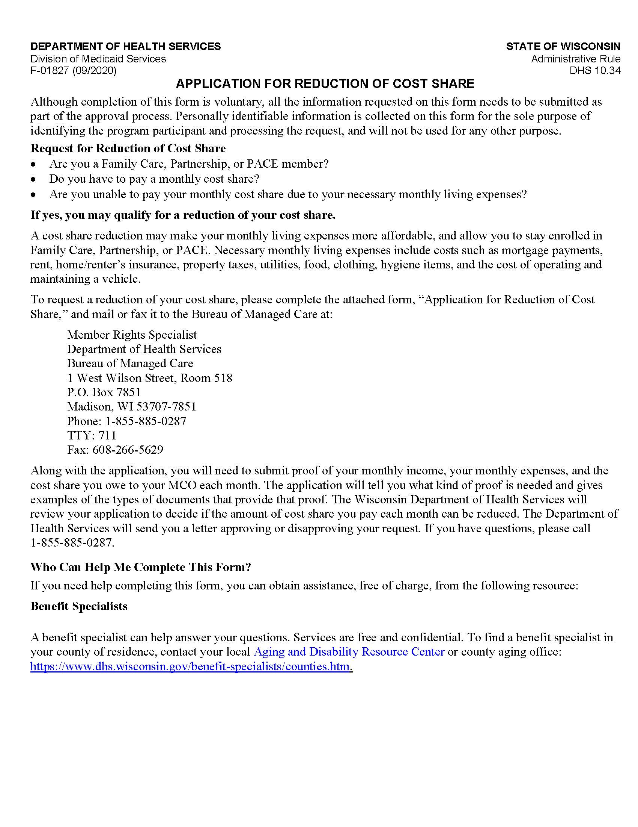
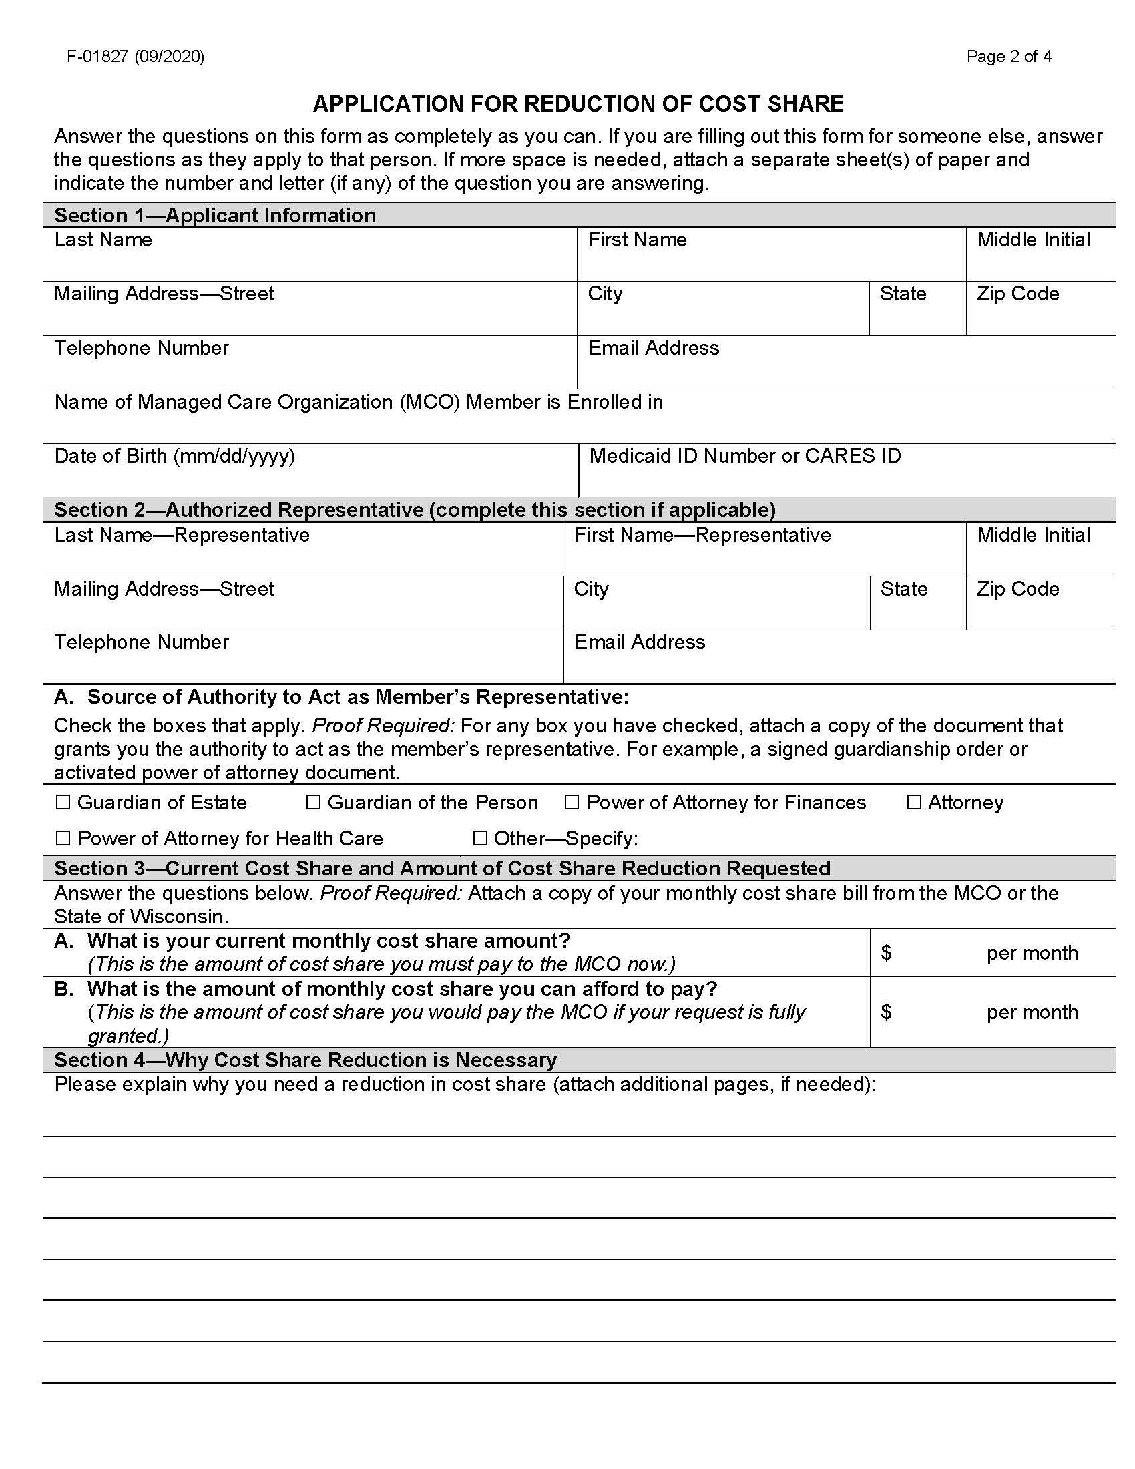
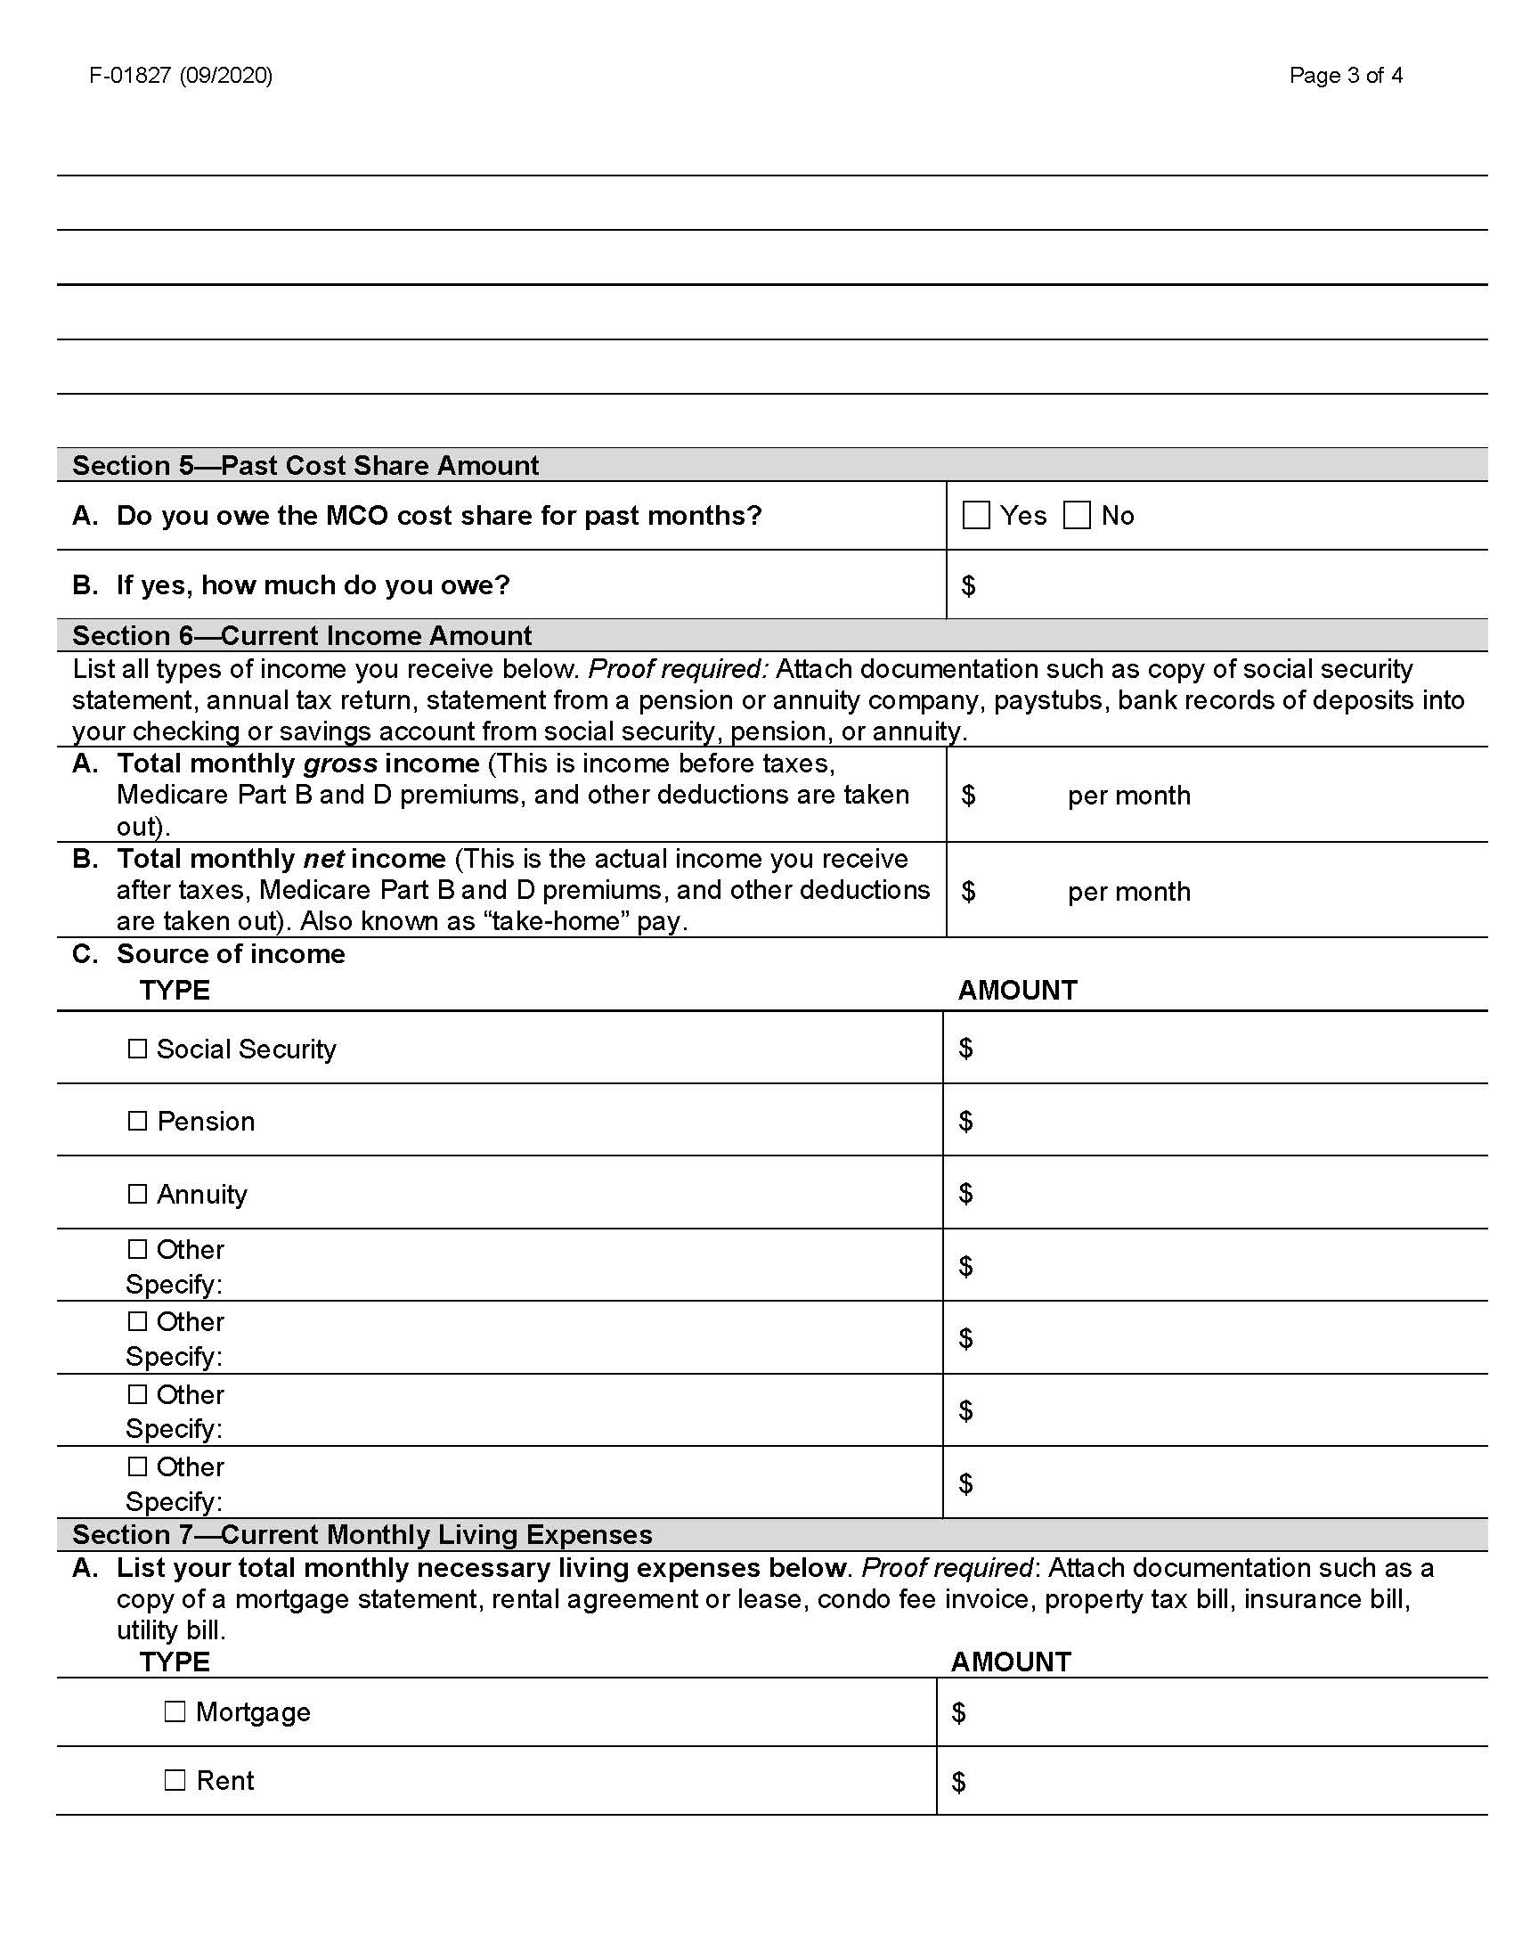
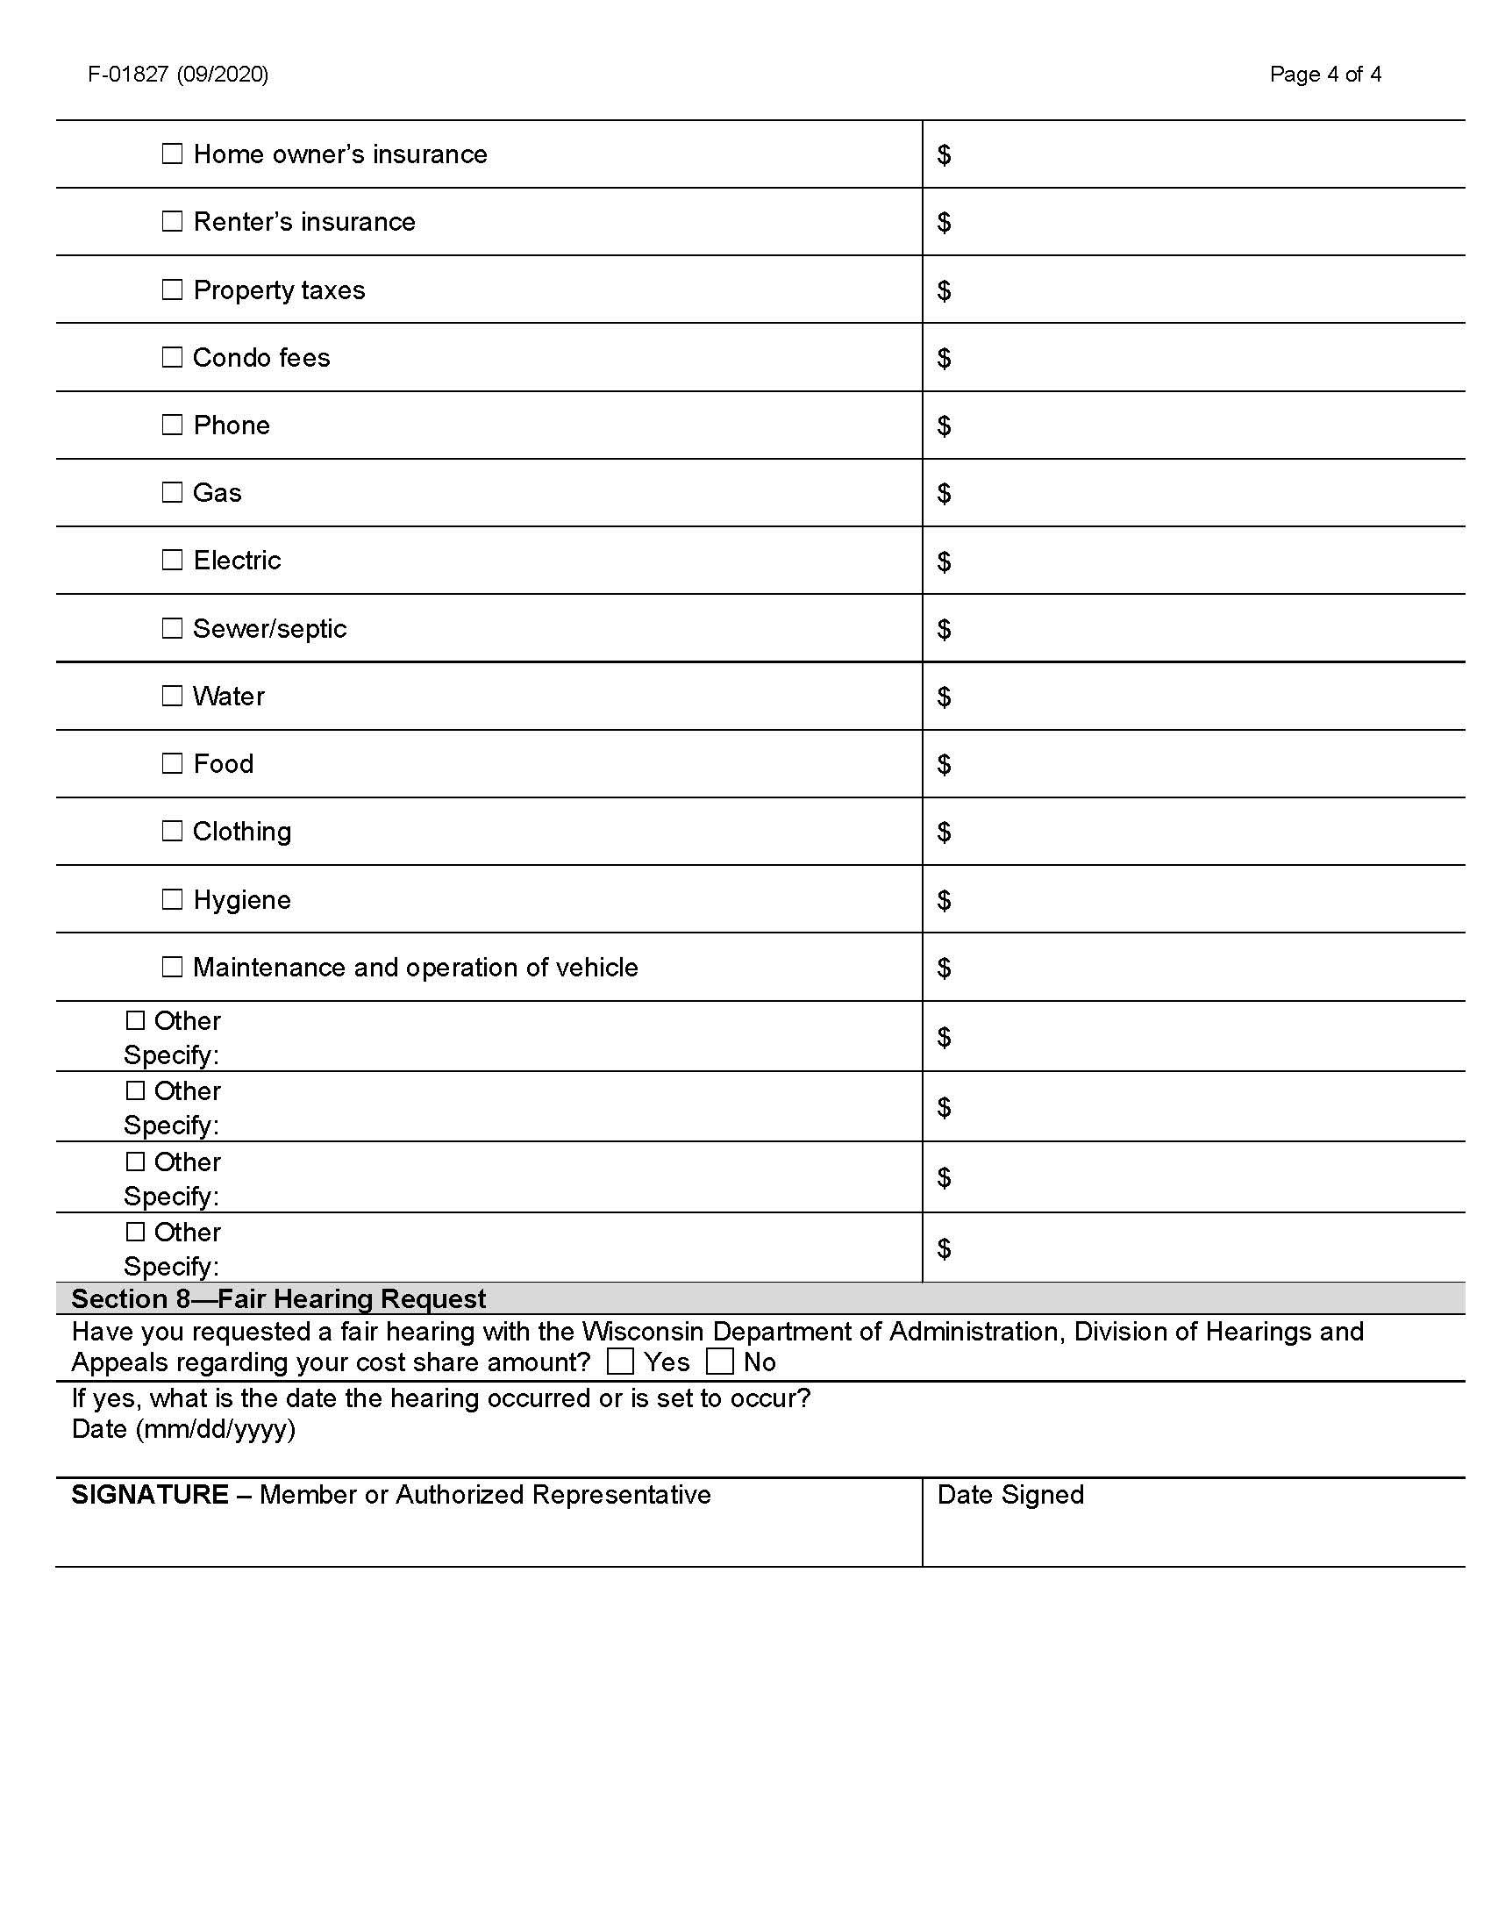

4. Sample Notice of Adverse Benefit Determination
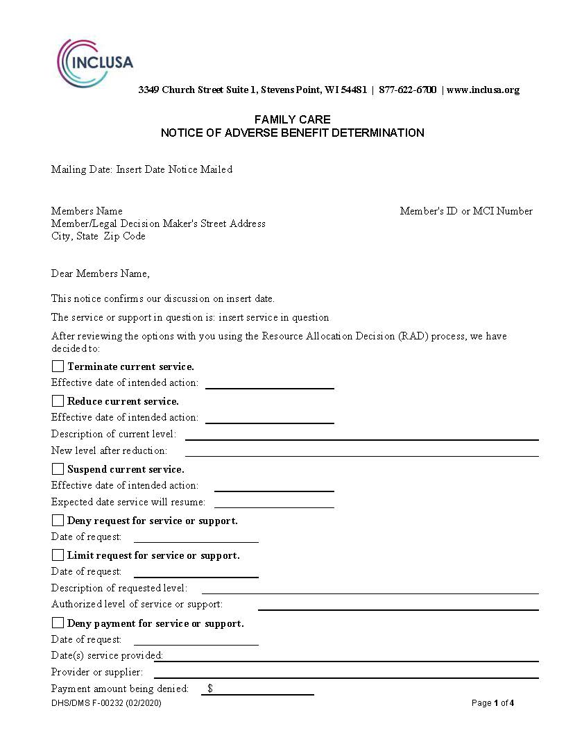
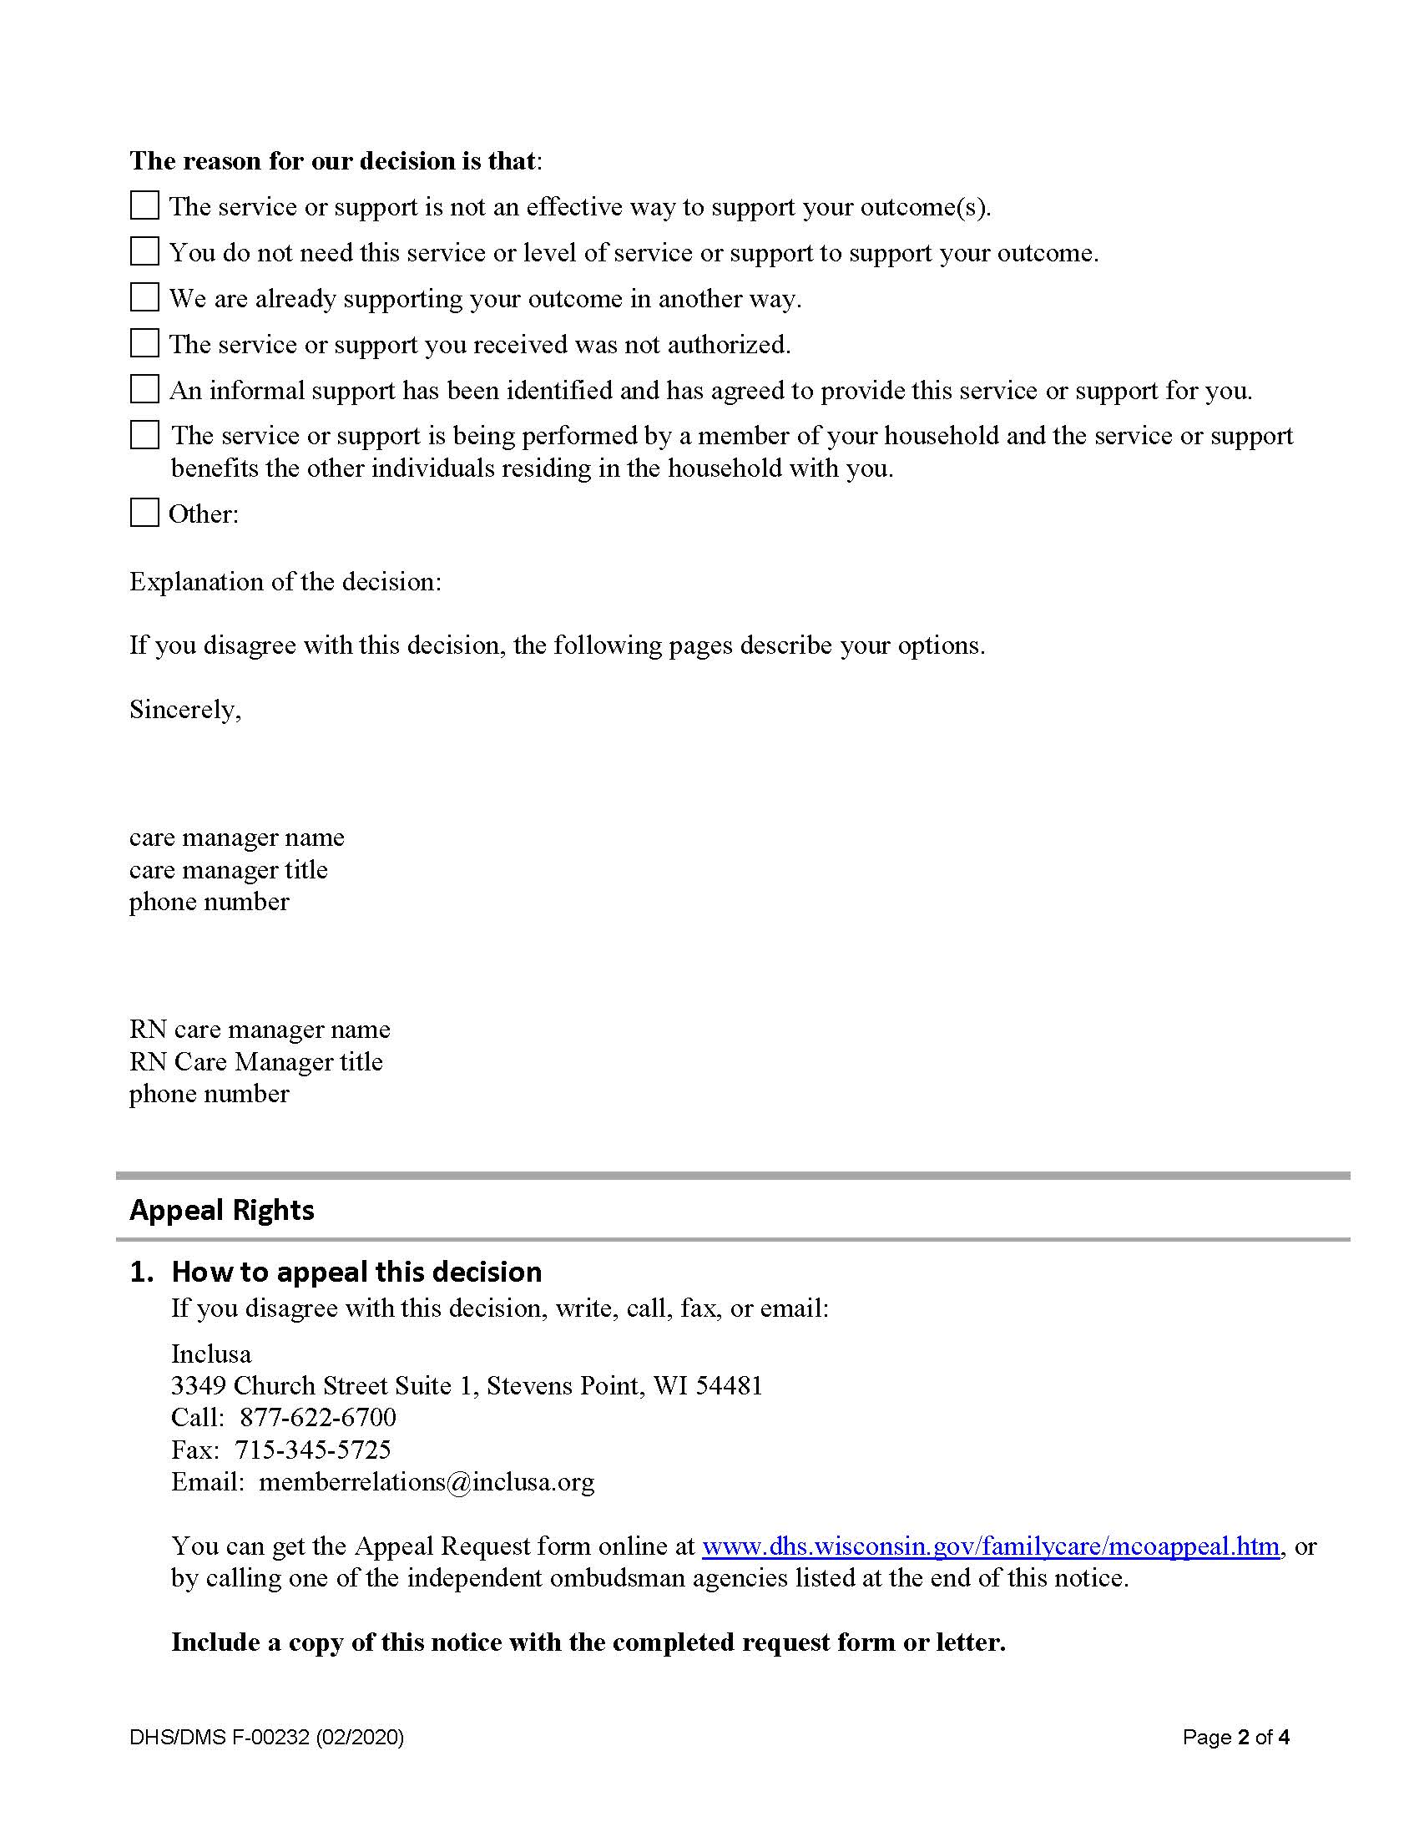

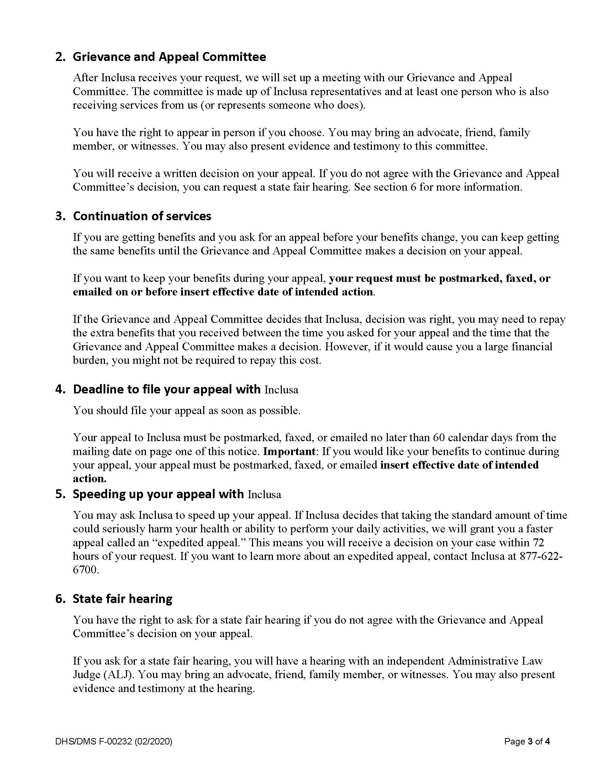

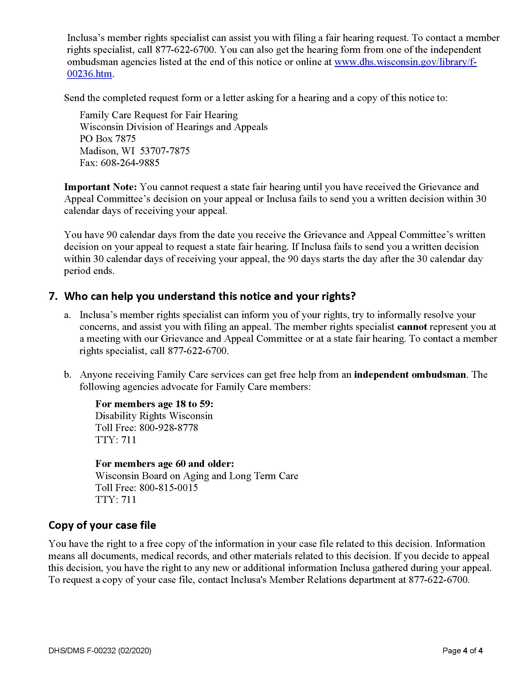

5.Inclusa appeal request form
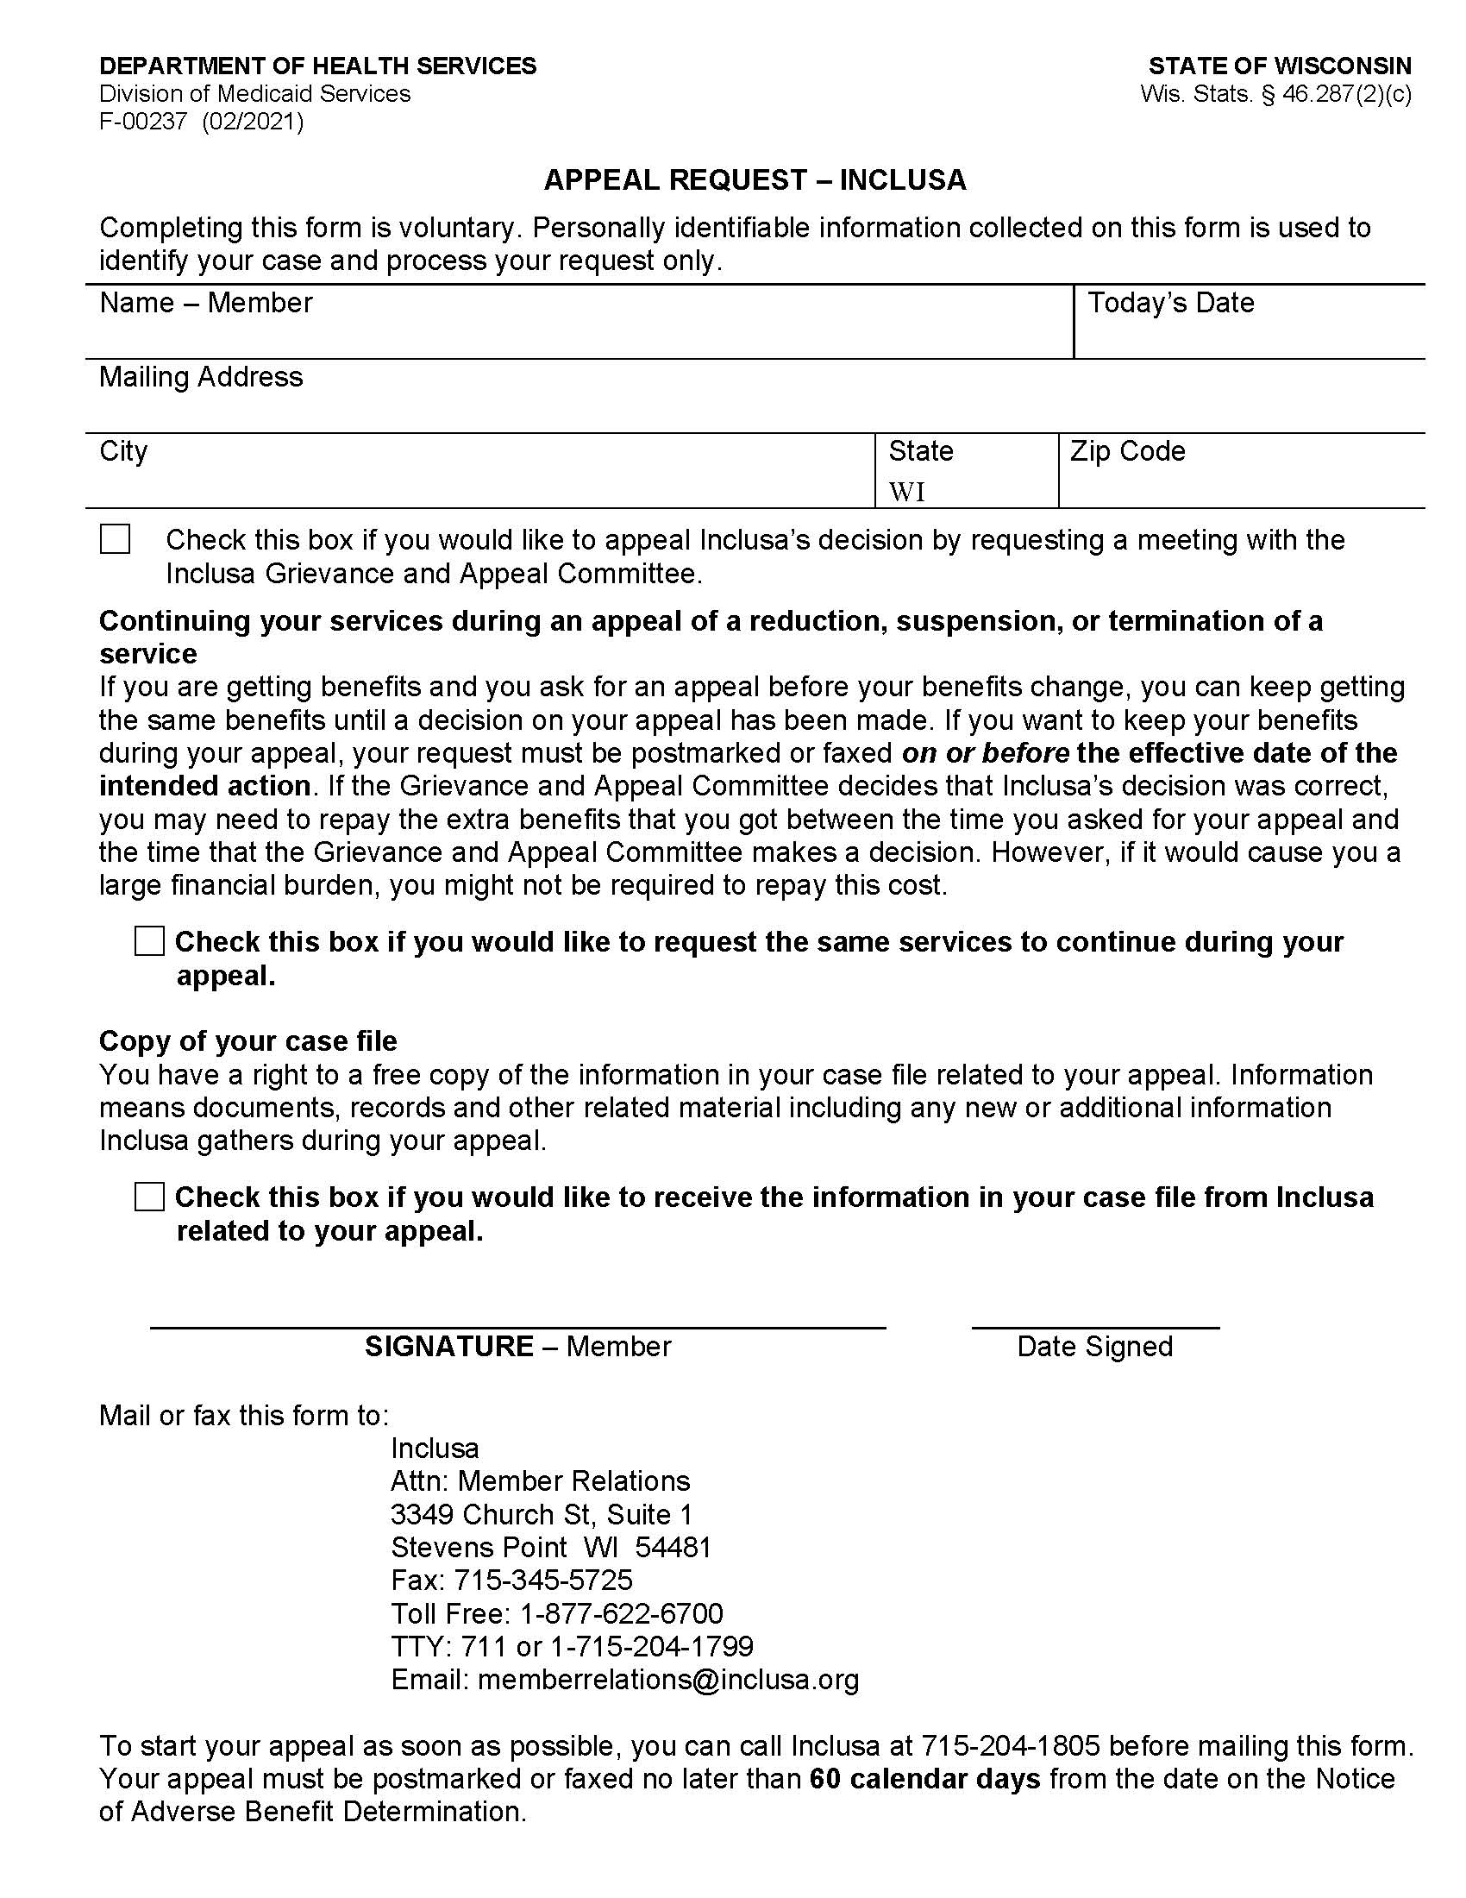
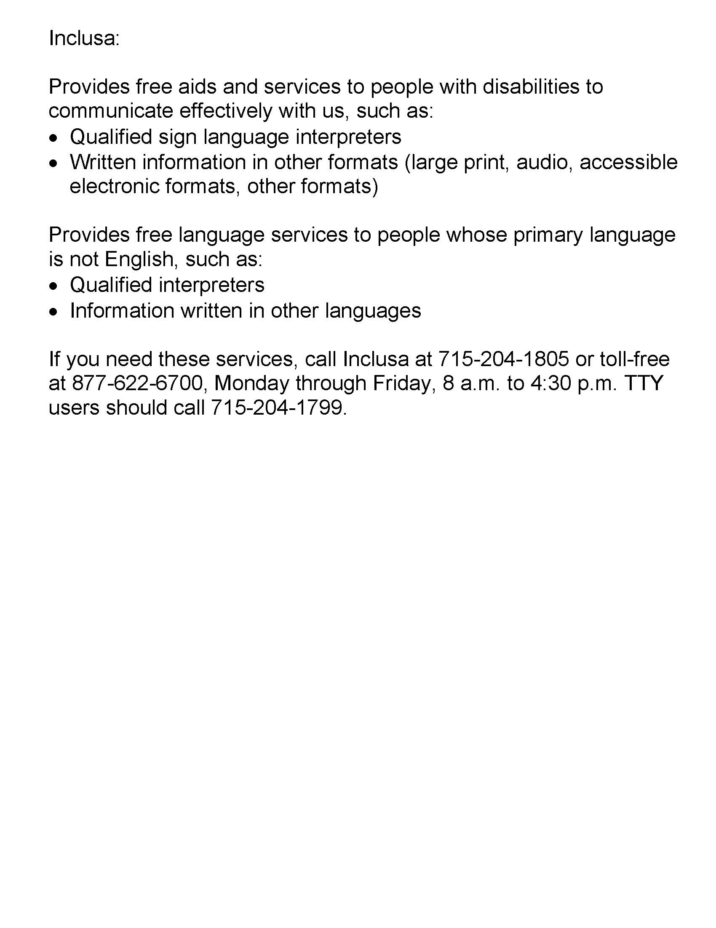

6. State Fair Hearing request form
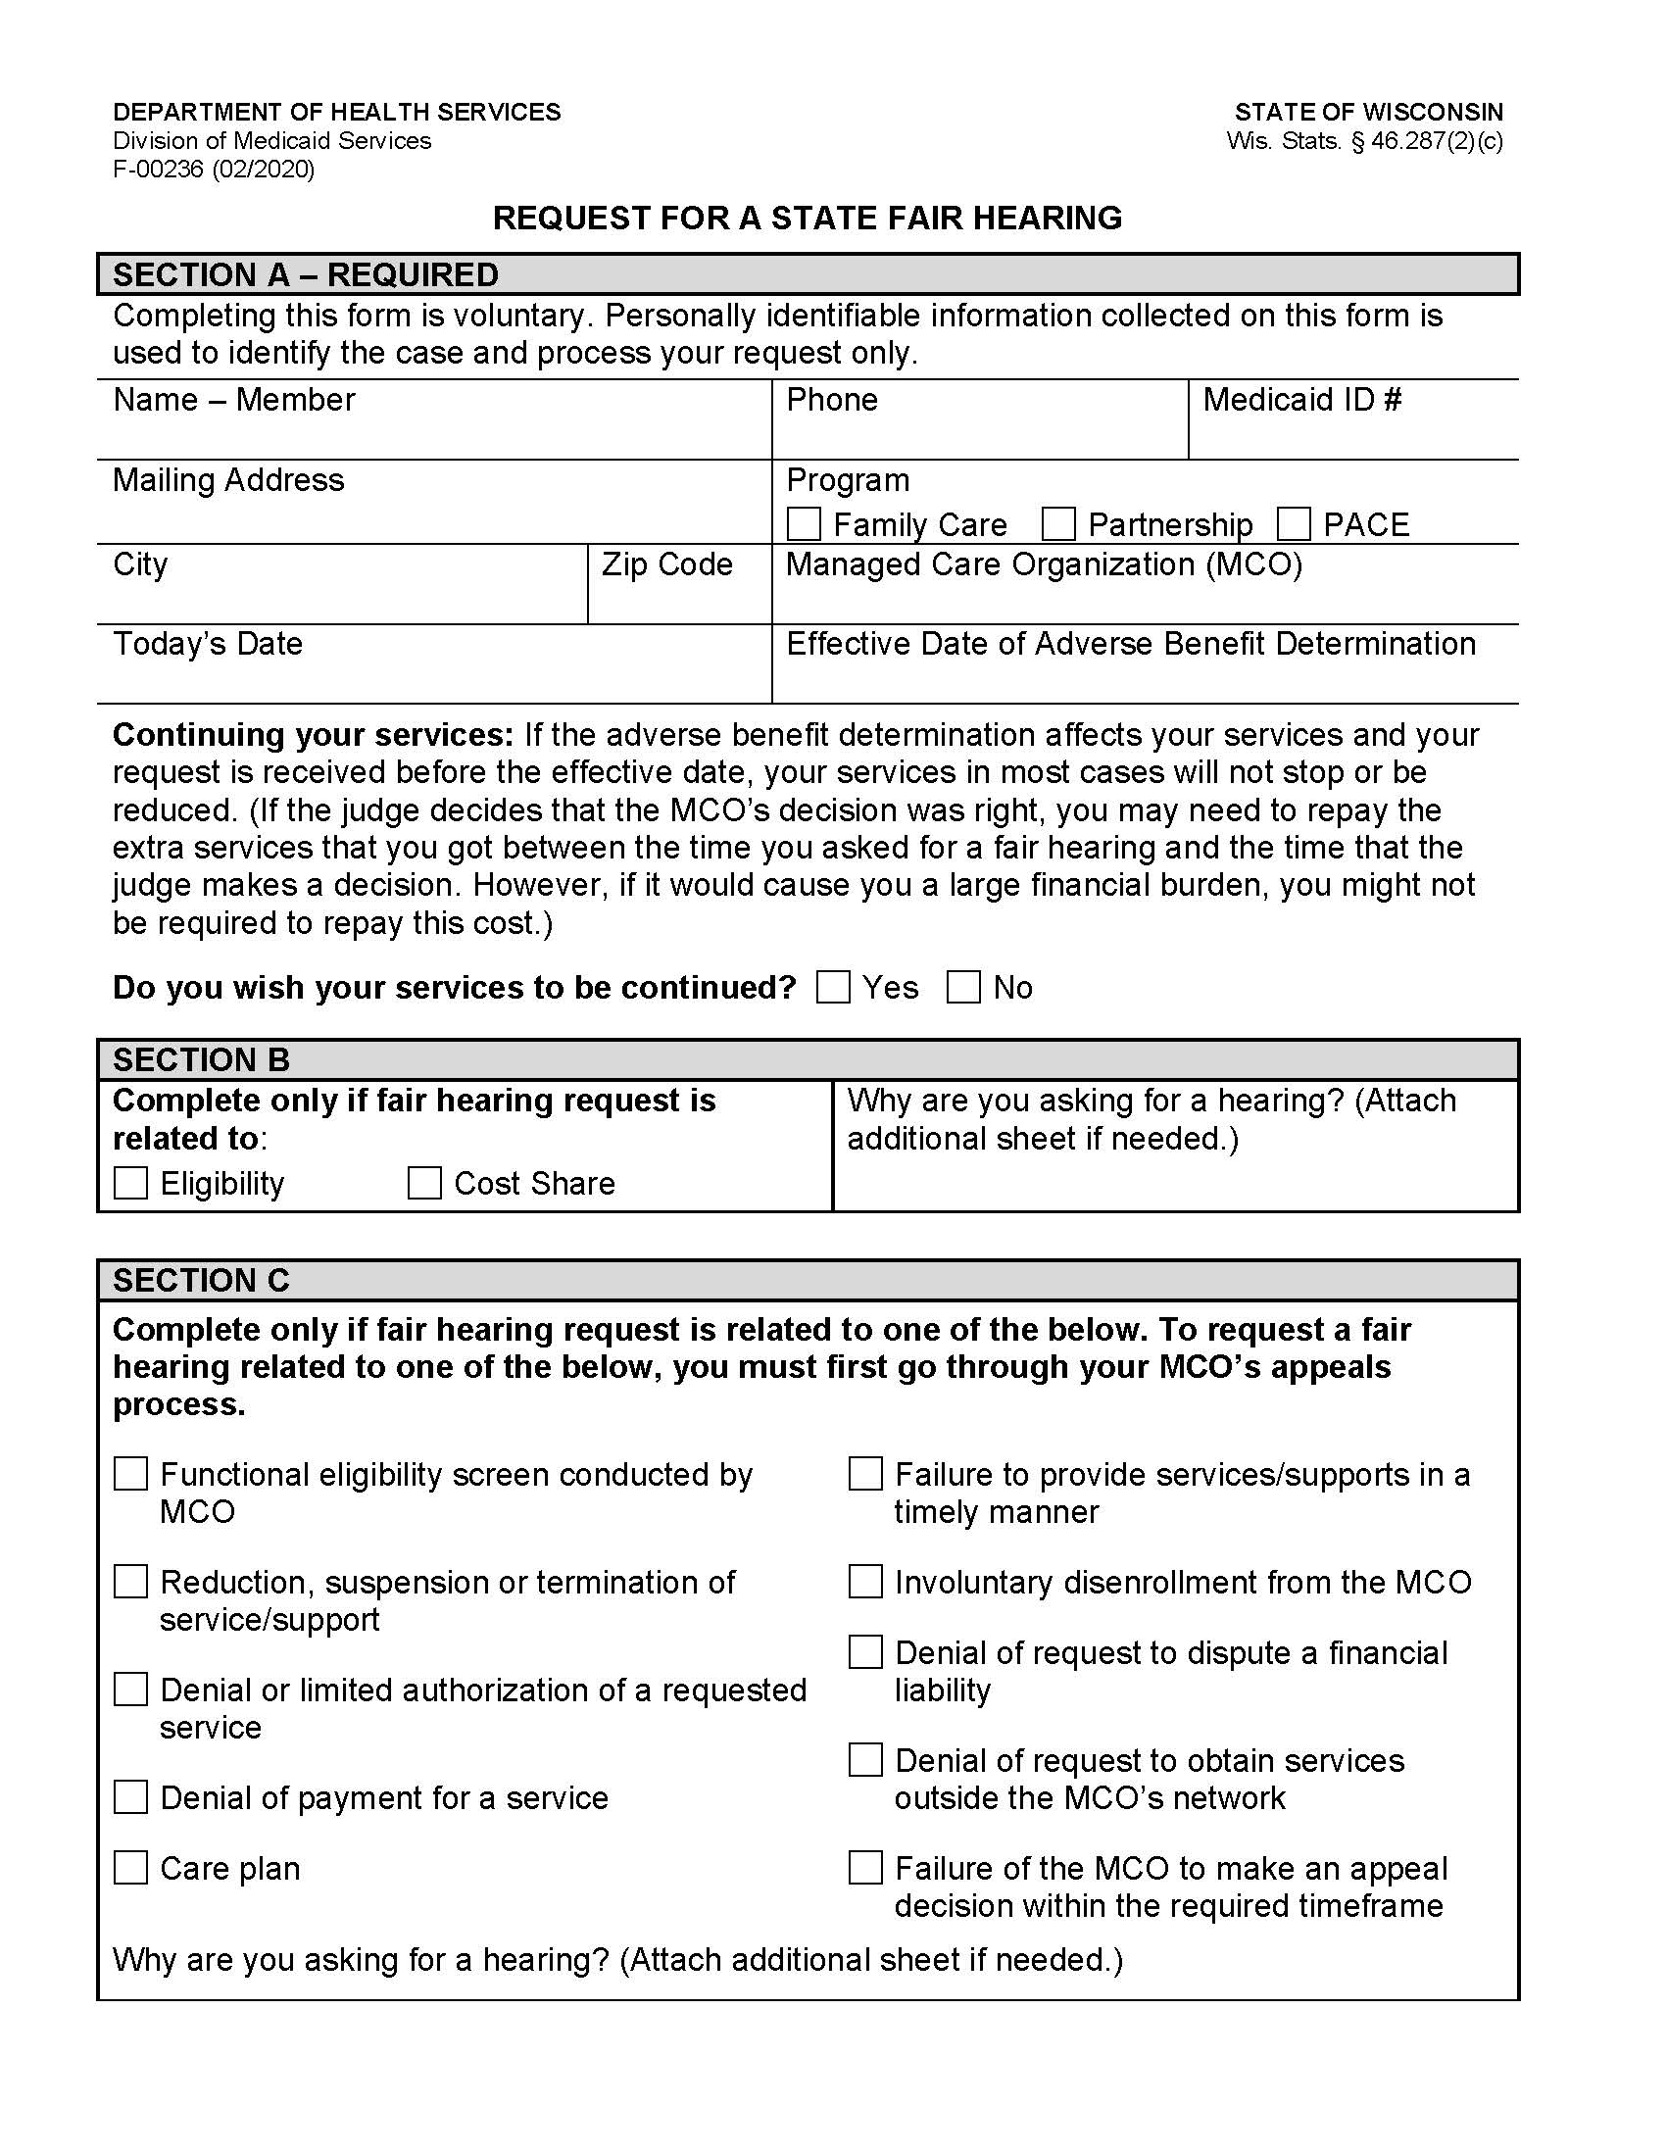
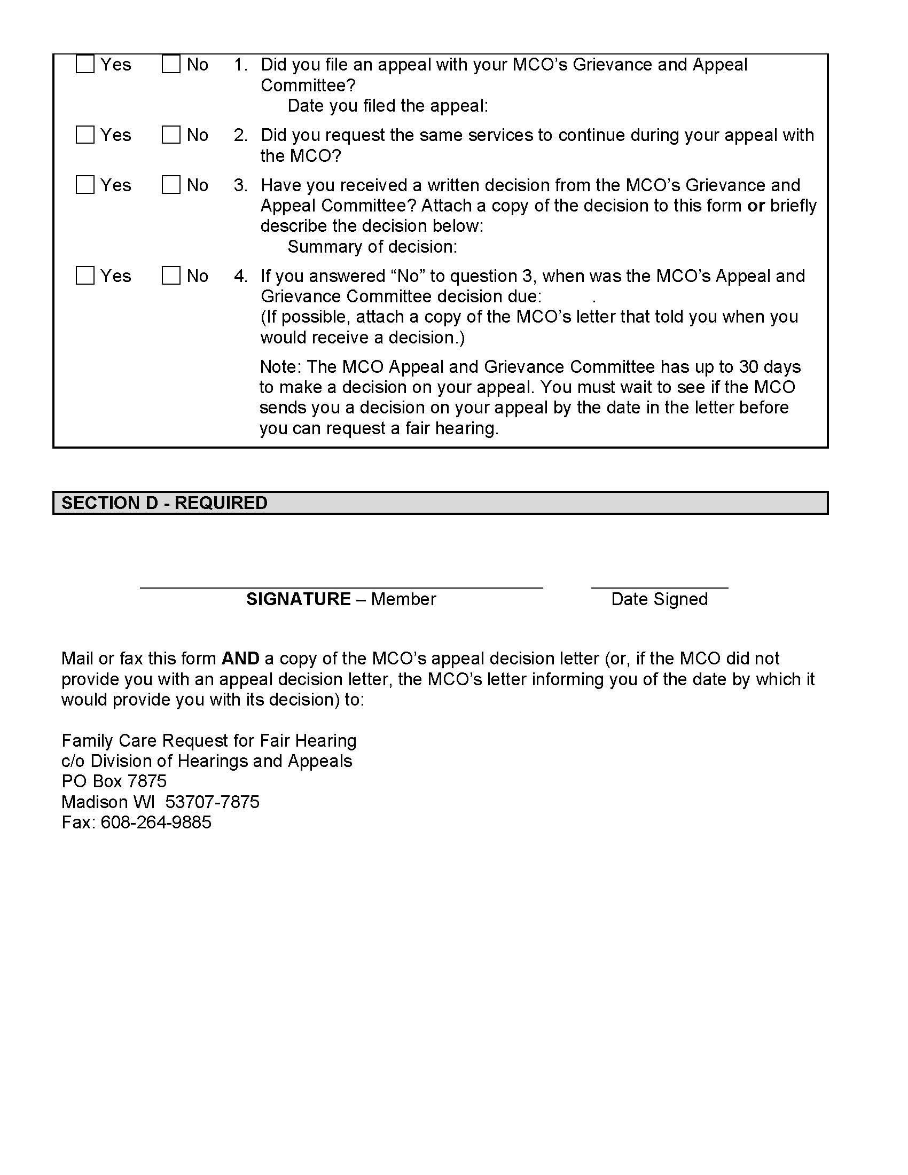
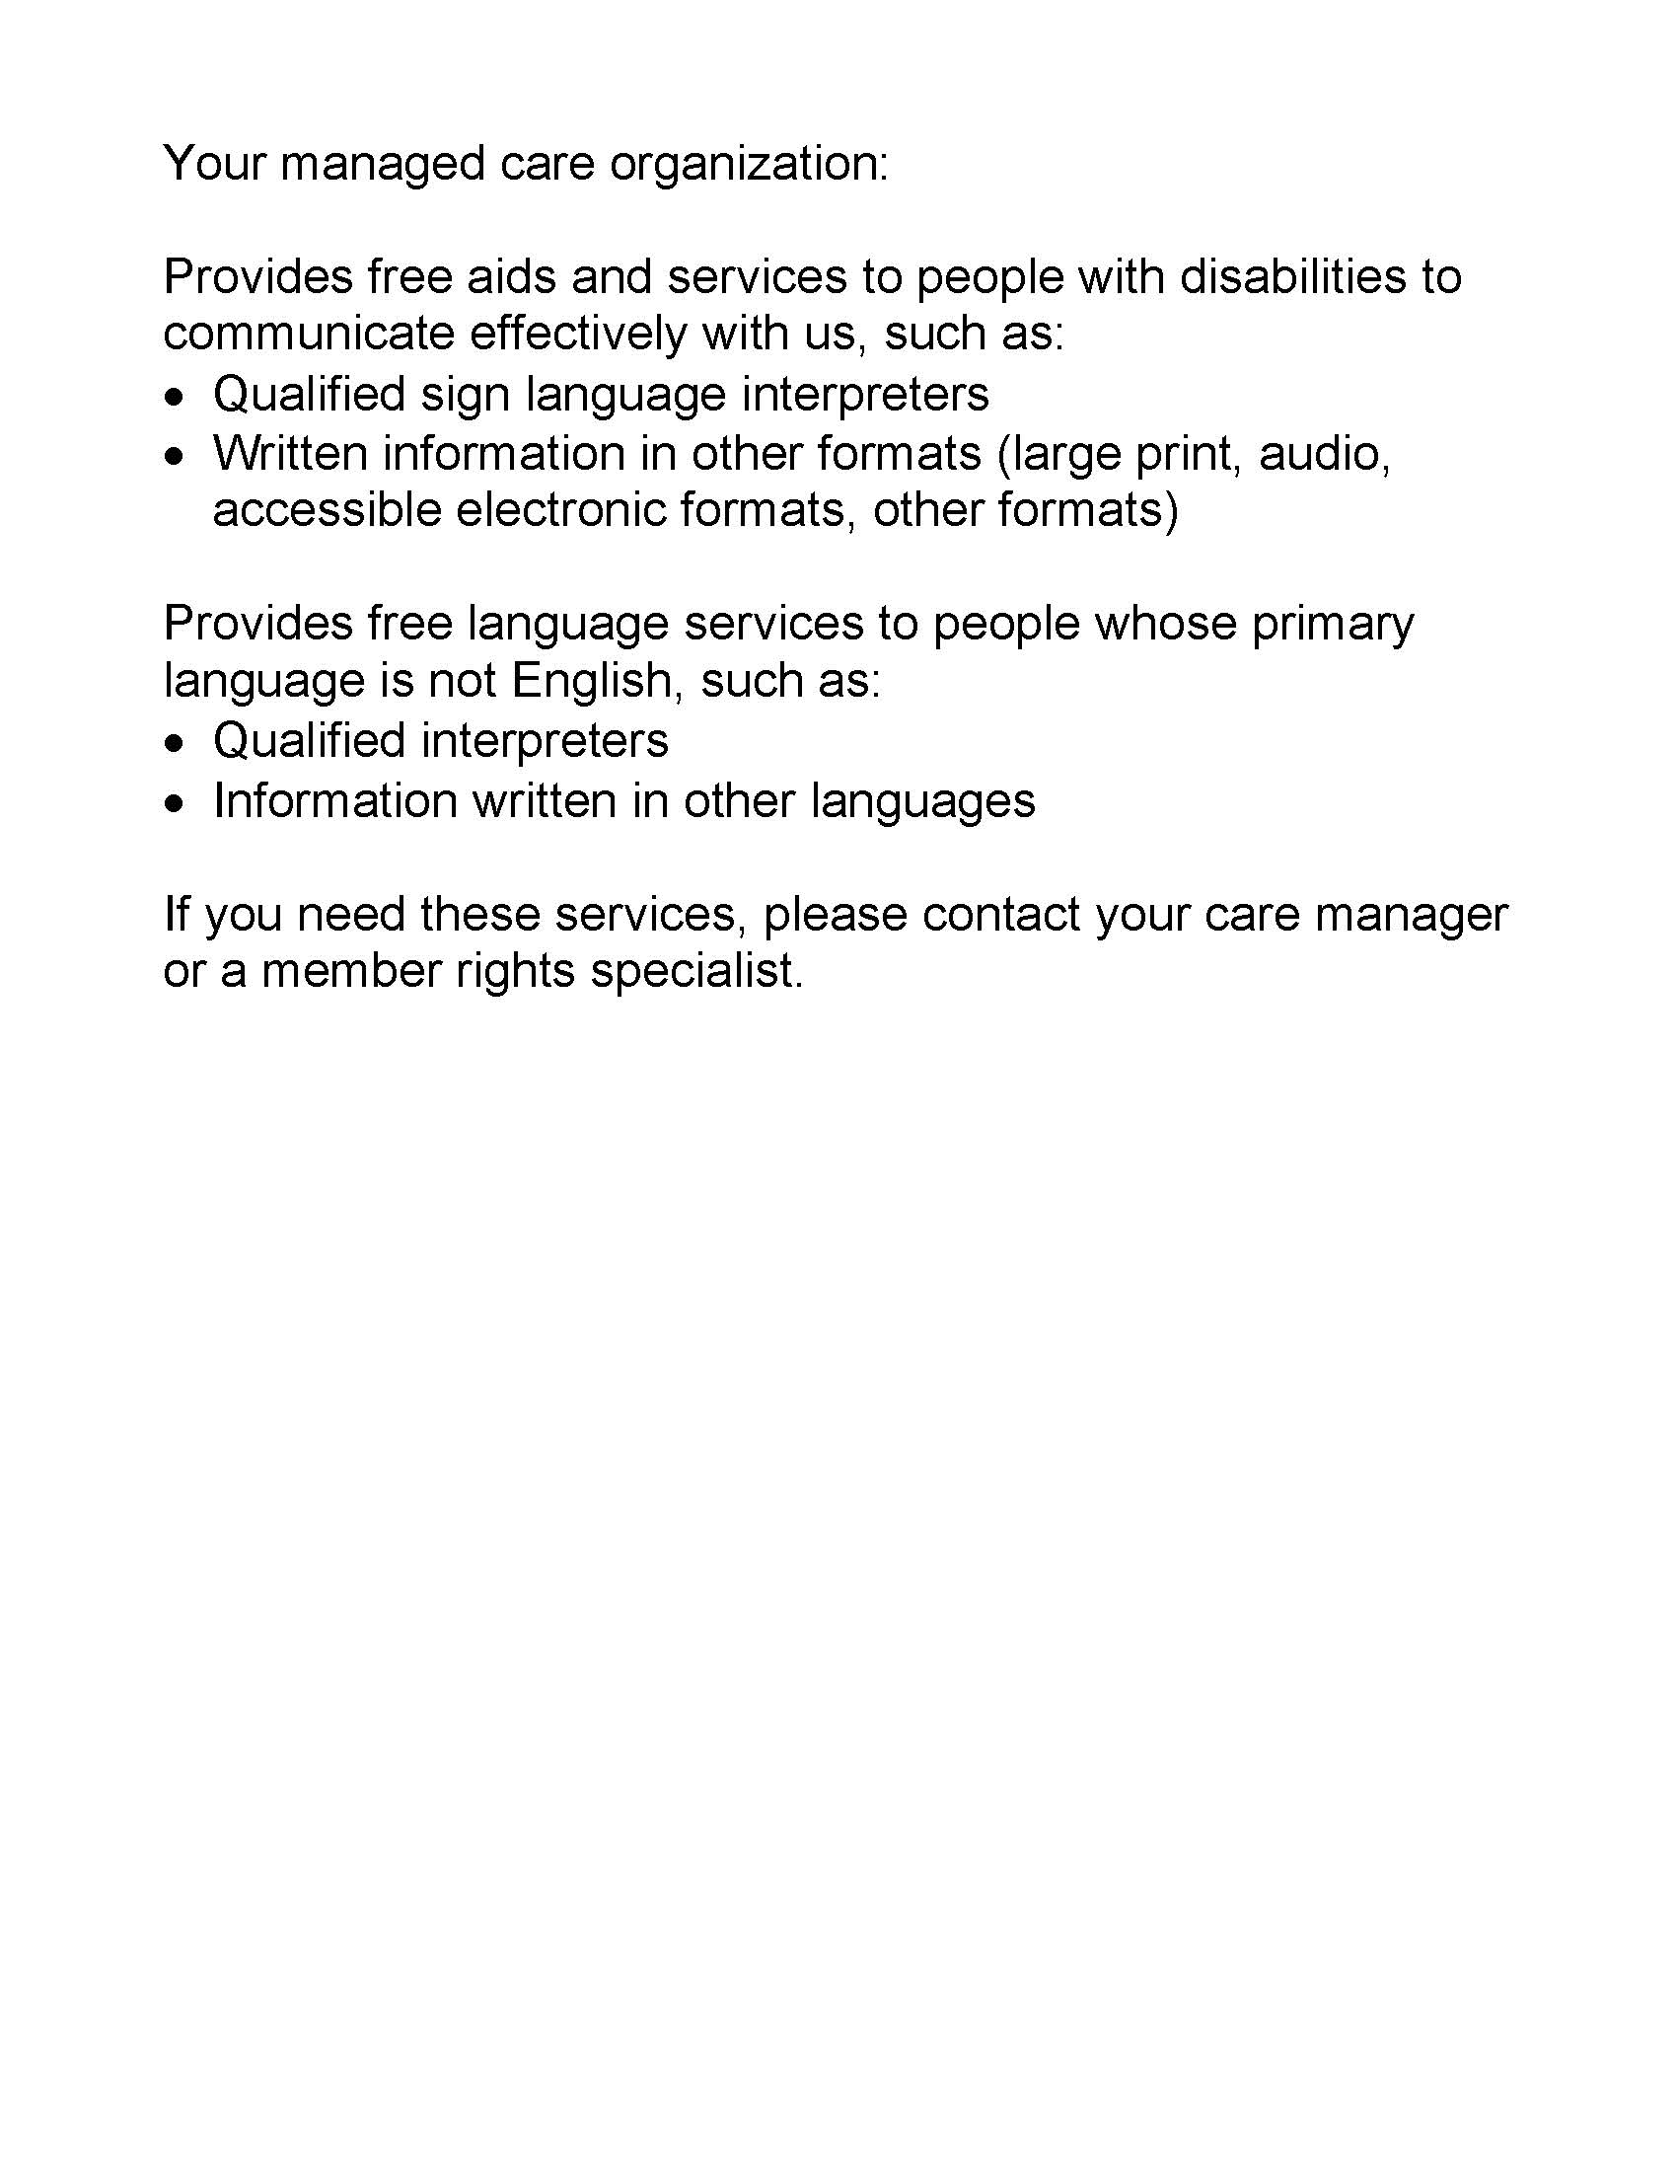

7. Notice of privacy practices

Notice of Privacy Practices
Inclusa
This Privacy Practices Notice describes how health care
information about you may be used and disclosed, and
how you can get access to this information.
Please read the notice carefully.

We are required to protect the privacy of health care information about you, to notify you of our legal duties and privacy practices with respect to your protected health information, and to notify you following a breach of unsecured protected health information. This Privacy Notice tells you about your rights regarding information about you that is kept in health care records. You can look at this anytime to see how your health care records are used by Inclusa as part of your care, and who gets to see them.
This Privacy Notice includes answers to the following questions:
- What is health care information?
- Who can see health care information about you without your written authorization?
- Who cannot see health care information about you unless you give written authorization?
- What are your rights regarding health information about you?

Changes to this Privacy Notice.
We are required to abide by the terms of this notice currently in effect. We reserve the right to change this Privacy Notice. We reserve the right to make the changed Privacy Notice apply to the health care records we already have about you in addition to any information we receive in the future. The Member Handbook will contain the most current Privacy Notice available. You will be offered an updated Member Handbook each year. We will also post a copy of the current Privacy Notice on Inclusa’s website. The effective date of the notice can be found in the lower left-hand corner of the first page.

1. What is Health Care Information?
Any information that can identify you and relates to your past, present, or future physical or mental health or condition; the provision of health care to you; or the past, present, or future payment for the provision of health care to you, is considered your protected health care information. Inclusa may have health care information regarding services we provide to you or payment for services provided to you or information about your past, present, or future health condition. We are required by law to protect health care information about you. We are required to follow the policies in the most current Privacy Notice available.

Health care information about you is kept in a health care record. This health care record contains your assessments, your member-centered plan, and other information related to your care. Each time you visit or are visited by your Community Resource Coordinator, Health & Wellness Coordinator, or other professionals on behalf of Inclusa, a record of the visit is made. This health care record serves as:
- a starting point for planning your care, treatment and any needed follow-up care;
- a means of communication among your care team and the many professionals who contribute to your care;
- a means by which you or a third-party payer (for example, insurance carriers, Medicare, Medicaid) can verify that services billed were actually provided; and
- a tool that can be used to evaluate and continually improve the care given and progress made.

Understanding what is in your health care record and how your health care information is used helps you to:
- make sure health care information about you in the record is correct;
- better understand who, what, when, where, and why others may access health care information about you; and
- make better-informed decisions when you authorize health care information about you to be shared with others in situations where your consent is required to share the information.

2. Who Can Access Health Care Information About You Without Your Written Authorization?
Listed below are reasons why we use and may share your health information without your written authorization:
- For Treatment: We are permitted to use and share health care information about you with health care individuals involved in your care. We are also permitted to share information about you with your health care providers. For example, your Health & Wellness Coordinator may call your pharmacist to reorder medications for you. We are permitted to use and share health information about you with providers of service under contract with Inclusa. For example, a Community Resource Coordinator may need to speak with a transportation provider to arrange transportation for you.
- For Payment: We are permitted to use and share your health care information so that the services you receive through Inclusa may be billed to, and payment collected from, your insurance company, Medicare, and/or Medical Assistance. For example, Inclusa may use health care information about you to pay a provider who has provided long-term care services to you, or Inclusa, or your care team may work with your Income Maintenance Worker to make sure you maintain financial eligibility for Family Care.

- For Health Care Operations: We can use and share your health care information for our operations. We may use health care records to review our treatment and services and to evaluate the performance of our staff in caring for you. We also may remove all information that identifies you from a set of health care information so that others may use that information to study health care and the health care delivery without learning who the specific people are. For example, health care information may be collected and analyzed to improve the quality of our services.

- To Business Associates for Treatment, Payment and Quality Assurance: We may use and share your health care information for our business operations. This using and sharing is necessary to run Inclusa and to make sure that all members receive quality care. We have written agreements with our business associates for administrative purposes, including payment of claims for your services or management of our member-related software system. For example, Inclusa has a contract with WPS to pay claims on our behalf. WPS is considered a business associate to Inclusa We have a formal written agreement with WPS to protect your health care information.

Special Situations
- Individuals Involved in Your Care or Payment of Your Care: We may use or disclose health care information to a family member, other relative, a close personal friend, or any other person identified by you when you are present and you, based on your participation, do not object to the sharing of health care information. If you are not present, or you are not able to agree because you are hurt or experiencing an emergency, we may use our professional judgment to determine whether sharing your health care information is in your best interest. We may also share health care information about you in order to notify your family member, other relative, a close, personal friend, or an agency involved in disaster relief efforts of your location, general condition, or death.

- As Required By Law: We will share your health care record when required to do so by federal, state, or local law. For example, state law requires us to report abuse and neglect. If we believe you are a victim of abuse or neglect, we may share health care information about you to governmental authorities, including protective services as authorized by law to receive such reports. Another example would be during an officially declared disaster or crisis if it is necessary to help ensure your safety or your community’s safety or to prevent disease. However, if you have specific preferences on how we disclose this information under these circumstances, or if you wish to opt out of any disclosure, please let us know and if we agree with the limitations, we will follow your instructions unless there is a specific legal prohibition against it.

- Health Oversight Activities: We will share your health care information with a health oversight agency as authorized by the law for audits, investigations, inspections, and licensure. These activities are necessary to monitor the health care system, government programs, and compliance with civil rights laws. For example, the State of Wisconsin’s Department of Health Services contracts with an agency to provide quality oversight of Inclusa. The oversight agency may conduct file reviews of records to assure compliance with contract requirements.

- Lawsuits and Disputes: If you are involved in a lawsuit or a dispute, we will share your health care information in response to a court or administrative order. We may also share your health care information in response to a subpoena or other lawful process. For example, a subpoena may require disclosure, or a judge may order us to disclose health care information about you.

- If You Dis-enroll and go to Another Family Care Agency: Should you leave Inclusa and sign up for Family Care through another agency, we may be asked to provide a copy of your most recent Long Term Care Functional Screen. Once the request has been verified as a legitimate request, Inclusa will release the screen to them without requesting your permission.

- Other: If you have given someone medical power of attorney, or if someone is your legal guardian, that person can exercise your rights and make choices about your health information. We will make sure the person has this authority and can act for you before we take any action. Another exception includes organ transplants; we can also share health information about you with organ procurement organizations.

In addition, under some circumstances, we may share your health care information permitted or as required by law:
- to report and/or investigate a death (including sharing information with the coroner, medical examiners, or funeral directors)
- Worker’s Compensation claims;
- for judicial and administrative proceedings;
- with protection agencies, advocacy agencies, and ombudsmen programs;
      - to a facility to which you may be involuntarily committed;
      - to avert a serious threat to health or safety; and
      - to a law enforcement or correction agency.

Uses or disclosures of your health care information for other purposes or activities not listed above will be made only with your written permission. If you give us permission to use or share your health care information, you may cancel your permission in writing at any time. If you cancel your permission, we will no longer use or share your health care information for the reasons covered by your written permission. However, we are unable to take back anything we had given already with your permission.

    - Who Cannot See Health Care Information About You Unless You Give Written Authorization?
Other than the uses and disclosures described generally above, we will not use or disclose health care information about you without authorization, or signed permission, from you or your legal decision maker. We would get authorization or signed permission from you, or your legal decision maker, by having you sign an Release of Information for Use and Disclosure of Confidential Information form.

Most uses and disclosures of psychotherapy notes, uses and disclosures of protected health information for marketing purposes, and disclosures that constitute a sale of protected health information, require your written authorization.

Inclusa does not conduct any fundraising, marketing, or medical research. We do not sell any of your information. We do ask members to respond to a survey, provided annually, on their satisfaction with care provided by Inclusa Participation in the survey is always voluntary and you always have the option to say no.

Inclusa is prohibited from the use or disclosure of protected health information for underwriting purposes, including your genetic information. This is required by the Genetic Information Nondiscrimination Act (GINA) of 2008.

    - What Are Your Rights Regarding Health Care Information about You?
You have the following rights regarding the health care information we maintain about you:
- The Right to Ask for Limitations: You have the right to ask for a limitation on the health care information we use or share about you for treatment, payment, or health care operations. You also have the right to ask for a limit on the health care information we share about you to someone who is involved in your care, or the payment for your care, such as a family member or friend. Inclusa must comply with your request to restrict disclosure of your health information to a health plan if:
(A) The disclosure is for the purpose of carrying out payment or health care operations and is not otherwise required by law; and
(B) The protected health information pertains solely to a health care item or service for which you or a person on your behalf has paid Inclusa in full.

In your request, you must tell us:
- what information you want to limit;
- whether you want to limit Inclusa’s use and/or disclosure of the information;
- to whom you want the limits to apply (for example, sharing information with your spouse); and
- your contact address and daytime phone number.

We are not required to agree with your request, especially in those situations where your consent is not required before disclosing the information as described above. If we do agree, we will honor your request unless the information is needed to provide you with emergency treatment. Inclusa will notify you in writing with our decision.

- The Right to Request Confidential Communications: You have the right to request that we speak with you about your services in a certain way or at a certain location. Your request must specify how or where you wish to be contacted. We will accommodate all reasonable requests. For example, you can ask that we only contact you by telephone at work or that we only contact you by mail at home.

- The Right to Inspect and Receive a Copy: You have the right to inspect and receive a copy of your health care information that may be used to make decisions about your care. Usually, this includes case notes and billing records. Psychotherapy notes may not be seen by others or copied. We will provide you a copy or summary of your health information, usually within thirty (30) days; however, under unique circumstances we do have an option of taking a thirty (30) day extension. If there is a delay, we must notify you in writing why we need the extra time and when we think we will be able to fulfill your request. All requests for information must be in writing. Your care team can provide you with a request form and help you fill out the request.

If you request a copy of your health care information, we may charge a fee for the costs of copying, mailing, or other supplies associated with your request. We may deny your request to see or receive a copy in certain very limited circumstances. If you are denied access to your health care information, we will notify you in writing. You may request that the denial be reviewed. The person conducting the review will not be the person who denied your request. We will follow through with the outcome of the review.

- The Right to Amend: If you think there is something wrong or missing in your health care information, you may ask that it be changed. You have the right to request a change to your Inclusa member file. You must include a reason that supports your request. We may say no to your request, but we will tell you why in writing within sixty (60) days.

We may deny your request for a change if it is not in writing or does not include a reason to support the request. In addition, we may deny your request if you ask us to change information that:
- was not created by Inclusa;
- the person or entity that created the information is no longer available to make the amendment;
- is not part of the health care information kept by or for Inclusa; or
- is accurate and complete.

Inclusa will notify you in writing whether we agree or do not agree with your amendment request.

Additionally, if we grant the request, we will make the correction and distribute it to all necessary recipients as well as those you ask to receive the corrected information. If we deny your request for a change to your health care information, we will notify you how you may file a complaint with Inclusa
  - The Right to be Notified of a Breach of your Personal Health Information: With the exceptions outlined under HIPAA Regulations, you have a right to be notified if your information is ever mishandled and a breach (loss) of your personal health information has occurred or has likely occurred.

- The Right to an Accounting of Disclosures: You have the right to request an accounting of disclosures that has been made by Inclusa in the past six (6) years. We will include all the disclosures except for those about treatment, payment, and health care operations and certain other disclosures, such as any you asked us to make.

Your request must state a time period not longer than six (6) years and may not include dates before July 1, 2008. The first list you request within a twelve (12) month period will be free of charge. For additional lists, we may charge you for the costs of providing the list. We will also notify you of the cost involved before any costs are incurred.

  - The Right to a Paper Copy of This Notice: You have the right to receive a paper copy of this Privacy Notice. To obtain a paper copy of this Privacy Notice, contact the Inclusa Privacy Officer at 1-877-622-6700.

