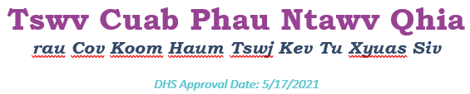
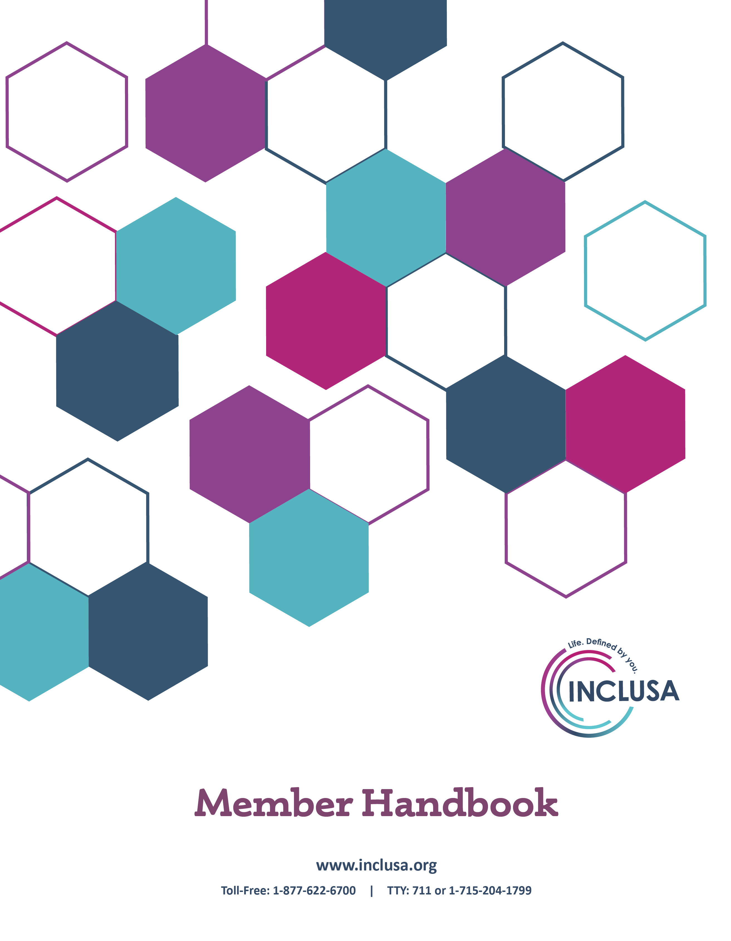

Cov Sob Teem
Tshooj 1. Cov xov tooj thiab chaw muaj kev pab tseem ceeb 6
Inclusa Cov Ncauj Lus Kev Sib Cuag 6
Lwm Cov Neeg Tseem Ceeb Hu Cuag 7
Tshooj 2. Zoo siab txais tos thiab kev nthuav lus 17
Zoo siab txais tos tuaj rau Inclusa 17
Txoj kev pab cuam Family Care yuav pab tau kuv li cas? 18
Leej twg thiaj yuav pab kuv? 18
Kev ua ib tug tswv cuab yog txhais li cas? 19
Leej twg ua tau ib tug tswv cuab ntawm Inclusa? 20
Kuv yuav ua li cas thiaj li ua tau ib tug tswv cuab? 22
Tshooj 3. Cov yuav tau paub txog ntawm kev tau cov kev pab 23
Family Care ua hauj lwm li cas? 23
Yuav tsum muaj dab tsi hauv koj lub tsev yim tu xyuas? 24
Xaiv cov kev pab thiab tau kev tso cai li cas? 25
Yuav ua li cas yog kuv cov kev tu ncua hloov? 26
Kuv yuav siv lub koom haum muab kev pab li cas? 27
Family Care pab koj tswj koj cov kev pab li cas? 27
Cov kev pab txhawb uas tus kheej cob yog dab tsi? 28
Kuv yuav ua li cas thaum muaj kev kub ceev? 29
Kuv yuav ua li cas tau kev tu xyuas tom qab cov sij hawm qhib lag luam? 30
Yuav ua li cas yog kuv yuav tau muaj kev tu xyuas thaum kuv tsis nyob hauv cheeb tsam lawm? 30
Tshooj 4. Family Care cov txiaj ntsim kev pab 31
Muab cov hom kev pab dab tsi? 31
Family Care cov txiaj ntsim kev pab 32
Tsis muab cov hom kev pab dab tsi? 35
Tshooj 5. Kev nkag siab txog leej them rau cov kev pab thiab kev lis txog koj cov txiaj ntsim kev pab 37
Kuv puas them rau tej kev pab? 37
Kuv yuav them nqi li cas? 39
Yuav ua li cas yog kuv txais tau ib daim nqi rau cov kev pab? 39
Ua Family Care puas them rau cov pab neeg nyob hauv lub tsev tu los sis cov tsev laus tu mob? 39
Kev lis ua ke cov txiaj ntsim ntawn Medicare thiab kuv lwm cov kev pab them nqi kho mob li cas? 40
Estate recovery (Kev pab kom tau rov qab cuab yeej cuab tam) yog dab tsi? Nws muaj feem xyuam li cas rau kuv? 41
Tshooj 6. Koj cov cai 43
Txhooj 7. Koj cov tes luag num 47
Tshooj 8. Cov kev chim siab thiab cov kev thov txiav txim dua 50
Kev Nthuav Qhia 50
Cov Kev Chim Siab 51
Cov Kev Thov Txiav Txim Dua 55
Xeev Cov Rooj Sib Hais Ncaj Ncees (State Fair Hearings) 61
Leej twg thiaj pab tau kuv txog kuv txoj kev chim siab los sis kev thov txiav txim dua? 65
Tshooj 9. Kev xaus koj txoj kev ua tswv cuab nrog Inclusa 67
COV NTAWV RHAIS TOM QAB 69
1. Cov lus txhais rau cov lo lus tseem ceeb 69
2. Cov ntsiab lus txhais txog cov kev pab ntawm Family Care cov txiaj ntsim kev pab 75
3. Tsab Ntawv Thov Kev Txo Tsawg Tus Nqi Sib Faib Them 81
4. Qauv Ua Piv Txwv Rau Notice of Adverse Benefit Determination (Tsab Ntawv Faj Seeb Txog Kev Txiav Txim Nyhav Rau Txiaj Ntsim Kev Pab) 86
5. Inclusa tsab ntawv thov kev txiav txim dua 91
6. Tsab ntawv thov Xeev Lub Rooj Sib Hais Ncaj Ncees 94
7. Tsab ntawv faj seeb txog cov kev ceev ntiag tug 98

Tshooj 1. Cov xov tooj thiab chaw muaj kev pab tseem ceeb

Inclusa Cov Ncauj Lus Kev Sib Cuag

- Tus xov tooj hu txog ntau yam dav 8:00 a.m. – 4:30 p.m. Monday - Friday

- Cov chaw khiav hauj lwm

- Cov kev pab tswv cuab
1-877-622-6700
TTY: 711 or 1-715-204-1799

- Kev pab rau tom qab kaw lawm
1-877-622-6700
TTY: 711 or 1-715-204-1799
8:00 a.m. on Weekdays
24 hours a day on Weekends & Holidays

- Cov Kws Pab Tshwj Xeeb Rau Tswv Cuab Cov Cai
Neeg ua hauj lwm pab tswv cuab yog cov neeg tshwj xeeb uas piav qhia txog tswv cuab cov cai. Lawv yeej khoom los pab yog tias koj muaj kev tsis txaus siab los sis kev chim siab. Lawv yuav qhia tej ncauj lus los sis muab kev pab txhawb yog tias koj xav kom txiav txim dua txog ib txoj kev txiav txim ntawm koj pawg neeg

Toll-Free: 1-877-622-6700
8:00 a.m. – 4:30 p.m. Monday-Friday

Yog tias koj ntsib kev kub ntxhov ceeb, hu 911

Lwm Cov Neeg Tseem Ceeb Hu Cuag

Cov Kev Pab Tiv Thaiv Neeg Laus
Txhua lub cheeb koog yeej muaj ib koom haum uas tshawb xyuas cov lus ceeb toom txog kev tsim txom, kev tsis saib xyuas, kev rhuav qhia nyiaj txiag tsis raug cai, thiab kev tsis saib xyuas tus kheej. Hu rau koj lub cheeb koog tus xov tooj pab neeg yog tias koj xav tham nrog ib tug neeg txog kev xav tias tsam ib tug neeg laus ntsib teeb meem kev tsim txom (hnub nyoog 18 txog 59). Xav ceeb toom txog kev tsim txom ib tug neeg laus muaj hnub nyoog laus dua 60 xyoo, hu cuag koj lub cheeb koog lub koom haum pab cov neeg laus ntsib taus teeb meem.
Adams County (Health & Human Services Department)
Phone: 608-339-4505
● Ashland County (Health & Human Services Department)
Phone: 715-682-7004
● Barron County (Department of Health & Human Services)
Phone: 715-537-5691
● Bayfield County (Department of Human Services)
Phone: 715-373-6144
● Brown County (Human Services)
Phone: 920-448-7885
● Buffalo County (Aging and Disability Resource Center)
Phone: 866-578-2372
● Burnett County (Health & Human Services Department)
Phone: 715-349-7600
● Calumet County (Department of Health & Human Services)
Phone: 920-849-1400
● Chippewa County (Department of Human Services)
Phone: 715-726-7788
● Clark County (Department of Social Services)
Phone: 866-743-5233
● Columbia County (Aging and Disability Resource Center)
Phone: 608-742-9233
● Crawford County (Human Services Department)
Phone: 608-326-0248
● Dodge County (Aging and Disability Resource Center)
Phone: 920-386-3580
● Door County (Human Services)
Phone: 920-746-7155
● Douglas County (Department of Health & Human Services)
Phone: 715-395-1304
● Dunn County (Aging and Disability Resource Center)
Phone: 715-232-4006
● Eau Claire County (Department of Human Services)
Phone: 715-839-7118
● Fond Du Lac County (Aging and Disability Resource Center)
Phone: (920) 929-3466
● Forest County (Human Services Department)
Phone: 888-452-3296
● Florence County (Department of Human Services)
Phone: 715-478-7709
● Grant County (Department of Social Services)
Phone: 608-723-2136
● Green County (Aging and Disability Resource Center)
Phone: 608-328-9499
● Green Lake County (Health and Human Services)
Phone: 920-294-4070
● Iowa County (Aging and Disability Resource Center)
Phone: 608-930-9835
● Iron County (Human Services Department)
Phone: 715-561-3636
● Jackson County (Aging and Disability Resource Center)
Phone: 844-493-4245
● Jefferson County (Human Services)
Phone: 920-674-3105
● Juneau County (Department of Human Services)
Phone: 608-847-2400
● Kewaunee County (Human Services)
Phone: 920-338-0626
● La Crosse County (Aging and Disability Resource Center)
Phone: 800-500-3910
● Lafayette County (Human Services)
Phone: 608-776-4800
● Langlade, Lincoln, and Marathon Counties (North Central Community Services)
Phone: 855-487-3338 or 715-841-5160
● Manitowoc County (Department of Human Services)
Phone: 920-683-4230
● Marinette County (Aging and Disability Resource Center)
Phone: 715-732-3850
● Marquette County (Human Services)
Phone: 608-297-3124
● Menomonee County (Health & Human Services)
Phone: 715-799-3861
● Monroe County (Aging and Disability Resource Center)
Phone: 800-500-3910
● Oconto County (Health & Human Services)
Phone: 920-834-7000
● Oneida County (Department of Social Services)
Phone: 715-369-7499
● Outagamie County (Health and Human Services)
Phone: 920-832-5169
● Ozaukee County (Human Services)
Phone: 262-284-8200
Pepin County (Aging and Disability Resource Center)
Phone: 866-578-2372
● Pierce County (Aging and Disability Resource Center)
Phone: 715-273-6780
● Polk County (Human Services Department)
Phone: 715-485-8400
● Portage County (Health & Human Services Department)
Phone: 715-345-5350
● Price County (Health & Human Services)
Phone: 715-339-2158
● Richland County (Aging and Disability Resource Center)
Phone: 608-647-4616
● Rock County (Human Services Department – ADRC)
Phone: 608-741-3600 or 855-741-3600
● Rusk County (Department of Health & Human Services)
Phone: 715-532-2299
● St. Croix County (Department of Health and Human Services)
Phone: 715-246-8255
● Sauk County (Department of Human Services)
Phone: 608-355-4200
● Sawyer County (Health & Human Services Department)
Phone: 800-569-4162
● Shawano County (Department of Social Services)
Phone: 715-526-4700
● Sheboygan County (Aging and Disability Resource Center)
Phone: 920-467-4700
● Taylor County (Human Services Department)
Phone: 715-748-3332
● Trempealeau County (Aging and Disability Resource Center)
Phone: 800-273-2001
● Vernon County (Aging and Disability Resource Center)
Phone: 800-500-3910
● Vilas County (Department of Social Services)
Phone: 715-479-3668
● Walworth County (Department of Health & Human Services)
Phone: 262-741-3200
● Washburn County (Health & Human Services Department)
Phone: 715-468-4747
● Washington County (Aging and Disability Resource Center)
Phone: 262-335-4497
● Waukesha County (Aging and Disability Resource Center)
Phone: 262-548-7848
● Waupaca County (Health and Human Services)
Phone: 715-258-6400
● Waushara County (Department of Human Services)
Phone: 920-787-6618
● Winnebago County (Department of Human Services)
Phone: 877-886-2372
● Wood County (Department of Social Services)
Marshfield Area Phone: 715-387-6374
Wisconsin Rapids Area Phone: 715-421-8600

Aging and Disability Resource Centers (Cov Chaw Pab Kev Laus Zus thiab Kev Tsis Taus)
Aging and disability resource centers (cov chaw pab kev laus zus thiab kev tsis taus) (ADRC) yog thawj qhov chaw mus cuag kom tau cov ncauj lus yog, tsis ntxub ntxaug txhua yam hauv lub neej uas txuam nrog txoj kev laus zus los sis ua lub neej nrog txoj kev tsis taus. Cov ADRC yog cov chaw muaj lub siab zoo, zoo siab txais tos txhua tus—cov tib neeg, cov tsev neeg los sis cov phooj txhawj txog los sis cov kws tshaj lij ua hauj lwm txog cov xwm txheej txuam rau txoj kev laus zus los sis cov kev tsis taus—yeej mus cuag kom tau cov ncauj lus haum raws lawv qhov xwm txheej. Lub ADRC muaj cov ncauj lus txog cov kev pab cuam thiab cov kev tu xyuas, yuav pab cov neeg kom nkag siab txog cov kev tu xyuas muaj ntev rau lawv, thiab yuav pab lawv ua ntawv thov cov kev pab cuam thiab cov txiaj ntsim kev pab. Cov ADRC hauv Inclusa cov cheeb tsam muab kev pab yog:
- Aging & Disability Resource Center Serving Adams, Green Lake, Marquette, and Waushara Counties
Toll-Free: 1-877-883-5378
- ADRC of Barron, Rusk & Washburn Counties
Toll-Free: 1-888-538-3031

- ADRC of Brown County
Toll-Free: 920-448-4300
- ADRC of Buffalo and Pepin Counties
Toll-Free: 866-578-2372
- ADRC of Calumet, Outagamie and Waupaca Counties
Toll-Free: 1-883-620-2730
- ADRC of Central Wisconsin
Serves residents of Langlade, Lincoln, Marathon, and Wood Counties
Toll-Free: 1-888-486-9545
- ADRC of Chippewa County
Toll-Free: 1-888-400-6920
- ADRC of Clark County
Toll-Free: 866-743-5144
- ADRC of Columbia County
Toll-Free: 1-888-742-9233
- ADRC of Dodge County
Toll-Free: 1-800-924-6407
- ADRC of Door County
Toll-Free: 855-828-2372
- ADRC of Douglas County
Toll-Free: 1-866-946-2372
- ADRC of Dunn County
Phone: 1-715-232-4006
- ADRC of Eagle Country
Serves residents of Crawford, Juneau, Richland and Sauk Counties
Toll-Free: 1-877-794-2372
- ADRC of Eau Claire County
Toll-Free: 1-888-338-4636
- ADRC of Florence County
Toll-Free: 1-855-528-2372
- ADRC of Fond Du Lac County
Toll-Free: 1-888-435-7335
- ADRC of Jackson County
Toll-Free: 1-844-493-4245
- ADRC of Jefferson County
Toll-Free: 1-866-740-2372

- ADRC of La Crosse County
Toll-Free: 1-800-500-3910
- ADRC of the Lakeshore
Serving residents of Kewaunee and Manitowoc Counties
Toll-Free: 877-416-7083
- ADRC of Marinette County
Toll-Free: 888-442-3267
- ADRC of Monroe County
Toll-Free: 1-888-339-7854
- ADRC of the North
Serves residents of Ashland, Bayfield, Iron, Price, and Sawyer Counties
Toll-Free: 1-866-663-3607
- ADRC of Northwest Wisconsin
Serves residents of Burnett and Polk Counties and the St. Croix Chippewa Tribe
Toll-Free: 1-877-485-2372
- ADRC of the Northwoods
Serves residents of Forest, Oneida, Taylor, and Vilas Counties
Toll-Free: 1-800-699-6704
- ADRC of Ozaukee County
Toll-Free: 1-866-537-4261
- ADRC of Pierce County
Toll-Free: 1-877-273-0804
- ADRC of Portage County
Serves residents of Portage County
Toll-Free: 1-866-920-2525
- ADRC of Rock County
Phone: 1-608-741-3600 or
Toll-Free: 1-855-741-3600
- ADRC of St. Croix County
Toll-Free: 1-800-372-2333
- ADRC of Sheboygan County
Toll-Free: 800-596-1919
- ADRC of Southwest Wisconsin
Serves residents of Grant, Green, Iowa, and Lafayette Counties
Toll-Free: 1-877-794-2372
- ADRC of Trempealeau County
Phone: 1-715-538-2001 or
Toll-Free: 1-800-273-2001

- ADRC of Vernon County
Toll-Free: 1-888-637-1323
- ADRC of Walworth County
Toll-Free: 800-365-1587
- ADRC of Washington County
Toll-Free: 1-877-306-3030
- ADRC of Waukesha County
Toll-Free: 1-866-677-2372
- ADRC of Winnebago County
Toll-Free: 1-877-886-2372
- ADRC – Wolf River Region (Shawano, Oconto & Menomonee Counties)
Toll-Free: 855-492-2372

Mus xyuas www.dhs.wisconsin.gov/adrc kom paub ntxiv txog cov ADRC.

Cov Kev Pab Cuam Ombudsman (Neeg Ywj Pheej Pab Daws Teeb Meem)
Tus ombudsman (om-budz-man) (neeg ywj pheej pab daws teeb meem) yog ib tug kws pab tswv yim sab nraud los sis ib tug neeg pab uas tsis ua hauj lwm rau Inclusa. Txhua tus neeg uas tau txais cov kev pab ntawm Family Care yeej tau cov kev pab dawb los ntawm tus ombudman (neeg ywj pheej pab daws teeb meem). Lub koom haum yuav tau mus cuag yog nyob ntawm tus tswv cuab qib hnub nyoog.
Yog tias koj muaj hnub nyoog 60 xyoo los sis laus dua, mus cuag:
Wisconsin Board on Aging and Long Term Care
1402 Pankratz Street, Suite 111
Madison, WI 53703
Xov tooj hu dawb: 800-815-0015
TTY: 711
Tshuab xa ntawv: 608-246-7001
Sau ntawv email: BOALTC@wisconsin.gov
longtermcare.wi.gov

Yog tias koj muaj hnub nyoog 18 txog 59, mus cuag:
Disability Rights Wisconsin
1502 West Broadway, Suite 201
Madison, WI 53713
Xov tooj hu dawb: 800-928-8778
TTY: 711
Tshuab xa ntawv: 833-635-1968
www.disabilityrightswi.org

Income Maintenance Consortiums (Cov Koom Haum Tswj Xyuas Nyiaj Txiag)
Koj yuav tsum tau ceeb toom qhia cov kev pauv hauv koj txoj kev ua lub neej los sis cov nyiaj txiag ua ntej 10 hnub. Yog tias koj tsiv tsev, koj yuav tsum tau ceeb toom qhia koj qhov chaw nyob siab. Cov kev pauv no yeej muaj feem xyuam tau rau koj txoj kev tsim nyog tau Medicaid thiab Family Care. Ceeb toom qhia cov kev pauv no mus rau koj lub cheeb koog lub income maintenance consortium (koom haum tswj xyuas nyiaj txiag) thiab Inclusa. Cov koom haum nyob rau hauv peb cheeb tsam muab kev pab yog:
- Bay Lake Consortium
Serves residents of Brown, Door, Marinette, Oconto and Shawano Counties
Phone: 1-888-794-5747
Fax: 1-855-293-1822
● Capital Consortium
Serves residents of Adams, Columbia, Dane, Dodge, Juneau, Richland, Sauk, and Sheboygan Counties
Phone: 1-888-794-5556
Fax: 1-855-293-1822
● Central Consortium
Serves residents of Langlade, Marathon, Oneida, and Portage Counties
Phone: 1-888-445-1621
Fax: 1-855-293-1822
● East Central Consortium
Serves residents of Calumet, Green Lake, Kewaunee, Manitowoc, Marquette, Outagamie, Waupaca, Waushara, and Winnebago
Phone: 1-888-256-4563
Fax: 1-855-293-1822
● Great Rivers Consortium
Serves residents of Barron, Burnett, Chippewa, Douglas, Dunn, Eau Claire, Pierce, Polk, St. Croix, and Washburn Counties
Phone: 1-888-283-0012
Fax: 1-855-293-1822
● Moraine Lakes Consortium
Serves residents of Fond du Lac, Ozaukee, Walworth, Washington, and Waukesha Counties
Phone: 1-888-446-1239
Fax: 1-855-293-1822
● Northern Consortium
Serves residents of Ashland, Bayfield, Florence, Forest, Iron, Lincoln, Price, Rusk, Sawyer, Taylor, Vilas, and Wood Counties
Phone: 1-888-794-5722
Fax: 1-855-293-1822
● Southern Consortium
Serves residents of Crawford, Grant, Green, Iowa, Jefferson, Lafayette, and Rock Counties
Phone: 1-888-794-5780
Fax: 1-855-293-1822
● Western Consortium
Serves residents of Buffalo, Clark, Jackson, La Crosse, Monroe, Pepin, Trempealeau, and Vernon Counties
Phone: 1-888-627-0430
Fax: 1-855-293-1822

Wisconsin Medicaid (ForwardHealth)
Yog tias koj muaj cov teeb kev siv koj daim yuaj ForwardHealth rau cov kev kho kab mob kev nkeeg los sis cov khoom cuab yeej hauv Family Care cov txiaj ntsim kev pab (xws li cov iav qhov muag, cov kev mus ntsib koj tus kws kho mob, los sis cov ntawv sau tshuaj), hu rau ForwardHealth Member Services (Chaw Pab Tswv Cuab) ntawm tus xov tooj hu dawb:
800-362-3002

Kev Ceeb Toom Qhia Kev Tub Sab Tub Nyiaj Cov Kev Pab Rau Pej Xeem Huab Hwm
Kev tub sab tub nyiag yog tau kev pab them nqi kho mob los sis cov nyiaj them uas koj yeej paub tias koj tsis tsim nyog tau los sis kev pab ib tug neeg tau txoj kev pab them nqi kho mob los sis cov nyiaj them uas koj paub tias lawv tsis tsim nyog tau. Txhua tus neeg ua tub sab tub nyiag yuav raug nplua. Yog lub tsev hais plaub txiav txim tias ib tug neeg uas tau cov txiaj ntsim kev pab them nqi kho mob tau tub sab tug nyiag, lub tsev hais plaub yuav yuam kom tus neeg ntawd them rov qab rau cov txiaj ntsim kev pab ntawd rau lub xeev, nrog rau lwm cov kev nplua.

Yog koj xav tias ib tug neeg tau siv cov nyiaj pab txhawb pej xeem huab hwm txhaum cai, nrog rau Family Care, hu rau tus xov tooj pab txog kev tub sab tub nyiag los sis mus ceeb toom rau saum huab cua ntawm:
877-865-3432
www.dhs.wisconsin.gov/fraud

or

Toll-Free: 1-877-622-6700
fraud@inclusa.org

Wisconsin FoodShare (Daim Yuaj QUEST)
Yog tias koj muaj lus nug los sis kev txhawj xeeb txog FoodShare, los sis yog koj xav paub seb tshuav npaum li cas hauv koj daim yuaj rau FoodShare/QUEST, los sis xav ceeb toom txog daim yuaj QUEST ploj los sis raug nyiag, hu rau FoodShare tus xov tooj hu dawb pab neeg qhua ntawm:
877-415-5164

Wisconsin Division of Quality Assurance (Wisconsin Fab Tswj Xyuas Kev Pab Zoo)
Yog koj xav tias ib tug neeg zov tu, ib lub koom haum, los sis ib lub chaw tau ua txhaum lub xeev los sis tsoom fwv teb chaws cov cai, koj muaj txoj cai ua ntawv tsis txaus siab nrog Wisconsin Division of Quality Assurance (Wisconsin Fab Tswj Xyuas Kev Pab Zoo). Thaum ua ntawv tsis txaus siab, yuav nug kom koj qhia lub cheeb koog uas lub chaw muab kev pab nyob rau. Xav hais qhia kev tsis txaus siab, hu rau:
800-642-6552

Inclusa Billing Questions
If you have questions about cost share, room and board charges, or billing processes, call our main office toll free at 1-877-622-6700 during normal business hours (8:30 to 4:30, Monday – Friday) and ask to speak to a Member Liabilities Specialist. They can also help you if you are not able to pay a bill or want to set up automatic billing and payment.

1-877-622-6700

Tshooj 2. Zoo siab txais tos thiab kev nthuav lus

Zoo siab txais tos tuaj rau Inclusa

Zoo siab txais tos tuaj rau Inclusa, uas yog ib lub koom haum tswj xyuas kev tu mob uas hauj lwm nrog txoj kev pab Family Care. Family Care yog Medicaid ib txoj kev pab tu xyuas mus ntev uas muab kev pab rau cov laus neeg thiab cov neeg laus uas muaj cov kev puas ib ce, puas siab ntsws los sis puas hlwb. Cov neeg hauv txoj kev pab yuav tau cov kev tu xyuas uas pab kom lawv ua tau lub neej nyob rau hauv lawv lub vaj lub tsev thaum twg yog tsim nyog. Family Care tau nyiaj txiag txhawb los ntawm lub xeev thiab tsoom fwv cov nyiaj se sau tau.

Phau ntawv coj qhia no yuav qhia cov ncauj lus uas koj yuav tau paub:

- Nkag siab txog cov ntsiab tseem ceeb ntawm Family Care.
- Kom paub txog cov kev tu xyuas uas muaj nyob rau hauv cov txiaj ntsim kev pab.
- Nkag siab txog koj cov cai thiab cov tes dej num tam ib tug tswv cuab hauv Family Care.
- Zwm qhia txog txoj kev chim siab los sis kev txiav txim dua yog tias koj muaj ib qho teeb meem los sis kev txhawj xeeb.

Yog tias koj xav tau neeg pab koj xyuas phau ntawv no, thov hu cuag koj pawg neeg tu xyuas. Cov ncauj lus sib cuag tau koj pawg neeg tu xyuas yog nyob rau ntawm nplooj
1-877-622-6700, and ask to speak with a member of your team.

Hais rau qhov dav, cov lo lus “koj” thiab “koj tug” nyob rau hauv daim ntawv no yog hais txog koj, uas yog tus tswv cuab. “Koj” thiab “koj tug” yuav puav leej txhais tias yog tus neg txiav txim raug cai rau koj, xws li tus neeg muaj cai saib xyuas los sis kev sawv cev tam raug cai.

Ntawm kawg hauv phau ntawv no (nplooj 60) yog txhais rau cov lo lus tseem ceeb. Cov kev txhais no yuav pab kom koj nkag siab cov lo lus thiab cov nqe lus uas nquag siv hauv phau ntawv no.

Yog tias koj tseem tsis tau yog ib tug tswv cuab thiab muaj tej lus nug, los sis xav paub ntxiv txog kev rau npe koom nrog Family Care los sis lwm cov kev pab cuam, thov hu cuag lub aging and disability resource center (chaw pab txhawb kev laus zus thiab kev tsis taus) (ADRC) hauv koj cheeb tsam. Cov ADRC yuav qhia tau tej ncauj lus thiab muab tau kev pab thiab yuav pab tib neeg ua ntawv thov cov kev pab cuam thiab cov txiaj ntsim kev pab. Lub ADRC yog ib lub koom haum sab nraud. Nws tsis yog ib feem ntawm Inclusa. Muaj lub ADRC pab koj, txawm yog koj xav koom ua ib tug tswv cuab hauv Family Care los tsis ua. Muaj qhov chaw nyob thiab xov tooj rau lub ADRC hauv koj zos nyob ntawm nplooj 10-13.

Txoj kev pab cuam Family Care yuav pab tau kuv li cas?
Family Care:
- Yuav txhawb tau los sis tswj xyuas tau koj txoj kev ua lub neej kom zoo dua.
- Yuav pab kom koj nyob twj ywm tau hauv koj lub tsev los sis chav tsev, nrog rau lub tsev neeg thiab cov phooj ywg.
- Yuav txuam koj nrog cov kev txiav txim txog txoj kev npaj tu xyuas kab mob kev nkeeg thiab cov kev tu xyuas rau koj.
- Yuav pab txhawb rau koj txoj kev ywj pheej kom muaj ntau tshaj plaws.

Lub hom phiaj loj ntawm Family Care yog tswj xyuas kom koj nyob nyab xeeb thiab muaj kev pab txhawb rau tom vaj tom tsev. Thaum twg koj nyob rau hauv koj lub tsev los sis hauv koj lub tsev neeg lub vaj lub tsev, koj muaj peev xwm tswj xyuas tau koj lub neej dua. Koj yeej txiav txim tau txog kev yuav ua dab tsi rau thaum twg, xws li thaum twg mam li sawv thiab noj cov pluas, thiab koj yuav npaj li cas rau hnub ntawd.

Thaum koj koom nrog Family Care, Inclusa yuav sib tham nrog koj txog cov hom kev tu xyuas twg thiaj yuav pab kom koj ua tau lub neej ywj pheej npaum li muaj rab peev xwm. Neeg pab rau kev ntxuav cev, tsheb thauj, kev tu vaj tu tsev, thiab kev xa cov pluas noj rau tom tsev yog qee cov kev tu xyuas uas peb muaj. Cov kev tu xyuas puav leej yog nruab tus lag kev kom thawb tau lub laub muaj log los sis kev siv lub tshuab ceeb toom qhia kev muaj mob. (Xyuas tshooj 4 kom pom tag nrho cov hom kev tu xyuas uas kam them rau.)
Family Care:
- Yuav txhawb tau los sis tswj xyuas tau koj txoj kev ua lub neej kom zoo dua.
- Yuav pab kom koj nyob twj ywm tau hauv koj lub tsev los sis chav tsev, nrog rau lub tsev neeg thiab cov phooj ywg.
- Yuav txuam koj nrog cov kev txiav txim txog txoj kev npaj tu xyuas kab mob kev nkeegg thiab cov kev tu xyuas rau koj.
- Yuav pab txhawb rau koj txoj kev ywj pheej kom muaj ntau tshaj plaws.

Family Care yuav muab kev tswj xyuas txoj kev kho mob thiab muaj ntau cov hom kev tu xyuas uas npaj los kom haum rau koj cov kev tu ncua. Peb yuav xyuas kom koj tau txoj kev kho kab mob kev nkeeg tsim nyog rau koj kom koj noj qab haus huv thiab nyob nyab xeeb. Peb yuav puav leej pab kom koj muaj cov kev sib cuag nrog koj lub tsev neeg, cov phooj ywg thiab lub zej zog.

Yog tias koj yog ib tug neeg hluas npaj yuav tsiv tawm mus nyob koj ib qho chaw, Inclusa yuav pab tau kom koj nyob ywj pheej dua. Piv txwv, peb pab tau kom koj xyaum cov txuj ci uas koj yuav tsum muaj mus nrhiav ib txoj hauj lwm ua los sis xyaum ua cov pluas noj pluas haus rau koj tus kheej.

Leej twg thiaj yuav pab kuv?

Thaum twg koj ua ib tug tswv cuab hauv Family Care lawm, koj yuav ua hauj lwm nrog ib pawg kws tshaj lij los ntawm Inclusa. Koj yog tus neeg nruab nraub hauv koj pawg neeg tu xyuas thiab koj yuav koom nrog txhua ntu ntawm txoj kev npaj tu xyuas kab mob kev nkeeg rau koj.

Koj pawg neeg tu xyuas yuav txuam muaj koj thiab:

- Kws kho mob zwm muaj ntawv.
- Tus neeg ua hauj lwm pab pej xeem (Community Resource Coordinator).
- Lwm cov kws tshaj lij, nyob ntawm koj cov kev tu ncua, xws li cov kws pab kho lub cev ua hauj lwm thiab qoj lub cev ntaj ntsug, los sis tus kws kho kev puas hlwb.
- Txhua tus neeg uas koj xav kom txuam nrog, nrog rau cov neeg hauv koj yim neeg los sis cov phooj ywg.

Txoj hauj lwm ntawm koj pawg neeg tu xyuas yog yuav ua hauj lwm nrog koj kom:

- Paub txog cov koj ua tau zoo, cov chaw muaj kev pab, cov kev tu ncua thiab cov siab nyiam.
- Tsim muaj ib lub tswv yim npaj kev tu xyuas uas muaj cov kev pab koj xav tau.
- Tswj xyuas kom cov kev pab tu xyuas uas muaj rau hauv koj lub tswv yim yeej ua hauj lwm tiag rau koj.
- Tswj xyuas kom cov kev pab tu xyuas uas Family Care muab yeej haum rau koj cov kev tu ncua thiab yeej tsim nyog tus nqi tsub.
- Xyuas kom koj lub tswv yim npaj kev tu xyuas yeej ua hauj lwm zoo rau koj mus ntxiv.

Qhia rau koj pawg neeg paub yog koj xav tau kev pab kom koom tau nrog qhov txheej txheem.

Family Care yuav tsis los hloov tau txoj kev pab uas koj tau los ntawm koj lub tsev neeg, cov phooj ywg los sis lwm cov neeg hauv lub zej zog. Inclusa xav txhawb kom cov neeg hauv lub tsev neeg, cov phooj ywg thiab lwm cov neeg tseem ceeb rau koj raus tes nrog txoj kev tu xyuas kab mob kev nkeeg rau koj. Peb yuav ua hauj lwm nrog koj kom cov kev sib raug zoo tseem ceeb no muaj zog. Peb yuav puav leej pab nrhiav tau cov chaw muaj kev pab hauv koj lub zej zog uas yuav pab tau koj, xws li cov tsev qiv ntawv, cov chaw rau neeg laus mus nyob ua ke, thiab cov tsev teev ntuj.

Thaum twg xav tau, peb puav leej pab nrhiav tau cov kev los txhawb rau koj pawb neeg sib koom tes kom muaj zog dua. Piv txwv, yog tias cov neeg pab koj yuav tau muaj sij hawm mus so, peb yuav muab tau cov kev pab dim pa. Kev pab dim pa yuav muab sij hawm so ib ntus rau cov neeg tu xyuas koj mus nyob lam cum thiab tswj xyuas lawv txoj kev noj qab haus huv.

Kev ua ib tug tswv cuab yog txhais li cas?

Tam ib tug tswv cuab ntawm Inclusa txoj kev pab cuam Family Care, koj thiab pawg neeg tu xyuas koj yuav ua hauj lwm ua ke los txiav txim txog koj txoj kev noj qab haus thiab txoj kev ua koj lub neej. Ua ib ke, koj thiab koj pawg neeg tu xyuas yuav txiav txim txog cov kev pab txhawb zoo tshaj plaws rau koj.

Koj yuav tau cov kev pab tu xyuas mus ntev los ntawm cov chaw muab kev pab Inclusa. Thaum koj koom nrog Family Care lawm, peb yuav qhia rau koj mus muab kom tau cov chaw muab kev pab uas cog lus ua hauj lwm nrog peb. Koj thiab pawb neeg tu xyuas yuav ua hauj lwm ua ke xais cov chaw muab kev pab uas haum zoo rau koj cov kev tu ncua tshaj plaws.

Inclusa ntseeg tias peb cov tswv cuab yuav tsum muaj kev xaiv rau tus kheej thaum tau cov kev pab tu xyuas. Kev xaiv yog tawm tau suab lus txog txoj kev tu xyuas kab mob kev nkeeg mus zoo li cas thiab thaum twg. Kev ua ib tug tswv uab thiab muaj kev xaiv tau puav leej txhais tau tias koj yog tus muaj lub luag num pab nrog koj pawg neeg tu xyuas nrhiav cov kev pab txhawb rau koj uas raug nyiaj txiag tsim nyog.

Inclusa muaj tes luag num yuav tsum pab tau cov kev tu xyuas mus ntev ntawm peb txhua tus tswv cuab. Peb tsuas ua tau yog tias txhua tus tswv cuab pab peb tsim muaj cov tswv yim npaj kev tu xyuas uas tsis yog ua hauj lwm xwb, tiam sis puav leej zoo tsim nyog thiab raug nyiaj txiag tsim nyog. Txoj kev ua hauj lwm ua kev yog peb tswj xyuas kom yeej muaj Family Care pab rau lwm cov tib neeg uas yuav tsum tau peb cov kev pab.

Koj yeej siv tau koj cov kws kho mob (piv txwv, koj tus kws kho mob txhua yam, tus kws kho ko taw, tus kws kho hniav, thiab tus kws qoj pob txha cev), cov tuam tsev kho mob, cov chaw kho mob thiab cov khw muag tshuaj uas koj mus nqa tshuaj tam sim no. Inclusa txoj kev pab cuam Family Care tsis muaj txoj luag num muab cov kev pab no. Cov kev pab no yog them los ntawm lwm hom kev pab them nqi kho mob. Koj pawg neeg tu xyuas yuav pab lis txog koj cov kev pab ntawm Family Care nrog koj cov kev pab ntawm koj tus kws kho mob thiab lwm cov kws kho mob.

Leej twg ua tau ib tug tswv cuab ntawm Inclusa?

Kev ua tswv cuab yog nyog ntawm siab yeem. Nws yog koj txoj kev xaiv seb koj puas xav rau npe koom nrog Inclusa. Kom tau kev pab los ntawm peb koj yuav tsum muaj raws tag nrho cov kev txwv nram no:

- Yuav tsum yog ib tug neeg laus muaj kev tsis taus ntawm lub cev ntaj ntsug los sis kev xeeb meej/lub hlwb los sis muaj hnub nyoog 65 xyoos los sis laus dua.
- Yuav tsum yog ib tug pej xeem nyob rau hauv cov cheeb tsam peb muaj kev pab (xyuas cov chaw teev rau nram no).
- Yuav tsum muaj nyiaj txiag tsim nyog tau Medicaid.
- Muaj peev xwm ua taus raws li ntsuas los ntawm Wisconsin Adult Long Term Care Functional Screen (Kev Ntsuas Txog Kev Ua Taus Rau Kev Tu Xyuas Neeg Laus Mus Ntev).
- Kos npe rau tsab ntawv thov rau npe koom.

Qhov chaw peb muaj kev pab rau puav leej yog ntawm cov cheeb koog hauv Wisconsin no:

Adams
Ashland
Barron
Bayfield
Brown
Buffalo
Burnett
Calumet
Chippewa
Clark
Columbia
Crawford
Dodge
Door
Douglas
Dunn
Eau Claire
Florence
Fond Du Lac
Forest
Grant
Green
Green Lake
Iowa
Iron
Jackson
Jefferson
Juneau
Kewaunee
La Crosse
Lafayette
Langlade
Lincoln
Manitowoc
Marathon
Marinette
Marquette
Menomonee
Monroe
Oconto
Oneida
Outagamie
Ozaukee
Pepin
Pierce
Polk
Portage
Price
Richland
Rock
Rusk
St. Croix
Sauk
Sawyer
Shawano
Sheboygan
Taylor
Trempealeau
Vernon
Vilas
Walworth
Washburn
Washington
Waukesha
Waupaca
Waushara
Winnebago
Wood

Yog tias koj npaj yuav tsiv tawm ntawm cheeb tsam muaj kev pab, koj yuav tsum tau faj seeb qhia rau your care team. Yog tias koj tsiv tawm ntawm peb cheeb tsam muaj kev pab, koj yuav tsis muaj npe koom nrog Inclusa lawm.

Thaum twg koj yog ib tug tswv cuab, koj yuav tsum muaj nyiaj txiag thiab ua taus tsim nyog raws li cov kev txwv thiaj li muaj npe twj ywm tau.

- Nyiaj txiag tsim nyog txhais tau tias muaj nyiaj txiag tsim nyog tau Medicaid (puav leej paub hu ua Medical Assistance, MA, los sis Title 19). Lub income maintenance agency (koom haum tswj xyuas nyiaj txiag) yuav xyuas tus tib neeg cov nyiaj txiag thiab cuab yeej cuab tam muaj nqis kom ntsuas tau seb tus neeg puas tsim nyog tau Medicaid. Qee zaum, kom tau nyiaj txiag tsim nyog, cov tswv cuab yuav tau them ib feem ntawm cov nqi tu xyuas uas lawv tau txais. Qhov no yog hu ua “cost share (nqi sib faib tham)” thiab yuav tsum them nws thiaj li tsim nyog tau Family Care mus ntxiv. Yog tias koj muaj tus nqi sib faib them, cov neeg ua hauj lwm ntawm ADRC yuav sib tham nrog koj ua ntej koj txiav txim ua zaum kawm txog txoj kev rau npe koom. Lub income maintenance agency (koom haum tswj xyuas nyiaj txiag) yuav xyuas koj qhov nyiaj txiag tsim nyog thiab qhov nqi sib faib them tsawg kawg ib xyoos ib zaug kom paub tseeb tias koj yeej tseem muaj nyiaj txiag tsim nyog tau Family Care.
- Kev ua taus tsim nyog yog txuam nrog tus neeg txoj kev noj qab haus huv thiab kev tu ncua uas yuav tau muaj kev pab xws li kev ntxuav cev, kev hnav khaub ncaws, thiab kev tso zis tso quav. Lub ADRC yuav qhia rau koj yog tias koj ua tau tsim nyob tau Family Care. Koj pawg neeg tu xyuas yuav xyuas koj txoj kev ua taus tsim nyog tsawg kawg li ib xyoos ib zaug kom koj yeej tseem tsim nyog tau kev pab.

Kuv yuav ua li cas thiaj li ua tau ib tug tswv cuab?

Yog tias koj tsis npaj txhij yuav ua ib tug tswv cuab, tiam sis txaus siab xav ua ib tug tswv cuab nrog Inclusa, thov hu los sis mus ntsib lub ADRC hauv koj cheeb tsam. Muaj qhov chaw nyob thiab xov tooj rau lub ADRC hauv koj zos nyob ntawm nplooj 10-13.

Lub ADRC yuav pab ntsuam xyuas koj qib kev tu ncua uas yuav tau muaj kev pab rau thiab kom paub tseeb tias koj yeej ua tau tsim nyog tau Family Care. Lawv yuav qhia rau koj txog lwm cov kev pab cuam uas muaj thiab pab koj xaiv qhov chaw muaj kev pab los sis txoj kev pab cuam uas zoo tsim nyog tshaj plaws rau koj.

Thaum txheej txheem rau npe, lub ADRC yuav hais kom koj:

- Qhia cov ncauj lus txog koj txoj kev noj qab haus huv thiab cov kev tu ncua.
- Qhia cov ncauj lus rau koj txog koj cov nyiaj txiag thiab cov cuab yeej cuab tam muaj nqis.
- Kos npe rau tsab ntawv “Release of Information (Tso Tawm Ntaub Ntawv)” rau koj cov ntaub ntawv teev kab mob kev nkeeg.
- Ua tiav thiab kos npe rau tsab ntawv thov rau npe koom.

Koj yuav puav leej sib tham nrog ib tug neeg ua hauj lwm tswj xyuas nyiaj txiag. Tus neeg no yuav ntsuas seb koj puas muaj nyiaj txiag tsim nyog tau Family Care.

Tshooj 3. Cov yuav tau paub txog ntawm kev tau cov kev pab

Family Care ua hauj lwm li cas?

Thaum koj rau npe koom nrog Family Care, koj thiab koj pawg neeg tu xyuas yuav ntsuas txog koj cov kev tu ncua, cov ua tau zoo thiab cov siab nyiam. Koj ntu ntawm qhov txheej txheem no yog qhia rau koj pawg neeg txog hom kev ua lub neej uas koj xav tau thiab txoj kev pab txhawb uas koj xav tau kom ua tau lub neej li koj nyiam. Qhov no pab kom koj pawg neeg nkag siab tseeb txog yam tseem ceeb rau koj.

Txheeb Kom Paub Koj Tus Kheej Cov Xav Ua Tau Raws Kev Ntsib Los

Thaum lub sij hawm ntsuas, koj pawg neeg tu xyuas yuav pab koj txheeb koj tus kheej cov xav ua tau raws kev ntsib los. Cov ua tau no yog cov hom phiaj uas koj muaj rau koj lub neej thiab lawv yog:

- Tswv yim txog:
  - Qhov twg thiab nyob nrog leej twg
  - Cov kev pab txhawb thiab pab tu xyuas yuav tau muaj thiab leej twg yuav yog tus pab
  - Koj cov dej num ua txhua hnub
- Tus kheej kev ntsib los—tau muaj:
  - Kev sib raug zoo nrog lub tsev neeg thiab cov phooj ywg
  - Ib txoj hauj lwm los sis lwm cov tes dej num muaj txiaj ntsim
  - Kev raus tes nrog lub zej zog
  - Kev ruaj ntseg
  - Kev rau lub sam xeeb thiab kev ncaj ncees
  - Kev ntiag tug
- Kev noj qab haus huv thiab kev nyab xeeb—tau muaj
  - Kev noj qab haus huv
  - Kev nyab xeeb
  - Kev dim ntawm txoj kev tsim txom thiab kev tsis saib xyuas

Tsuas yog koj thiaj li qhia tau rau koj pawg neeg tu xyuas txog yam uas tseem ceeb rau koj. Koj tshab txhais tau cov nqe lus xav ua tau no muaj nqis li cas rau koj thiab koj lub neej. Piv txwv, tej zaum tus tib neeg xav:

- Kom noj qab haus huv tsim nyob mus saib cov xeeb leej xeeb ntxwv.
- Muaj ib txoj hauj lwm them nyiaj.
- Muaj kev ywj pheej tsim nyog kom nyob tau tus kheej hauv nws chav tsev.

Koj muaj txoj cai tau koj pawg neeg tu xyuas ua hauj lwm nrog koj kom txheeb paub koj tus kheej cov xav ua tau raws kev ntsib los. Ua ntej Inclusa yuav muas cov kev pab rau koj, koj pawg neeg tu xyuas yuav tau xav txog cov hom kev twg thiaj txhawb tau zoo tshaj rau koj cov kev tu ncua thiab raug nyiaj txiag tsim nyog. Qhov no txhais tsis tau tias Inclusa yuav muab cov kev pab rau koj tas li kom koj ua tau li koj cov kev xav. Cov uas koj ua rau koj tus kheej thiab txoj kev pab uas koj tau los ntawm koj lub tsev neeg, cov phooj twg, thiab lwm cov neeg yog ib yam tseem ceeb heev ntawm lub tswv yim los txhawb rau koj cov xav ua tau.

Txheeb Kom Paub Cov Koj Xav Tau Ntawm Kev Tu Xyuas Mus Ntev

Thaum qhov txheej txheem ntsuas, koj thiab koj pawg neeg tu xyuas yuav puav leej txheeb kom paub cov koj xav tau ntawm kev tu xyuas mus ntev. Qhov no yuav pab koj thiab koj pawg neeg tu xyuas kom paub tias cov hom kev pab twg thiaj li yuav haum rau koj cov kev tu ncua ntawm txoj kev tu xyuas mus ntev. Cov ua tau ntawm txoj kev tu xyuas mus ntev yog cov uas Family Care yuav pab koj ua tau kom ua tau lub neej raws li koj xav tau. Piv txwv:

- Muaj peev xwm pab tau koj cov kev tu ncua txhua hnub
- Tau yam koj xav tau kom koj nyob nyab xeeb, noj qab haus huv thiab ywj pheej tshaj plaws

Kev muaj cov no yuav pab kom koj tsi xyuas cov tiv neeg thiab cov tes dej num uas tseem ceeb tshaj plaws rau koj. Piv txwv, kev hnav khaub ncaws los sis ntxuav cev yuav puav leej pab kom tus neeg zoo neej tsim nyog mus ua hauj lwm los sis mus saib lub tsev neeg thiab cov phooj ywg.

Koj pawg neeg tu xyuas yuav tsim muaj lub tswv yim npaj kev tu xyuas uas yuav pab koj mus cuag cov kev xav ua tau uas koj thiab koj pawg neeg txheeb pom thaum qhov txheej txheem ntsuas.

Yuav tsum muaj dab tsi hauv koj lub tsev yim tu xyuas?

Koj lub tswv yim npaj kev tu xyuas yuav muaj thiab qhia meej txog:

- Cov kev tu ncua ntawm koj lub cev ntaj ntsug thiab koj rab peej xwm ua tau qee cov tes num thiab cov tes dej num (xws li kev noj haus thiab kev hnav khaub ncaws).
- Cov koj ua tau zoo thiab cov koj siab nyiam.
- Txheeb kom paub koj tus kheej cov xav ua tau raws kev ntsib los
- Cov koj xav ua tau yav mus ntev.
- Cov kev pab uas koj yuav tau.
- Leej twg yuav muab ib yam kev pab twg.
- Cov uas koj yuav ua tau koj tus kheej los sis lub tsev neeg, cov phooj lwm los sis lwm cov chaw muaj kev pab hauv lub zej zog pab nrog koj ua.

Koj pawg neeg tu xyuas yuav hais kom koj kos npe rau koj lub tswv yim npaj kev tu xyuas, uas yog qhia tias koj tau raus tes nrog txoj kev tsim nws. Yuav muab tsab ntawv teev lub tswv yim kos npe rau luam tawm rau koj. Yog tias koj tsis txaus siab rau koj lub tswv yim, yuav muaj cov txheej txheem kev chim siab thiab thov kev txiav txim dua rau koj siv. (Xyuas tshooj 8 kom paub ntxiv).

Koj pawg neeg tu xyuas yuav muaj kev sib cuag nrog koj tsis tu ncua kom sib tham txog seb koj zoo li cas lawm thiab xyuas seb cov kev pab puas pab tau koj tiag. Koj pawg neeg yuav tsum tau sib ntsib nrog koj tim ntsej tim muag tsawg kawg li peb hlis ib zaug. Koj pawg neeg yuav sib ntsib tau nrog koj ntau dua yog tias tsim nyog yuav tau nquag muaj cov kev sib ntsib dua.

Xaiv cov kev pab thiab tau kev tso cai li cas?

Cov kev cai tseem ceeb kom tau cov kev pab
Feem ntau peb yuav them rau koj cov kev pab tsuav yog:
- Cov kev pab yeej yog cov hauv Family Care cov txiaj ntsim kev pab.
- Cov kev pab yeej txhawb rau koj cov kev xav ua tau rau yav ntev mus.
- Cov kev pab raug nyiaj txiag tsim nyog tshaj plaws los txhawb rau koj cov kev tu ncua.
- Muaj cov kev pab no nyob rau hauv koj lub tswv yim npaj kev tu xyuas.
- Cov kev pab yeej tau kev pom zoo thiab kev tso cai los ntawm koj pawg neeg tu xyuas.
Koj pawg neeg tu xyuas yuav tsum pom zoo rau tag nrho cov kev pab ua ntej koj tau txais lawv. Inclusa yuav tsis raug them rau cov kev pab uas koj tau yam tsis muaj kev pom zoo ua ntej. Yog tias koj npaj cov kev pab koj tus kheej uas tsis muaj koj pawg neeg tu xyuas kev pom zoo, koj yuav raug them rau lawv. Thov sib tham nrog koj pawg neeg yog koj xav tau ib yam kev pab uas tsis tau pom zoo rau.

Faj seeb: Yog tias koj xav tias yuav tsim mus nyob rau hauv lub tsev nyob muaj neeg pab txhawb los sis ib lub tsev laus tu mob, Inclusa tsuas kam tso cai rau cov kev pab neeg nyob hauv lub tsev tu rau qee cov xwm txheej xwb. Xyuas nplooj 31 kom paub cov ntsiab lus ntxiv.

Inclusa muaj tes luag num muab kev txhawb rau koj cov kev xav ua tau rau yav ntev mus, tia msis peb puav leej yuav tau xav txog qhov nqi thaum tuav tswv yim txog txoj kev tu xyuas koj thiab thaum xaiv cov chaw muab kev pab kom haum rau koj cov kev tu ncua. Kom ua tau li no, koj pawg neeg tu xyuas yuav siv qhov txheej txheem Resource Allocation Decision (Kev Pab Rau Kev Txiav Txim Txog Kev Fab Chiv Keeb) (RAD) ua kev coj qhia hauv txoj kev txiav txim txog cov kev pab.

Qhia txog Txheej Txheem Resource Allocation Decision (Kev Pab Rau Kev Txiav Txim Txog Kev Fab Chiv Keeb)

Qhov txheej txheem RAD yog ib lub tswv yim muaj cov kauj ruam zuj zus uas koj thiab koj pawg neeg siv tau los nrhiav cov kev pab uas ua hauj lwm thiab tsim nyog tshaj plaws rau koj cov kev tu ncua thiab txhawb rau koj cov kev xav ua tau rau yav ntev mus.

Kev raug nyiaj txiag tsim nyog yog ib feem tseem ceeb ntawm RAD. Kev raug nyiaj txiag tsim nyog yog txhais tau tias kev txhawb rau koj cov kev xav ua tau rau yav ntev mus ntawm tus nqi thiab lub dag zog tsim nyog. Piv txwv, yog tias muaj ob lub chaw muab kev pab sib txawv muab hom kev pab txhawb uas koj yuav tau muaj, Inclusa yuav muas qhov kev pab uas tsim nyog tshaj.

Koj muaj txoj cai yuav tsum paub thiab nkag siab txog txhua txoj kev taug uas koj muaj, nrog rau kev raug nqi npaum li cas. Koj txoj luag num yog sib tham nrog koj pawg neeg tu xyuas txog cov kev taug no kom koj ua ke txiav txim txog. Qhov no puav leej yog kev nug cov lus thiab kev qhia koj cov kev xav.

Thaum qhov txheej txheem RAD, koj thiab koj pawg neeg tu xyuas yuav sib tham txog cov kev pab uas koj yuav tau muaj. Ua ib ke, nej yuav tshawb txog cov kev taug uas muaj haum rau koj cov kev xav tau rau yav ntev mus. Qhov no xam muaj kev sib tham txog cov phooj ywg, tsev neeg thiab lwm cov neeg pab tau li cas. Muaj ntau zaus, koj yuav ua tau ib yam los sis ntau yam ntawm koj cov kev xav ua tau uas tsis tag muaj neeg pab ntau heev los ntawm Inclusa vim tias lub tsev neeg, cov phooj ywg thiab lwm cov neeg muaj peev xwm thiab xaiv los pab koj. Inclusa yuav muas cov kev pab uas koj cov neeg pab txhawb muab tsis tau.

Peb lub hom phiaj yog txhawb cov neeg hauv koj lub neej uas twb yeej txiav txim pab koj lawm. “Cov kev txhawb ib txwm muaj” no yuav ceev kom muaj cov neeg uas tseem ceeb rau koj hauv koj lub neej ib hnub dhau ib hnub. Pab ntxiv rau, tsis yog muab hloov, txoj kev pab txhawb uas koj tau los ntawm koj lub tsev neeg thiab cov phooj ywg kom cov kev sib raug zoo tseem ceeb heev no zoo dua ntxiv thiab yuav pab Inclusa them rau cov kev pab nyob rau qhov twg thiab thaum twg yuav tau muaj.

Thaum kawg hauv qhov txheej txheem RAD, koj thiab koj pawg neeg tu xyuas yuav sib tham txog txoj kev tswj tau koj lub neej zoo dua thiab seb koj puas txaus siab rau txoj kev coj qhia siv koj cov kev pab.

Koj pawg neeg tu xyuas yuav nrhiav cov chaw muab kev pab kom los pab koj. Cov chaw muab kev pab no yuav tsum muaj ntawv sib cog lus nrog Inclusa. Yog tias koj tsis txaus siab rau lub chaw muab kev pab, koj muaj txoj cai thov dua lwm lub chaw muab kev pab tshiab, tiam sis koj yuav tau sib tham nrog koj pawg neeg tu xyuas ua ntej. Koj pawg neeg yuav tsum tau tso cai rau txhua cov kev pab uas koj tau txais.

Yuav ua li cas yog kuv cov kev tu ncua hloov?

Ntev mus koj cov kev pab yuav hloov zus thaum koj txoj kev noj qab haus huv thiab lub neej hloov zus mus. Piv txwv, koj cov kev pab yuav muaj tsawg zus yog tias koj lub cev zoo zuj zus. Yog tias koj cov kev tu ncua muaj ntau zus, peb yuav xyuas kom koj tau kev pab txhawb kom koj nyob nyab xeeb, noj qab haus huv thiab nyob ywj pheej taus npaum li tsim nyog. Peb ib lub hom phiaj yog muab txoj kev pab kom haum, kom txaus tsim nyog thiab muab rau ntawm qhov chaw tsim nyog.

Yog tias koj cov kev tu ncua hloov, thov qhia rau koj pawg neeg tu xyuas paub. Thov kom paub tias yeej muaj peb nyob nov pab koj tas li.

Kuv yuav siv lub koom haum muab kev pab li cas?

Koj thiab koj pawg neeg tu xyuas yuav xaiv cov chaw muab kev pab los ntawm lub “koom haum muab kev pab”. Teev muaj cov chaw muab kev pab uas peb siv tas li nyob rau peb qhov vas sab ntawm www.inclusa.org. Peb hu qhov no ua Provider Network Directory (Phau Ntawv Teev Qhia Koom Haum Muab Kev Pab). Yog koj xav tau Provider Network Directory (Phau Ntawv Teev Qhia Koom Haum Muab Kev Pab), koj thov tau ntawm from your care team.

Qhia rau koj pawg neeg tu xyuas paub yo tias koj xav tau cov ncauj lus txog cov kev peev xwm ntawm peb cov chaw muab kev pab. Piv txwv, koj thov nug tau cov chaw muab kev pab seb lawv muaj cov neeg ua hauj lwm uas hais tau qee hom lus, los sis nkag siab txog ib haiv neeg twg los sis ib hom kev ntseeg twg. Koj pawg neeg tu xyuas puav leej qhia tau rau koj yog tias cov tib neeg muaj cov kev tsis taus muaj kev nkag tau mus rau hauv qhov chaw muab kev pab lub chaw thiab cov khoom cuab yeej siv.

Peb yuav hu rau cov chaw muab kev pab uas pab txhawb peb cov tswv cuab cov kev xav ua tau rau yav ntev mus. Peb lub koom haum muab kev pab yuav siv txoj kev ua hauj lwm nrog peb kom raug nyiaj txiag tsim nyog thiab yuav tsum haum rau peb cov quag kev tu xyuas zoo. Peb lub koom haum muab kev pab yuav muaj cov chaw muab kev pab rau koj xaiv thaum twg tsim nyog. Tiam sis, Inclusa puav leej yuav xyuas kom lub chaw muab kev pab uas xaiv yeej raug nyiaj txiag tsim nyog.

Tom qab koj pawg neeg tu xyuas pom zoo rau koj cov kev pab, koj thiab koj pawg neeg tu xyuas yuav xaiv cov chaw muab kev pab hauv Inclusa Provider Network Directory (Phau Ntawv Teev Qhia Koom Haum Muab Kev Pab). Yog tias peb tsis muaj lub chaw muab kev pab haum rau koj cov kev tu ncua, los sis yog tag nrho cov chaw muab kev pab nyob deb dhau ntawm koj qhov chaw nyob, peb yuav siv tau lub chaw muab kev pab tsis nyob hauv peb lub koom haum. Yog xav xaiv ib lub chaw muab kev pab tsis nyob hauv peb lub koom haum, koj yuav tsum tham nrog koj pawg neeg tu xyuas.

Yog tias koj yog ib tug Neeg Asmeskas Qhab los sis Neeg Xeeb Txawm Alaska, koj yuav tau cov kev pab them los ntawm Neeg Qhab lub chaw kho mob uas tsis nyob rau hauv peb lub koom haum.

Yuav muaj tej lub sij hawm uas koj yuav xav hloov cov chaw muab kev pab. Hu cuag koj pawg neeg tu xyuas yog tias koj xav hloov ntawm ib lub chaw muab kev pab mus rau lwm lub hauv lub koom haum. Yog tias koj tsis tham thiab xub tau kev pom zoo nrog koj pawg neeg txog kev hloov cov chaw muab kev pab, koj yuav raug them rau qhov nqi kev pab.

Kom cov neeg muab kev pab tuaj rau hauv koj lub tsev los sis muab kev tu xyuas rau lub cev, peb yuav tau muas cov kev pab los ntawm cov tib neeg uas paub zoo txog koj, xws li ib tug neeg hauv koj lub tsev. Tus neeg uas koj xaiv los siv yuav tsum muaj txuj ci tsim nyog thiab pom zoo ua hauj lwm tau nyiaj them zoo sib xws li peb lwm cov neeg muab kev pab.

Family Care pab koj tswj koj cov kev pab li cas?

Inclusa yeej hwm cov kev xaiv ntawm peb cov tswv cuab. Piv txwv:

- Kev chaw nyob, cov dej num ua txhua hnub thiab cov kev pab txhawb uas koj xaiv yog cov qauv ua piv txwv ntawm cov kev xav ua tau uas Family Care txhawb rau. Koj qhia txog yam tseem ceeb rau koj ntawm cov kev xav ua tau no. Koj ua hauj lwm nrog koj pawg neeg tu xyuas kom nrhiav tau cov kev pab txhawb tsim nyog rau koj cov kev xav ua tau. Yog koj tsis xav tias lub tswv yim npaj kev tu xyuas rau koj yuav muaj cov kev pab txhawb tsim nyog rau koj cov kev xav ua tau, koj zwm tau kev chim siab los sis thov kev txiav txim dua. (Xyuas tshooj 8 kom paub ntxiv.)
- Yog koj nug txog, peb yuav xyuas txog kev siv tus neeg muab kev pab uas peb ib txwm tsis tau siv dua.
- Kom cov neeg muab kev pab tuaj rau hauv koj lub tsev los sis muab kev tu xyuas rau lub cev, peb yuav tau muas cov kev pab los ntawm cov tib neeg koj xaiv uas muaj txuj ci tsim nyog, nrog rau tus neeg hauv koj lub tsev-yog koj thov txog. Tus neeg muab kev pab los sis tus neeg hauv koj lub tsev yuav tsum muaj raws li peb cov kev txwv thiab kam txais qhov nyiaj uas peb them.
- Koj muaj txoj cai hloov mus rau ib pawg neeg tu xyuas tshiab, txog ob zaug hauv ib lub xyoo twg. Koj tsis tag yuav qhia tias vim li cas koj thiaj xav tau ib pawg neeg txawv. Inclusa yuav tsis ua tau raws li koj thov txog tas li los sis yuav muab tau tej pawg neeg twg kiag rau koj.
- Koj yeej xaiv ua tus kheej cob tau ib los sis ntau yam kev pab ntawm koj cov kev pab.

Cov kev pab txhawb uas tus kheej cob yog dab tsi?

Koj yeej xaiv tau Family Care txoj kev pab txhawb uas tus kheej cob yog tias koj xav ris cov tes luag num ntau dua thiab xav raus tes ntau dua rau txoj kev tswj xyuas cov kev pab rau koj tus kheej. Kev xaiv tus kheej cob txhais tau tias koj yuav muaj tawm suab ntau dua rau txoj kev muab cov kev pab li cas thiab los ntawm leej twg.

Rau qee hom kev pab txhawb uas tus kheej cob, koj yuav ceev tau thiab lis tes luag num ntawm koj qhov nyiaj them rau cov kev pab. Koj yuav puav leej ceev tau koj cov neeg muab kev pab, nrog rau kev lis tes luag num ntiav, cob qhia, saib xyuas thiab ncaws tawm cov neeg ua hauj lwm tu xyuas koj tus kheej. Rau lwm cov hom kev pab txhawb uas tus kheej cob, koj yuav xaiv tau koj tus neeg muab kev pab, tiam sis lub koom haum lis cov dej num kev ntiav, kev qhia thiab kev saib xyuas tus neeg ua hauj lwm.

Nquag pom siv cov kev pab txhawb uas tus kheej cob rau cov kev tu xyuas hauv tsev, tiam sis puav leej pom siv rau sab nraum lub tsev nyob, xws li yog tsheb thauj thiab kev tu xyuas tib neeg nyob rau hauv koj lub chaw hauj lwm. Koj pawg neeg tu xyuas yuav qhia rau koj txog cov hom kev pab twg yog cov tus kheej cob tau nyob hauv Family Care.

Koj xaiv tau txoj kev raus tes npaum li cas rau cov kev pab txhawb uas tus kheej cob. Nws tsis yog txoj kev “muaj tag nrho los sis tsis muaj hlo”. Koj yeej xaiv tau los cob ib yam los sis ntau yam dua ntawm koj cov kev pab. Piv txwv, koj xaiv cov kev pab uas tus kheej cob los pab kom koj nyob twj ywm tau hauv koj lub tsev los sis pab koj nrhiav thiab ua tau ib txoj hauj lwm. Ces koj mam li ua hauj lwm nrog koj pawg neeg tu xyuas los tswj cov kev pab uas tsi rau lwm cov kev xav ua tau nyob rau hauv koj lub tswv yim npaj cov kev pab.

Yog koj xaiv cov kev pab txhawb uas tus kheej cob, koj yuav ua hauj lwm nrog koj pawg neeg kom ntuas tau qhov nyiaj rau cov kev pab raws hauv koj lub tswv yim npaj cov kev pab. Koj yuav muas tau cov kev pab no raws li muaj qhov nyiaj, ncaj qha los sis nrog kev pab los ntawm lwm tus neeg los sis lub koom haum uas koj xaiv.

Yog koj txaus siab rau tus kheej cob cov kev pab txhawb, thov nug your care team kom paub ntxiv txog cov txiaj ntsim kev pab thiab cov kev txwv txiav.

Kuv yuav ua li cas thaum muaj kev kub ceev?

Yog tias koj muaj kev kub ceev, hu 911.
Koj tsis tag yuav hu cuag koj pawg neeg tu xyuas los sis muaj kev tso cai ua ntej thaum muaj kev kub ceev.

Kev kub ceev txhais tau tias yog koj ntseeg tias koj txoj kev noj qab haus huv ntsib teeb meem txaus ntshai. Kev kub ceev kuj yog tau kev cia li muaj mob, xav tias plawv yuav txhaws los sis hlab ntsha hlwb txhaws, pob txha dam, los sis hlab ntsws txhaws loj heev.

Yog tias koj muaj mob kub ceev:

- Mus cuag kev pab sai li sai tau. Hu rau 911 los sis mus cuag chav kho mob kub ceev, tuam tsev kho mob los sis chaw kho mob sai.
- Qhia rau cov neeg ua hauj lwm hauv chav kho mob kub ceev thiab lub tuam tsev kho mob tias koj yog ib tug tswv cuab ntawm Inclusa.
- Koj los sis lwm tus neeg yuav tau hu rau koj pawg neeg tu xyuas as soon as possible sai npam li sai tau mus qhia rau lawv txog koj txoj kev kho mob kub ceev.

Txawm yog Family Care tsis them rau cov kev kho kab mob kev nkeeg los nws tseem ceeb yuav tau qhia rau koj pawg neeg tu xyuas paub yog tias koj mus cuag chav kho mob kub ceev los sis mus kho hauv tuam tsev kho mob lawm. Li ntawd peb thiaj qhia tau rau koj cov neeg muab kev pab tam sim no paub tias koj mus hauv tuam tsev kho mob lawm thiab peb thiaj li lis tau cov kev pab taug qab. Piv txwv, ua ntej koj tawm hauv tuam tsev kho mob, koj tus kws kho mob yuav xa koj mus cuag ib lub koom haum muab kev tu xyuas kab mob kev nkeeg hauv tsev kom tau cov kev pab taug qab. Koj pawg neeg tu xyuas yuav tsum tau tso cai rau cov kev pab tu xyuas kab mob kev nkeeg hauv tsev ua ntej rho koj tawm mus tsev.

Kuv yuav ua li cas tau kev tu xyuas tom qab cov sij hawm qhib lag luam?

Yog tias koj muaj kev tu ncua sai uas tos tsis taus txog hnub qhib lag luam tom qab, hu rau 1-800-622-6700 / TTY: 711 or 1-715-204-1799. Muaj neeg ua hauj lwm hu cuag 24 teev ib hnub twg, xya hnub ib lim tiam twg. Tus neeg ua hauj lwm hu cuag yuav tso cai ib ntus rau cov kev pab kom txog hnub lag luam tom qab. Koj pawg neeg tu xyuas yuav taug qab kom paub seb puas tsim nyog muaj cov kev pab txuas mus ntxiv.

Yuav ua li cas yog kuv yuav tau muaj kev tu xyuas thaum kuv tsis nyob hauv cheeb tsam lawm?

Yog tias koj tawm ntawm Inclusa qhov cheeb tsam muaj kev pab thiab koj xav kom tau cov kev pab thaum koj tsis nyob lawm, koj yuav tsum faj seeb qhia rau koj pawg neeg tu xyuas sai li sai tau. Inclusa yuav tham nrog lub income maintenance agency (koom haum tswj xyuas nyiaj txiag) kom paub yog tias koj txoj kev tsis nyob yuav muaj feem xyuam rau koj txoj kev ua ib tug pej xeem hauv county (cheeb koog).

- Yog yuav xam tias koj koj tsis yog neeg pej xeem hauv lub county (cheeb koog) uas tau kev pab los ntawm Inclusa, hu cuag lub aging and disability resource center (chaw pab txhawb kev laus zus thiab kev tsis taus) (ADRC) hauv lub county (cheeb koog) uas koj yuav mus nyob rau. Lub ADRC yuav qhia rau koj txog cov kev pab cuam uas muaj nyob rau hauv lub county (cheeb koog) ntawd.
- Yog yeej tseem xam tias koj yog ib tug pej xeem, Inclusa yuav ua hauj lwm nrog koj npaj ib txoj kev raug nyiaj txiag tsim nyog los txhawb rau koj cov kev tu ncua thiab tswj kom koj noj qab haus huv thiab nyab xeeb thaum koj tsis nyob lawm.

Yog Inclusa ntseeg tias nws tsim tsis tau lub tswv yim raug nyiaj txiag tsim nyog kom haum rau koj cov kev tu ncua thiab tswj xyuas koj txoj kev noj qab haus huv thiab kev nyab xeeb thaum koj tawm ntawm cheeb tsam muaj kev pab, peb yuav hais kom lub xeev rho tawm koj lub npe tawm ntawm txoj kev pab. Yog peb hais kom lub xeev muab koj rho tawm, koj yuav muaj lub caij tawm tsam peb los ntawm qhov txheej txheem kev txiav txim dua. (Xyuas tshooj 8 kom paub ntxiv.)

Inclusa yuav tsis them rau kev tu xyuas yog tias koj tsiv tawm ntawm cheeb tsam muab kev pab mus li. Yog tias koj npaj yuav tsiv tawm mus li, hu cuag koj pawg neeg tu xyuas ua ntej kom ntev li ntev tau. Koj pawg neeg tu xyuas yuav sib tham nrog koj txog cov teeb meem kev tsiv tawm mus li. Yog tias koj yuav nyob twj ywm rau hauv Wisconsin, peb yuav xa koj mus cuag lub ADRC hauv koj qhov chaw nyob tshiab uas koj yuav txais tau cov ncauj lus qhia txog lwm cov kev pab cuam thiab cov koom haum muaj rau koj. Yog tias koj txiav txim yuav hloov ib yam, koj pawg neeg tu xyuas thiab lub ADRC tus neeg ua hauj lwm yuav pab koj hloov cov kev pab mus rau cov chaw muab kev pab nyob rau hauv koj cheeb tsam tshiab.

Tshooj 4. Family Care cov txiaj ntsim kev pab

Muab cov hom kev pab dab tsi?

Cov kev pab uas muaj rau koj yog nyob ntawm qib kev tu xyuas rau koj. Family Care muaj ob “qib kev tu xyuas:”

- “Nursing home level of care (qib tu xyuas hauv tsev laus tu mob)”—Yog koj muaj qib kev tu xyuas no, nws txhais tau tias koj muaj cov kev tu ncua loj heev txaus rau koj tsim nyog tau cov kev pab nyob rau hauv lub tsev laus tu mob. (Qhov no txhais tsis tau tias koj yuav tau mus nyob rau hauv lub tsev laus tu mob kom tau cov kev pab.) Yuav muaj cov kev pab ntau yam ntawm qib kev tu xyuas no.
- “Non-nursing home level of care (qib tu xyuas tsis yog tsev laus tu mob )”—Yog koj muaj qib kev tu xyuas no, nws txhais tau tias koj muaj qee cov kev tu ncua yuav tau tu xyuas mus ntev, tiam sis koj tsis tsim nyog tau cov kev pab nyob rau hauv lub tsev laus tu mob. Yuav muaj cov kev pab tsawg rau qib kev tu xyuas no.

Ntev mus koj cov kev pab yuav hloov zus thaum koj txoj kev noj qab haus huv thiab lub neej hloov zus mus. Piv txwv, yog txais koj mus rau hauv lub tuam tsev kho mob los sis lub tsev tu laus tu mob, koj pawg neeg tu xyuas yuav sib ntsib nrog koj kom txiav txim seb koj qib kev tu xyuas puav tau hloov. Yog koj tsis paub koj qib kev tu xyuas, nug koj pawg neeg tu xyuas.

Cov kev pab uas Family Care kam them rau muaj teev rau ntawm “Family Care Benefit Package (Cov Txiaj Ntsim Kev Pab)” hauv nplooj tom ntej. Txawm yog muaj cov txiaj ntsim kev pab no rau txhua tus tswv cuab los nws txhais tsis tau tias koj yuav tau qhov kev pab vim yog muaj nws. Koj tsuas tau cov kev pab tsim nyog los txhawb rau koj cov kev xav ua tau rau yav ntev mus thiab tswj xyuas koj txoj kev noj qab haus huv thiab kev nyab xeeb. Koj thiab koj pawg neeg tu xyuas yuav siv RAD qhov txheej txheem los tsim muaj lub tswv yim npaj kev tu xyuas raug nyiaj txiag tsim nyog rau koj.

Inclusa yuav tau muab ib qho kev pab uas tsis teev muaj. Lwm cov kev pab txhawb los sis kev pab yuav tsum haum raws li qee cov xwm txheej. Koj thiab koj pawg neeg tu xyuas yuav txiav txim thaum twg koj yuav muaj lwm cov kev pab kom haum rau koj cov kev xav ua tau rau yav ntev mus.

Koj pawg neeg tu xyuas yuav tsum tau pom zoo rau txhua cov kev pab ua ntej koj yuav pib tau lawv. Thov faj seeb tias:
- Qee cov tswv cuab yuav tau them qhov nqi sib faib them thiaj li tsim nyog tau Family Care.
- Yeej muaj cov kev cai rau txoj kev tso cai muab cov kev pab neeg nyob hauv lub tsev tu thiab cov kev nyob rau hauv lub tsev laus tu mob ntawm Family Care. Inclusa yuav tsuas pom zoo rau cov kev pab neeg lub hauv tsev tu uas muaj qee yam xwm txheej xwb.
- Tsuas yog qee cov kev pab ntawm cov txiaj ntsim kev pab thiaj li tsim nyog rau tus kheej cob hauv Family Care. Thov nug koj pawg neeg tu xyuas yog koj xav tau ncauj lus ntxiv.

Family Care cov txiaj ntsim kev pab

Muaj cov kev pab nram no tsuav yog lawv:

- Yuav tsum tau muaj los txhawb rau koj cov kev xav ua tau rau yav ntev mus.
- Tau kev tso cai ua ntej los ntawm koj pawg neeg tu xyuas.
- Teev muaj rau hauv koj lub tswv yim npaj kev tu xyuas.

 | Qib Kev Tu Xyuas hauv Nursing Home (Tsev Laus Tu Mob) | Qib Kev Tu Xyuas Non-Nursing Home (Tsis Yog Li Tsev Laus Tu Mob)
LUB XEEV COV TSWV YIM NPAJ KEV PAB NTAWM MEDICAID MUAJ RAU HAUV ZEJ ZOG
Cov kev kho Alcohol and Other Drug Abuse (Kev Quav Dej Caw thiab Lwm Cov Tshuaj Yeeb) (AODA) yav nruab hnub (ntawm txhua cov chaw tshwj tsis yog hauv tuam tsev kho mob los sis ntawm tus kws kho mob)
Cov kev kho Alcohol and Other Drug Abuse (Kev Quav Dej Caw thiab Lwm Cov Tshuaj Yeeb) (AODA) (tshwj tsis yog pw kho mob los sis ntawm tus kws kho mob)
Cov kev pab tu xyuas neeg/tswj xyuas txhooj xwm
Txoj kev pab cuam txhawb rau zej zog (tshwj tsis yog ntawm tus kws kho mob)
Cov khoom kho mob khov thiab cov khoom cuab yeej siv kho mob (tshwj tsis yog cov tswb pob ntseg, cov yas cev cuav, thiab cov khoom siv rau kev npaj tub ki)
Kev pab tu xyuas hauv tsev
Cov kev pab kho kev puas siab ntsws puas hlwb yav nruab hnub (ntawm txhua cov chaw)
Cov kev pab kho kev puas siab ntsws puas hlwb (tshwj tsis yog pw kho mob los sis ntawm tus kws kho mob kho)
Kev tu neeg mob (nrog rau kev tu xyuas hlab ntsws ua pa, kev ib sij nrog tu xyuas thiab kev ntiav neeg tu mob)
Kev kho lub cev kom ua tau hauj lwm (ntawm txhua cov chaw tshwj tsis yog pw hauv tuam tsev kho mob)
Kev tu xyuas neeg
Kev kho lub cev kom rov muaj zog (ntawm txhua cov chaw tshwj tsis yog pw hauv tuam tsev kho mob)
Cov kev kho qhov ncauj thiab kev hais lus (ntawm txhua cov chaw tshwj tsis yog pw hauv tuam tsev kho mob)
Tsheb thauj mus cuag cov sij hawm teem kho mob (tshwj tsis yog lub tsheb thauj neeg mob)
LUB XEEV COV TSWV YIM NPAJ KEV PAB NTAWM MEDICAID TSEV CEEV TU
Lub tsev laus tu mob, nrog rau lub tsev tu xyuas neeg mob ib ntus rau cov tib neeg uas muaj kev puas hlwb thiab raug ceev kho kev puas hlwb. (Tsuas kam them rau cov kev pab hauv lub tsev ceev kho kev puas hlwb rau cov tswv cuab yau dua 21 xyoos los sis 65 xyoos thiab laus dua xwb.)
COV KEV PAB TXHAWB HAUV TSEV THIAB ZEJ ZOG
Cov khoom pab txhawb
Chaw zov neeg laus yav nruab hnub
Cov tshuab hluav taws xob pab txhawb/cov khoom pab kev sib txuas lus
Tswv yim pab kev kho mob thiab cov kev kho mob kom xis nyob rau cov neeg zov tu
Neeg siv kev pab txoj kev kawm ntawv thiab kawm tswv yim
Cov kev pab txhawb tswv yim thiab kev kho kaj siab
Kev kawm siv lub cev ua lub neej txhua hnub
Cov kev pab yav nruab hnub
Cov kev pab tswj nyiaj txiag
kev xa cov pluas noj rau tom tsev
Kev kho hloov lub tsev
Kev pab tswv yim txog vaj tse nyob
Txoj kev pab tus kheej thaum muaj kev kub ceev
Cov kev pab ua ntej xyaum ua hauj lwm
Cov kev pab tsiv tsev
Kev tu xyuas neeg hauv lub tsev tu: lub tsev rau yim neeg laus muaj 1-2 lub txaj
Kev tu xyuas neeg hauv lub tsev tu: lub tsev rau yim neeg laus muaj 3-4 lub txaj
Kev tu xyuas neeg hauv lub tsev tu: lub tsev tu neeg nyob rau hauv lub zej zog
Kev tu xyuas neeg hauv lub tsev tu: lub tsev tu xyuas neeg ntau tus pej xeem ua ke
Kev pab tu kom dim pa
Cov kev tu xyuas raws tus kheej cob
Kev tu neeg mob tshaj lij
Cov khoom cuab yeej siv kho mob thiab cov khoom siv
Neeg txhawb nruab nrab
Txhawb kev ua hauj lwm—cov kev pab txhawb rau ib tug neeg thiab tej pab neeg tsawg tus
Kev pab txhawb tu xyuas hauv tsev
Cov kev cob qhia rau cov neeg zov tu uas tsis tau nyiaj them
Tsheb thauj (tsheb tshwj xeeb)—hauv lub zej zog thiab lwm cov tsheb thauj
Kev tuav tswv yim thiab pab txhawb rau txoj kev kawm hauj lwm yav tom ntej mus

Tsis muab cov hom kev pab dab tsi?

Cov kev pab nram no tsis muaj hauv Family Care cov txiaj ntsim kev pab mus ntev, tiam sis yeej muaj rau koj los ntawm koj daim yuaj hauv Wisconsin Medicaid ForwardHealth:

- Cov kev kho Alcohol and Other Drug Abuse (Kev Quav Dej Caw thiab Lwm Cov Tshuaj Yeeb) (AODA) (muaj los ntawm tus kws kho mob los sis chaw pw kho mob)
- Qhov ntsej kev hnov lus, muaj kev ntsuas qhov ntsej ua hauj lwm thiab kev kho kom rov zoo cov kev tsis hnov lus
- Kev kho qoj pob txha cev
- Kev cuam tshuam kev puas ntsoog
- Kev kho hniav
- Kev tu xyuas kub ceev (nrog rau dav hlau ya thiab tsheb thauj neeg mob)
- Cov tsom iav qhov muag
- Cov Kev Kho Npaj Tub Ki Nkaus Xwb
- Cov tswb pob ntseg thiab cov roj teeb rau tswb pob ntseg
- Kev tu xyuas tos tu siav (kev tu xyuas pab txhawb rau tus mob tsis muaj hnub zoo)
- Tuam tsev kho mob: kev pw kho mob thiab kev tsis pw kho mob, nrog rau chav kho mob kub ceev (tshwj tsis yog kev tsis pw kho lub cev kom muaj zog, kev kho kom ua tau hauj lwm, thiab kev kho qhov ncauj thiab hais lus, cov kev kho puas siab ntsws puas hlwb los ntawm ib tug kws kho uas tsis yog kws kho mob, thiab cov kev kho kev quav dej caw thiab lwm cov tshuaj yeeb los ntawm ib tug kho uas tsis yog kws kho mob)
- Cov kev pab hauv lub tsev ceev kho cov kev puas hlwb (tsuas kam them rau cov kev pab rau cov tswv cuab yau dua 21 xyoos los sis 65 xyoos thiab laus dua xwb)
- Cov kev pab los ntawm neeg tu mob ywj pheej
- Chaw Ntsuas Roj Ntsha thiab Xoo Duab X-ray
- Cov tshuaj/cov tshuaj sau
- Cov kev kho kev puas hlwb (muaj los ntawm tus kws kho mob los sis chaw pw kho mob)
- Kev kho qhov muag pom kev
- Cov kev kho los ntawm tus kws kho mob thiab lub chaw kho mob (tshwj tsis yog kev tsis pw kho lub cev kom muaj zog, kev kho kom ua tau hauj lwm, thiab kev kho qhov ncauj thiab hais lus, cov kev kho puas siab ntsws puas hlwb los ntawm ib tug kws kho uas tsis yog kws kho mob, thiab cov kev kho kev quav dej caw thiab lwm cov tshuaj yeeb los ntawm ib tug kho uas tsis yog kws kho mob)
- Kev kho ko taw (tu xyuas ko taw)
- Kev tswj xyuas cev xeeb me nyuam
- Cov yas cev cuav
- Kev kho puas hlwb
- Cov kev pab kho nyob rau hauv tsev kawm ntawv
- Tsheb thauj los ntawm lub tsheb thauj neeg mob

Family Care yuav tsis kam them rau cov kev pab teev saum no, tiam sis koj yeej tsim nyog tau lawv los ntawm txoj kev pab them nqi kho mob Medicaid. Koj pawg neeg tu xyuas yuav ua hauj lwm ze nrog koj kom pab koj muab tau cov kev pab no thaum twg koj yuav tau muaj. Yog koj muaj cov txiaj ntsim kev pab Medicare, Veterans (Cov Qub Tub Rog) (VA), los sis lwm cov kev pov hwm them nqi kho mob dua li Medicaid, cov kev pov hwm them nqi kho mob no yuav kam them rau cov kev pab saum no. Tej zaum yuav muaj cov nqi them nrog rau cov kev pab no.

Ntxiv rau cov teev saum no, yuav tsis muab cov khoom thiab cov kev pab nram no:

- Cov kev pab us koj pawg neeg tu xyuas tsis tau tso cai los sis tsis teev muaj hauv koj lub tswv yim npaj kev tu xyuas
- Cov kev pab uas tsis tsim nyog txhawb tau rau koj cov kev xav ua tau rau yav ntev mus
- Cov nuj nqis ua lub neej, xws li cov nqi khiab tsev nyob los sis nqi muas tsev, khoom noj khoom haus, nqi dej nqi fais fab, kev lom zem, khaub ncaws hnav, khoom rooj tog, cov khoom siv rau vaj tse, thiab kev pov hwm pab them nqi kho mob.
- Cov khoom ntiag tug hauv koj chav pw nyob rau hauv lub tsev nyob muaj neeg pab txhawb los sis lub tsev laus tu mob, xws li lub xov tooj los sis lub tv.
- Chav pw thiab kev noj haus hauv lub tsev pab rau cov neeg nyob
- Cov nqi kev ua neeg saib xyuas

Tshooj 5. Kev nkag siab txog leej them rau cov kev pab thiab kev lis txog koj cov txiaj ntsim kev pab

Kuv puas them rau tej kev pab?

Koj tsis tag yuav tau them rau cov kev pab uas teev rau hauv koj lub tswv yim npaj kev tu xyuas raws li tsim nyog los txhawb rau koj cov kev xav ua tau rau yav mus ntev. Yog tias koj npaj tau cov kev pab uas tsis teev muaj nyob rau hauv koj lub tsev yim npaj kev tu xyuas, koj yuav raug them rau lawv.

Koj muaj tes luag num yuav them rau cov nqi them nrog rau cov kev pab uas koj tau txais los ntawm txoj kev pab cuam Medicaid. Qhov no puav leej yog cov nqi them nrog rau cov tshuaj, cov sij hawm mus cuag kws kho mob, thiab cov sij hawm mus cuag tuam tsev kho mob. Cov nqi them nrog yog cov nqi teeb ruaj (piv txwv li, $5) rau koj them rau cov nqi kev kho kab mob kev nkeeg. Koj puav leej yuav tau them rau cov nqi them nrog yog tias koj muaj cov txiaj ntsim kev pab Veterans (Cov Qub Tub Rog) (VA) los sis lwm cov kev pov hwm them nqi kho mob dua li Medicaid.

Muaj ob hom nuj nqis uas koj yuav tau them txhua lub hlis:

- Nqi sib faib them
- Chav pw thiab kev noj kev haus

Nqi sib faib them thiab chav pw thiab kev noj kev haus yog ob yam sib txawv, tiam sis koj yuav tau them rau ob qho.

Nqi Sib Faib Them

Qee cov tswv cuab yuav tau them ib qho nqi txhua lub hlis thiaj li tsim nyog tau Family Care. Qhov nqi them txhua hli yog hu ua nqi sib faib them. Koj qhov nqi faib them yog ntsuas raws ob peb yam, nrog rau koj qhov nyiaj tau, nuj nqis vaj tse, thiab cov nuj nqis kho mob. Qhov nqi koj them rau qee cov nuj nqis yuav qis dua koj qhov nqi sib faib them. Koj pawg neeg tu xyuas yuav piav qhia txog cov hom nuj nqis uas yuav pab txo tsawg tau koj qhov nqi sib faib them thiab cov ntawv pov thawj them nqi uas koj yuav tau khaws cia. Lawv yuav thov kom luam cov ntawv pov thawj them nqi thiab xyuas seb qhov nuj nqis puas pab txo tsawg tau qhov nqi uas koj tiv.

Yog koj muaj qhov nqi sib faib them, koj yuav tau txais ib daim nqi los ntawm Inclusa txhua lub hlis. Txawm yog koj xa koj qhov nyiaj them mus rau Inclusa los lub income maintenance agency (koom haum tswj xyuas nyiaj txiag) yuav ntsuas qhov nqi koj yuav raug them ib hlis twg.

Yuav muab koj qhov nqi sib faib them coj los xyuas ib xyoos ib zaug, los sis txhua lub sij hawm koj qhov nyiaj hloov. Koj yuav tsum tau ceeb toom qhia tag nrho cov kev hloov ntawm qhov nyiaj tau thiab cov cuab yeej cuab tam muaj nqis mus rau koj pawg neeg tu xyuas thiab lub income maintenance agency (koom haum tswj xyuas nyiaj txiag) ua ntej 10 hnub txij li hnub hloov. Cov cuab yeej cuag tam muaj nqis muaj xws li, tiam sis tsis tag rau, cov tsheb, nyiaj ntsuab, cov as khauj tso nyiaj thiab khaws tseg nyiaj, thiab cov nuj nqis ntawm kev pov hwm siav.

Txoj kev tsis them rau koj qhov nqi sib faib them txhua lub hlis yuav plam txoj kev tsim nyog tau kev pab thiab koj yuav raug rho npe tawm ntawm Family Care. Yog koj xav tias koj qhov nqi sib faib them tsis yog lawm, koj thov tau xeev lub rooj sib hais ncaj ncees ntawm Wisconsin Division of Hearings and Appeals (Fab Tswj Xyuas Cov Rooj Sib Hais thiab Kev Txiav Txim Dua). Xyuas nplooj 53 kom paub cov kev qhia thov xeev lub rooj sib hais ncaj ncees.

Yog koj muaj cov lus nug txog qhov nqi sib faib them, hu rau your care team.

Kev Txo Tsawg Qhov Nqi Sib Faib Them

Yog koj tsis muaj peev xwm them rau qhov nqi sib faib them vim yog koj cov nuj nqis tsim nyog rau kev ua lub neej, koj yuav tsim nyog tau kev txo tsawg qhov nqi sib faib them. Cov nuj nqis tsim nyog rau kev ua lub neej yog xws li cov nqi muas tsev, khiab tsev nyob los sis nqi muas kev pov hwm khiab tsev nyob, cov se vaj tse, cov hluav taws xob thiab dej, khoom noj khoom haus, khaub ncaws, cov khoom tu cev, thiab tus nqi tsav thiab kho tsheb.

Kev txo tsawg qhov nqi sib faib them yuav ua rau koj them taus dua cov nuj nqis txhua hli rau kev ua lub neej, thiab yuav cia koj muaj npe koom nrog Family Care mus ntxiv.

Kom tau kev txo tsawg koj qhov nqi sib faib them, koj yuav tsum ua tiav “Application for Reduction of Cost Share (Tsab Ntawv Thov Txo Tsawg Qhov Nqi Sib Faib Them).” Xyuas nplooj ntawv rhais tom qab Appendix 3 kom tau tsab ntawv, los sis mus muab tsab ntawv thov saum huab cua ntawm www.dhs.wisconsin.gov/library/f-01827.htm.

Nrog rau tsab ntawv thov, koj yuav tau xa ntawv pov thawj nyiaj tau, koj cov nuj nqis txhua hli, thiab qhov nqi sib faib them uas koj them mus rau Inclusa txhua lub hlis. Tsab ntawv thov yuav teev qhia txog hom ntawv pov thawj uas yuav tau muaj thiab muab cov qauv ua piv txwv rau cov hom ntaub ntawv uas koj yuav tau muab.

Yog tias koj xav tau kev pab ua tsab ntawv thov, koj yuav tau kev pab dawb los ntawm tus ombudsman (neeg ywj pheej pab daws teeb meem). Muaj cov ncauj kev lus sib cuag nrog Family Care cov kev pab cuam ombudsman (neeg ywj pheej daws teeb meem) nyob rau ntawm nplooj 56.

Chav pw thiab kev noj kev haus

Koj yuav raug them cov nqi rau chav pw thiab kev noj kev haus (khiab tsev nyob thiab khoom noj khoom haus) yog tias koj nyob rau hauv ib lub tsev laus, lub tsev tu neeg nyob rau hauv lub zej zog, los sis cov chav tsev nyob uas tau kev pab tu xyuas.

Inclusa yuav them rau ntu kev tu xyuas thiab kev nrog tswj xyuas ntawm koj cov kev pab. Peb yuav qhia qhov nqi rau chav pw thiab kev noj kev haus, thiab peb yuav xa ib daim nqi tuaj rau koj txhua lub hlis.

Yog tias koj muaj lus nug txog chav pw thiab kev noj kev haus, los sis them tsis taus, mus cuag contact your team or your Member Liabilities Specialist at 1-877-622-6700 toll-free. Koj pawg neeg tu xyuas yuav pab tau koj nrhiav ib lub tsev uas yuav haum rau koj co kev tu ncua ntawm tus nqi them tau.

Kuv yuav them nqi li cas?

Siv tau daim nyiaj check los sis muas daim nyiaj ntawv them qhov nqi sib faib them thiab cov nqi them rau chav pw thiab kev noj kev haus. Xav cov nyiaj them mus rau:

Payments should be sent to the address referenced on your monthly statement.

Puav leej muaj kev cia li rho tawm ntawm koj qhov as khauj hauv txhab nyiaj. Nug koj pawg neeg tu xyuas kom paub ntxiv.

Yuav ua li cas yog kuv txais tau ib daim nqi rau cov kev pab?

Koj tsis tag yuav tau them rau cov kev pab uas koj pawg neeg tu xyuas tau tso cai ua ib feem ntawm koj lub tswv yim npaj kev tu xyuas. Yog koj tau txais ib daim nqi yuam kev los ntawm lub chaw muab kev pab, tsis txhob them nws. Hu cuag koj pawg neeg tu xyuas kom lawv daws tau qhov xwm txheej.

Ua Family Care puas them rau cov pab neeg nyob hauv lub tsev tu los sis cov tsev laus tu mob?

Ib lub hom phiaj tseem ceeb ntawm Family Care yog pab cov tswv cuab ua lub neej ywj pheej npaum ua tau. Tag nrho cov neeg—nrog rau cov neeg muaj cov kev tsis taus thiab cov laus neeg—yuav tsum nyob tau hauv tsev nrog cov kev pab txhawb uas koj yuav tsum tau muaj, thiab koom nrog cov zej zog uas saib lawv cov kev raus tes muaj txiaj ntsim.

Cov kev tshawb kawm thiab cov kev tshawb ntsuas puas pom tias feem neeg coob xav nyob twj ywm hauv lawv lub tsev los sis chav tsev, nrog rau lub tsev neeg thiab cov phooj ywg. Yuav muab tau feem ntau ntawm Family Care cov kev pab rau tom vaj tom tsev rau feem neeg coob thiab kev nyob rau tom vaj tom tsev yog txoj kev taug raug nyiaj txiag tsim nyog dua.
Family Care cov txiaj ntsim kev pab muaj cov kev cov pab neeg nyob hauv lub tsev tu los sis lub tsev laus tu mob. Tiam sis, kev tsiv ntawm lub vaj lub tsev mus rau ib lub tsev tu xyuas los sis lub tsev laus tu mob tsuas yog txoj kev taug kawg kiag xwb.

Koj pawg neeg tu xyuas yuav tso cai rau cov kev pab neeg nyob hauv lub tsev tu los sis cov kev nyob rau hauv lub tsev laus tu mob thaum twg muaj ib los sis ntau yam dua cov nram no nkaus xwb:

- Tswj xyuas tsis tau koj txoj kev noj qab haus huv thiab kev nyab xeeb.
- Txhawb tsis tau koj cov kev xav ua tau rau yav ntev mus kom raug nyiaj txiag tsim nyog nyob rau hauv koj lub vaj lub tsev.
- Kev tsiv mus rau hauv ib lub tsev tu xyuas yeej yog txoj kev raug nyiaj txiag tsim nyog tshaj los txhawb rau koj cov kev xav ua tau rau yav ntev mus.

Txawm tias kev tu xyuas neeg hauv lub tsev tu tsuas yog tib txoj kev taug xwb los tej zaum koj yuav nyob tsis tau, los sis tsiv tsis tau mus rau lub tsev tu uas koj nyiam. Tej zaum lub tsev tu ntawd twb tsis muaj kev sob cog lus ua hauj lwm nrog Inclusa los sis tsis kam txais tus nqi uas peb them. Family Care yuav tsis yuam cov chaw muab kev pab kom txais peb cov nqi.

Yog koj nyob rau hauv koj lub vaj lub tsev es koj thiab koj pawg neeg tu xyuas pom zoo tias koj nyob tsis tau li ntawd ntxiv lawm, koj yuav tau txiav txim ua ke txog cov kev tu xyuas neeg hauv lub tsev tu. Koj thiab koj pawg neeg tu xyuas muaj tes luag num yuav tsum nrhiav cov kev tu xyuas neeg hauv lub tsev tu kom raug nyiaj txiag tsim nyog tshaj plaws nyob rau hauv Inclusa lub koom haum muab kev pab. Thaum twg koj tsiv tsev lawm, peb yuav ua hauj lwm nrog koj thaum koj mus nyob rau hauv lub tsev nyob muaj neeg pab txhawb los sis ib lub tsev laus tu mob.

Koj pawg neeg tu xyuas yuav tsum tau tso cai rau tag nrho cov kev tu xyuas neeg hauv lub tsev tu. Nws tseem ceeb heev uas koj tsis txhob xaiv tus neeg muab kev pab hauv lub tsev tu koj tus kheej. Koj yuav tsum ua hauj lwm nrog koj pawg neeg tu xyuas txog cov kev txiav txim no kom paub tseeb tias Inclusa yuav them rau cov kev pab no.

Koj yuav tsum tau them rau ntu nqi khiab tsev nyob thiab khoom noj khoom haus ntawm lub tsev tu tus nqi. Cov nqi no puav leej yog hu ua cov nuj nqis “chav pw thiab kev noj kev haus”.

Kev lis ua ke cov txiaj ntsim ntawn Medicare thiab kuv lwm cov kev pab them nqi kho mob li cas?

Thaum koj rau npe nrog Inclusa, peb yuav nug seb koj puas muaj lwm cov kev pab them nqi kho mob dua li Medicaid (Medicaid puav leej paub hu ua Medical Assistance, MA, los sis Title 19). Lwm cov kev pab them nqi kho mob muaj xws li Medicare, kev pab them nqi kho mob rau neeg laus so tsis ua hauj lwm, kev pab them nqi tu xyuas mus ntev, thiab lwm cov kev pab them nqi kho mob uas muas.

Nws tseem ceeb uas koj qhia rau peb txog lwm cov kev pab them nqi kho mob uas koj muaj. Yog koj xaiv tsis siv koj lwm cov kev pab them nqi kho mob, tej zaum peb yuav tsis kam them rau tej kev pab uas lawv kam them rau.

Ua ntej Medicaid, nrog rau Family Care, yuav them rau cov kev pab, yuav xub sau nqi ntawm koj lwm cov kev pab them nqi kho mob. Inclusa xav kom koj:

- Qhia rau peb paub yog tias koj muaj lwm cov kev pab them nqi kho mob, nrog rau Medicare cov ntu A thiab B.
- Qhia rau peb paub yog muaj cov kev hloov rau txoj kev kam them los ntawm Medicare cov ntu A thiab B los sis lwm cov kev pab them nqi kho mob.
- Qhia rau peb paub yog tias koj tau txais ib qho nyiaj them los ntawm lub chaw pab them nqi kho mob, vim tias tej zaum koj raug them rov qab Inclusa. Koj txoj kev lis cov nuj nqis no yuav muaj feem xyuam rau koj txoj kev tsim nyog tau Family Care.

Yog tam sim no koj tsis muaj Medicare vim koj them tsis taus, koj pawg neeg tu xyuas yuav nrhiav tau ib txoj kev pab cuam uas yuav pab koj them rau cov nqi muas Medicare.

Yog tias koj muaj Medicare, nws yuav them rau feem ntau ntawm koj cov nqi kho kab mob kev nkeeg, nrog rau cov kws kho mob thiab cov tuam tsev kho mob. Feem nqi uas Medicare tsis kam them rau yog hu ua Medicare qhov nqi lov them. Medicaid los sis Inclusa yuav pab them rau Medicare qhov nqi lov them, cov nqi koom them los sis qhov nqi them nrog rau koj.

Yog koj txais tau ib daim nqi los ntawm Medicare los sis ib lub chaw muab kev pab rau Medicare qhov nqi lov them, nqi koom them los sis nqi them nrog, thov hu cuag koj pawg neeg tu xyuas.

Estate recovery (Kev pab kom tau rov qab cuab yeej cuab tam) yog dab tsi? Nws muaj feem xyuam li cas rau kuv?

Yog tias koj yeej rau muaj npe nrog Medicaid lawm, los sis yog ib tug tswv cuab hauv Inclusa, cov estate recovery (kev pab kom tau rov qab cuab yeej cuab tam) yuav muaj feem xyuam rau koj. Medicaid txoj estate recovery (kev pab kom tau rov qab cuab yeej cuab tam) yuav muaj feem xyuam rau feem ntau ntawm cov kev pab tu xyuas mus ntev txawm yog tau los ntawm Inclusa los sis ntawm lwm cov kev pab cuam.

Nyob rau ntawm txoj estate recovery (kev pab kom tau rov qab cuab yeej cuab tam), lub xeev yuav nrhiav kom tau nyiaj them rov qab rau tag nrho Medicaid cov kev pab tu xyuas mus ntev. Kev tau nyiaj rov qab yog tsib los ntawm koj cov cuab yeej cuab tam los sis koj tus txij nkawm cov cuab yeej cuab tam, tom qab neb ob leeg tuag lawm. Qhov nyiaj muab tau rov los yuav muab rov mus rau lub xeev kom siv mus tu xyuas lwm cov neeg muaj kev tu ncua.

Kev tau rov qab yog yuav tau ua cov ntaub ntawv sau nqi rau cov cuab yeej cuab tam. Lub xeev yuav tsis nrhiav kom them nyiaj rov qab los ntawm koj cov cuab yeej cuab tam vaj tse thaum koj tus txij nkawm los sis tus me nyuam muaj txoj kev tsis taus tseem muaj sia nyob. Kev tau nyiaj rov qab yuav tshwm sim tom qab lawv tuag lawm.

Xav paub ntxiv txog kev pab kom tau rov qab cuab yeej cuab tam, nug koj pawg neeg tu xyuas. Puav leej muaj cov ncauj lus txog Medicaid Estate Recovery (Kev Pab Kom Tau Rov Qab Cuab Yeej Cuab Tam) Program ntawm cov chaw muaj kev pab uas teev rau nram no:

Tus xov tooj hu dawb: 800-362-3002
TTY: WI Relay 711 los yog (800) 947-3529
Vas sab: www.dhs.wisconsin.gov/medicaid/erp.htm

Tshooj 6. Koj cov cai

Peb yuav tsum hwm koj cov cai tam ib tug tswv cuab hauv Inclusa.

- Peb yuav tsum qhia cov ncauj raws txoj kev uas yuav ua hauj lwm rau koj. Koj tau cov ncauj lus los ntawm peb raws txoj kev uas ua hauj lwm rau koj, thov hu cuag koj pawg neeg tu xyuas your care team.

- Peb yuav tsum saib koj muaj nqis, rau lub sam xeeb thiab coj kom ncaj ncees txhua lub sij hawm. Koj muaj txoj cai:

- Tau txoj kev tu xyuas kom muaj kev hmov tshua, txawj xav los ntawm Inclusa tus neeg ua hauj lwm thiab cov chaw muab kev pab.
- Tau txoj kev tu xyuas koj nyob rau hauv qhov chaw nyab xeeb, huv si.
- Tsis tag ua hauj lwm los sis ua ib yam kev pab rau Inclusa.
- Tau kev txhawb thiab kev pab kom sib tham nrog Inclusa tus neeg ua hauj lwm txog cov kev hloov ntawm txoj cai uas koj xav tias yuav tau muaj los sis cov kev pab uas koj xav tias yuav tau muaj.
- Tau kev txhawb kom siv koj cov cai tam ib tug tswv cuab ntawm Inclusa.
- Tsis raug kev ntxub ntxaug. Inclusa yuav tsum ua raws cov kev cai uas tiv thaiv koj ntawm txoj kev ntxub ntxaug thiab kev coj tsis ncaj ncees. Peb tsis ntxub ntxaug ib tug neeg vim yog haiv neeg, kev puas siab ntsws puas hlwb los sis ib ce ntaj ntsug, kev cai dab qhuas, zeej xeeb, kev cim zeej xeeb, kev yeem sib deev, kev noj qab haus huv, hom neeg, kev ntseeg (cov kev ntseeg), hnub nyoog, yug lwm teb chaws tuaj, los sis hom nyiaj them.
- Tsis raug txhua hom kev khi ceev los sis kev cais nyob ib leeg ua kev quab yuam, kev qhuab qhia, kev yooj yim los sis kev tawm tsam. Qhov no txhais tau tias koj muaj txoj cai tsis raug kev khi ceev los sis kev yuam nyob ib leeg kom koj coj raws tej yam los sis kom qhua qhia koj los sis vim leej twg pom tias nws ua hauj lwm zoo.
- Tsis raug kev tsim txom, kev tsis saib xyuas los sis kev rhuav qhia nyiaj txiag tsis raug cai.
- Kev tsim txom yog tau kev ua phem rau lub cev ntaj ntsug, lub siab ntsws, nyiaj txiag los sis kev sib deev. Kev tsim txom puav leej yog thaum twg ib tug neeg muab kev kho mob rau koj, xws li muab tshuaj kho los sis sim kho tshawb kawm uas koj tsis tau tso cai.
- Kev tsis saib xyuas yog thaum twg ib tug neeg zov tu tsis muab txoj kev tu xyuas, cov kev pab los sis kev saib xyuas, uas tsim muaj teeb meem txaus ntshai loj heev rau tus tib neeg. Kev tsis saib xyuas tus kheej yog thaum twg ib tug neeg uas muaj tes luag num tu xyuas nws tus kheej tsis mus cuag cov kev tu xyuas tsim nyog, nrog rau khoom noj khoom haus, vaj tse nyob, khaub ncaws hnav, los sis kev kho mob los sis kev kho hniav.
- Kev rhuav qhia nyiaj txiag tsis raug cai yog tau kev tub sab tub nyiag, kev ntxias los sis kev quab yuam, kev nyiag, kev coj tsis yog los ntawm tus neeg tuav nyiaj txiag, kev nyiag cim thawj, kev kos npe dag ua lwm tus neeg, los sis kev siv cov yuaj nyiaj tsis tau kev tso cai, xws li daim yuaj credit, debit, ATM, thiab cov yuaj zoo sib xws li ntawd.

Koj ua tau dab tsi yog koj ntsib kev tsim txom, kev tsis saib xyuas, los sis kev rhuav qhia nyiaj txiag tsis raug cai? Muaj koj pawg neeg tu xyuas sib tham nrog koj txog cov xwm txheej uas koj xav tias koj raug kev tsim txom, kev tsis saib xyuas los sis kev rhuav qhia nyiaj txiag tsis raug cai. Lawv yuav pab koj ceeb toomq hia los sis nrhiav cov kev pab rau txoj kev nyab xeeb. Koj yuav tsum hu 911 tas li thaum muaj kev kub ceev.

Yog koj xav tias koj los sis ib tug neeg koj paub yog ib tug neeg raug kev tsim txom, kev tsis saib xyuas los sis kev rhuav qhia nyiaj txiag tsis raug cai, koj hu cuag tau Adult Protective Services (Cov Kev Pab Tiv Thaiv Neeg Laus). Adult Protective Services (Cov Kev Pab Tiv Thaiv Neeg Laus) yuav pab tiv thaiv cov laus neeg thiab cov neeg laus uas muaj teeb meem raug kev tsim txom, kev tsis saib xyuas, los sis kev rhuav qhia nyiaj txiag tsis raug cai. Lawv yuav puav leej pab tau thaum ib tug neeg tsis muaj peev xwm saib xyuas tau nws tus kheej txoj kev nyab xeeb vim yog txoj kev muaj mob muaj nkeeg los sis ib txoj kev tsis taus.

Nplooj 7-10 teev qhia cov xov tooj hu mus ceeb toom cov xwm txheej uas pom muaj los sis xav tias muaj kev tsim txom.

- Peb yuav tsum tswj xyuas kom koj tau cov kev pab uas kam them rau kom raws sij hawm. Tam ib tug tswv cuab hauv Inclusa, koj muaj txoj cai tau txais cov kev pab uas teev muaj rau hauv koj lub tswv yim npaj kev tu xyuas thaum twg koj yuav tau muaj. Koj pawg neeg tu xyuas yuav npaj kom tau cov kev tu xyuas kam them rau koj. Koj pawg neeg yuav puav leej ua hauj lwm nrog koj cov chaw kho mob. Cov qauv ua piv ntxwv yog cov kws kho mob, cov kws kho hniav, thiab cov kws kho ko taw. Hu cuag koj pawg neeg kom tau kev pab xaiv cov chaw muab kev pab.

Yog koj los rau hauv Inclusa los ntawm Medicaid lwm txoj kev pab cuam los sis koom haum, peb yuav xyuas kom koj yeej tau tib co kev pab li koj tau los. Tom qab koj rau npe tag, peb yuav sib ntsib nrog koj kom tsim muaj lub tswv yim npaj kev tu xyuas. Koj cov kev pab thiab cov chaw muab kev pab yuav hloov hauv koj lub tswv yim npaj kev tu xyuas tshiab, tiam sis koj yeej siv tau koj cov chaw muab kev pab qub yog tias lawv pom zoo ua hauj lwm nrog peb thiab ua raws peb cov kev txwv.

- Peb yuav tsum tiv thaiv koj cov ntaub ntawv teev kab mob kev nkeeg. Yog koj muaj cov lus nug los sis cov kev txhawj xeeb txog kev ceev koj cov ntaub ntawv teev kab mob kev nkeeg, thov hu rau your care team.

- Peb yuav tsum cia koj muab cuag tau koj cov ntaub ntawv teev kab mob kev nkeeg. Nug koj pawg neeg tu xyuas yog koj xav kom luam koj cov ntaub ntawv rau koj. Koj muaj txoj cai thov kom Inclusa hloov los sis kho koj cov ntaub ntawv.
- Peb yuav tsum muab cov ncauj lus rau koj txog Inclusa, peb lub koom muab kev pab thiab cov kev pab uas muaj. Thov hu cuag koj pawg neeg tu xyuas yog tias koj xav tau cov ncauj lus no.

- Peb yuav tsum txhawb koj txoj cai txiav txim txog cov kev pab rau koj.

- Koj muaj txoj cai yuav tsum paub txhua nrho koj cov kev taug. Qhov no txhais tau tias koj muaj txoj cai tau neeg qhia rau koj txhua cov kev taug uas koj muaj, lawv raug nqi li cas, thiab seb Family Care puas kam them rau. Koj puav leej qhia tau lawm cov kev pab uas koj xav tias yuav pab tau koj cov kev tu ncua.
- Koj muaj txoj cai tau neeg qhia rau koj txog cov teeb meem txuam muaj taus nrog txoj kev tu xyuas koj.
- Koj muaj txoj cai “tsis yuav” rau tej kev tu xyuas los sis kev pab uas pom zoo.
- Koj muaj txoj cai tau lwm lub tswv yim kev xav txog kab mob kev nkeeg. Nug koj pawg neeg tu xyuas yog koj xav tau kev pab nrhiav lwm lub tswv yim kev xav.
- Koj muaj txoj cai qhia cov ncauj lus txog yam koj xav tau yog tias koj tsis muaj peev xwm txiav txim rau koj tus kheej. Qee zaum tib neeg yuav cia li txiav txim tsis tau txog kev kho kab mob kev nkeeg rau lawv tus kheev vim yog cov ua yuam kev los sis kev muaj mob loj. Koj muaj txoj cai qhia yam koj xav kom ua yog tias koj raug qhov xwm txheej no. Qhov no txhais tau tias koj yeej ua tau tsab “advance directive (ntawv teev lus cob qhia ua ntej tseg).”

Muaj ntau cov ntawv teev lus cob qhia ua ntej tseg thiab ntau lub npe tis rau lawv. Cov ntaub ntawv hu ua “living will (lus teev tseg kev faib lub neej)” thiab “power of attorney (kev sawv cev tam raug cai) rau txoj kev kho kab mob kev nkeeg” yog qee cov qauv advance directives (ntawv teev lus cob qhia ua ntej tseg).

Koj txiav txim seb koj puas yuav xav muaj tsab advance directive (ntawv teev lus cob qhia ua ntej tseg). Koj pawg neeg tu xyuas yuav piav qhia tau txoj kev sau li cas thiab kev siv tsab advance directive (ntawv teev lus cob qhia ua ntej tseg) li cas, tiam sis lawv yuam tsis tau koj kom sau ib tsab los sis coj txawv rau koj vim koj muaj los sis tsis muaj ib tsab advance directive (ntawv teev lus cob qhia ua ntej tseg).

Koj ua ntawv lus tsis txaus siab mus rau Wisconsin Division of Quality Assurance (Wisconsin Fab Tswj Xyuas Kev Pab Zoo) yog koj xav tias Inclusa tsis ua raws li koj tsab advance directive (ntawv teev lus cob qhia ua ntej tseg). Xav hais qhia kev tsis txaus siab, hu rau 800-642-6552.

Hu cuag koj pawg neeg tu xyuas yog tias koj xav paub ntxiv txog advance directive (ntawv teev lus cob qhia ua ntej tseg). Koj yuav pua leej nrhiav tau cov ntawv los sau advance directive (ntawv teev lus cob qhia ua ntej tseg) nyob rau ntawm State of Wisconsin qhov vas sab ntawm www.dhs.wisconsin.gov/forms/advdirectives.

- Koj muaj txoj cai tau koj cov kev pab ntawm Family Care nyob rau hauv cov chaw uas kheev koj ua ib feem tiag ntawm lub zej zog uas koj nyob rau. Qhov no yog koj txoj cai muaj raws li tsoom fwv teb chaws txoj cai txog kev muab cov kev pab nyob rau ntawm cov chaw hauv lub vaj lub tsev thiab lub zej zog. Txoj cai muaj feem xyuam rau qhov chaw uas koj nyob rau thiab cov chaw sab nraum koj lub tsev uas koj tau cov kev pab rau yav nruab hnub. Inclusa tau tswj xyuas kom koj yeej tau Family Care cov kev pab nyob rau ntawm cov chaw uas txuam koj mus nrog koj lub zej zog thiab txhawb rau koj txoj kev ywj pheej. Qhov no txhais tau tias yog cov chaw uas txhawb rau koj txoj kev peev xwm:

- Nyob rau qhov chaw koj nyiam.
- Koom nrog lub zej zog.
- Nrhiav thiab koom ua hauj lwm tib yam li lwm cov neeg hauv lub zej zog.
- Tswj tau koj cov sij hawm tus kheej.
- Muab cuag thiab tswj xyuas tau koj cov nyiaj txiag tus kheej.
- Txiav txim seb yuav mus ntsib leej twg thiab thaum twg.
- Tswj xyuas tau koj ntiag tug.

Yog tias koj muaj cov kev txhawj xeeb txog cov chaw uas koj tau kev pab, koj hu cuag tau koj pawg neeg tu xyuas.

- Koj muaj txoj cai ua tau ntawv tsis txaus siab los sis thov kev txiav txim dua yog tias koj tsis txaus siab rau koj cov kev pab. (Xyuas txhooj 8 kom paub ntxiv txog kev ua ntawv tsis txaus siab los sis thov kev txiav txim dua.)

Txhooj 7. Koj cov tes luag num

Muaj cov koj ua tau tam ib tug tswv cuab ntawm Inclusa teev rau nram no. Yog koj muaj lus dab tsi, thov hu rau koj pawg neeg tu xyuas. Muaj peb nyob ntawm no pab.

- Xyuas kom paub txog cov kev pab yeej yog cov hauv Family Care cov txiaj ntsim kev pab. Qhov no xam nrog txoj kev nkag siab txog yam koj yuav tau ua thiaj li tau cov kev pab.

- Koom tes nrog txoj kev npaj lub tswv yim muaj kev pab thaum chiv thawj thiab mus tas li.

- Koom nrog RAD qhov txheej txheem nrhiav cov kev raug nyiaj txiag tsim nyog tshaj plaws los haum rau koj cov kev tu ncua thiab kev txhawb rau koj cov kev xav ua tau rau yav mus ntev. Cov tswv cuab, cov tsev neeg, thiab cov phooj ywg sib pab kom siv tau pej xeem cov nyiaj se raug nyiaj txiag tsim nyog tshaj plaws.

- Sib tham nrog koj pawg neeg tu xyuas txog cov kev rau koj cov phooj ywg, lub tsev neeg thiab lwm cov zej zog thiab cov koom haum pab dag zog dawb kom pab txhawb tau koj los sis cov kev uas koj ua tau ntau dua rau koj tus kheej.

- Ua raws lub tswv yim npaj kev tu xyuas uas koj thiab koj pawg neeg tu xyuas pom zoo rau.

- Lees paub txog koj cov kev txiav txim yog koj tsis kam kho mob los sis ua raws cov lus qhia los ntawm koj pawg neeg tu xyuas los sis cov neeg muab kev pab.

- Siv cov chaw muab kev pab los sis cov koom haum uas yog ib feem ntawm Inclusa, tshwj tsis yog koj thiab koj pawg neeg tu xyuas txiav txim lwm txoj hau kev.

- Coj raws li Inclusa cov txheej txheem mus cuag kev kho mob tom qab cov sij hawm qhib ua lag luam.

- Faj seeb qhia rau peb yog tias koj tsiv mus nyob rau lub tsev tshiab los sis hloov koj tus xov tooj.

- Faj seeb qhia rau peb txog tej kev npaj yuav mus nyob lwm qhov chaw ib tus los sis yuav tsiv tawm ntawm cheeb tsam muaj kev pab.

- Qhia rau Inclusa cov ncauj lus tseeb txog koj cov kev tu ncua ntawm kab mob kev nkeeg, cov nyiaj txiag thiab cov siab nyiam thiab qhia rau peb sai li sai tau txog cov kev hloov. Qhov no yog kev kos npe rau tsab ntawv “tso tawm cov ntaub ntawv” thaum twg peb xav tau lwm cov ncauj lus uas koj muab tsis tau yooj yim.

- Saib koj pawg neeg tu xyuas, tus neeg ua hauj lwm tu xyuas hauv tsev, thiab cov neeg muab kev pab kom muaj nqis thiab rau lub sam xeeb.

- Txais cov kev pab yam tsis xam txog tus neeg muab kev pab ntawd haiv neeg, xim nqaij daim tawv, kev cai dab qhuas, hnub nyoog, zeej xeeb, kev yeem sib deev, kev noj qab haus huv, hom neeg, kev ntseeg (cov kev ntseeg), los sis yug lwm teb chaws tuaj.

- Them tej nuj nqis txhua hli raws sij hawm, nrog rau tej nqi sib faib them los sis nqi chav pw thiab kev noj kev haus uas koj muaj. Qhia rau koj pawg neeg tu xyuas your care team paub sai li sai tau yog tias koj muaj cov teeb meem nrog koj cov nqi them.

- Siv Medicare thiab kev muas cov txiaj ntsim pab them nqi kho mob, thaum twg tsim nyog. Yog tias koj muaj lwm cov kev pab them nqi kho mob, qhia rau Inclusa thiab lub income maintenance agency (chaw tsw xyuas nyiaj txiag).

- Tu xyuas cov khoom kho mob khov, xws li cov rooj zaum muaj log, thiab tuam tsev kho mob cov txaj uas muab rau koj los ntawm Inclusa.

- Ceeb toom qhia kev tub sab tub nyiag los sis kev tsim txom los ntawm cov neeg muab kev pab los sis Inclusa cov neeg ua hauj lwm. Yog koj xav tias ib tug neeg tab tom tub sab tub nyiag los sis tau tub sab tub nyiaj los sis tau siv cov nyiaj pab txhawb pej xeem huab hwm tsis raug cai, nrog rau Family Care, hu rau tus xov tooj pab txog kev tub sab tub nyiag los sis mus ceeb toom rau saum huab cua ntawm:

Report Public Assistance Fraud (Ceeb Toom Kev Tub Sab Tub Nyiag Tsoom Fwv Cov Txiaj Ntsim Kev Pab Rau Pej Xeem)
877-865-3432 (tus xov tooj hu dawb) los sis mus xyuas
www.dhs.wisconsin.gov/fraud

- Tsis txhob koom kev tub sab tub nyiag los sis siv cov txiaj ntsim kev pab tsis raug cai. Qhov no muaj xws li:
- Qhia tsis yog koj qib kev tsis taus.
- Qhia tsis yog qib nyiaj txiag tau thiab cuab yeej cuab tam muaj nqis.
- Qhia tsis yog chaw nyob.
- Kev muag cov khoom siv kho mob ntawm Inclusa.

Tej kev tub sab tu nyiaj uas yuav raug rho npe tawm ntawm Family Care los sis muaj kev raug nplua txim txhaum.

- Hu rau koj pawg neeg tu xyuas kom tau kev pab yog tias koj muaj cov lus nug los sis kev txhawj xeeb.

- Qhia rau peb paub seb peb ua tau zoo li cas. Peb yuav ib sij nug seb koj puas kam koom nrog cov kev sib tham, kev tshawb nug txog kev txaus siab, los sis lwm cov kev tshab xyuas txog kev ua zoo. Koj cov lus nug thiab cov ncauj lus tswv yim yuav pab kom peb paub txog cov koj ua tau zoo thiab cov uas peb yuav tau txhim kho kom zoo dua. Thov qhia rau peb paub yog tias koj xav paub cov kev tshawb nug tau li cas. Peb yuav zoo siab qhia cov ncauj lus no rau koj.

Tshooj 8. Cov kev chim siab thiab cov kev thov txiav txim dua

Kev Nthuav Qhia

Peb ruaj siab yuav muab cov kev pab zoo rau peb cov tswv cuab. Yuav muaj tej lub sij hawm uas koj yuav muaj tej yam kev txhawj xeeb. Tam ib tug tswv cuab, koj muaj txoj cai zwm kev chim siab los sis thov kev txiav txim dua rau ib txoj kev txiav txim los ntawm Inclusa thiab yuav tsum tau txoj kev nrog xyuas kom sai thiab ncaj ncees.

Yog tias koj tsis txaus siab rau txoj kev tu xyuas los sis cov kev pab rau koj, koj yuav tau xub tham nrog koj pawg neeg tu xyuas. Kev sib tham nrog koj pawg neeg tu xyuas yuav yog txoj kev yooj yim thiab ceev tshawj plaws los daws koj cov kev txhawj xeeb. Yog koj tsis xav tham nrog koj pawg neeg, koj hu cuag tau peb ib tug neeg pab tshwj xeeb tswv cuab cov cai. Tus member rights specialist (kws pab tshwj xeeb tswv cuab cov cai) yuav qhia tau rau koj txog koj cov cai, sim daws koj cov kev txhawj xeeb thiab pab koj zwm ntawv teev kev chim siab los sis thov kev txiav txim dua. Tus member rights specialist (kws pab tshwj xeeb tswv cuab cov cai) yuav ua hauj lwm nrog koj thawm qhov txheej txheem lis kev chim siab thiab kev txiav txim dua kom sim nrhiav tau txoj kev daws teeb meem zoo.

Xav tau kev pab rau qhov txheej txheem lis kev chim siab thiab kev txiav txim dua, hu cuag Inclusa ib tug kws pab tshwj xeeb tswv cuab cov cai ntawm:
Inclusa
Member Rights Specialist
3349 Church Street, Suite 1
Stevens Point, WI 54481
Xov tooj hu dawb: 1-877-622-6700
TTY: 1-715-204-1799
Chaw sau ntawv email: memberrelations@inclusa.org

Yog tias koj tsis muaj peev xwm daws tau koj cov kev txhawj xeeb thaum ua hauj lwm ncaj qha nrog koj tus member rights specialist (kws pab tshwj xeeb tswv cuab cov cai), koj zwm tau ntawv teev kev chim siab los sis thov kev txiav txim dua nrog Inclusa.

Phau ntawv qhia no yuav qhia koj zwm ntawv teev kev chim siab los sis thov kev txiav txim dua, uas nws yuav zoo ua rau tsis paub tseeb vim ib txoj kev taug twg muaj cov caij nyoog xaus sib txawv. Faj seeb: Thaum twg phau ntawv qhia no hais txog “cov hnub,” nws txhais tau tias yog txhua hnub hauv lub xyoo, nrog rau cov hnub caiv. Thaum twg phau ntawv qhia no hais txog “cov hnub qhib lag luam,” nws txhais tau tias yog hnub Monday (Zwj Hli) txog Friday (Zwj Kuab), tsis xam cov hnub caiv. Koj tsis tag yuav paub los sis nkag siab txhua cov ncauj lus hauv tshooj no vim tias yeej muaj tib neeg yuav pab tau koj.

Yog koj muaj tej yam kev txhawj xeeb twg uas koj tsis paub daws tau, koj thov tau koj pawg neeg tu xyuas los sis Inclusa ib tug kws pab tshwj xeeb tswv cuab cov cai. Puav leej muaj cov kev pab cuam ombudsman (neeg ywj pheej pab daws teeb meem) los pab rau tag nrho Family Care cov tswv cuab cov kev chim siab thiab cov kev thov txiav txim dua. (Muaj cov ncauj lus kev sib cuag nrog cov kev pab cuam ombudsman (neeg ywj pheej pab daws teeb meem) nyob rau ntawm nplooj 56.) Koj yeej puav leej thov tau ib tug neeg hauv lub tsev neeg, tus phooj ywg, tus kws lij choj los sis tus kws pab tswv yim kom pab koj. Tus member rights specialist (kws pab tshwj xeeb tswv cuab cov cai) yuav qhia tau rau koj txog lwm cov chaw uas yuav pab tau koj thiab.

Luam koj cov ntaub ntawv

Koj muaj txoj cai luam tau dawb cov koj cov ntaub ntawv uas txuam nrog txoj kev chim siab los yog thov kev rov txiav txim dua. Cov ncauj lus txhais tau tias yog tag nrho cov ntaub ntawv, cov ntaub ntawv teeb kab mob kev nkeeg, thiab lwm cov ntaub ntawv txuam nrog txoj kev txiav txim no. Qhov no puav leej yog tau tej ntaub ntawv tshiab los sis ntaub ntawv Inclusa sau muaj ntxiv thaum lis koj txoj kev chim siab los sis kev txiav txim dua. Xav thov kom luam koj cov ntaub ntawv, hu cuag Member Relations at 1-877-622-6700 or memberrelations@inclusa.org.

Koj yuav tsis raug plaub ntug yog tias koj tsis txaus siab los sis tsis pom zoo nrog koj pawg neeg tu xyuas los sis koj cov chaw muab kev pab. Yog koj zwm ntawv teev kev chim siab los sis thov kev txiav txim dua, koj yuav tsis raug kev coj txawv rau koj.
Peb xav kom koj txaus siab rau txoj kev tu xyuas koj.

Cov Kev Chim Siab

Kev chim siab yog dab tsi?

Kev chim siab yog thaum twg koj tsis zoo siab nrog Inclusa, peb ib tug neeg muab kev pab, los sis txoj kev tu xyuas los sis kev pab rau koj. Piv txwv, tej zaum koj yuav zwm ntawv teev kev chim siab yog tias:

- Koj tus neeg ua hauj lwm tu xyuas koj pheej nquag tuaj txog lig.
- Koj xav tias koj pawg neeg tu xyuas tsis mloog koj hais.
- Koj ntsib teeb meem kev teem sij hawm nrog koj tus neeg muab kev pab.
- Koj tsis zoo siab rau koj tus neeg muab kev pab cov khoom pab kev tso zis tso quav.

Leej twg thiaj zwm tau ntawv chim teev kev siab?

Zwm tau ntawv teev kev chim siab raws ib txoj kev nram no:

- Koj
- Koj tus neeg txiav txim raug cai. Piv txwv, tus neeg muaj cai saib xyuas los sis sawv cev tam raug cai rau txoj kev kho kab mob kev nkeeg.
- Tus neeg los sis lub koom haum uas koj xaiv ua tus tau kev tso cai sawv cev rau Medicaid cov laj thawj
- Txhua tus tib neeg uas tau koj daim ntawv sau tso cai. Piv twv, tus neeg hauv tsev, tus phooj ywg, los sis tus neeg muab kev pab.

Hnub xaus los ua daim ntawv chim siab yog dab tsi?

Koj yeej ua tau ntawv chim siab txhua lub sij hawm.

Kuv yuav zwm ntawv teev kev chim siab li cas?

Yog tias koj xav zwm ntawv teev kev chim siab, koj yuav tsum hu cuag an Inclusa Member Rights Specialist in the Member Relations Department at 1-877-622-6700 mus pib qhov txheej txheem.

KAUJ RUAM 1: Zwm koj kev chim siab nrog Inclusa

Inclusa xav kom koj kaj siab nrog koj txoj kev tu xyuas thiab cov kev pab. Peb ib tug member rights specialist (kws pab tshwj xeeb tswv cuab cov cai) yuav ua hauj lwm nrog koj thiab koj pawg neeg tu xyuas kom daws tau koj cov kev txhawj xeeb lawv tus kheej. Feem ntau, peb yeej daws tau koj cov kev txhawj xeeb uas tsis tag yuav lis mus ntxiv. Tiam sis, yog peb tsis muaj peev xwm daws tau koj cov kev txhawj xeeb, koj hu los sis sau ntawv zwm tau ntawv teev kev chim siab rau peb nrog Inclusa.

Inclusa - Member Relations
Attn: Member Rights Specialist
3349 Church Street, Suite 1
Stevens Point, WI 54481

Xov tooj hu dawb: 1-877-622-6700
TTY: 711 or 1-715-204-1799
Chaw Sau Ntawv Email: memberrelations@inclusa.org

Yuav ua li cas ntxiv?

Yog tias koj zwm ntawv teev kev chim siab nrog Inclusa, peb yuav xa ib tsab ntawv ua ntej tsib hnub qhib lag luam tuaj qhia rau koj paub tias peb txais tau koj daim ntawv teev kev chim siab lawm. Ces, Inclusa tus neeg ua hauj lwm uas tsis yog koj pawg neeg tu xyuas yuav sim daws koj cov kev txhawj xeeb nws tus kheej los sis tawm ib lub tswv yim daws teeb meem uas zoo rau Inclusa thiab koj tib si. Yog tias peb tsis muaj peev xwm tawm tau ib lub tswv yim los sis yog tias koj tsis kam ua hauaj lwm nrog Inclusa tus neeg ua hauj lwm kom daws tau koj cov kev txhawj xeeb, peb cov Grievance and Appeal Committee (Pab Tswj Xyuas Kev Chim Siab thiab Kev Txiav Txim Dua) yuav muab koj txoj kev chim siab coj los xyuas thiab muab ib txoj kev txiav txim rau.

- Pab tswj xyuas yog muaj cov neeg sawv cev rau Inclusa thiab tsawg kawg yog ib tus “consumer (neeg siv).” Tus consumer (neeg siv) yog ib tug neeg uas puav leej tau txais cov kev pab los ntawm peb los sis sawv cev tam ib tug neeg uas tau. Qee zaum lwm cov neeg uas xyuas tshwj xeeb txog koj txoj kev tsis txaus siab yuav yog ib feem ntawm pab tswj xyuas.
- Peb yuav qhia rau koj paub thaum twg pab tswj xyuas npaj yuav sib ntsib los xyuas txog koj txoj kev chim siab.
- Lub rooj sib tham no yuav ceev zoo tsis qhia leej twg paub. Koj thov tau kom tus consumer (neeg siv) tsis yog koom nrog pab tswj xyuas, yog koj txhawj txog kev ceev ntiag tug los sis muaj lwm cov kev txhawj xeeb.
- Koj muaj txoj cai tuaj tshwm tim ntsej tim muag. Koj coj tau tus kws pab tswv yim, tus phooj ywg, tus neeg hauv lub tsev neeg los sis cov neeg tim khawv nrog koj tuaj.
- Pab neeg tswj xyuas yuav muab lub caij nyoog rau koj piav qhia txog koj cov kev txhawj xeeb. Koj yuav qhia tau cov ncauj lus, cov pov thawj thiab teev lus rau pab tswj xyuas mloog.
- Koj pawg neeg tu xyuas los sis Inclusa lwm cov neeg ua hauj lwm yuav muaj feem tuaj tshwm rau hauv lub rooj sib tham.
- Pab neeg tswj xyuas yuav txiav txim siab ua ntej 90 hnub txij li hnub peb xub txais tau koj daim ntawv teev kev chim siab. Pab neeg tswj xyuas yuav xa ib tsab ntawv teev kev txiav txim.

Yuav ua li cas yog kuv tsis pom zoo raws li Grievance and Appeal Committee (Pab Tswj Xyuas Kev Chim Siab thiab Kev Txiav Txim Dua) txoj kev txiav txim?

Yog tias koj tsis pom zoo raws li Grievance and Appeal Committee (Pab Tswj Xyuas Kev Chim Siab thiab Kev Txiav Txim Dua) txoj kev txiav txim, koj thov tau kom Wisconsin Department of Health Services (Tuam Tsev Tswj Xyuas Cov Kev Kho Kab Mob Kev Nkeeg) (DHS) pab nrog xyuas.

KAUJ RUAM 2: Thov DHS pab nrog xyuas

Faj seeb: Xub thawj koj yua tsum ua raws li Inclusa qhov txheej txheem daws kev chim siab ua ntej koj yuav thov tau DHS pab nrog xyuas.

Koj thov tau kom DHS pab nrog xyuas Grievance and Appeal Committee (Pab Tswj Xyuas Kev Chim Siab thiab Kev Txiav Txim Dua) txoj kev txiav txim txog koj txoj kev chim siab. DHS yog xeev ib lub koom haum ceev xyuas txog txoj kev pab cuam Family Care. DHS ua hauj lwm nrog ib lub koom haum ywj pheej hu ua MetaStar los pab nrog xyuas txog cov kev chim siab. MetaStar yuav muab cov lus teev tseeb txog koj txoj kev chim siab coj los xyuas thiab xyuas Grievance and Appeal Committee (Pab Tswj Xyuas Kev Chim Siab thiab Kev Rov Txiav Txim Dua) txoj kev txiav txim. MetaStar yuav xa ib tsab ntawv teev kev txiav txim kawg txog koj txoj kev chim siab tuaj rau koj.

Xav thov kom DHS pab nrog xyuas koj txoj kev chim siab, hu los sis sau ntawv e-mail rau:
DHS Family Care Grievances
Tus xov tooj hu dawb: 888-203-8338
Chaw sau ntawv Email: dhsfamcare@dhs.wisconsin.gov

Hnub kawg rau kev thov DHS pab nrog xyuas yog dab tsi?

Inclusa Grievance and Appeal Committee (Pab Tswj Xyuas Kev Chim Siab thiab Kev Txiav Txim Dua) yuav tsum xa ib tsab ntawv teev kev txiav txim txog koj txoj kev chim siab tuaj rau koj ua ntej 90 hnub txij li hnub peb tau txais koj txoj kev chim siab. Piv txwv, yog tias Inclusa txais tau koj txoj kev chim siab thaum Tsib Hlis Ntuj tim 1, peb yuav tsum xa peb daim ntawv txiav txim rau koj ua ntej lub Xya Hli Ntuj tim 30.

- Yog tias Grievance and Appeal Committee (Pab Tswj Xyuas Kev Chim Siab thiab Kev Txiav Txim Dua) xa daim ntawv txiav txim rau koj ua ntej 90 hnub, koj muaj 45 hnub txij li hnub koj txais tau daim ntawv txiav txim mus thov kom DHS pab nrog xyuas.
Piv txwv, Inclusa muaj txog lub Xya Hli Ntuj tim 30 kom xa daim ntawv txiav txim rau koj. Koj txais tau daim ntawv txiav txim thaum lub Rau Hli Ntuj tim 1. Koj tsis pom zoo nrog txoj kev txiav txim. Koj muaj txog lub Xya Hli Ntuj tim 16 mus thov kom DHS pab nrog xyuas Inclusa txoj kev txiav txim.

- Yog tias Grievance and Appeal Committee (Pab Tswj Xyuas Kev Chim Siab thiab Kev Txiav Txim Dua) tsis xa daim ntawv txiav txim rau koj ua ntej 90 hnub, koj muaj 45 hnub txij li hnub xaus mus thov kom DHS pab nrog xyuas.
Piv txwv, Inclusa muaj txog lub Xya Hli Ntuj tim 30 kom xa daim ntawv txiav txim rau koj. Thaum Xya Hli Ntuj tim 30 los txog, Inclusa tseem tsis tau xa ntawv txiav txim rau koj. Pib txij li thaum Xya Hli Ntuj tim 31, koj muaj txog lub Cuaj Hli Ntuj tim 14 mus thov kom DHS pab nrog xyuas koj txoj kev chim siab.

Yuav ua li cas ntxiv?

DHS ua hauj lwm nrog ib lub koom haum ywj pheej hu ua MetaStar los pab nrog xyuas txog cov kev chim siab. Yog koj thov kom DHS pab nrog xyuas, MetaStar yuav sib cuag koj.

- MetaStar yuav sau ntawv teb tuaj qhia rau koj paub tias lawv txais tau koj cov lus thov kom DHS pab nrog xyuas koj txoj kev chim siab.
- Yog MetaStar qhia rau DHS paub tias Inclusa tsis muaj peev xwm coj raws qee cov kev cai, DHS yuav yuam kom peb rhais cov kauj ruam los daws kom tau qhov teeb meem.
- MetaStar muab koj txoj kev chim siab xyuas kom tiav ua ntej 30 hnub txij li hnub txais tau koj daim ntawv thov.
- MetaStar yuav xa daim ntawv txiav txim kawg txog koj txoj kev chim siab tuaj rau koj thiab Inclusa ua ntej xya hnub txij li muab xyuas tiav.

Yuav ua li cas yog kuv tsis pom zoo raws li DHS txoj kev nrog xyuas?

MetaStar txoj kev txiav txim yog qhov kawg kiag. Koj thov tsis tau xeev lub rooj sib hais ncaj ncees rau txoj kev chim siab.

Cov Kev Thov Txiav Txim Dua

Txoj kev thov txiav txim dua yog dab tsi?

Txoj kev thov txiav txim dua yog kev thov kom pab xyuas txog ib txoj kev txiav txim los ntawm Inclusa. Piv txwv, koj zwm tau ntawv thov txiav txim dua yog tias koj pawg neeg tu xyuas tsis kam muab ib yam kev pab los sis kev txhawb uas koj tau thov txog. Lwm cov qauv ua piv txwv yog cov kev txiav txim txo tsawg los sis xaus ib yam kev pab los sis kom tsis kam them nyiaj rau ib yam kev pab.

Leej twg thiaj zwm tau ntawv thov kev txiav txim dua?

Txhua tus nram no zwm tau ntawv teev thov kev txiav txim dua:

- Koj
- Koj tus neeg txiav txim raug cai. Piv txwv, tus neeg muaj cai saib xyuas los sis sawv cev tam raug cai rau txoj kev kho kab mob kev nkeeg.
- Tus neeg los sis lub koom haum uas koj xaiv ua tus tau kev tso cai sawv cev rau Medicaid cov laj thawj.
- Txhua tus tib neeg uas tau koj daim ntawv sau tso cai. Piv twv, tus neeg hauv tsev, tus phooj ywg, los sis tus neeg muab kev pab.

Kuv thov kev txiav txim dua tau rau cov hom xwm txheej twg?

Koj muaj txoj cai zwm ntawv thov kev txiav txim dua rau cov hom xwm txheej nram no:

- Koj yuav zwm ntawv thov kev txiav txim dua yog tias Inclusa:
- Npaj yuav txiav tu, tso tseg ib ntus los sis txo tsawg ib yam kev pab tau kev tso cai uas koj tam tom yeej tau.
- Txiav txim tsis kam muab ib yam kev pab uas koj thov txog thiab yam kev pab ntawd yeej muaj nyob rau hauv Family Care cov txiaj ntsim kev pab.*
- Txiav tsim tsis kam them rau ib yam kev pab uas yeej muaj hauv cov txiaj ntsim kev pab.*

Yog tias peb ua ib yam li teev muaj saum no, peb yuav tsum xa “Notice of Adverse Benefit Determination (Tsab Ntawv Faj Seeb Txog Kev Txiav Txim Nyhav Rau Txiaj Ntsim Kev Pab)” tuaj rau koj. Tsab ntawv faj seeb noj yuav teev muaj hnub yuav txiav tu, tso tseg ib ntus los sis txo tsawg koj cov kev pab. Xav pom seb Notice of Adverse Benefit Determination (Tsab Ntawv Faj Seeb Txog Kev Txiav Txim Nyhav Rau Txiaj Ntsim Kev Pab) zoo li cas, mus xyuas nplooj ntawv rhais tom qab Appendix 4.
*Faj seeb: Family Care qhia muaj cov kev pab nyob rau hauv daim ntawv teev cov txiaj ntsim kev pab. Yog koj thov ib yam kev pab uas tsis teev muaj, Inclusa tsis tag yuav muab rau koj los sis them rau qhov kev pab. Peb yuav muab koj txoj kev thov los xav, tiam sis yog peb tsis kam muab, koj thov kev txiav txim dua tsis tau rau peb txoj kev txiav txim. Peb yuav sau ib tsab ntawv tuaj faj seeb qhia rau koj tias hom kev pab koj thov txog tsis muaj nyob hauv cov txiaj ntsim kev pab.

- Koj yuav zwm ntawv thov kev txiav txim dua yog tias Inclusa:
- Koj txoj kev ua tau tsim nyog hloov.
- Koj tsis nyiam koj lub tswv yim npaj kev tu xyuas vim nws:
- Tsis txhawb rau kom koj nyob tau ntawm qhov chaw uas koj xav nyob.
- Tsis muab kev tu xyuas, kev kho mob, los sis kev pab txhawb txaus kom haum rau koj cov kev tu ncua thiab cov kev xav ua tau uas txheeb tau.
- Yuam kom koj yuav tsum txais txoj kev tu xyuas, kev kho mob, los sis kev pab txhawb uas koj tsis xav yuav los sis koj ntseeg tias tsis tsim nyog muaj kev ceev nruj.
- Inclusa tsis muaj peev xwm:
- Yuav npaj tau los sis muab tau cov kev pab kom raws sij hawm.
- Yuav haum rau cov caij nyoog los daws tau koj txoj kev thov txiav txim dua.
- Yuav them rau koj cov kev pab ntawm cov chaw muab kev pab tsis nyob hauv koom haum yog tias koj yog ib tug tswv cuab uas nyob rau sab nraum nroog loj uas tsuas muaj kiag tib lub managed care organization (koom haum tswj xyuas kev tu mob).
- Inclusa tau thov kom DHS muab koj rho tawm npe.
- Inclusa tau thov kom koj them ib qhov nqi uas koj tsis ntseeg tias koj tiv.

Hauv cov xwm txheej no, Inclusa yuav sau ntawv tuaj qhia rau koj txog koj cov cai thov kev txiav txim dua. Thaum twg koj txais tau daim ntawv qhia rau koj txog koj cov cai thov kev txiav txim dua, koj yuav tsum muab tsab ntawv no ua tib zoo nyeem. Tsab ntawv yuav qhua rau koj txog hnub kawg zwm ntawv thov kev txiav txim dua. Yog tias koj muaj cov lus nug txog tsab ntawv los sis ntawv faj seeb, koj yeej hu tau rau peb ib tug member rights specialists (kws pab tshwj xeeb tswv cuab cov cai) kom tau kev pab.

Kuv yuav zwm ntawv thov kev txiav txim dua li cas?

Yog tias koj xav zwm ntawv thov kev txiav txim dua, koj yuav tsum pib qhov txheej txheem raws kev hu cuag Member Rights Specialist in the Member Relations Department at 1-877-622-6700.
Kev Tau Koj Cov Kev Pab Mus Txiv Thaum Lis Kev Txiav Txim Dua rau Koj ntawm Inclusa
Yog tias koj yeej tau cov txiaj ntsim kev pab thiab thov kev txiav txim dua ua ntej hloov koj cov txiaj ntsim kev pab, koj yeej tau cov kev pab li qub mus kom txog thaum twg Inclusa Grievance and Appeal Committee (Pab Tswj Xyuas Kev Chim Siab thiab Kev Txiav Txim Dua) txiav txim dua tiav rau koj.
Yog koj xav tau koj cov txiaj ntsim kev pab twj ywm rau thaum koj thov kev txiav txim dua nrog Inclusa, koj yuav tsum:
- Ntaus thwj hnub xa hauv chaw xa ntawv, xa hauv tshuab xa ntawv, los sis sau ntawv email koj daim ntawv thov kev txiav txim dua rau hnub los sis ua ntej hnub uas Inclusa npaj yuav txiav tu, tso tseg ib ntus, los sis txo tsawg koj cov kev pab.
- Nug seb puas muaj tau koj cov kev pab thawm rau lub sij hawm lis txoj kev txiav txim dua nrog Inclusa.
Yog tias Inclusa Grievance and Appeal Committee (Pab Tswj Xyuas Kev Chim Siab thiab Kev Txiav Txim Dua) txoj kev txiav txim Inclusa yeej yog lawm, tej zaum koj yuav raug them rov qab cov txiaj ntsim kev pab uas koj tau tshaj thaum lub caij txiav txim dua mus txog thaum Grievance and Appeal Committee ( Pab Tswj Xyuas Kev Chim Siab thiab Kev Txiav Txim Dua) txiav txim tiav. Tiam sis, yog tias nws yuav tsim muaj ib qho teeb meem nyiaj txiag kub ntxhov heev, tej zaum koj yuav tsis raug them rov qab qhov nqi no.

Yog tias koj xav tau leej twg pab koj zwm ntawv thov kev txiav txim dua, koj tham tau nrog Inclusa ib tug member rights specialists (kws pab tshwj xeeb rau tswv cuab cov cai). Yuav puav leej muaj ib tug kws pab tswv yim pab tau koj. Tus kws pab tswv yim yog tau ib tug neeg hauv tsev, tus phooj ywg, tus kws lij choj, ombudsman (neeg ywj pheej pab daws teeb meem), los sis lwm tus neeg uas kam pab. Muaj cov kev pab cuam ombudsman (neeg ywj pheej pab daws teeb meem) los pab rau tag nrho Family Care cov tswv cuab uas muaj cov kev thov txiav txim dua. (Muaj cov ncauj lus sib cuag nrog Family Care cov kev pab cuam ombudsman (cov neeg pab ywj pheej daws teeb meem) nyob rau ntawm nplooj 56).
Zwm koj daim ntawv thov kev txiav txim dua nrog Inclusa

Koj yuav zwm ntawv thov kev txiav txim dua nrog Inclusa koj:

- Hu rau Inclusa. Yog tias koj pib qhov txheej txheem thov kev txiav txim dua los ntawm txoj kev hu xov tooj rau peb, peb yuav hais kom koj muab sau ua ntawv xa tuaj rau peb. Yog tias koj xav tau, tus member rights specialist (kws pab tshwj xeeb rau tswv cuab cov cai) yuav pab koj sau tau daim ntawv thov kev txiav txim dua.
- Muab tsab ntawv xa hauv chaw xa ntawv los sis xa hauv tshuab los sis rhais tsab ntawv thov nrog qhov email. Xyuas nplooj ntawv rhais tom qab Appendix 5 kom luam tau tsab ntawv thov. Koj yuav nrhiav tau tsab ntawv saum huab cua ntawm www.dhs.wisconsin.gov/familycare/mcoappeal.htm.
- Sau koj cov lus thov rau ib daim ntawv los sis ib nplooj ntawv thiab muab xa hauv chaw xa ntawv los sis hauv tshuab mus rau qhov chaw nram no.
- Xa koj daim ntawv thov hauv email mus rau qhov chaw nram no.

Xav pib qhov txheej txheem thov kev txiav txim dua hauv xov tooj, hu los sis xa hauv tshuab:
Member Relations
Attn: Member Rights Specialist
Toll Free 1-877-622-6700
TTY: 1-715-204-1799
Yog tias koj pib qhov txheej txheem thov kev txiav txim dua los ntawm txoj kev hu xov tooj rau peb, peb yuav hais kom koj muab sau ua ntawv xa tuaj rau peb.
Xav pib qhov txheej txheem thov kev txiav txim dua ua ntawv sau, muab tsab ntawv, nplooj ntawv los sis daim ntawv sau faj seeb xa hauv chaw xa ntawv los sis xa hauv email mus rau:
Inclusa – Member Relations
Attn: Member Rights Specialist
3349 Church Street, Suite 1
Stevens Point, WI 54481
E-mail: MemberRelations@inclusa.org
Koj muab tau tsab ntawv thov kev txiav txim dua saum huab cua ntawm www.dhs.wisconsin.gov/familycare/mcoappeal.htm. Xyuas nplooj ntawv rhais tom qab Appendix 5 kom luam tau tsab ntawv thov.

Hnub xaus zwm ntawv thov kev txiav tim dua nrog Inclusa yog dab tsi?

Koj tsab ntawv thov kev txiav txim dua Inclusa yuav muaj ntaus thwj hnub xa hauv chaw xa ntawv, xa hauv tshuab xa ntawv, los sis sau ntawv email tsis kheev lig dua 60 hnub txij li hnub teev ntawm Notice of Adverse Benefit Determination (Tsab Ntawv Faj Seeb Txog Kev Txiav Txim Nyhav Rau Txiaj Ntsim Kev Pab). Piv txwv, yog tias koj tau txais tsab ntawv faj seeb ntaus hnub tim Yim Hli Ntuj tim 1, yuav tsum muab koj tsab ntawv thov txiav txim dua ntaus thwj hnub xa hauv chaw xa ntawv, xa hauv tshuab xa ntawv, los sis sau ntawv email rau los sis ua ntej Cuaj Hli Ntuj tim 30.

Yog tias Inclusa yuav txiav tu, tso tseg ib ntus, los sis txo tsawg koj cov kev pab, koj thov tau kom muaj cov kev pab twj ywm mus ntxiv rau thaum kev txiav txim dua yog tias koj ntaus thwj hnub xa hauv chaw xa ntawv, xa hauv tshuab xa ntawv, los sis sau ntawv email koj tsab ntawv thov rau los sis ua ntej hnub uas Inclusa npaj yuav hloov koj cov kev pab.

Yuav ua li cas ntxiv?

Yog tias koj zwm ntawv thov kev txiav txim dua nrog Inclusa, peb yuav xa ib tsab ntawv ua ntej tsib hnub qhib lag luam tuaj qhia rau koj paub tias peb txais tau koj daim ntawv thov kev txiav txim dua. Peb yuav sim daws koj cov kev txhawj xeeb los sis tawm ib lub tswv yim daws teeb meem uas zoo rau Inclusa thiab koj tib si. Yog tias peb tsis muaj peev xwm nrhiav tau ib lub tswv yim daws teeb meem los sis yog tias koj tsis xav ua hauj lwm nrog Inclusa tus neeg ua hauj lwm kom daws tau koj cov kev txhawj xeeb, peb cov Grievance and Appeal Committee (Pab Tswj Xyuas Kev Chim Siab thiab Kev Txiav Txim Dua) yuav sib ntsib los nrog xyuas kev txiav txim dua rau koj.

- Peb yuav qhia rau koj paub thaum twg pab tswj xyuas npaj yuav sib ntsib los xyuas txog koj txoj kev txiav txim dua.
- Pab tswj xyuas yog muaj cov neeg sawv cev rau Inclusa thiab tsawg kawg yog ib “consumer (tus neeg siv).” Tus consumer (tus neeg siv) yog ib tug neeg uas puav leej tau cov kev pab los ntawm peb los sis sawv cev rau ib tug uas tau. Qee zaum lwm cov neeg uas lis tshwj xeeb rau koj hom kev txiav txim dua yuav yog ib feem ntawm pab tswj xyuas.
- Lub rooj sib tham no yuav ceev zoo tsis qhia leej twg paub. Koj thov tau kom tus consumer (neeg siv) tsis yog koom nrog pab tswj xyuas yog koj txhawj txog kev ceev ntiag tug los sis muaj lwm cov kev txhawj xeeb.
- Koj muaj txoj cai tuaj tshwm tim ntsej tim muag. Koj coj tau tus kws pab tswv yim, tus phooj ywg, tus neeg hauv lub tsev neeg los sis cov neeg tim khawv nrog koj tuaj.
- Koj pawg neeg tu xyuas los sis Inclusa lwm cov neeg ua hauj lwm yuav muaj feem tuaj tshwm rau hauv lub rooj sib tham.
- Pab tswj xyuas yuav muab caij rau koj piav seb vim li cas koj thiaj tsis pom zoo nrog koj pawg neeg tu xyuas txoj kev txiav txim. Koj los sis tus neeg sawv cev rau koj nthuav qhia tau cov ncauj lus, cov pov thawj thiab teev lus. Koj coj tau cov neeg tim khawv los sis piav qhia txog koj cov kev txhawj xeeb kom pab tau pab tswj xyuas nkag siab txog koj txoj kev xav.
- Tom qab pab tswj xyuas hnov txog koj txoj kev thov txiav txim dua, Inclusa yuav xa tsab ntawv txiav txim tuaj rau koj ua ntej 30 hnub txij li hnub peb txais tau koj tsab ntawv thov kev txiav dua. Inclusa yuav siv sij hawm txog 44 hnub thiaj txiav txim tiav yog tias:
- Koj thov kom muaj sij hawm ntev dua rau kev muab ntaub ntawv ntxiv rau pab tswj xyuas.
- Peb yuav tau muaj sij hawm ntev dua los sau ua ke cov ntaub ntawv. Yog tias peb xav tau sij hawm ntau ntxiv, peb yuav sau ntawv tuaj faj seeb qhia rau koj txog qhov laj thawj kev ncua lig.

Txhib ceev txoj kev txiav txim dua rau koj.

Inclusa muaj 30 hnub los txiav txim rau txoj kev txiav txim dua rau koj. Koj thov tau peb kom txhib ceev txoj kev txiav txim dua rau koj. Peb hu qhov no uas “kev txiav txim dua sai.” Yog koj thov kom peb txiav txim dua sai rau koj, peb yuav txiav txim seb koj txoj kev noj qab haus huv los sis kev peev xwm ua koj cov tes dej num txhua hnub puas tsim nyog kev txiav txim dua sai. Peb yuav qhia rau koj sai li sau tau yog tias peb yuav txiav txim dua sai.

Hauv txoj kev txiav txim dua sai, koj yuav tau txais kev txiav txim dua ua ntej 72 teev txij li koj thov. Tiam sis Inclusa yuav ncua lig mus txog 14 hnub yog tias tsim nyog muaj ntaub ntawv ntxiv thiab yog kev ncua lig yuav zoo tshaj rau koj. Yog koj muaj cov ntaub ntawv ntxiv uas koj xav kom peb muab los xav, koj yuav tau muab xa kom ceev nrooj.

Xav thov kev txiav txim dua sai, hu cuag:
Inclusa – Member Relations
Attn: Member Rights Specialist
3349 Church Street, Suite 1
Stevens Point, WI 54481
E-mail: MemberRelations@inclusa.org

Or call:

Toll Free 1-877-622-6700
TTY: 1-715-204-1799

Yuav ua li cas yog kuv tsis pom zoo raws li Grievance and Appeal Committee (Pab Tswj Xyuas Kev Chim Siab thiab Kev Txiav Txim Dua)

Yog tias koj tsis pom zoo raws li txoj kev txiav txim, koj thov tau xeev lub rooj sib hais ncaj ncees ntawm Division of Hearings and Appeals (Fab Tswj Xyuas Cov Rooj Sib Hais thiab Kev Txiav Txim Dua). Koj yuav tsum thov ua ntej 90 hnub txij li hnub koj txais tau Grievance and Appeal Committee (Pab Tswj Xyuas Kev Chim Siab thiab Kev Txiav Txim Dua) txoj kev txiav txim. Koj puav leej thov tau xeev lub rooj sib hais ncaj ncees yog tias Inclusa tsis muaj peev xwm xa daim ntawv txiav txim ua ntej 30 hnub txij li txais tau koj tsab ntawv thov kev txiav txim dua.

Thov faj seeb: Koj thov tsis tau xeev lub rooj sib hais ncaj ncees kom txog thaum twg koj txais tau Grievance and Appeal Committee (Pab Tswj Xyuas Kev Chim Siab thiab Kev Txiav Txim Dua) daim ntawv txiav txim los sis pab tswj xyuas tsis muaj peev xwm xa daim ntawv txiav txim kom raws sij hawm.

Xeev Cov Rooj Sib Hais Ncaj Ncees (State Fair Hearings)

Yog koj thov xeev lub rooj sib hais ncaj ncees, koj yuav tau ib lub rooj sib hais nrog ib tug administrative law judge (tus kws phua txim kev lis ntaub ntawv) ywj pheej. Tus administrative law judge (tus kws phua txim kev lis ntaub ntawv) tsis muaj kev txuam nrog Inclusa.

Koj yuav nrhiav tau cov ncauj lus txog xeev cov rooj sib hais saum huab cua https://doa.wi.gov/Pages/LicensesHearings/DHAAdministrativeHearingProcess.aspx.

Kuv yuav thov xeev lub rooj sib hais ncaj ncees li cas?

Kom thov tau xeev lub rooj sib hais ncaj ncees, koj yuav tau:

- Xa tsab ntawv thov mus rau Division of Hearings and Appeals (Fab Tswj Xyuas Cov Rooj Sib Hais thiab Kev Txiav Txim Dua). Muaj tsab ntawv thov saum huab cua ntawm www.dhs.wisconsin.gov/library/f-00236.htm. Koj puav leej mus muab tau ib daim ntawm Inclusa member rights specialist (kws pab tshwj xeeb rau tswv cuab cov cai) los sis cov koom haum pab tswv yim uas teev rau hauv phau ntawv qhia no (xyuas nplooj 56). Muaj daim qauv ntawm tsab ntawv no rhais tom qab Appendix 6.
- Xa tsab ntawv hauv chaw xa ntawv. Qhia muaj koj lub npe, kev sib cuag thiab kev kos npe. Piav qhia seb koj thov kev txiav txim dua txog dab tsi.

Xyuas kom muaj koj lub npe kos rau tsab ntawv los sis daim ntawv thiab luam Inclusa tsab ntawv txiav txim dua rau hauv tsab ntawv thov xeev lub rooj sib hais. Yog tias Inclusa tsis muab daim ntawv txiav txim dua rau koj, luam Inclusa tsab ntawv lees txais tau koj tsab ntawv thov kev txiav txim dua nrog. Tsis txhob xa koj tsab ntawv tseem. Tus member rights specialist (kws pab tshwj xeeb rau tswv cuab cov cai) los sis tus kws pab tswv yim yuav pab koj sau tau daim ntawv thov kev txiav txim dua.

Xav thov xeev lub rooj sib hais ncaj ncees

Xa tsab ntawv thov teb tiav los sis sau ib daim ntawv mus thov kom tau lub rooj sib hais ntawm:

Wisconsin Division of Hearings and Appeals
Family Care Request for Fair Hearing
P.O. Box 7875
Madison, WI 53707-7875
Chaw sau ntawv Email: DHAMail@wisconsin.gov
Xov tooj xa ntawv: 608-264-9885
Hnub xaus thob xeev lub rooj sib hais ncaj ncees yog dab tsi?

- Yuav tsum muab koj tsab ntawv thov lub rooj sib hais ncaj ncees ntaus thwj hnub xa los sis xa hauv tshuab tsis pub lig dua 90 hnub txij li hnub txais tau daim ntawv txiav txim los ntawm Inclusa Grievance and Appeal Committee (Pab Tswj Xyuas Kev Chim Siab thiab Kev Txiav Txim Dua).
Piv txwv, yog tias koj txais tau Inclusa daim ntawv txiav txim xa tuaj txog thaum Yim Hli Ntuj tim 1, koj tsab ntawv thov lub rooj sib hais ncaj ncees ntaus thwj hnub xa los sis xa hauv tshuab rau los sis ua ntej Kaum Hli Ntuj tim 30.
- Koj puav leej thov tau xeev lub rooj sib hais yog tias Inclusa tsis muab daim ntawv txiav txim rau koj ua ntej 30 hnub txij li hnub txais tau koj tsab ntawv thov kev txiav txim dua. Yog li ntawd, koj muaj 90 hnub txij li hnub Inclusa lub caij nyoog txiav txim xaus mus thov lub rooj sib hais ncaj ncees.
Piv txwv, yog tias Inclusa muaj txog Cuaj Hli Ntuj tim 1 los txiav txim rau koj thiab tsis tau muab ntawv txiav txim rau koj thaum txog hnub ntawd, pib txij li Cuaj Hli Ntuj tim 2 ces koj muaj txog Kaum Ob Hlis Ntuj tim 1 mus thov lub rooj sib hais ncaj ncees.

Kev Tau Cov Kev Pab Kho Koj Thaum Lub Caij Thov Kev Rov Txiav Txim Dua Txog Kev Txo Tsawg, Kev Txo Tsawg, Kev Tso Tseg Ib Ntus los sis Kev Txiav Tug Ib Txoj Kev Pab.
Yog tias yuav muaj cov kev pab rau koj thaum txiav txim dua rau koj nrog Inclusa, koj yuav tau tib co kev pab qub kom txog thaum twg tus administrative law judge (kws phua txim lis ntaub ntawv) txiav txim txog koj txoj kev thov lub rooj sib hais ncaj ncees.
Yog koj xav tau koj cov txiaj ntsim kev pab twj ywm rau thaum xeev lub rooj sib hais ncauj ncees, koj yuav tsum:
- Ntaus thwj hnub xa hauv chaw xa ntawv, xa hauv tshuab xa ntawv, los sis sau ntawv email koj daim ntawv thov xeev lub rooj sib hais ncaj ncees rau hnub los sis ua ntej hnub uas Inclusa npaj yuav txiav tu, tso tseg ib ntus, los sis txo tsawg koj cov kev pab.
- Nug seb puas muaj tau koj cov kev pab thawm rau lub sij hawm lis xeev lub rooj sib hais ncaj ncees.
Yog tias tus kws txiav txim plaub ntug pom tias txoj kev txiav txim Inclusa yeej yog lawm, tej zaum koj yuav raug them rov qab cov txiaj ntsim zoo uas koj tau txais tshaj thaum lub sij hawm koj thov kev txiav txim dua thiab thaum tus kws txiav txim plaub ntug txiav txim tiav. Tiam sis, yog tias nws yuav tsim muaj ib qho teeb meem nyiaj txiag kub ntxhov heev, tej zaum koj yuav tsis raug them rov qab qhov nqi no
Yuav ua li cas ntxiv?

- Thaum twg koj xa koj tsab ntawv thov xeev lub rooj sib hais ncees lawm, Division of Hearings and Appeals (Fab Tswj Xyuas Cov Rooj Sib Hais thiab Kev Rov Txiav Txim Dua) yuav sau ib tsab ntawv qhia hnub, sij hawm thiab qhov chaw yuav muaj koj lub rooj sib hais.
- Yuav muaj lub rooj sib haiv hauv xov tooj los sis hauv ib lub chaw khiav hauj lwm hauv koj lub cheeb koog.
- Tus administrative law judge (kws phua txim lis ntaub ntawv) yuav yog tus lis lub rooj sib hais.
- Koj muaj txoj cai tuaj koom nrog lub rooj sib hais. Koj coj tau tus kws pab tswv yim, tus phooj ywg, tus neeg hauv lub tsev neeg los sis cov neeg tim khawv nrog koj tuaj.
- Yuav muaj koj pawg neeg tu xyuas los sis Inclusa lwm tus neeg ua hauj lwm nyob rau hauv lub rooj sib haum tuaj piav qhia txog lawv txoj kev txiav txim.
- Yuav muab caij rau koj piav seb vim li cas koj thiaj tsis pom zoo nrog koj pawg neeg tu xyuas txoj kev txiav txim. Koj los sis tus neeg sawv cev rau koj yuav nthuav tau tej ntaub ntawv, coj cov neeg tim khawv tuaj los sis piav qhia txog koj cov kev txhawj xeeb kom pab tus administrative law judge (kws phua txim lis ntaub ntawv) nkag siab txog koj txoj kev xav.
- Tus administrative law judge (kws phua txim lis ntaub ntawv) yuav tsum txiav txim ua ntej 90 hnub txij li hnub koj zwm ntawv thov lub rooj sib hais.

Koj yeej puav leej zwm tau ntawv thov kev txiav txim dua txog cov kev txiav txiam rau koj txoj kev muaj nyiaj txiag tsim nyog tau Family Care.
- Lub income maintenance agency (koom haum tswj xyuas nyiaj txiag) ib tug neeg ua hauj lwm yuav xyuas koj ntaub ntawv kom paub tseeb tias koj yeej tseem muaj nyiaj txiag tsim nyog tau Family Care. Yog tias koj muaj qhov nqi sib faib them lub income maintenance agency (koom haum tswj xyuas nyiaj txiag) yuav puav leej xyuas kom koj yeej them qhov nqi yog.
- Yog tias lub income maintenance agency (koom haum tswj xyuas nyiaj txiag) txiav txim tais koj muaj nyiaj txiag tsis tsim nyog tau Family Care lawm los sis hais tias koj qhov nqi sib faib them yuav hloov, lub koom haum yuav xa ib tsab ntawv tuaj qhia rau koj txog koj txoj kev tsim nyog tau Family Care. Cov ntawv no yuav muaj cov lo lus “About Your Benefits (Qhia Txog Cov Txiaj Ntsim Kev Pab Rau Koj)” nyob rau ntawm thawj nplooj. Nplooj kawg yuav muaj cov ncauj lus txog koj cov cai thov lub rooj sib hais ncaj ncees.

Kev zwm ntawv thov kev txiav txim dua ntawm Division of Hearings and Appeals (Fab Tswj Xyuas Cov Rooj Sib Hais thiab Kev Txiav Txim Dua) thiaj yog tib txoj kev rau koj tawm tsam cov kev txiav txim txuam rau kev muaj nyiaj txiag tsim nyog tau Family Care. Qhov no xam muaj cov kev txiav txim txog koj qhov nqi sib faib them.
Kuv yuav ua tau dab tsi yog kuv tsis pom zoo li tus administrative law judge (kws phua txim lis ntaub ntawv) txoj kev txiav txim?

Yog tias koj tsis pom zoo li tus administrative law judge (kws phua txim lis ntaub ntawv) txoj kev txiav txim, koj muaj ob txoj kev taug.

- Thov kom tau lub rooj sib hais. Yog tias koj xav kom Division of Hearings and Appeals (Fab Tswj Xyuas Cov Rooj Sib Hais thiab Kev Txiav Txim Dua) rov xav txog nws txoj kev txiav txim, koj yuav tau thov ua ntej 20 hnub txij li hnub tus administrative law judge (kws phua txim lis ntaub ntawv) txiav txim tag. Tus administrative law judge (kws phua txim lis ntaub ntawv) tsuas pom zoo muaj lub rooj sib hais yog muaj ib yam los sis ob yam tib si nram no:
- Koj qhia tau tias cov lus tseeb muaj yuam kev loj heev los sis txoj cai tshwm sim
- Koj muaj cov ncauj lus tshiab tias koj tsis muaj peev xwm thov tau thiab mus tshwm rau lub rooj sib hais
- Coj koj rooj plaub mus sib hais hauv circuit court (tsev hais plaub ntug ntau yam). Yog tias koj xav coj koj rooj plaub mus hais hauv circuit court (tsev hais plaub ntug ntau yam), koj yuav tsum xub ua tsab ntawv thov ua ntej 30 hnub txij li tus administrative law judge (kws phua txim lis ntaub ntawv) txoj kev txiav txim

Leej twg thiaj pab tau kuv txog kuv txoj kev chim siab los sis kev thov txiav txim dua?

Koj mus cuag tau Inclusa ib tug member rights specialists (kws pab tshwj xeeb rau tswv cuab cov cai) txhua lub sij hawm uas koj xav tau kev pab rau txoj kev chim siab los sis thov kev txiav txim dua los sis yog koj muaj cov lus nug txog koj cov cai. Puav leej muaj cov kws pab tswv yim los teb cov lus nug txog cov txheej txheem lis kev chim siab thiab thov kev txiav txim dua. Tus kws pab tswv yim yuav puav leej qhia tau ntxiv txog koj cov cai thiab pab xyuas kom Inclusa yeej pab txhawb rau koj cov kev tu ncua thiab cov kev xav ua tau. Koj thov tau txhua tus neeg ua tus kws pab tswv yim rau koj, nrog rau cov neeg hauv tsev, cov phooj ywg, tus kws lij choj, los sis lwm cov tib neeg uas txaus siab pab.

Nram no yog cov chaw uas koj mus cuag tau kev pab. Tus member rights specialist (kws pab tshwj xeeb tswv cuab cov cai) yuav qhia tau rau koj txog lwm cov chaw uas yuav pab tau koj thiab.

Cov Kev Pab Cuam Ombudsman (Neeg Ywj Pheej Pab Daws Teeb Meem)

Muaj cov kev pab cuam ombudsmen (neeg ywj pheej pab daws teeb meem) pab rau tag nrho Family Care cov tswv cuab txog cov kev chim siab thiab cov kev txiav txim dua, pub dawb tsis raug nqi. Lawv yuav teb rau koj cov kev txhawj xeeb raws sij hawm. Cov kev pab cuam ombudsmen (neeg ywj pheej pab daws teeb meem) yeej siv cov kev daws teeb meem tssi tag muaj lub rooj sib hais. Cov koom haum nram no pab tswv yim txhawb rau Family Care cov tswv cuab:

Rau cov tswv cuab hnub nyoog 60 thiab laus dua:

Wisconsin Board on Aging and Long Term Care
1402 Pankratz Street, Suite 111
Madison, WI 53704-4001
Xov tooj hu dawb: 800-815-0015
TYY: 711
Tshuab xa ntawv: 608-246-7001
Sau ntawv email: boaltc@wisconsin.gov
http://longtermcare.wi.gov

Rau cov tswv cuab hnub nyoog 18 txog 59 xyoo:

Disability Rights Wisconsin
1502 West Broadway, Suite 201
Madison, WI 53713
Xov tooj hu dawb: 800-928-8778
TTY: 711
Tshuab xa ntawv: 833-635-1968
Sau ntawv email rau: info@drwi.org
www.disabilityrightswi.org

Tshooj 9. Kev xaus koj txoj kev ua tswv cuab nrog Inclusa

Koj xaiv tau txoj kev xaus koj txoj kev ua tswv cuab nrog Inclusa txhua lub sij hawm thiab koj xav tau hnub uas koj xav rho npe tawm. Peb qhia tsis tau los sis txhawb tsis tau kom koj rho npe tawm ntawm Family Care vim yog koj qhov xwm txheej los sis kev muaj. Tiam sis, muaj cov xwm txheej tsawg rau koj txoj kev ua tswv cuab xaus txawm tsis yog koj xaiv. Piv txwv, koj txoj kev ua tswv cuab yuav xaus yog koj plam txoj kev tsim nyog tau Medicaid.

Koj yeej yuav tau kev tu xyuas los ntawm Inclusa mus kom txog koj qhov kev ua tswv cuab xaus. Koj qhov kev ua tswv cuab xaus tau vim koj tsis tsim nyog tau lawm, los sis vim yog koj txiav txim mus cuag cov kev pab tu xyuas mus ntev sab nraum txoj kev pab cuam Family Care. Qhov no yuav xam cov kev txiav txim rau npe koom nrog lwm txoj kev pab tu xyuas mus ntev los sis lwm lub managed care organization (koom haum tswj xyuas kev tu mob), yog tias muaj.

1.) Koj xav xaus koj txoj kev ua tswv cuab ntawm Family Care.
Xav xaus koj txoj kev ua tswv cuab, mus cuag lub ADRC hauv koj cheeb tsam (xyuas nplooj 10-13 kom tau cov ncauj lus kev sib cuag). Lub ADRC yuav lis koj txoj kev rho tawm npe thiab nug seb koj puas xav tau npe koom nrog lwm lub managed care organization (koom haum tswj xyuas kev tu mob) los sis Medicaid cov kev pab cuam, xws li txoj kev pab IRIS (Include, Respect, I Self-Direct) (Txuam Muaj, Sib Hwm, Kuv Coj Tus Kheej). Lub ADRC yuav pab koj hloov thiab txav koj cov kev pab mus rau cov chaw muab kev pab hauv koj txoj kev pab cuam los sis lub koom haum tshiab.

2.) Yuav muab koj rho tawm npe ntawm Family Care yog tias koj txoj kev tsim nyog tau kev pab xaus.
Inclusa yuav tsum ceeb toom qhia cov ncauj lus teev muaj nram no rau lub income maintenance agency (koom haum tswj xyuas nyiaj txiag). lub income maintenance agency (koom haum tswj xyuas nyiaj txiag) tus neeg ua hauj lwm yuav xyuas cov ntaub ntawv seb koj puas tseem tsim nyog tau Family Care. Yog lawv pom tias koj tsis tsim nyog tau kev pab ntxiv lawm, lawv yuav xaus koj txoj kev ua tswv cuab ntawm Family Care. Cov laj thawj uas koj plam tau txoj kev tsim nyog tau kev pab muaj xws li:
- Koj cov nyiaj txiag hloov, uas yuav ua rau koj plam txoj kev muaj nyiaj txiag tsim nyog tau Family Care
- Wisconsin Adult Long Term Care Functional Screen (Kev Ntsuas Txog Kev Ua Taus Rau Kev Tu Xyuas Neeg Laus Mus Ntev) pom tias koj tsis muaj kev ua taus tsim nyog ntxiv lawm
- Koj tsis them koj qhov nqi sib faib them
- Koj txhob txwm qhia cov ncauj lus tsis yog rau peb uas cuam tshuam rau koj txoj kev tsim nyog tau txoj kev pab cuam
- Koj mus raug kaw nkuag los sis tsev kaw neeg txhaum
- Koj muaj hnub nyoog 21-64 xyoos thiab koj raug mus nyob rau hauv lub kho kev puas siab ntsws puas hlwb
- Koj tsiv tawm ntawm Inclusa qhov cheeb tsam muaj kev pab mus li lawm. Yog koj tsiv los sis mus kev deb ntev, koj yuav tau faj seeb qhia rau koj pawg neeg tu xyuas.
3.) Inclusa yuav xaus txoj kev rau npe koom Family Care nrog txoj kev pom zoo los ntawm DHS.
Inclusa yuav thov kom DHS rho koj npe tawm vim tias:
- Koj txiav tu txoj kev txais cov kev pab mus ntev tshaj 30 hnub thiab peb tsis paub tias yog vim li cas.
- Koj tsis kam koom nrog txoj kev tuav tswv yim tu xyuas thiab peb tswj xyuas tsis tau koj txoj kev noj qab haus huv thiab kev nyab xeeb.
- Koj pheej coj tus yam ntxwv cuam tshuam thiab tsis nyab xeeb rau cov neeg ua hauj lwm, cov neeg muab kev pab los sis lwm cov tswv cuab.

DHS yuav xyuas peb cov ntaub ntawv thov rho tawm koj npe thiab lawv yuav txiav txim yog tias yuav tau xaus koj txoj kev ua tswv cuab.

Xaus tsis tau koj txoj kev ua tswv cuab vim koj txoj kev noj qab haus huv puas loj zuj zus los sis koj yuav tau muaj cov kev ntau dua ntxiv.

Koj muaj txoj cai zwm ntawv thov kev txiav txim dua yog tias koj raug rho npe tawm ntawm Family Care los sis koj txoj kev ua tswv cuab hauv Inclusa xaus lawm. Koj yuav tau txais ib tsab ntawv los ntawm income maintenance agency (koom haum tswj xyuas nyiaj txiag)uas qhia rau koj tias vim li cas koj cov txiaj ntsim kev pab yuav tu. Tsab ntawv no yuav muaj cov lo lus “About Your Benefits (Qhia Txog Cov Txiaj Ntsim Kev Pab Rau Koj)” nyob rau ntawm thawj nplooj. Tsab ntawv no yuav piav qhia rau koj txog txoj kev zwm ntawv thov kev txiav txim dua. (xyuas tshooj 8 kom paub ntxiv).

COV NTAWV RHAIS TOM QAB

1. Cov lus txhais rau cov lo lus tseem ceeb
Kev tsim txom – Txoj kev tsim txom lub cev ntaj ntsug, lub siab ntsws los sis kev yuam deev ib tug tib neeg. Kev tsim txom puav leej yog kev tsis saib xyuas, kev rhuav qhia nyiaj txiag tsis raug cai, kev kho mob yam tsis tau kev tso cai, los sis kev ceev kaw los sis kev khi tseg.
Administrative Law Judge (Kws Phua Txim Lis Ntaub Ntawv) – Tus kws ceev xwm uas lis xeev lub rooj sib hais kom daws tau kev tsis haum xeeb ntawm ib tug tswv cuab thiab nws lub managed care organization (koom haum tswj xyuas kev tu mob).
Advance Directive (Ntawv Teev Lus Cob Qhia Ua Ntej Tseg) – Cov nqe lus teev tseg txog tus tib neeg cov kev xav tau txog txoj kev kho kab mob kev nkeeg. Yuav siv advance directive (ntawv teev lus cob qhia ua ntej tseg) kom tus neeg kho kab mob kev nkeeg ua raws li cov kev xav ntawm tus tib neeg uas tsis muaj peev xwm sib txuas lus tau.
Advocate (Kws Pab Tswv Yim) – Ib tug neeg uas yuav pab koj lub managed care organization (koom haum tswj xyuas kev tu mob) kom pab tau rau koj cov kev tu ncua thiab cov kev xav ua tau. Tus advocate (kws pab tswv yim) yuav pab koj ua hauj lwm nrog koj lub managed care organization (koom haum tswj xyuas kev tu mob) kom daws tau cov kev tsis haum xeeb thiab puav leej muaj peev xwm sawv cev tam koj yog tias koj txiav txim zwm ntawv thov kev txiav txim dua los sis ntawv chim siab.
Aging and disability resource centers (cov chaw pab kev laus zus thiab kev tsis taus) (ADRC) yog thawj qhov chaw mus cuag kom tau cov ncauj lus yog, tsis ntxub ntxaug txhua yam hauv lub neej uas txuam nrog txoj kev laus zus los sis ua lub neej nrog txoj kev tsis taus. Lub ADRC muaj tes luag num lis kev rau npe thiab kev rho npe tawm ntawm txoj kev pab cuam Family Care.
Appeal (Thov Kev Txiav Txim Dua) – Kev thov koj lub managed care organization (koom haum tswj xyuas kev tu mob) kom nrog xyuas ib txoj kev txiav txim tsis kam, txo tsawg los sis ncua ib ntus txoj kev pab. Piv txwv, yog tias koj pawg neeg tu xyuas tsis kam them rau ib yam kev pab los sis txiav tu ib yam kev pab, koj muaj txoj cai zwm ntawv thov kev txiav txim dua.
Assets (Cov cuab yeej cuab tam muaj nqis) –Cov cuab yeej cuag tam muaj nqis muaj xws li, tiam sis tsis tag rau, cov tsheb, nyiaj ntsuab, cov as khauj tso nyiaj thiab khaws tseg nyiaj, thiab cov nuj nqis ntawm kev pov hwm siav.
Authorized Representative (Tus Tau Kev Tso Cai Sawv Cev) rau Medicaid – Tus neeg los sis lub koom haum uas koj xaiv los pab kom koj tau Medicaid uas siv tsab ntawv F-10126A (www.dhs.wisconsin.gov/library/F-10126.htm) los sis F-10126B (www.dhs.wisconsin.gov/forms/f10126b.pdf).
Benefit Package (Cov Txiaj Ntsim Kev Pab) – Muaj cov kev pab rau Family Care cov tswv cuab. Cov no muaj xws li, tiam sis tsis tag rau kev tu xyuas neeg, kev tu xyuas kab mob kev nkeeg hauv tsev, tsheb thauj, cov khoom siv kho mob thiab neeg tu mob.
Care Plan (Lub Tswv Yim Npaj Kev Tu Xyuas) – Ib lub tswv yim uas teev txog yam koj tau ntsib thiab koj cov kev xav ua tau, cov kev tu ncua, cov siab nyiam thiab cov ua tau rau yav mus ntev. Lub tswv yim teev qhia cov kev pab uas koj yuav tau los ntawm lub tsev neeg thiab cov phooj ywg thiab qhia cov kev pab uas tau kev tso cai yuav muab los ntawm koj lub managed care organization (koom haum tswj xyuas kev tu mob).
Care Team (Pawg Neeg Tu Xyuas) – Txhua tus tswv cuab hauv Family Care yuav raug muab rau ib pawg neeg tu xyuas, uas yuav muaj tus tswv cuab, thiab tsawg kawg yog ib tug neeg ua hauj lwm pab pej xeem thiab tus neeg tu mob zwm muaj ntaub ntawv. Koj thiab koj pawg neeg tu xyuas yuav ntsuas koj cov kev tu ncua, txheeb kom paub koj cov xav ua tau thiab tsim muaj lub tswv yim tu xyuas. Koj tus neeg ua hauj lwm pab pej xeem thiab tus neeg tu mob tso cai, lis thiab soj xyuas koj cov kev pab.
Kev Xaiv – Txoj kev pab cuam Family Care yuav txhawb rau tus tswv cuab txoj kev xaiv thaum twg tau cov kev pab. Kev xaiv txhais tau tias koj tawm suab lus tau rau kev muab txoj kev tu xyuas li cas thiab thaum twg.
Cov Nqi Them Nrog – Tus nqi teeb ruaj (piv txwv li, $5) rau koj them rau cov nqi kev kho kab mob kev nkeeg.
Cost Share (Nqi Sib Faib Them) – Qhov nqi ib hlis twg uas koj yuav tau them kom tsim nyog tau Family Care.
Cost-Effective (Kev Raug Nyiaj Txiag Tsim Nyog) – Txoj kev taug uas yuav txhawb rau koj cov kev xav ua tau rau yav ntev mus ntawm tus nqi thiab lub dag zog tsim nyog.
Department of Health Services (Tuam Tsev Tswj Xyuas Cov Kev Kho Kab Mob Kev Nkeeg) (DHS) – State of Wisconsin lub koom haum uas lis Wisconsin cov kev pab cuam Medicaid, nrog rau Family Care.
DHS Pab Nrog Xyuas – Ib txoj kev txiav txim txog tus tswv cuab txoj kev chim siab los ntawm Department of Health Services (Tuam Tsev Tswj Xyuas Cov Kev Kho Kab Mob Kev Nkeeg) (DHS). DHS ua hauj lwm nrog MetaStar kom pab nrog xyuas thiab txiav txim kawg rau cov kev chim siab.
Rho Npe Tawm/Kev Rho Npe Tawm – Qhov txheej txheem xaus ib tug neeg txoj kev ua tswv cuab nrog Family Care.
Division of Hearings and Appeals (Fab Tswj Xyuas Cov Rooj Sib Hais thiab Kev Txiav Txim Dua) – State of Wisconsin lub koom haum muaj tes luag num lis xeev cov rooj sib hais ncaj ncees.
Rau Npe/Kev Rau Npe – Kev Rau Npe nrog Family Care yog nyob ntawm siab yeem. Kom rau npe tau, cov tib neeg hu cuag lawv lub aging and disability resource center (chaw pab kev laus zus thiab kev tsis taus) (ADRC).
Estate Recovery (Kev Pab Kom Tau Rov Qab Cuab Yeej Cuab Tam) – Qhov txheej txheem uas State of Wisconsin nrhiav kom them rov qab Medicaid cov nqi kev pab thaum twg tus tib neeg tau Medicaid-txoj kev tu xyuas mus ntev uas tau nyiaj txiag pab. Lub Xeev tau rov qab nyiaj los ntawm tus tib neeg cov cuab yeej cuab tam tom qab tus neeg thiab nws tus txij nkawm tuag lawm.
Expedited Appeal (Kev Thov Txiav Txim Dua Sai) – Qhov txheej txheem koj siv tau los txiav txim dua sai rau koj. Koj thov tau koj lub managed care organization (koom haum tswj xyuas kev tu mob) kom txiav txim dua sai yog tias koj xav tias kev siv sij hawm txiav txim li ib txwm yuav tsim kev mob loj heev rau koj txoj kev noj qab haus huv los sis kev niaj hnub ua koj cov tes dej num.
Family Care – Medicaid ib txoj kev pab tu xyuas mus ntev uas muab kev pab rau cov laus neeg thiab cov neeg laus uas muaj cov kev puas ib ce, puas siab ntsws los sis puas hlwb. Cov neeg hauv txoj kev pab cuam yuav tau cov kev tu xyuas uas pab kom lawv ua tau lub neej nyob rau hauv lawv lub vaj lub tsev thaum twg yog tsim nyog.
Financial Eligibility (Nyiaj Txiag Tsim Nyog) – Nyiaj txiag tsim nyog txhais tau tias muaj nyiaj txiag tsim nyob tau Medicaid. Lub income maintenance agency (koom haum tswj xyuas nyiaj txiag) yuav xyuas koj cov nyiaj txiag thiab cuab yeej cuab tam muaj nqis kom ntsuas tau seb koj puas tsim nyog tau Medicaid. Koj yuav tsum tsim nyog tau Medicaid thiaj li koom tau nrog Family Care.
Functional Eligibility (Kev Ua Taus Tsim Nyog) – Wisconsin Long Term Care Functional Screen (Kev Ntsuas Txog Kev Ua Taus Rau Kev Tu Xyuas Mus Ntev) txiav txim seb koj puas ua tau tsim nyog tau Family Care. Functional Screen yuav sau ua ke cov ncauj lus txog tus tib neeg txoj kev muaj kab mob kev nkeeg thiab kev tu ncua kom tau kev pab xws li cov tes dej num ntxuav cev, hnav khaub ncaws thiab tso zis tso quav.
Grievance (Kev Chim Siab) – Ib txoj kev tsis zoo siab txog txoj kev tu xyuas, cov kev pab los sis lwm cov xwm txheej dav. Cov kev chim siab tau rau muaj xws li txoj kev tu xyuas zoo, cov kev sib raug zoo ntawm koj thiab koj pawg neeg tu xyuas, thiab tswv cuab cov cai.
Guardian (Neeg Saib Xyuas) – Lub tsev hais plaub yuav xaiv ib tug neeg saib xyuas rau tus tib neeg yog tias tus neeg tsis muaj peev xwm txiav txim tau txog nws lub neej.
Income Maintenance Agency (Koom Haum Tswj Xyuas Nyiaj Txiag)– Tus neeg ua hauj lwm ntawm lub income maintenance agency (koom haum tswj xyuas nyiaj txiag) txiav txim txog kev muaj nyiaj txiag tsim nyog tau Medicaid, Family Care, thiab lwm cov txiaj ntsim kev pab rau pej xeem huab hwm.
Legal Decision Maker (Neeg Txiav Txim Raug Cai)– Ib tug neeg uas muaj txoj cai txiav txim rau ib tug tswv cuab. Tus neeg txiav txim raug cai yog tau ib tug neeg saib xyuas rau lwm tus neeg los sis cuab yeej cuab tam (los sis ob yam tib si), tus neeg ceev xyuas, los sis tus neeg raug txib raws kev sawv cev tam raug cai rau txoj kev kho kab mob kev nkeeg los sis cov ntaub ntawv nyiaj txiag.
Level of Care (Qib Tu Xyuas) – Yog qhov kev pab uas koj yuav tau muaj kom ua tau koj cov tes dej num txhua hnub. Koj yuav tsum yog nyob rau qib kev tu xyuas hauv “tsev laus tu mob” los sis “tsis yog tsev laus tu mob” thiab thiaj tsim nyog tau Family Care.
Long-Term Care (Kev Tu Xyuas Mus Ntev) – Cov kev pab txhawb thiab kev pab uas yuav tau muaj vim yog txoj kev tsis taus, kev laus zuj zus, los sis muaj ib tug kab mob kho tsis zoo uas txwv txiav lawv cov kev peev xwm ua tej yam lawv xav tau ua thawm hnub. Qhov no yog tej yam xws li kev ntxuav cev, kev hnav khaub ncaws, kev ua cov pluas noj thiab kev mus ua hauj lwm. Muaj tau kev tu xyuas mus ntev nyob rau hauv tsev, hauv lub zej zog los sis hauv cov tsev laus tu mob thiab cov tsev nyob muaj neeg pab tu xyuas.
Long-Term Care Outcome (Kev Tu Xyuas Mus Ntev Tau Li Cas) – Qhov xwm txheej, kev muaj los sis zwj ceeb uas koj los sis koj pawg neeg tu xyuas txheeb paub tias yuav pab tau rau koj txoj kev ywj pheej zoo tshaj plaws.
Managed Care Organization (Koom Haum Tswj Xyuas Kev Tu Mob) – Lub koom haum uas khiav txoj kev pab cuam Family Care.
Medicaid – Ib txoj kev pab them nqi kho mob thiab kev tu xyuas mus ntev los ntawm Wisconsin Department of Health Services (Tuam Tsev Tswj Xyuas Cov Kev Kho Kab Mob Kev Nkeeg) (DHS). Medicaid puav leej paub hu ua “Medical Assistance,” “MA,” thiab “Title 19.” Koj yuav tsum muaj raws li cov kev tsim nyog tau Medicaid thiaj li tsim nyog ua tus tswv cuab rau Family Care.
Medicare – Tsoom fwv teb chaws ib txoj kev pab them nqi kho mob rau cov neeg muaj 65 xyoos thiab laus dua, qee cov neeg tsis nto hnub nyoog 65 xyoos uas muaj qee cov kev tsis taus, thiab cov neeg mob raum txog qib kawg (raum puas kho tsis tau uas yuav tau mus lim ntshav los sis hloov raum. Medicare kam them rau cov kev pw tuam tsev kho mob, cov kev kho mob ntawm kws kho mob, cov tshuaj sau thiab lwm cov kev pab.
Member (Tswv Cuab) – Ib tug neeg yeej muaj raws cov kev ua tsis taus thiab muaj nyiaj txiag tsim nyog thiab rau muaj npe nrog Family Care.
Member Rights Specialist (Kws Pab Tshwj Xeeb Rau Tswv Cuab Cov Cai) – Lub managed care organization (koom haum tswj xyuas kev tu mob) uas pab koj nkag siab txog koj cov cai thiab cov tes luag num. Tus member rights specialist (kws pab tshwj xeeb rau tswv cuab cov cai) yuav pab txog cov kev txhawj xeeb thiab cov kev pab thiab yuav pab koj zwm ntawv teev kev chim siab los sis ntawv thov txiav txim dua.
MetaStar – Lub koom haum uas Wisconsin Department of Health Services (Tuam Tsev Tswj Xyuas Cov Kev Kho Kab Mob Kev Nkeeg) (DHS) ua hauj lwm pab nrog xyuas thiab txiav txim rau tswv cuab cov kev chim siab.
Natural Supports (Cov Kev Txhawb Ib Txwm Muaj) – Cov neeg hauv koj lub neej uas twb yeej txaus siab pab koj lawm.
Non-Nursing Home Level of Care (Qib Tu Xyuas Tsis Yog Tsev Laus Tu Mob) —Cov tswv cuab muaj qib kev tu xyuas no muaj qee cov kev tu ncua yuav tau tu xyuas mus ntev, tiam sis koj tsis tsim nyog tau cov kev pab nyob rau hauv lub tsev laus tu mob. Yuav muaj Family Care cov kev pab tsawg rau qib kev tu xyuas no.
Notice of Adverse Benefit Determination (Tsab Ntawv Faj Seeb Txog Kev Txiav Txim Nyhav Rau Txiaj Ntsim Kev Pab) – Ib tsab ntawv faj seeb los ntawm managed care organization (koom haum tswj xyuas kev tu mob) uas piav qhia txog kev hloov ntawm txoj kev pab thiab qhov laj thawj rau txoj kev hloov. Lub managed care organization (koom haum tswj xyuas kev tu mob) yuav tsum xa Notice of Adverse Benefit Determination (Tsab Ntawv Faj Seeb Txog Kev Txiav Txim Nyhav Rau Txiaj Ntsim Kev Pab) tuaj rau koj yog tias lawv tsis kam muab ib txoj kev kam them rau uas koj thov txog, tsis them rau ib yam kev pab uas yeej them rau, los sis lub tswv yim npaj kev pab raug txiav tu, ncua ib ntus los sis txo tsawg ib yam kev pab.
Notification of Appeal Rights (Ntawv Faj Seeb Txog Cov Cai Thov Kev Txiav Txim Dua) – Yog ib tsab ntawv uas piav qhia txog koj cov kev taug rau txoj kev zwm ntawv thov kev txiav txim dua. Cov managed care organization (koom haum tswj xyuas kev tu mob) yuav tsum xa tsab ntawv teev qhia txog cov cai zwm ntawv thov kev txiav txim dua yog tias lawv tsis muab cov kev pab raws sij hawm los sis tsis lis txoj kev txiav txim dua raws cov hnub kawg.
Nursing home level of care (qib tu xyuas hauv tsev laus tu mob) —Cov tswv cuab nyob rau qib no muaj cov kev tu ncua loj heev txaus rau koj tsim nyog tau cov kev pab nyob rau hauv lub tsev laus tu mob. Yuav muaj Family Care cov kev pab ntau yam rau qib kev tu xyuas no.
Ombudsman (neeg ywj pheej pab daws teeb meem)– Tus neeg tshawb fawb txog cov kev txhawj xeeb uas ceeb toom muaj thiab yuav pab koj daws cov teeb meem ntawm koj txoj kev tu xyuas thiab cov kev pab.
Personal Experience Outcomes (Txheeb Kom Paub Koj Tus Kheej Cov Xav Ua Tau Raws Kev Ntsib Los) – Cov hom phiaj koj muaj rau koj lub neej.
Power of Attorney for Health Care (Kev Sawv Cev Tam Raug Cai Rau Kev Kho Kab Mob Kev Nkeeg) – Daim ntawv raug cai uas tib neeg siv tau los tso cai rau ib tug neeg txiav txim txog kev kho kab mob kev nkeeg rau lawv tus kheej thaum twg lawv tsis muaj peev xwm txiav txim tau rau lawv tus kheej.
Prior Authorization (Kev Tso Cai Ua Ntej) (Prior Approval (Kev Pom Zoo Ua Ntej)) – Pawg neeg tu xyuas yuav tsum tso cai rau koj cov kev pab ua ntej koj yuav tau lawv (tshwj tsis yog kev kub ceev). Yog tias koj tau ib yam kev pab los sis mus cuag ib lub chaw muab kev pab rab nraum lub koom haum, lub managed care organization (koom haum tswj xyuas kev tu mob) yuav tsis them rau txoj kev pab.
Provider Network (Koom Haum Muab Kev Pab) – Cov koom haum thiab cov tib neeg uas lub managed care organization (koom haum tswj xyuas kev tu mob) muaj kev sib cog kom muab tau cov kev pab. Cov chaw muab kev pab muaj cov neeg pab, cov kev tu xyuas neeg, kev pab txhawb tu xyuas hauv tsev, cov koom haum tu xyuas mob hauv tsev, cov tsev nyob muaj neeg pab tu xyuas thiab cov tsev laus tu mob. Pawg neeg tu xyuas yuav tsum tso cai rau cov kev pab ua ntej koj xaiv tau lub chaw muab kev pab hauv phau ntawv teev qhia.
Residential Services (Cov Kev Tu Xyuas Neeg Hauv Lub Tsev Tu) – Cov chaw tu neeg yog xws li lub tsev laus, cov tsev tu neeg nyob rau hauv lub zej zog, cov chav tsev nyob uas tau kev pab tu xyuas, thiab cov tsev laus tu mob.
Txheej Txheem Resource Allocation Decision (Kev Pab Rau Kev Txiav Txim Txog Kev Fab Chiv Keeb) (RAD) – Ib lub tswv yim uas koj thiab koj pawg neeg siv tau los nrhiav cov kev pab uas ua hauj lwm thiab tsim nyog tshaj plaws rau koj cov kev tu ncua thiab txhawb rau koj cov kev xav ua tau rau yav ntev mus.
Room and Board (Chav Pw thiab Kev Noj Haus) – Feem nqi ntawm txoj kev noj kev haus hauv chaw tu xyuas neeg hauv lub tsev tu uas txuam rau kev khiab chaw nyob thiab cov nqi khoom noj khoom haus. Cov tswv cuab muaj tes luag num yuav tau them rau cov nuj nqis ntawm lawv chav pw thiab kev noj kev haus.
Self-Directed Supports (Cov Kev Pab Txhawb Uas Tus Kheej Cob) – Ib txoj kev rau koj npaj, muas thiab cob koj qee cov kev pab tu xyuas mus ntev. Cov kev pab txhawb uas tus kheej cob, koj xaiv ceev tau thiab lis tes luag num rau, koj qhov nyiaj them rau cov kev pab, thiab yuav ceev tau koj cov neeg muab kev pab, nrog rau kev lis tes luag num ntiav, cob qhia, saib xyuas thiab ncaws tawm cov neeg ua hauj lwm tu xyuas koj tus kheej.
Service Area (Cheeb Tsam Muaj Kev Pab) – Qhov cheeb tsam uas koj yuav tsum nyob rau kom rau muaj npe thiab nyob twj ywm nrog Inclusa.
State Fair Hearing (Xeev Lub Rooj Sib Hais Ncaj Ncees) – Lub rooj sib hais lis los ntawm tus administrative law judge (tus kws phua txim kev lis ntaub ntawv) uas ua hauj lwm rau State of Wisconsin Division of Hearing and Appeals (Fab Tswj Xyuas Cov Rooj Sib Hais thiab Kev Txiav Txim Dua).

2. Cov ntsiab lus txhais txog cov kev pab ntawm Family Care
cov txiaj ntsim kev pab

Cov Ntsiab Lus Txhais txog Kev Pab Zam Hauv Tsev thiab Hauv Zej Zog
Muaj cov ntsiab lus txhais txhij txhua yog hnub txog
Cov kev pab no tsis muaj rau cov tswv cuab ntawm qib tu xyuas tsis yog tsev laus tu mob.
Cov khoom pab txhawb yog cov khoom ntswj los sis cov cuab yeej uas txhawb tib neeg cov kev peev xwm ua tau cov tes dej num txhua hnub hauv lub neej los sis ntswj ib puag ncig uas lawv nyob rau (nrog rau cov lag tshoom, cov chaw txhais, thiab tej yam li ntawd). Cov khoom pab txhawb puav leej yog cov kev pab uas tib neeg muab cuag, koom nrog thiab muaj nyob rau hauv lawv lub zej zog. Qhov no yog kev hloov kho tsheb (xws li cov lag tshoom ntawm cov tsheb van, cov tuav ntawm tes ntswj), thiab yog tau tus nqi muas tus dev cob qhia muab kev pab los ntawm ib lub chaw nrov koob nrov npe, tej kev cob qhia tom qab muas tau tus dev ntawm ib lub chaw nrov koob nrov npe rau ib tug tswv cuab thiab cob qhia txhij txhua rau tus dev kom ua hauj lwm tau ue ke thiab cov nqi cob qhia rau tus dev kom txuas mus tsis tu ncua los ntawm ib lub chaw nrov koob nrov npe. (Thaum tus tswv cuab muas tus dev pab tam ib qho txiaj ntsim kev pab, tus tswv cuab pom tias nws muaj tus dev pab thiab lees tes luag num rau thiab ris cov nuj nqis rau tus dev pab).
Cov kev pab zov neeg laus yav nruab hnub yog cov kev pab ib nrab hnub rau hauv lub chaw tu xyuas tsis yog pej xeem chaw nyob uas yuav tau muaj kev sib raug zoo los sis kev pab txhawb rau txoj kev noj qab haus huv los sis xav tau kev pab ua cov tes dej num hauv lub neej txhua hnub, kev saib xyuas thiab/los sis kev tiv thaiv. Cov kev pab yuav muaj xws li kev tu xyuas thiab saib xyuas neeg, cov pluas noj haus me, kev xyuas txog kab mob kev nkeeg thiab tsheb thauj ntawm qhov chaw zov
Cov tshuab hluav taws xob/cov khoom pab kev sib txuas lus txhais tau tias yog yam khoom, qhov khoom cuab yeej, los sis lub tshuab uas txhawb ntxiv, tswj tau los sis txhim kho tau kev peev xwm ua taus ntawm cov tswv cuab hauv lub tsev, hauj lwm thiab hauv lub zej zog. Cov kev pab muaj xws li cov khoom tshuab los sis cov kev pab uas txhawb rau tswv cuab txoj kev hnov lus, hais lus, los sis pom kev, xws li cov tshuab pab kev sib txuas lus, cov tswb pob ntseg, cov khoom txhawb kev hais lus, cov neeg txhais lus, thiab cov tshuab hluav taws xob (cov phiaj tablet, cov khoom nqa ntawm tes, cov khoom nruab tshuab).
Cov kev tswj tu xyuas neeg (puav leej paub hu ua kev tswj txhooj los sis kev khiav lis kev pab) uas muab los ntawm pawg neeg tu xyuas. Tus tswv cuab yog tus neeg nruab nrab ntawm pawg neeg tu xyuas. Pawg neeg muaj, tsawg kawg yog ib tug neeg tu mob zwm muaj ntaub ntawv thiab tus neeg ua hauj lwm lis kev pab noj pab haus, thiab puav leej muaj lwm cov kws tshaj lij, raws li haum rau cov kev tu ncua ntawm tus tswv cuab, thiab tsev neeg los sis lwm cov kev pab txhawb ib txwm muaj uas xav tau los ntawm tus tswv cuab. Cov kev pab muaj xws li kev ntsuas, kev tuav tswv yim tu xyuas, kev tso cai rau kev pab, thiab kev soj xyuas tus tswv cuab txoj kev noj qab haus huv thiab kev noj qab nyob zoo.
Cov tswv yim pab kev kho mob thiab cov kev kho kom xis nyob pab rau cov neeg zov tu tsis tau nyiaj them thiab tus neeg ntiav ua hauj lwm pab txhawb txoj kev kho mob rau tus tswv cuab thiab lub tswv yim pab txhawb. Cov kev pab muaj xws li cov kev ntsuas, kev tsim muaj cov tswv yim kho mob hauv tsev, cov tswv yim pab txhawb, cov tswv yim cuam tshuam, kev cob qhia thiab kev pab txog tshuab siv kom ua tau raws cov tswv yim. Cov kev pab puav leej kev cob qhia cov neeg zov tu thiab cov neeg ua hauj lwm uas pab rau cov tswv cuab uas muaj cov kev tu ncua cov nyom (dhau txoj kev tu xyuas tsis tu ncua).
Kev kawm ntawv thiab kev cob qhia neeg siv yog cov kev pab uas tsim los pab tus neeg muaj txoj kev tsis taus kawm cov txuj ci pab tswv yim rau tus kheej, txhawb rau kev muaj siab, siv pej xeem cov cai, thiab kawm cov txuj ci yuav tau muaj los tswj thiab tuav lwm cov kev pab txhawb. Cov kev pab no muaj xws kev kawm ntawv thiab kev cob qhia cov tswv cuab, lawv cov neeg zov tu thiab cov neeg txiav txim raug cai. Cov nuj nqis kam them yog cov nqi rau npe kawm, cov phau ntawv thiab lwm cov khoom cuab yeej kev kawm ntawv thiab tsheb thauj rau cov kev kawm, cov kev sib tham thiab lwm cov koom txoos zoo sib xws li ntawd.
Cov kev pab txhawb tswv yim thiab kev kho kaj siab yog cov kev pab yuav tau kho tus kheej, kev sib raug zoo, lub cev ntaj ntsug, kab mob kev nkeeg, kev yam ntxwv, siab ntsws, hlwb, kev puas siab ntsws puas hlwb, los sis cov kev quav dej caw los sis quav tshuaj yeeb. Cov kev pab muaj xws li txhawb kom haum rau txoj kev laus zus thiab kev tsis taus, kev pab txhawb rau cov kev sib raug zoo, kev siv cov kev lom zem kho, kev ua khoom zoo nkauj kho, kev pab tswv yim noj haus, kev pab tswv yim kab mob kev nkeeg, kev pab tswv yim txog cev nyhav, thiab kev pab tswv yim txog kev tu siab.
Kev kawm txuj ci ua lub neej txhua hnub yog qhia cov tswv cuab thiab lawv cov neeg pab txhawb ib txwm muaj kom txawj cov txuj ci lis cov dej num txhua hnub, nrog rau cov txuj ci txhawb tus tswv cuab txoj kev ywj pheej thiab kev koom nrog txoj kev ua lub neej hauv zej zog. Cov qauv ua piv txwv, muaj xws li kev tswj nyiaj txiag, kev kho vaj tse tu neeg, kev npaj khoom noj khoom haus, kev cob qhia txav mus los, cov txuj ci tu xyuas tus kheej, thiab cov txuj ci tsim nyog rau kev muab cuag thiab kev siv cov kev pab hauv zej zog.
Cov kev pab yav nruab hnub yog cov tes dej num teem ua txhua hnub hauv qhov chaw tsis yog pej xeem nyob rau (chaw zov me nyuam) kom txhawb rau txoj kev sib raug zoo thiab tsim muaj cov txuj ci ua cov tes dej num hauv txoj kev ua lub neej txhua hnub thiab kev ua lub neej nyob rau hauv lub zej zog.
Cov kev pab tswj xyuas nyiaj txiag yuav pab cov tswv cuab thiab lawv cov tsev neeg kom tswj xyuas tau cov nyiaj ntsuab los sis tus kheej cov nyiaj txiag. Qhov kev pab no yog tau tus neeg los sis lub koom haum them nyiaj rau cov chaw muab kev pab tom qab tus tswv cuab tso cai them rau cov kev pab uas muaj hauv tus tswv cuab lub tswv yim npaj kev txhawb uas tus kheej cob. Cov kev pab tswj xyuas nyiaj txiag puav leej yog kev pab rau cov tswv cuab txoj kev ntsuas tus kheej cov nyiaj txiag kom muaj cov kev pab rau vaj tse nyob thiab lwm cov nuj nqis tseem ceeb.
Cov pluas noj xa rau tom tsev (qee zaum hu ua “meals on wheels”) xam cov nqi txuam nrog kev muas thiab kev npaj cov khoom noj, cov khoom siv, cov khoom cuab yeej, lub dag zog thiab tsheb thauj ib los sis ob pluas noj ib hnub twg rau cov tswv cuab uas tsis muaj peev xwm ua tau los sis muab tau cov pluas noj zoo yog tsis muaj neeg pab.
Cov kev kho hloov tsev yog cov kev pab thiab cov khoom siv los ntsuas txoj kev tu ncua rau, npaj rau thiab muab rau cov kev kho hloov los sis cov kev txhim kho tus tswv cuab cov chav nyob kom muaj kev mus cuag tau los sis txhim kho txoj kev nyab xeeb kom zoo dua. Cov kev kho hloov tsev yog xam rau cov khoom thiab cov kev pab xws li cov lag txuas, cov rooj tshoom ntawm taw ntaiv, cov lag tshoom rooj zaum muaj log, cov kev hloov kho chav ua noj/chav dej, kev mus tau tshwj xeeb/cov kev siv kom nyab xeeb thiab siv suab lus txib kom ua hauj lwm, qhib teeb, txav lub cev thiab cov khoom hluav taws xob uas txhawb rau tus tswv cuab txoj kev tso siab tau rau tus kheej thiab kev peev xwm ua taus ywj pheej.
Kev pab tswv yim txog vaj tse nyob yog ib txoj kev pab uas yuav pab tau cov tswv cuab mus muab vaj tse nyob hauv zej zog, uas kev ua tswv cuab los sis khiab tsev nyob txawv ntawm txoj kev pab. Kev pab tswv yim txog vaj tse nyob yog tshawb txog kev muas los sis khiab vaj tse nyob, txheeb tau cov kev muab kev pab nyiaj txiag, txheeb tau qhov chaw thiab hom vaj tse nyob, txheeb tau kev muab cuag thiab kev kho hloov, thiab nrhiav cov vaj tse nyob uas muaj.
Tshuab txais pab kev kub ceev yog ib yam kev pab uas muab cov kev sib tham txuas (hauv xov tooj los sis lwm cov tshuab) thaum ib tug neeg nyob rau hauv zej zog thiab cov kws kho mob tshaj lij kom tau kev pab tam sis thaum twg muaj kev kub ceev rau lub cev ntaj ntsug, lub siab ntsws los sis ib puag ncig.
Cov kev pab ua ntej kawm hauj lwm txuam muaj kev kawm thiab cov kev ua hauj lwm uas tus tswv cuab yuav tsim muaj cov kev ua tau zoo uas tsis yog kev ua zog thiab cov txuj ci txhawb rau txoj kev ua tau hauj lwm hauv cov chaw sib txuam hauv zej zog. Cov kev pab no tsim muaj thiab qhia cob qhia cov txuj ci dav, uas yog kev peev xwm sib txuas lus zoo nrog cov thawj tswj xyuas, cov neeg ua hauj lwm nrog thiab cov neeg qhua, feem ntau yog cov yam ntxwv thiab kev hnav khaub ncaws hauv chaw hauj lwm hauv zej zog, kev peev xwm ua raws cov lus qhia, kev peev xwm mus ua cov dej num, cov txuj ci daws teeb meem hauv chaw hauj lwm, kev nyab xeeb hauv chaw hauj lwm thiab kev cob qhia txog kev txav mus los. Cov kev pab ua ntej kawm hauj lwm yog tsim muaj ib txoj kev los ua hauj lwm sib txuam nyob hauv lub zej zog uas tus tib neeg tau nyiaj them txog los sis ntau dua qhov nqi khwv tsawg kawg nkaus, tiam sis tsis tsawg dua tus nqi khwv ib txwm them thiab qib txiaj ntsim nyiaj pab them rau tib hom los sis hom hauj lwm zoo siab xws uas ua los ntawm cov neeg tsis muaj cov kev tsis taus.
Cov kev pab tsiv tsev yog cov kev pab thiab tej khoom uas ib tug tswv cuab yuav tau muaj thiab tsiv tau ntawm lub tsev tu los sis tsev neeg lub tsev mus rau qhov chaw nyob ywj pheej npaj nyob rau hauv lub zej zog. Cov kev pab tsiv tsev yuav yog li nyiaj them rau kev tsiv ib tug tswv cuab cov khoom cuab yeej, nyiaj them rau cov kev ntxuav tu thiab teeb tsa vaj tse, nyiaj them cas tsev, nyiaj them txuas nqi hluav taws xob nqi dej thiab cov nqi txuas xov tooj, nyiaj muas tej rooj tog tsim nyog, cov xov tooj, cov lauj kaub tais diav/diav rawg, cov khoom tu ntxuav vaj tse, cov khoom siv hauv vaj tse, cov khoom siv rau chav dej thiab chav pw, cov khoom qhov cub rau chav ua noj.
Kev tu xyuas neeg hauv lub tsev tu: lub tsev rau yim neeg laus muaj 1-2 lub txaj yog qhov chaw uas tus neeg lis khiav yog tus muab kev tu xyuas, kev kho mob, kev txhawb los sis cov kev pab ntxiv rau chav pw thiab kev noj kev haus rau ob tug neeg laus. Cov kev pab ib txwm muaj kev pab txhawb tu xyuas hauv tsev, kev tu xyuas neeg thiab kev tswj xyuas. Cov kev pab puav leej muaj tsheb thauj thiab cov kev ua si lom zem/cov kev sib raug zoo, kev xyaum coj yam ntxwv thiab kev txhawb rau kev sib raug zoo thiab cov kev xyaum ua lub neej txhua hnub.
Kev tu xyuas neeg hauv lub tsev tu: lub tsev rau yim neeg laus muaj 3-4 lub txaj yog qhov chaw uas 3-4 tus neeg laus tsis sib txheeb nrog tus neeg muaj ntawv zov tu thiab tau txais kev tu xyuas, kev kho mob los sis cov kev pab ntxiv rau chav pw thiab kev noj kev haus, thiab yuav muaj txog xya teev kev tu mob rau ib tug neeg nyob twg hauv ib lim tiam twg. Cov kev pab ib txwm muaj kev pab txhawb tu xyuas hauv tsev, kev tu xyuas neeg thiab kev tswj xyuas. Cov kev pab puav leej muaj kev xyaum coj yam ntxwv thiab kev txhawb rau kev sib raug zoo, cov kev xyaum ua lub neej txhua hnub thiab tsheb thauj.
Residential care (Lub tsev tu neeg nyob rau hauv lub zej zog): Lub tsev tu neeg nyob rau hauv lub zej zog yog qhov chaw zoo li lub tsev nyob uas muaj tsib los sis coob dua tus neeg laus uas tsis sib txheeb nrog tus neeg lis khiav los sis tus neeg tuav ntaub ntawv uas nyob rau hauv thiab tau txais kev tu xyuas, kev kho mob, kev tswj xyuas, kev cob qhia, tsheb thauj mus los thiab muaj txog peb teev kev tu mob rau ib tug neeg nyob twg hauv ib lim tiam twg.
Cov kev pab tu neeg hauv lub tsev: Cov chav tsev nyob uas tau kev pab tu xyuasyog qhov chaw zoo li lub tsev nyob hauv lub zej zog uas muaj tsib los sis coob dua tus neeg laus nyob rau hauv lawv cov chav tsev uas cais thiab sib txawv. Cov kev pab muaj xws li cov kev pab txhawb (ntxhua khaub ncaws, ntxuav tu vaj tse), kev tu neeg, cov kev tu mob (kev tu nqaij to, kev tswj tshuaj), thiab kev pab txhawb thaum twg muaj kev kub ceev.
Cov kev pab tu xyuas kom dim pa yog cov kev pab tu xyuas ib ntus rau tus me nyuam kom pab daws tau kev ntxhov siab thiab cov yuav tau muaj txhua hnub los ntawm lub tsev neeg los sis lwm cov neeg zov tu. Kev tu pab tu xyuas kom dim pa yuav muaj rau hauv tus tswv cuab lub tsev, lub tsev tu neeg nyob, lub tuam tsev kho mob los sis lub tsev laus tu mob.
Cov kev tu xyuas raws tus kheej cob yog cov kev pab txhawb cov tswv cuab ua cov tes dej num txhua hnub hauv lub neej thiab cov kev pab tu vaj tse uas cov tswv cuab yuav tau muaj kom nyob tau hauv lub zej zog. Cov tes dej num txhua hnub hauv lub neej yog xws li kev ntxuav cev, kev hnav khaub ncaws, kev tswj cov tshuaj, kev tu qhov ncauj, plaub haus thiab tawv nqai, kev npaj pluas noj pluas haus, kev them nuj nqis, kev txav mus los, kev tso zis tso quav, kev txav cev thiab kev siv tsheb thauj. Tus tswv cuab xaiv ib tug neeg los sis ib lub koom haum los muab nws cov kev pab rau nws, raws li tus kws kho mob cov lus txib thiab kev ua raws li lub tswv yim npaj rau tus tswv cuab.
Kev tu neeg mob tshaj lij yog cov kev tu mob tshaj lij tsim nyog los ntawm tus kws kho mob muaj txuj ci siab, tus kws tu mob muaj ntawv pov thawj, tus kws tu mob muaj ntawv tso cai uas muaj tus kws tu mob zwm muaj ntaub ntawv nrog tswj xyuas. Kev tu mob tshaj lij muaj xws li kev saib xyuas thiab teev tseg cov kev mob tshwm sim thiab cov kev kho zoo li cas, cov txheej txheem tu mob thiab cov tswv yim thiab yuav ib sij muaj kev ntsuas tus tswv cuab tus mob thiab yuav soj xyuas mus ntxiv tus tswv cuab txoj kev mob cov nyom los sis mob sab.
Cov khoom cuab yeej siv kho mob thiab cov khoom siv yog cov khoom tsim nyog los tswj xyuas tus tswv cuab txoj kev noj qab haus huv, tswj ib txoj kev muaj mob los sis lub cev ntaj ntsug, txhim kho txoj kev ua taus los sis txhawb rau txoj kev ywj pheej. Cov khoom kheev siv yog cov khoom pab rau kev tso zis tso quav, qhwv raug mob, cov khoom txheem pob txha, cov cuab yeej txuas cev pub khoom noj khoom haus, qee cov tshuaj muas hauv khw, cov tshuaj tawg pleb/tshuaj nplua uas sau tsim nyog rau kab mob kev nkeeg, cov tshuaj sau noj pab txhawb roj ntsha li Vitamin D, tshuaj qab los muaj ntau hom los sis tshuaj pab txhawb pob txha kom muaj zog thiab cov cuab yeej nkaug koob IV.
Neeg txhawb nruab nrab yog tus neeg uas tus tswv cuab xaiv los pab nws rau txoj kev tuav tswv yim, muab cuag thiab cov kev txhawb uas tus kheej cob.
Cov kev pab txhawb txoj kev ua hauj lwm (cov kev pab txhawb tib leeg thiab pab neeg kom tau thiab tswj tau txoj tsawg tus) yog pab cov tswv cuab vim yog lawv cov kev tsis taus, uas yuav tau muaj kev pab txhawb tas mus li thiab kev tswj kom ua tau hauj lwm txuam nyob rau hauv lub zej zog. Qhov ua tau ntawm txoj kev pab no yog kom muaj txoj hauj lwm them nyiaj txog los sis ntau dua qib nyiaj them tsawg kawg nkaus hauv ib qho chaw ua hau lwm, hauv txoj hauj lwm uas haum rau cov hom phiaj ntawm tus kheej thiab txoj kev khwv noj khwv haus.
- Cov kev pab txhawb txoj kev ua hauj lwm rau tib leeg yog npaj rau tib leeg thiab yuav muaj kev kawm hauj lwm/kev kawm txog txoj hauj lwm los sis kev ntsuas, kev tuav tswv yim ua hauj lwm haum rau tus tib neeg, kev nrhiav hauj lwm ua, kev tsim kom muaj hauj lwm ua, sib ntsib nrog cov chaw hauj lwm uas yuav ntiav, kev ntsuas hauj lwm, kev cob qhia thiab coj kev ua hauj lwm, tsheb thauj, cov kev pab txog kev nce qib ua hauj lwm, los sis kev pab txhawb rau txoj kev ua hauj lwm rau tus kheej.
- Cov kev pab txhawb txoj kev ua hauj lwm rau ib pab neeg tsawg tus yog cov kev pab thiab kev cob qhia hauv lub lag luam, hom lag luam los sis hauv lub zej zog rau cov pawg neeg muaj ob tug txog yim tus uas muaj cov kev tsis taus. Cov qauv ua piv txwv muaj xws li cov pab neeg txav tau mus los thiab lwm cov pab neeg tsawg tus muaj cov kev tsis taus ua hauj lwm rau nyob rau hauv lub zej zog. Cov kev pab txhawb txoj kev ua hauj lwm rau tib leeg yog npaj rau tib leeg thiab yuav muaj kev kawm hauj lwm/kev kawm txog txoj hauj lwm los sis kev ntsuas, kev tuav tswv yim ua hauj lwm haum rau tus tib neeg, kev nrhiav hauj lwm ua, kev tsim kom muaj hauj lwm ua, sib ntsib nrog cov chaw hauj lwm uas yuav ntiav, kev ntsuas hauj lwm, kev cob qhia thiab coj kev ua hauj lwm, tsheb thauj, cov kev pab txog kev nce qib ua hauj lwm, los sis kev pab txhawb rau txoj kev ua hauj lwm rau tus kheej.
Kev pab txhawb tu xyuas hauv tsev yog cov kev pab uas yuav txhawb ncaj qha rau cov tswv cuab cov tes dej num ua lub neej txhua hnub thiab cov kev tu ncua ntawm tus kheej kom ua taus tsim nyog nyob rau hauv lawv lub tsev thiab lub zej zog. Cov kev pab yuav muaj xws li kev pab hnav khaub ncaws, ntxuav cev, kev tswj cov tshuaj, kev noj, kev tso zis txo quav, kev tu cev, kev txav mus los, kev them nqi, kev siv tsheb thauj thiab cov tes dej huam hauv tsev.
Cov kev cob qhia rau cov neeg zov tu uas tsis tau nyiaj them yuav pab txhawb rau cov tib neeg uas muab kev tu xyuas uas tsis tau nyiaj them, kev cob qhia, kev ntaus phooj ywg, kev tswj xyuas los sis lwm cov kev txhawb rau tus tswv cuab. Kev cob qhia muaj xws li kev qhia txog cov kev kho mob thiab lwm cov kev pab muaj nyob rau hauv tus tswv cuab lub tswv yim npaj kev tu xyuas, kev siv cov khoom cuab yeej haus teev rau hauv lub tswv yim npaj kev pab, thiab kev coj qhia raws li tsim nyog, kom cia tau tus tswv cuab nyob rau hauv lub zej zog kom nyab xeeb.
Tsheb thauj (tsheb tshwj xeeb): Hauv lub zej zog thiab lwm cov tsheb thauj
- Cov kev pab tsheb thauj yuav pab cov tswv cuab mus cuag tau cov kev pab, cov tes dej num, thiab cov chaw muaj kev pab hauv lub zej zog. Cov kev pab yuav muaj xws li cov pib los sis cov yuaj nqi caij tsheb, nrog rau tsheb thauj cov tswv cuab thiab lawv cov neeg tuaj koom mus rau cov chaw. Tsis xam tsheb thauj mob kub ceev (tsheb thauj neeg mob).
- Lwm cov kev pab tsheb thauj yog pab cov tswv cuab cob rau tus kheej kom tau Medicaid-cov kev kho mob tsis kub ceev uas kam them rau. Cov kev pab yuav muaj xws li cov pib los sis cov yuaj nqi caij tsheb, kev them nyiaj rau tsheb mais, nrog rau tsheb thauj cov tswv cuab thiab lawv cov neeg tuaj koom mus rau cov chaw. Tsis xam tsheb thauj rau kev tsis kho mob, uas muaj raws tsheb thauj hauv zej zog-xyuas suam toj. Tsis xam tsheb thauj mob kub ceev (tsheb thauj neeg mob).
Kev tuav tswv yim thiab pab txhawb rau txoj kev kawm hauj lwm yav tom ntej mus yog txoj kev pab tuav tswv yim thiab pab txhawb los ntawm pawg neeg rau tus tib neeg nruab nrab uas pab txhawb rau cov tswv cuab kom muab tau, tswj tau, los sis nce tau qib hauj lwm los sis kev ua hauj lwm rau tus kheej. Txoj kev pab no yuav muaj kev tsim lub tswv yim kev ua hauj lwm, kev ntsuas cov txiaj ntsim nyiaj dej siab thiab kev pab txhawb, pab neeg muaj kev pab kev lis hauj lwm, kev tshawb txog kev khwv noj khwv haus thiab lub hom phiaj kev ua hauj lwm tseeg, kev pab txhawb thiab kev taug qab txoj kev nrhiav hauj lwm thiab kev pab txhawb rau yav ntev mus.

3. Tsab Ntawv Thov Kev Txo Tsawg Tus Nqi Sib Faib Them

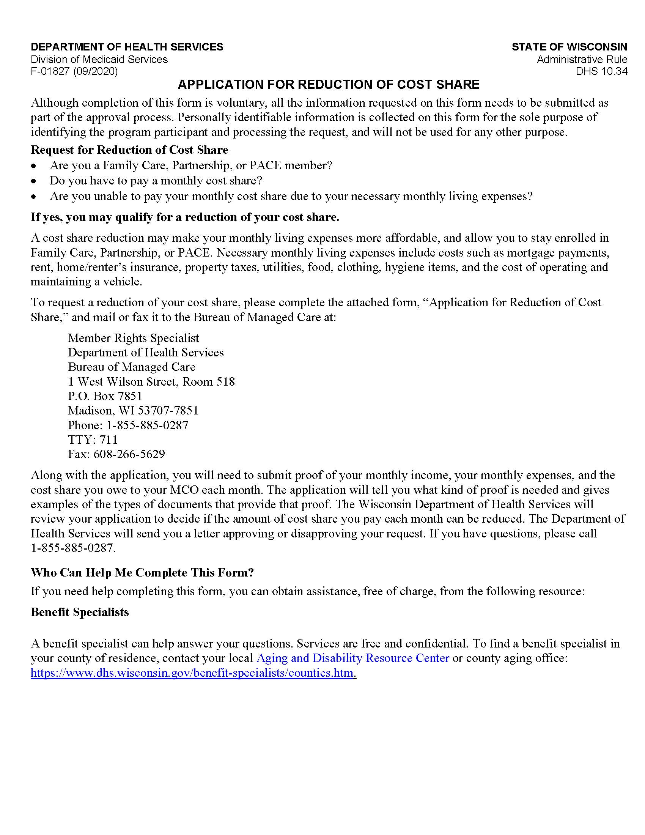

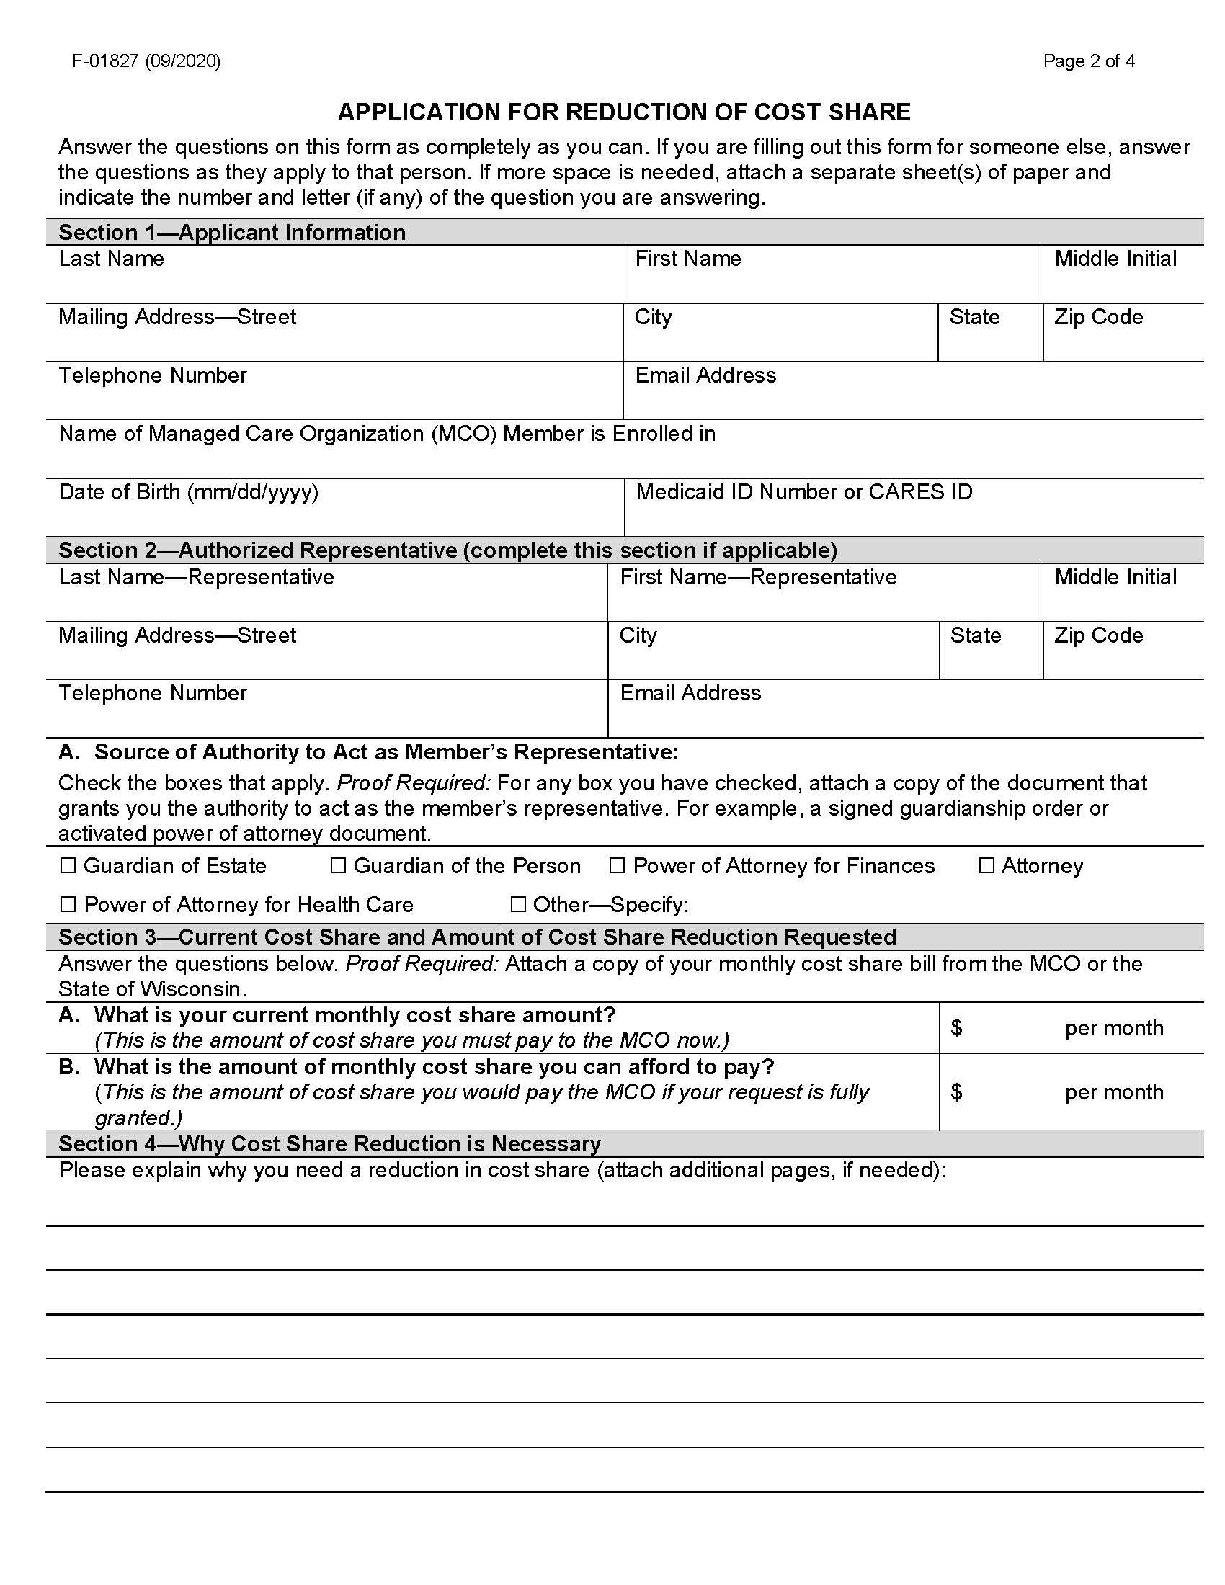

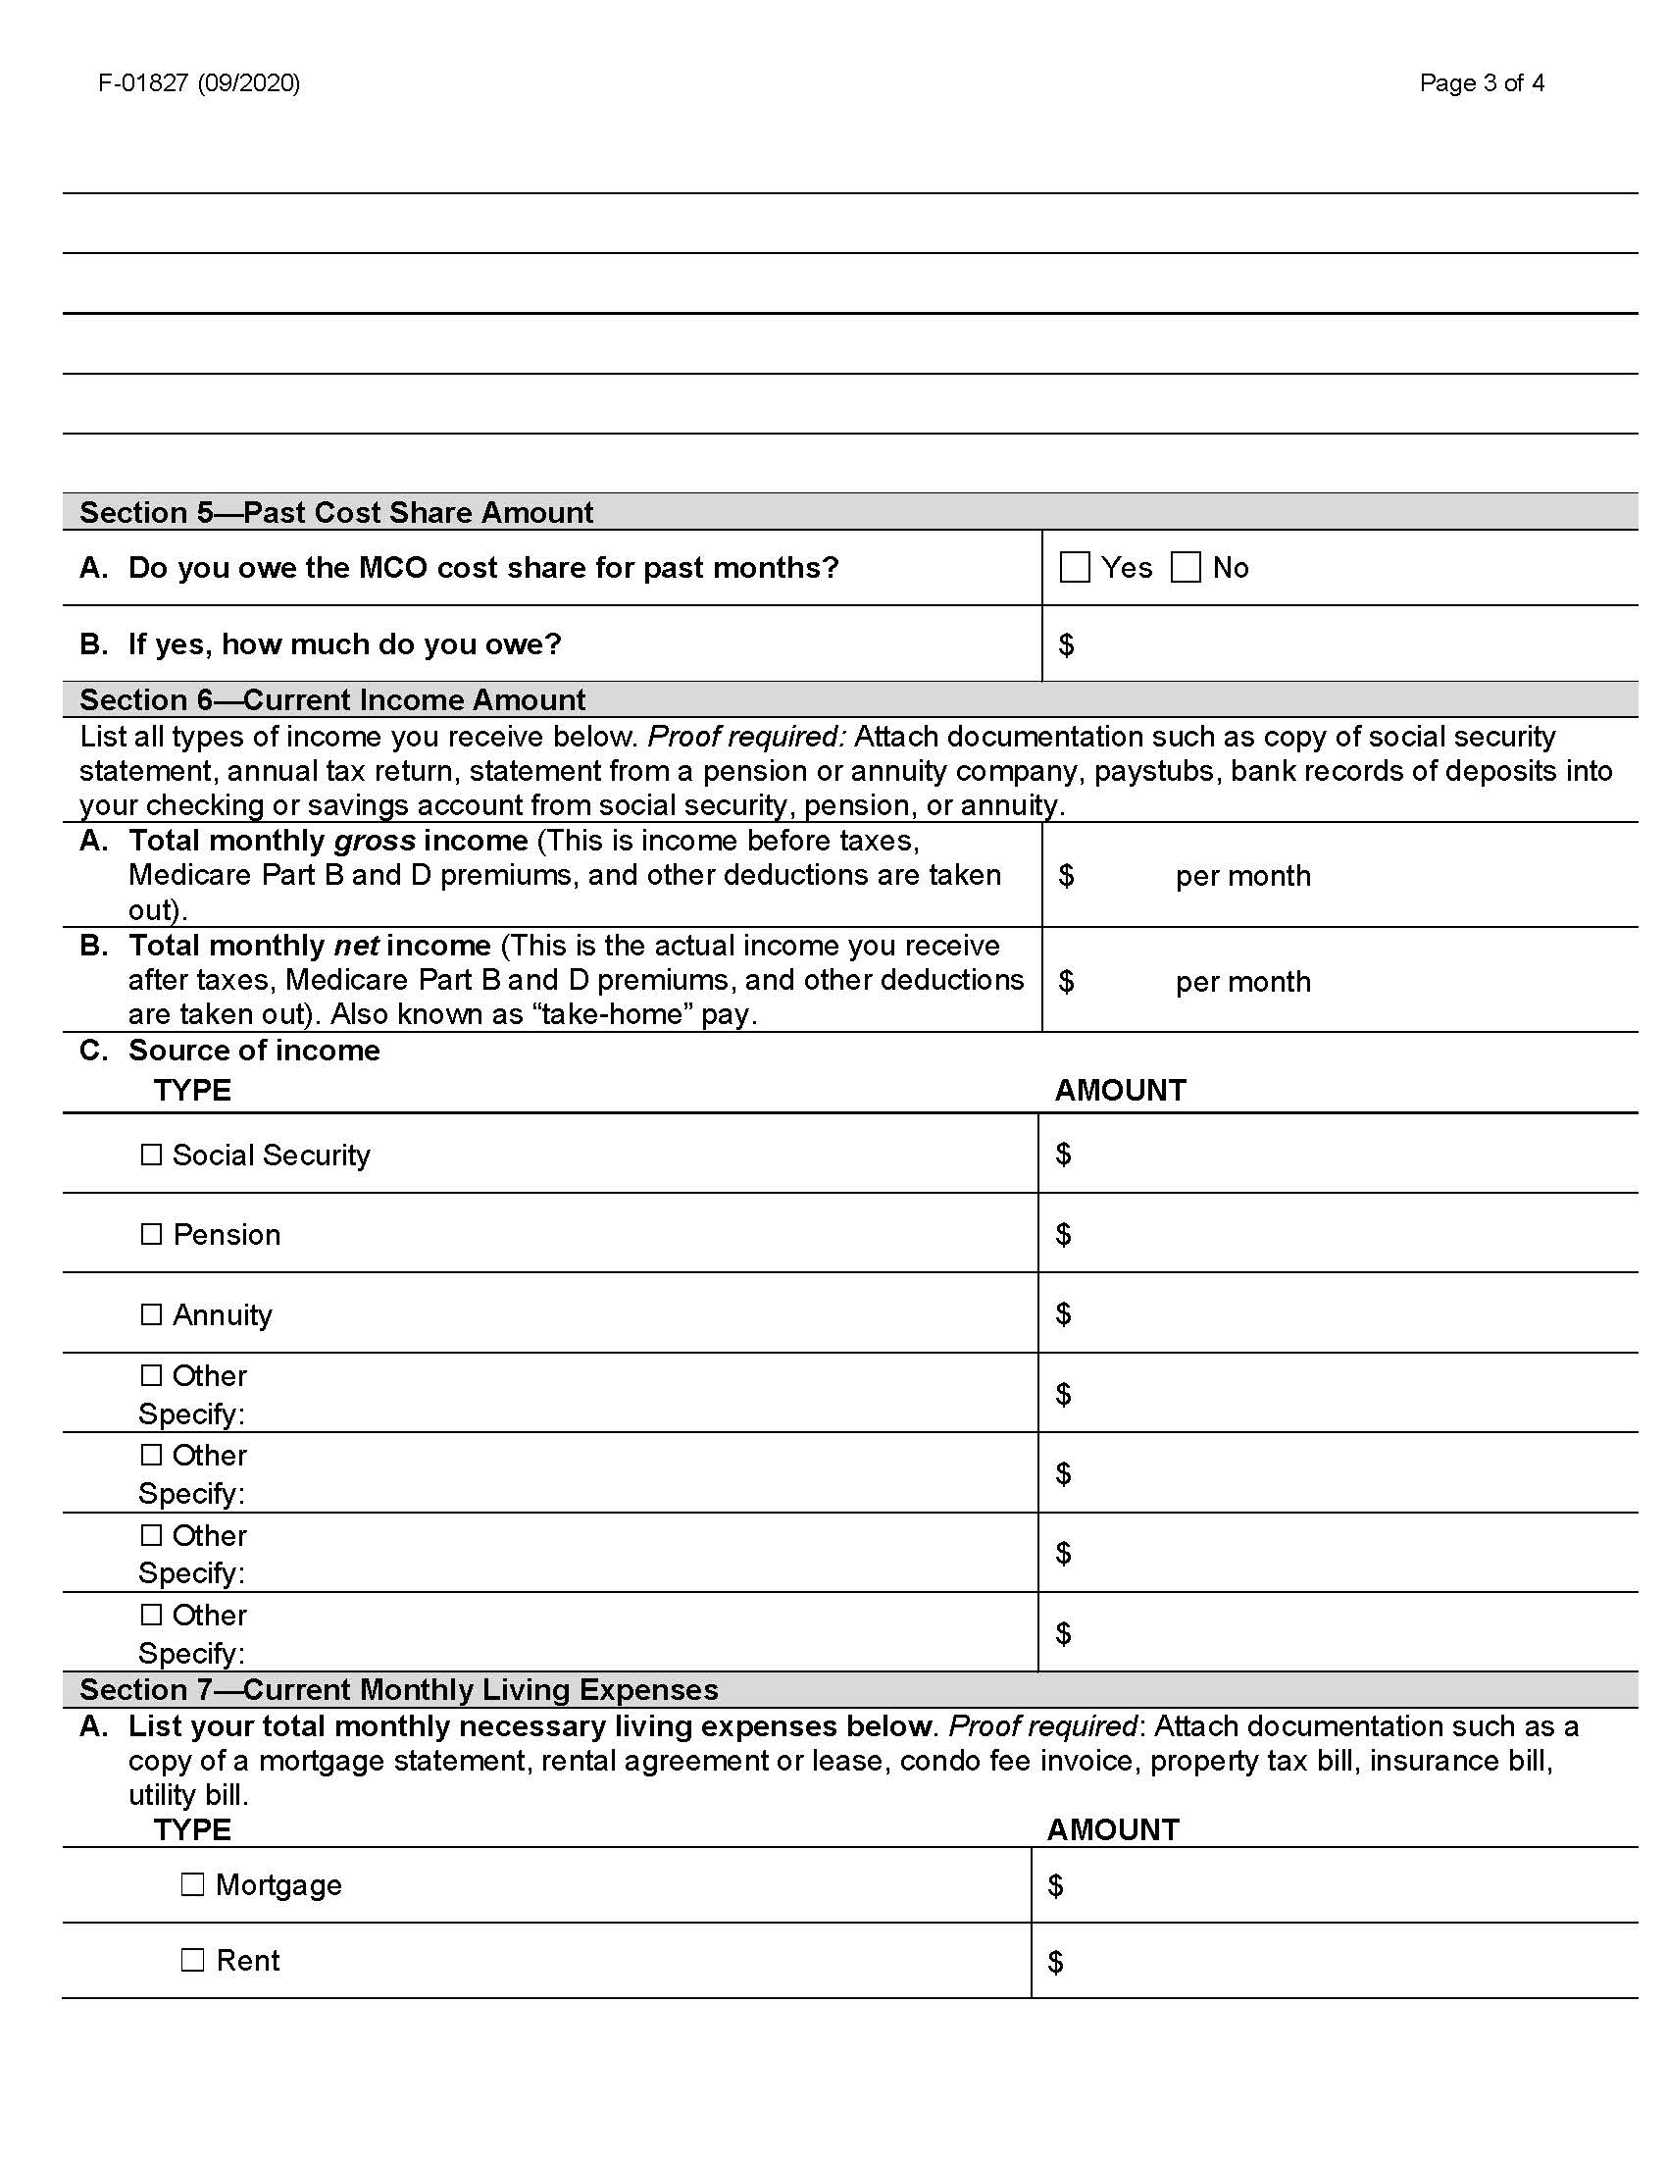

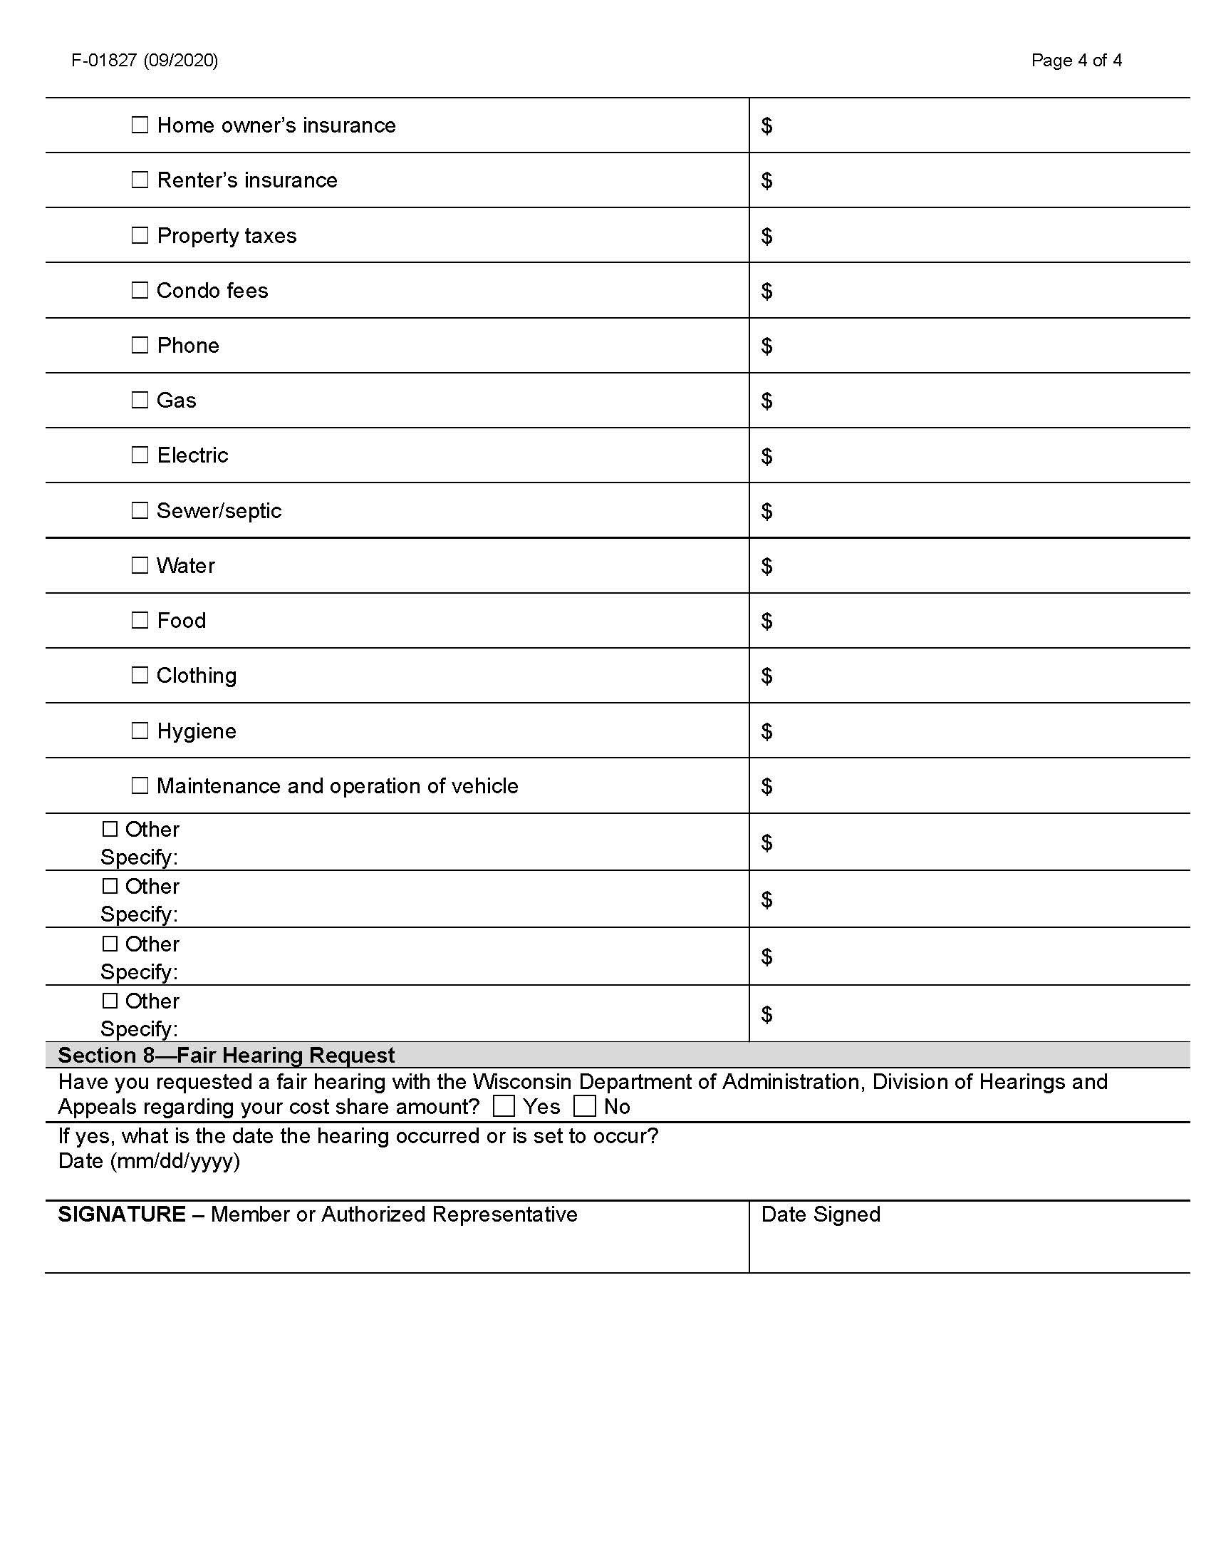

4. Qauv Ua Piv Txwv Rau Notice of Adverse Benefit Determination (Tsab Ntawv Faj Seeb Txog Kev Txiav Txim Nyhav Rau Txiaj Ntsim Kev Pab)

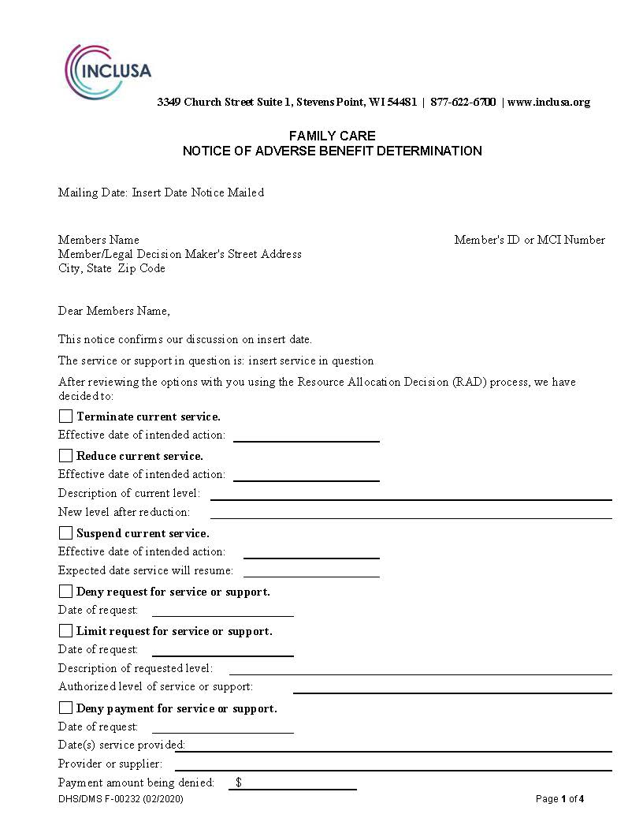
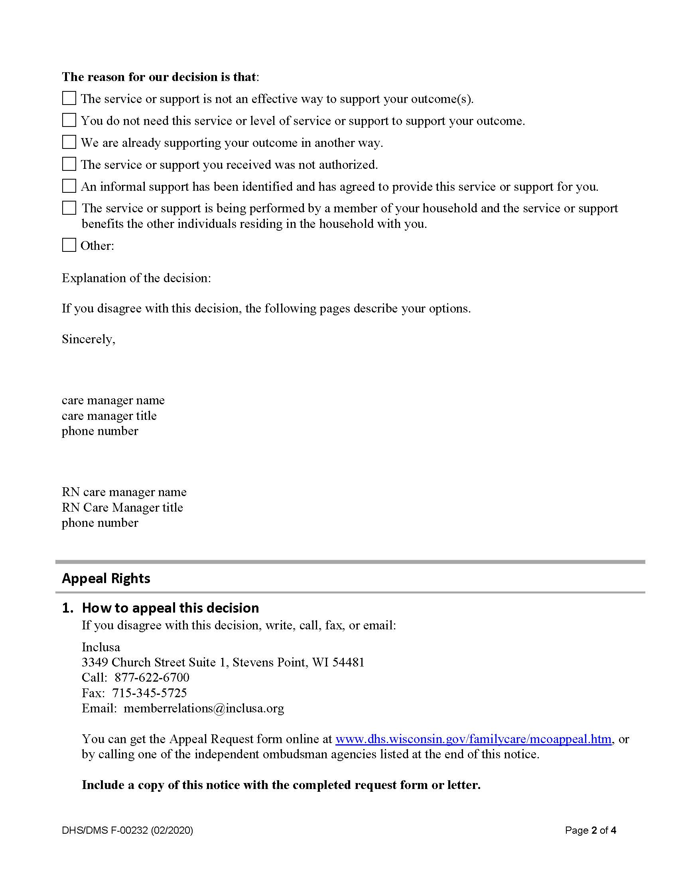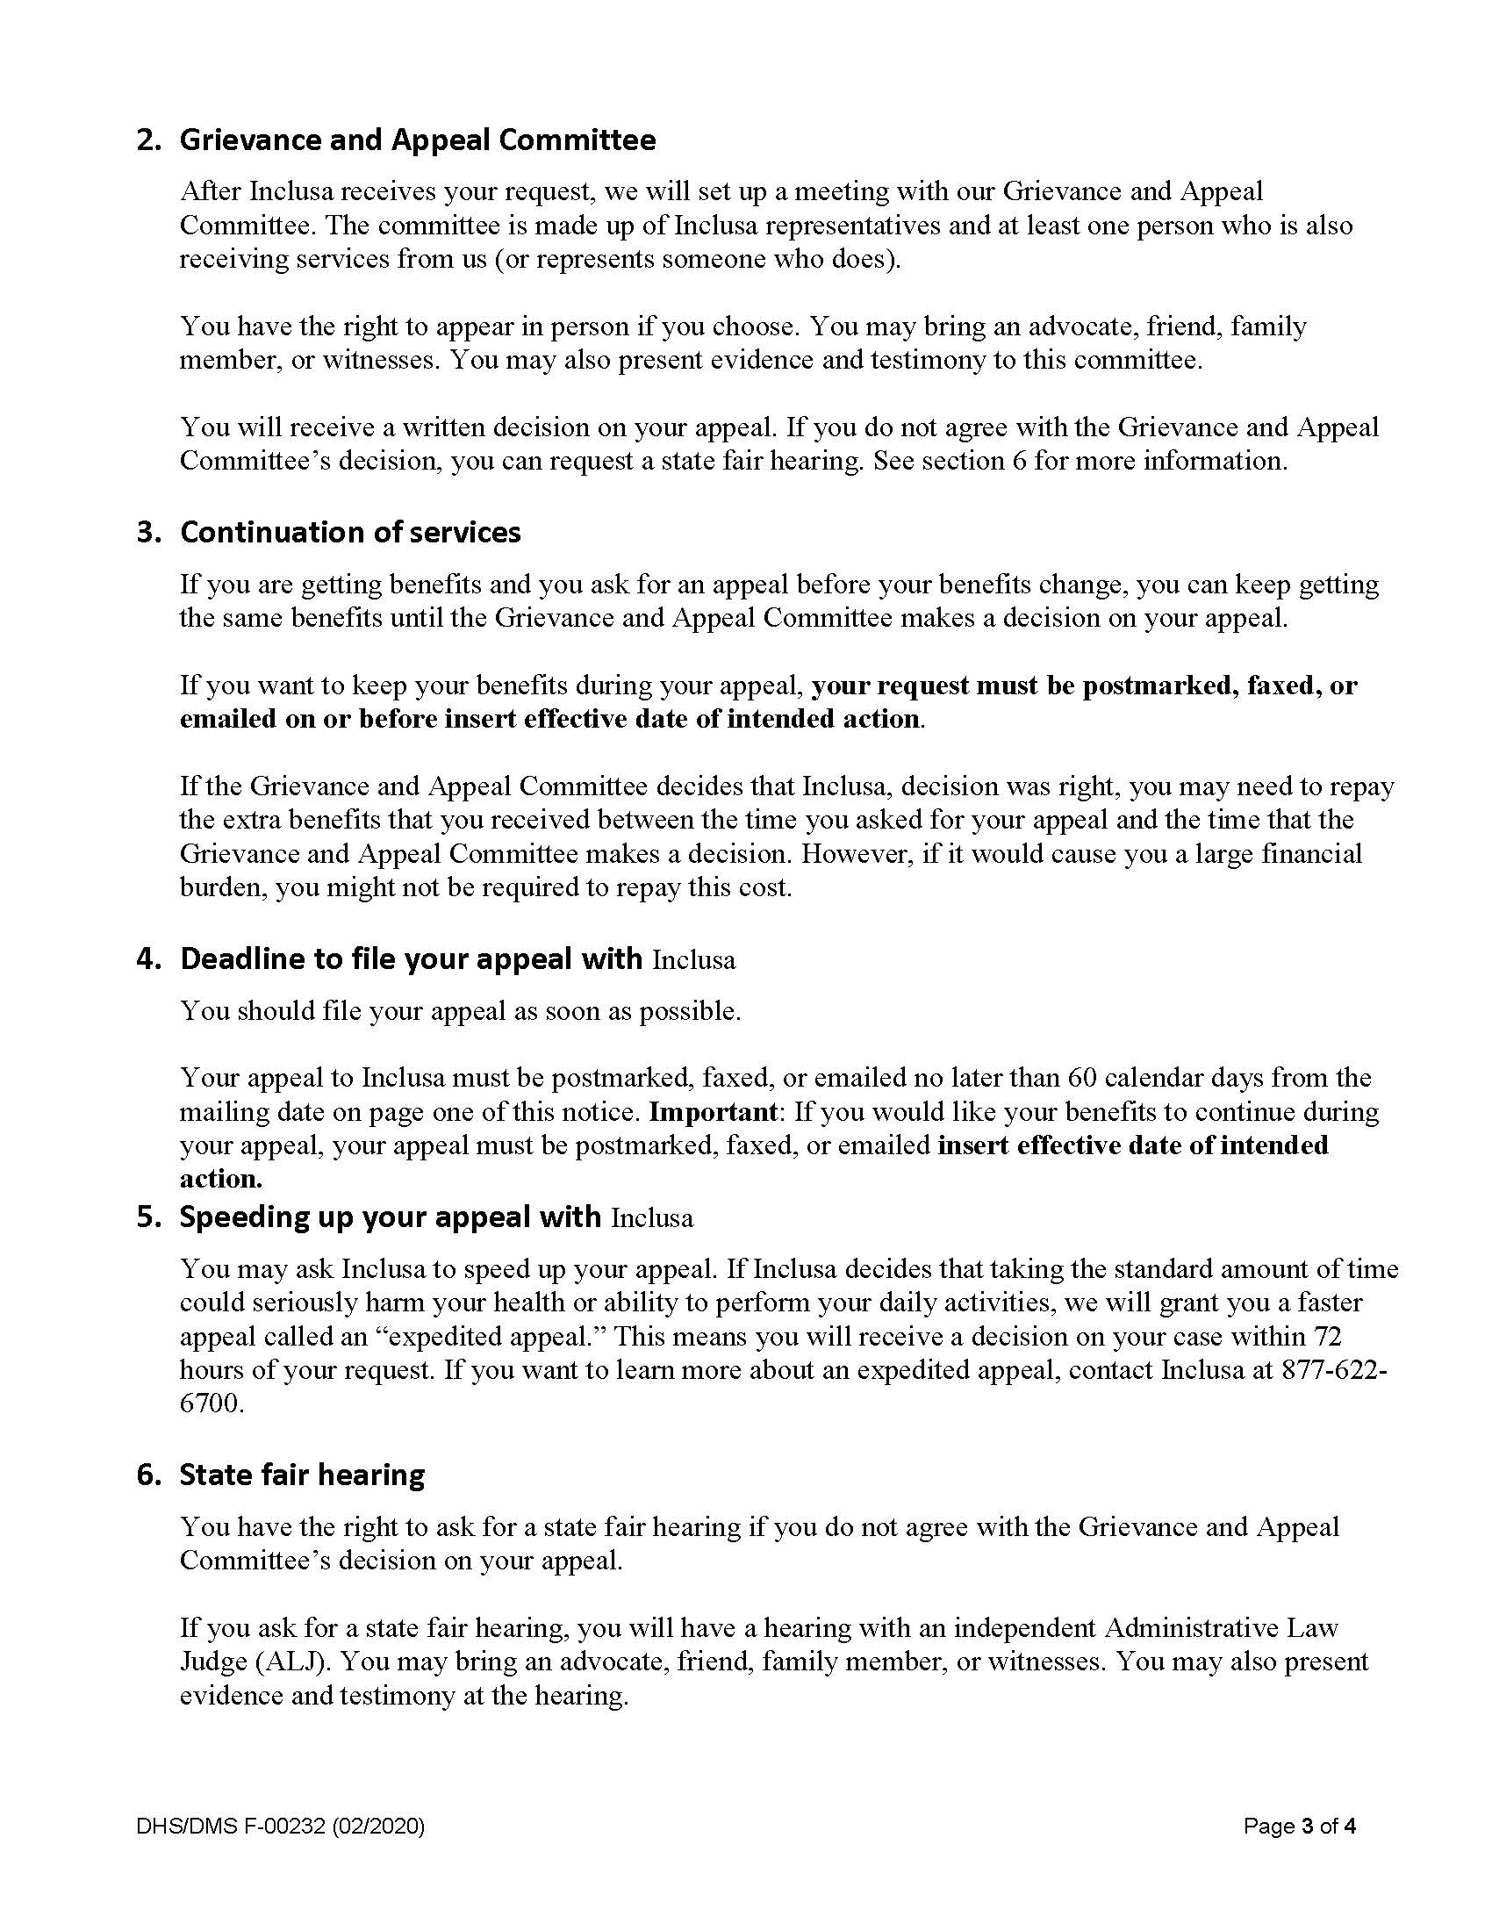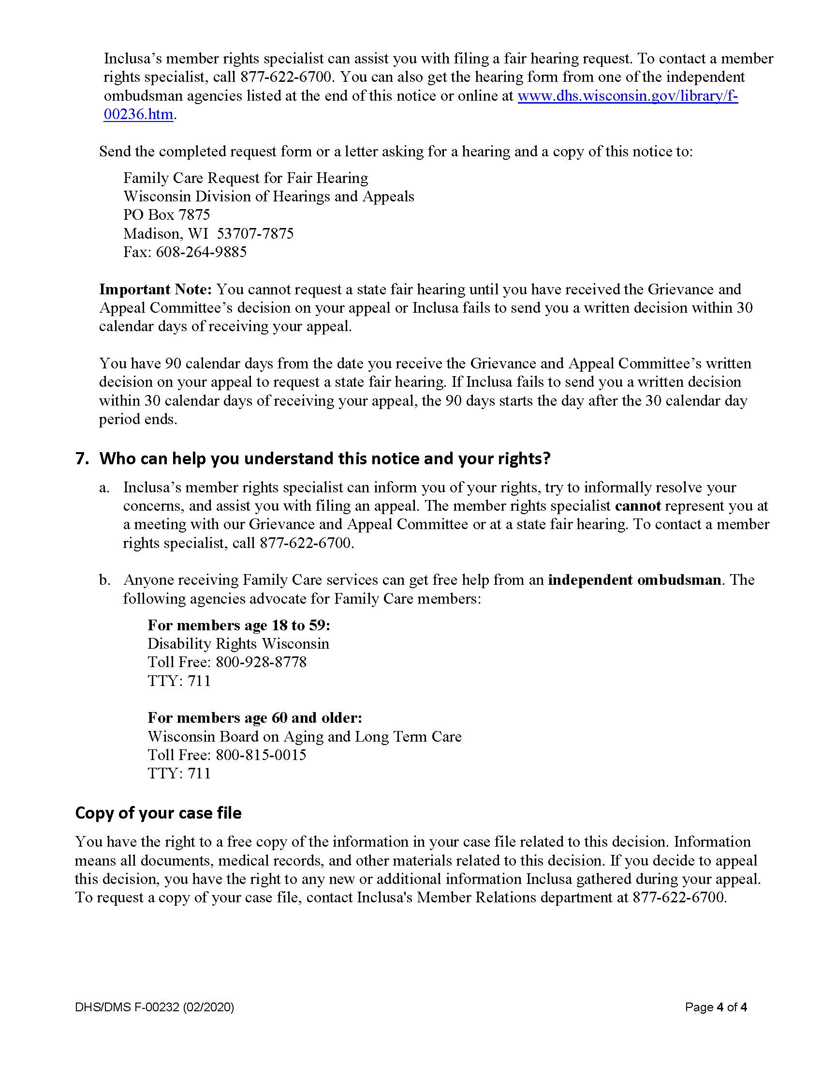

5. Inclusa tsab ntawv thov kev txiav txim dua

[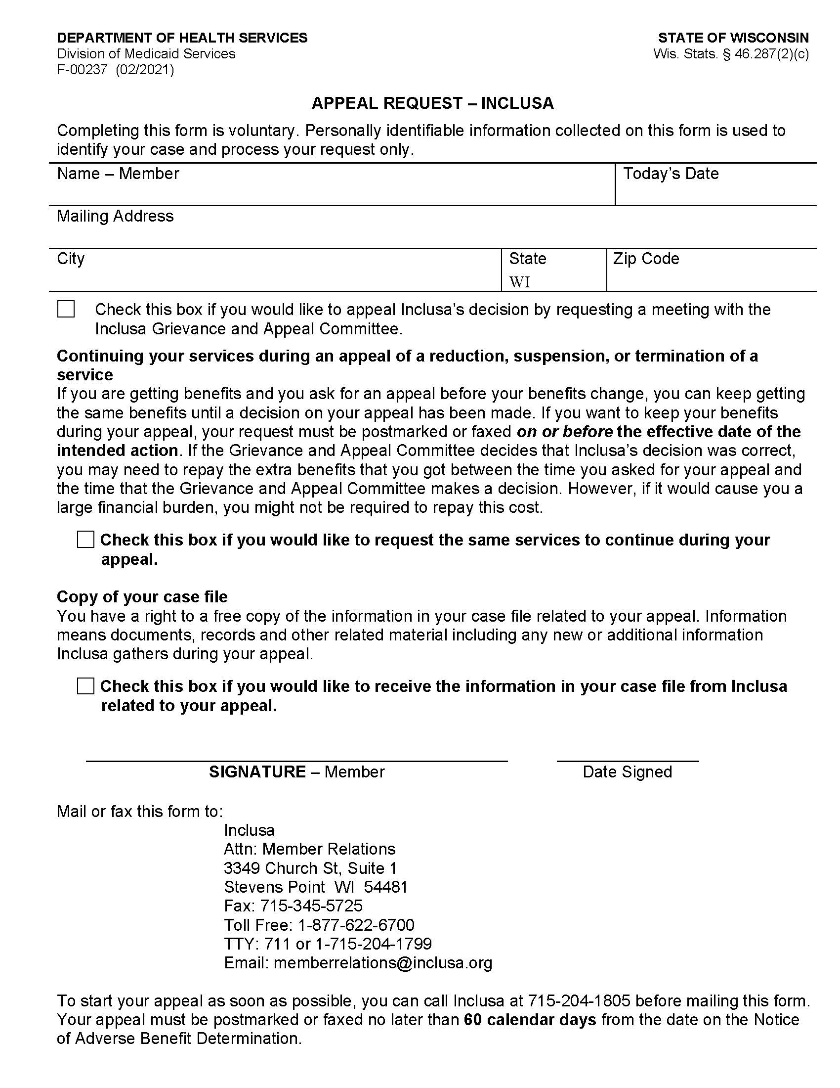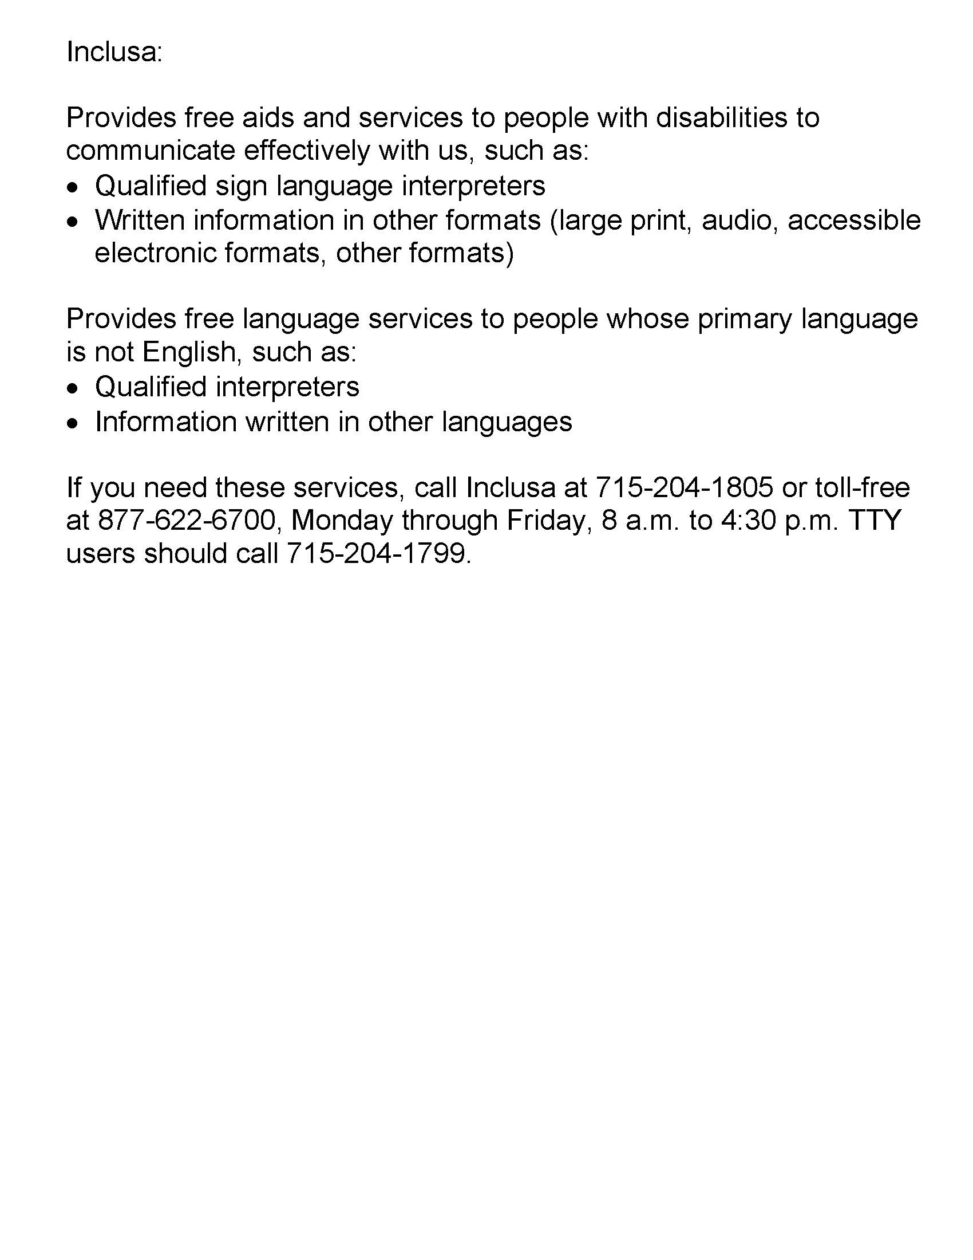

6. Tsab ntawv thov Xeev Lub Rooj Sib Hais Ncaj Ncees

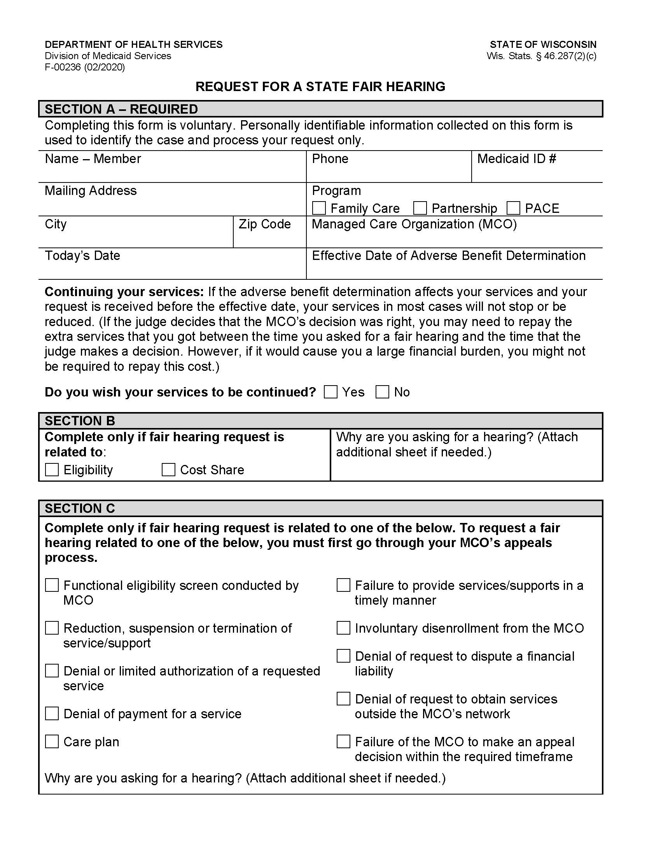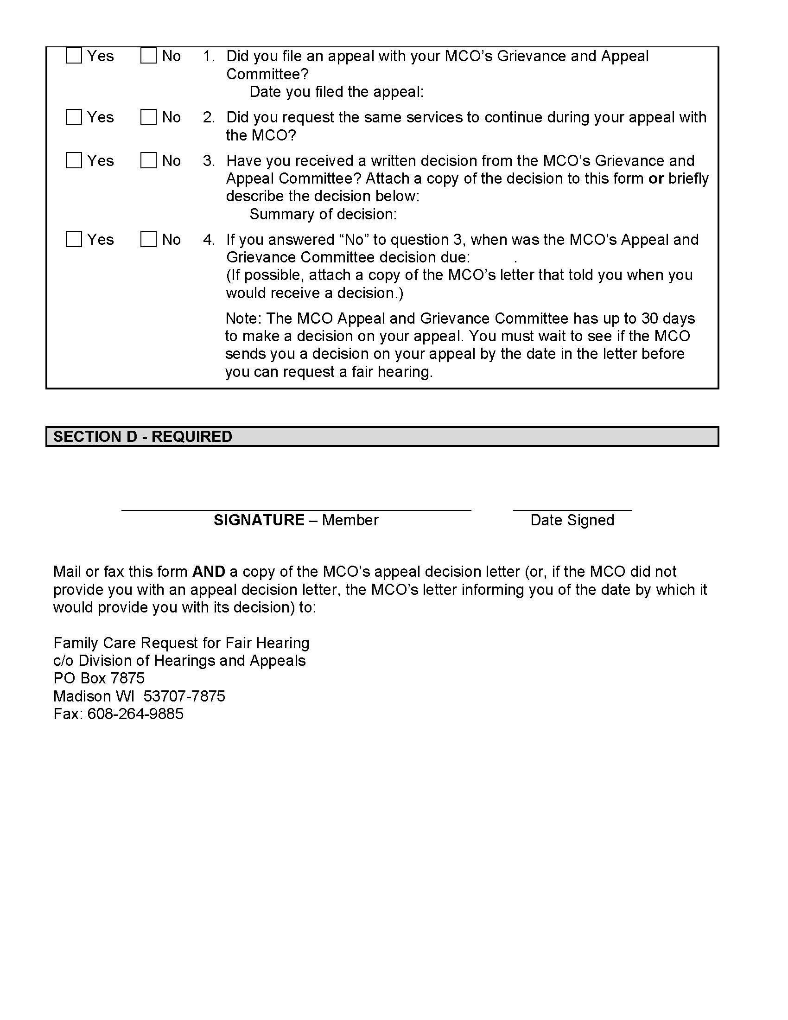
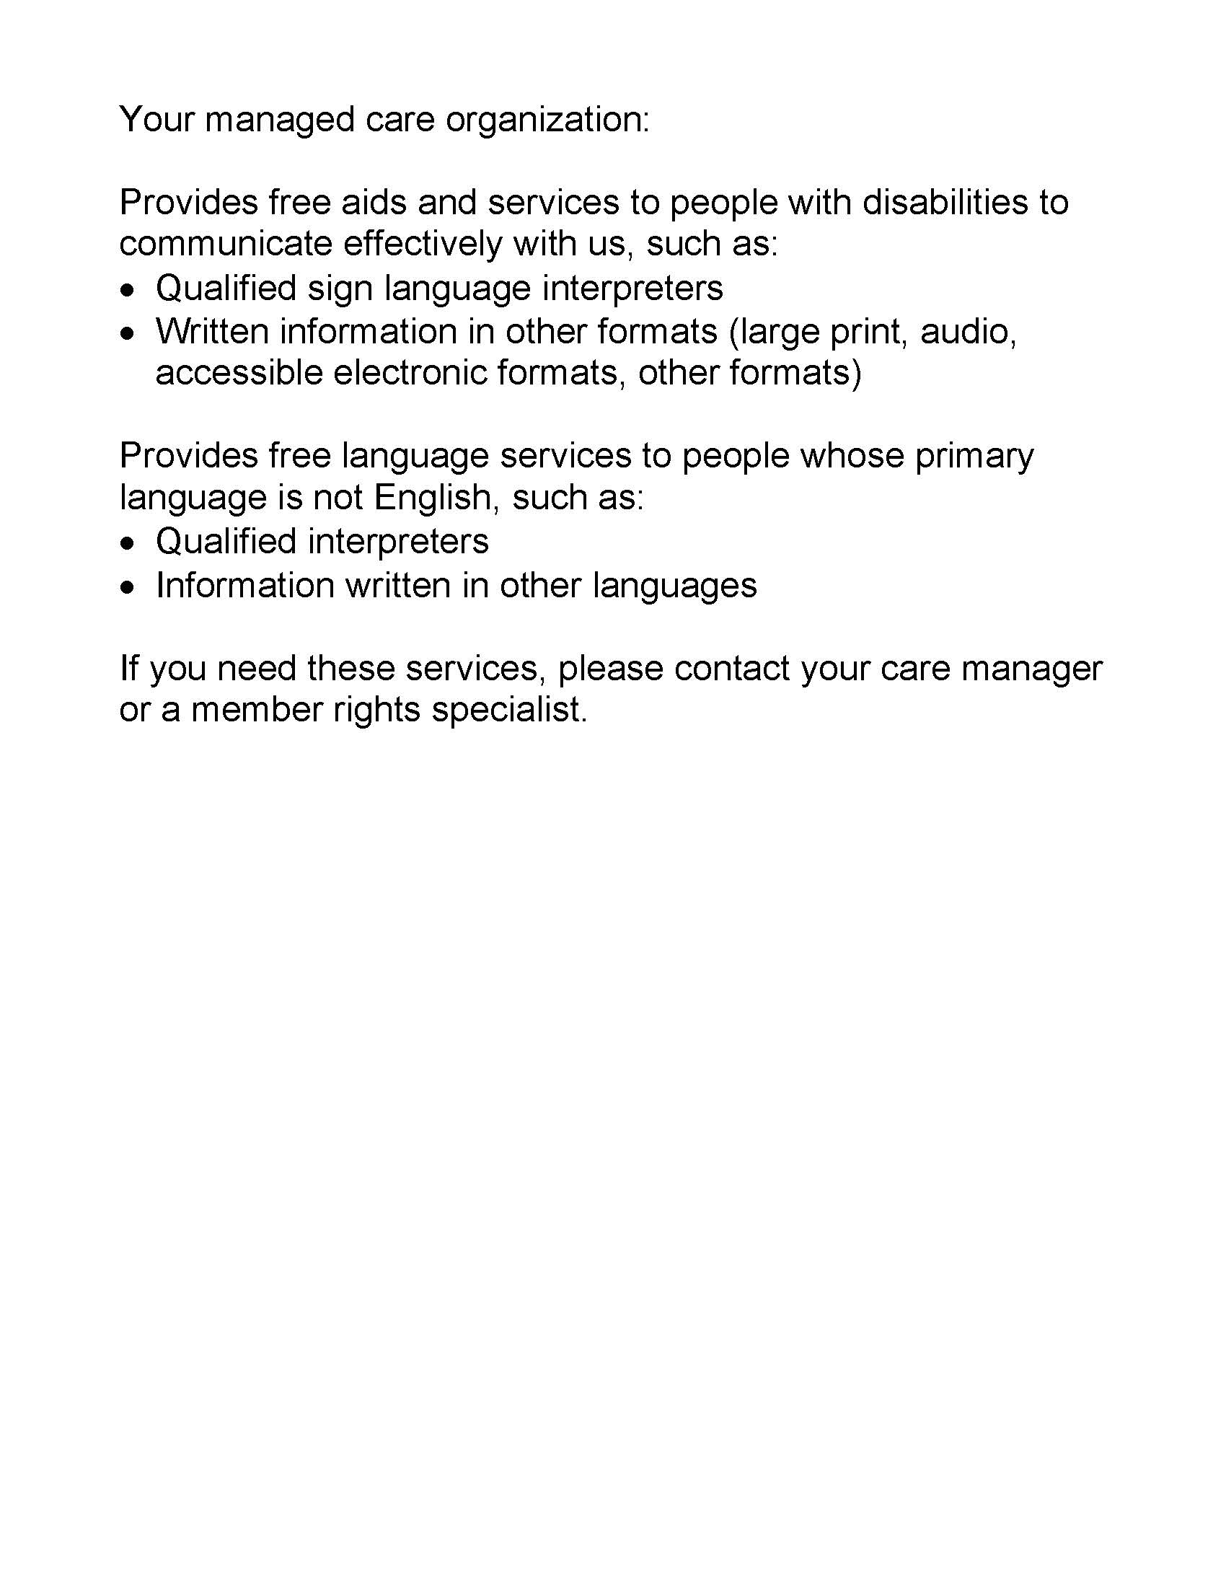

7. Tsab ntawv faj seeb txog cov kev ceev ntiag tug

Notice of Privacy Practices
Inclusa
This Privacy Practices Notice describes how health care
information about you may be used and disclosed, and
how you can get access to this information.
Please read the notice carefully.

We are required to protect the privacy of health care information about you, to notify you of our legal duties and privacy practices with respect to your protected health information, and to notify you following a breach of unsecured protected health information. This Privacy Notice tells you about your rights regarding information about you that is kept in health care records. You can look at this anytime to see how your health care records are used by Inclusa as part of your care, and who gets to see them.
This Privacy Notice includes answers to the following questions:
- What is health care information?
- Who can see health care information about you without your written authorization?
- Who cannot see health care information about you unless you give written authorization?
- What are your rights regarding health information about you?

Changes to this Privacy Notice.
We are required to abide by the terms of this notice currently in effect. We reserve the right to change this Privacy Notice. We reserve the right to make the changed Privacy Notice apply to the health care records we already have about you in addition to any information we receive in the future. The Member Handbook will contain the most current Privacy Notice available. You will be offered an updated Member Handbook each year. We will also post a copy of the current Privacy Notice on Inclusa’s website. The effective date of the notice can be found in the lower left-hand corner of the first page.

1. What is Health Care Information?
Any information that can identify you and relates to your past, present, or future physical or mental health or condition; the provision of health care to you; or the past, present, or future payment for the provision of health care to you, is considered your protected health care information. Inclusa may have health care information regarding services we provide to you or payment for services provided to you or information about your past, present, or future health condition. We are required by law to protect health care information about you. We are required to follow the policies in the most current Privacy Notice available.

Health care information about you is kept in a health care record. This health care record contains your assessments, your member-centered plan, and other information related to your care. Each time you visit or are visited by your Community Resource Coordinator, Health & Wellness Coordinator, or other professionals on behalf of Inclusa, a record of the visit is made. This health care record serves as:
- a starting point for planning your care, treatment and any needed follow-up care;
- a means of communication among your care team and the many professionals who contribute to your care;
- a means by which you or a third-party payer (for example, insurance carriers, Medicare, Medicaid) can verify that services billed were actually provided; and
- a tool that can be used to evaluate and continually improve the care given and progress made.

Understanding what is in your health care record and how your health care information is used helps you to:
- make sure health care information about you in the record is correct;
- better understand who, what, when, where, and why others may access health care information about you; and
- make better-informed decisions when you authorize health care information about you to be shared with others in situations where your consent is required to share the information.

2. Who Can Access Health Care Information About You Without Your Written Authorization?
Listed below are reasons why we use and may share your health information without your written authorization:
- For Treatment: We are permitted to use and share health care information about you with health care individuals involved in your care. We are also permitted to share information about you with your health care providers. For example, your Health & Wellness Coordinator may call your pharmacist to reorder medications for you. We are permitted to use and share health information about you with providers of service under contract with Inclusa. For example, a Community Resource Coordinator may need to speak with a transportation provider to arrange transportation for you.
- For Payment: We are permitted to use and share your health care information so that the services you receive through Inclusa may be billed to, and payment collected from, your insurance company, Medicare, and/or Medical Assistance. For example, Inclusa may use health care information about you to pay a provider who has provided long-term care services to you, or Inclusa, or your care team may work with your Income Maintenance Worker to make sure you maintain financial eligibility for Family Care.

- For Health Care Operations: We can use and share your health care information for our operations. We may use health care records to review our treatment and services and to evaluate the performance of our staff in caring for you. We also may remove all information that identifies you from a set of health care information so that others may use that information to study health care and the health care delivery without learning who the specific people are. For example, health care information may be collected and analyzed to improve the quality of our services.

- To Business Associates for Treatment, Payment and Quality Assurance: We may use and share your health care information for our business operations. This using and sharing is necessary to run Inclusa and to make sure that all members receive quality care. We have written agreements with our business associates for administrative purposes, including payment of claims for your services or management of our member-related software system. For example, Inclusa has a contract with WPS to pay claims on our behalf. WPS is considered a business associate to Inclusa We have a formal written agreement with WPS to protect your health care information.

Special Situations
- Individuals Involved in Your Care or Payment of Your Care: We may use or disclose health care information to a family member, other relative, a close personal friend, or any other person identified by you when you are present and you, based on your participation, do not object to the sharing of health care information. If you are not present, or you are not able to agree because you are hurt or experiencing an emergency, we may use our professional judgment to determine whether sharing your health care information is in your best interest. We may also share health care information about you in order to notify your family member, other relative, a close, personal friend, or an agency involved in disaster relief efforts of your location, general condition, or death.

- As Required By Law: We will share your health care record when required to do so by federal, state, or local law. For example, state law requires us to report abuse and neglect. If we believe you are a victim of abuse or neglect, we may share health care information about you to governmental authorities, including protective services as authorized by law to receive such reports. Another example would be during an officially declared disaster or crisis if it is necessary to help ensure your safety or your community’s safety or to prevent disease. However, if you have specific preferences on how we disclose this information under these circumstances, or if you wish to opt out of any disclosure, please let us know and if we agree with the limitations, we will follow your instructions unless there is a specific legal prohibition against it.

- Health Oversight Activities: We will share your health care information with a health oversight agency as authorized by the law for audits, investigations, inspections, and licensure. These activities are necessary to monitor the health care system, government programs, and compliance with civil rights laws. For example, the State of Wisconsin’s Department of Health Services contracts with an agency to provide quality oversight of Inclusa. The oversight agency may conduct file reviews of records to assure compliance with contract requirements.

- Lawsuits and Disputes: If you are involved in a lawsuit or a dispute, we will share your health care information in response to a court or administrative order. We may also share your health care information in response to a subpoena or other lawful process. For example, a subpoena may require disclosure, or a judge may order us to disclose health care information about you.

- If You Dis-enroll and go to Another Family Care Agency: Should you leave Inclusa and sign up for Family Care through another agency, we may be asked to provide a copy of your most recent Long Term Care Functional Screen. Once the request has been verified as a legitimate request, Inclusa will release the screen to them without requesting your permission.

- Other: If you have given someone medical power of attorney, or if someone is your legal guardian, that person can exercise your rights and make choices about your health information. We will make sure the person has this authority and can act for you before we take any action. Another exception includes organ transplants; we can also share health information about you with organ procurement organizations.

In addition, under some circumstances, we may share your health care information permitted or as required by law:
- to report and/or investigate a death (including sharing information with the coroner, medical examiners, or funeral directors)
- Worker’s Compensation claims;
- for judicial and administrative proceedings;
- with protection agencies, advocacy agencies, and ombudsmen programs;
      - to a facility to which you may be involuntarily committed;
      - to avert a serious threat to health or safety; and
      - to a law enforcement or correction agency.

Uses or disclosures of your health care information for other purposes or activities not listed above will be made only with your written permission. If you give us permission to use or share your health care information, you may cancel your permission in writing at any time. If you cancel your permission, we will no longer use or share your health care information for the reasons covered by your written permission. However, we are unable to take back anything we had given already with your permission.

    - Who Cannot See Health Care Information About You Unless You Give Written Authorization?
Other than the uses and disclosures described generally above, we will not use or disclose health care information about you without authorization, or signed permission, from you or your legal decision maker. We would get authorization or signed permission from you, or your legal decision maker, by having you sign an Release of Information for Use and Disclosure of Confidential Information form.

Most uses and disclosures of psychotherapy notes, uses and disclosures of protected health information for marketing purposes, and disclosures that constitute a sale of protected health information, require your written authorization.

Inclusa does not conduct any fundraising, marketing, or medical research. We do not sell any of your information. We do ask members to respond to a survey, provided annually, on their satisfaction with care provided by Inclusa Participation in the survey is always voluntary and you always have the option to say no.

Inclusa is prohibited from the use or disclosure of protected health information for underwriting purposes, including your genetic information. This is required by the Genetic Information Nondiscrimination Act (GINA) of 2008.

    - What Are Your Rights Regarding Health Care Information about You?
You have the following rights regarding the health care information we maintain about you:
- The Right to Ask for Limitations: You have the right to ask for a limitation on the health care information we use or share about you for treatment, payment, or health care operations. You also have the right to ask for a limit on the health care information we share about you to someone who is involved in your care, or the payment for your care, such as a family member or friend. Inclusa must comply with your request to restrict disclosure of your health information to a health plan if:
(A) The disclosure is for the purpose of carrying out payment or health care operations and is not otherwise required by law; and
(B) The protected health information pertains solely to a health care item or service for which you or a person on your behalf has paid Inclusa in full.

In your request, you must tell us:
- what information you want to limit;
- whether you want to limit Inclusa’s use and/or disclosure of the information;
- to whom you want the limits to apply (for example, sharing information with your spouse); and
- your contact address and daytime phone number.

We are not required to agree with your request, especially in those situations where your consent is not required before disclosing the information as described above. If we do agree, we will honor your request unless the information is needed to provide you with emergency treatment. Inclusa will notify you in writing with our decision.

- The Right to Request Confidential Communications: You have the right to request that we speak with you about your services in a certain way or at a certain location. Your request must specify how or where you wish to be contacted. We will accommodate all reasonable requests. For example, you can ask that we only contact you by telephone at work or that we only contact you by mail at home.

- The Right to Inspect and Receive a Copy: You have the right to inspect and receive a copy of your health care information that may be used to make decisions about your care. Usually, this includes case notes and billing records. Psychotherapy notes may not be seen by others or copied. We will provide you a copy or summary of your health information, usually within thirty (30) days; however, under unique circumstances we do have an option of taking a thirty (30) day extension. If there is a delay, we must notify you in writing why we need the extra time and when we think we will be able to fulfill your request. All requests for information must be in writing. Your care team can provide you with a request form and help you fill out the request.

If you request a copy of your health care information, we may charge a fee for the costs of copying, mailing, or other supplies associated with your request. We may deny your request to see or receive a copy in certain very limited circumstances. If you are denied access to your health care information, we will notify you in writing. You may request that the denial be reviewed. The person conducting the review will not be the person who denied your request. We will follow through with the outcome of the review.

- The Right to Amend: If you think there is something wrong or missing in your health care information, you may ask that it be changed. You have the right to request a change to your Inclusa member file. You must include a reason that supports your request. We may say no to your request, but we will tell you why in writing within sixty (60) days.

We may deny your request for a change if it is not in writing or does not include a reason to support the request. In addition, we may deny your request if you ask us to change information that:
- was not created by Inclusa;
- the person or entity that created the information is no longer available to make the amendment;
- is not part of the health care information kept by or for Inclusa; or
- is accurate and complete.

Inclusa will notify you in writing whether we agree or do not agree with your amendment request.

Additionally, if we grant the request, we will make the correction and distribute it to all necessary recipients as well as those you ask to receive the corrected information. If we deny your request for a change to your health care information, we will notify you how you may file a complaint with Inclusa
  - The Right to be Notified of a Breach of your Personal Health Information: With the exceptions outlined under HIPAA Regulations, you have a right to be notified if your information is ever mishandled and a breach (loss) of your personal health information has occurred or has likely occurred.

- The Right to an Accounting of Disclosures: You have the right to request an accounting of disclosures that has been made by Inclusa in the past six (6) years. We will include all the disclosures except for those about treatment, payment, and health care operations and certain other disclosures, such as any you asked us to make.

Your request must state a time period not longer than six (6) years and may not include dates before July 1, 2008. The first list you request within a twelve (12) month period will be free of charge. For additional lists, we may charge you for the costs of providing the list. We will also notify you of the cost involved before any costs are incurred.

  - The Right to a Paper Copy of This Notice: You have the right to receive a paper copy of this Privacy Notice. To obtain a paper copy of this Privacy Notice, contact the Inclusa Privacy Officer at 1-877-622-6700..

