Family Care
Buugyaraha Macaamiisha

TEMPLATE

oo ay Isticaalaan Ururrada Maamulka Caafimaadka
(Member Handbook for Use by Managed Care Organizations)

Template provided by the Wisconsin Department of Health Services
P-00649SO (08/2021)

Tusmada Qoraalka

Cutubka 1-aad. Lambarrada taleefannada iyo waxyaabaha kale ee muhiimka ah 6
Inclusa Sida Loola Xiriirayo 6
Meelo Kale oo lala Xiriiro oo Muhiim ah 7
Cutubka 2-aad. Soo-dhaweyn iyo Hordhac 10
Ku soo dhawoow Inclusa 10
Sidee buu barnaamijka Family Care ii caawin karaa? 11
Yaa dadka caawinaya? 11
Waa maxay macnaha in aad xubin tahay? 12
Yaa xubin ka noqon kara Inclusa? 13
Sidee baan xubin ku noqon karaa? 14
Cutubka 3-aad. Waxyaabo muhiim u ah adeegyada dadka 15
Sidee buu barnaamijka Family Care u shaqeeyaa? 15
Maxaad qeyb uga noqoneysaa qorshaha daryeelkaaga? 16
Sidee baa adeegyada loo kala doortaa oo loo oggolaadaa? 17
Maxaa dhacaya haddii ay baahidu is beddesho? 18
Sidee baa loo isticmaalayaa shaqaalaha adeegga? 18
Sidee buu Family Care dadka ugu caawinayaa maareynta adeegyada? 19
Waa maxay waxa noqon kara hagidda shakhsiga ah? 20
Maxaa la sameynayaa markay jirto xaaladaha degdegga ah? 20
Sidee baan daryeel ku helayaa saacadaha aan la shaqeyn? 21
Ka warran marka loo baahdo daryeel ka baxsan deegaanka? 21
Cutubka 4-aad. Adeegyada ku jira Family Care qorshihiisa guud 23
Waa maxay adeegyada la hayo? 23
Family Care Liiskiisa qorshaha manaafacaadka 24
Waa maxay adeegyada aan la hayn? 27
Cutubka 5-aad. Fahmidda dadka bixinaya adeegyada iyo isku-duwidda manaafacaadka 29
Anigu miyaan iska bixinayaa wax adeegyo ah? 29
Sidee baan u bixinayaa lacagta? 31
Ka warran haddii la iga rabo lacagta adeeg la iii qabtay? 31
Miyuu barnaamijka Family Care bixinayaa adeegyada guriga ama xarumaha dadka xanuunsan? 31
Sidee bay Medicare iyo manaafacaadka ceymiska kale u wada shaqeyn doonaan? 32
Waa maxay estate recovery (qaadashada guriga)? Sidee buu dadka u khuseysaa? 33
Cutubka 6-aad. Xuquuqda Dadka 34
Cutubka 7-aad. Waajibaadka dadka 38
Cutubka 8-aad. Cabashooyinka iyo racfaanka 41
Hordhac 41
Cabasho 42
Racfaan 45
Dacwad-dhageysiga Gobolka 51
Yaa dadka ku caawin kara cabashooyinka ama racfaanka? 54
Cutubka 9-aad. Joojinta in adeeg laga helo Inclusa 55
LIFAAQYO 57
1. Qeexidaha erayada muhiimka ah 57
2. Qeexidda adeegyada qorshaha manaafacaadka Family Care 62
3. Codsiga Yareynta Qeybta Kharashka 67
4. Tusaale Notice of Adverse Benefit Determination (Ogeysiis Go’aanka Beddelka Manaafacaadka) 68
5. Inclusa foomka codsiga racfaanka 69
6. Foomka codsiga Dacwad-dhageysiga Gobolka 70
7. Ogeysiiska arrimaha shakhsiga ah 71

Cutubka 1-aad. Lambarrada taleefannada iyo waxyaabaha kale ee muhiimka ah

Inclusa Sida Loola Xiriirayo

- Lambarka taleefanka guud (Indicate hours of operation)

Inclusa Main Office (Stevens Point)
8:00 a.m. – 4:30 p.m. Monday – Friday

- Goobaha xafiisyada

- Adeegyada macaamiisha
Toll-Free: 1-877-622-6700
TTY: 711 or 1-715-204-1799
Fax: 1-715-345-5725
Website: www.inclusa.org

- Caawimaadda wakhtiyada aan la shaqeyn
Toll-Free: 1-877-622-6700

- Shaqaalaha Xuquuqda Macaamiisha
Dadka u adeegaya macaamiisha waa shaqaale takhasus ku haysta in ay sharxaan xuquuqda macaamiisha. Waxay diyaar u yihiin in ay dadka caawiyaan marka ay qabaan dacwo ama cabasho. Waxay ku siin karaan macluumaad ama caawimaad haddii aad racfaan ka qaadaneyso go’aan lagaa soo gaaray.

Toll-Free: 1-877-622-6700
8:00 a.m. – 4:30 p.m. Monday-Friday

Haddii aad ku jirto xaalad degdeg ah, garaac 911

Meelo Kale oo lala Xiriiro oo Muhiim ah

Adeegyada Difaacidda Dadka Waaweyn
Degmo kasta waxay leedahay xafiis la socda waxyaabaha kala ah dhibaateynta, dayaca, khasaarinta dhaqaalaha, iyo qofka naftiisa dayaca. Soo garaac taleefanka caawimaadda ee degmadaada marka aad ka shakiso qof dhibaato loo geysanayo (da’da 18 ilaa 59). Si aad u soo sheegto dhib haysta qof waayeel ah oo ka weyn 60 sano, la soo xiriir xafiiska waayeelka khatarta ku jira ee degmadaada.
Adams County (Health & Human Services Department)
Phone: 608-339-4505
● Ashland County (Health & Human Services Department)
Phone: 715-682-7004
● Barron County (Department of Health & Human Services)
Phone: 715-537-5691
● Bayfield County (Department of Human Services)
Phone: 715-373-6144
● Brown County (Human Services)
Phone: 920-448-7885
● Buffalo County (Aging and Disability Resource Center)
Phone: 866-578-2372
● Burnett County (Health & Human Services Department)
Phone: 715-349-7600
● Calumet County (Department of Health & Human Services)
Phone: 920-849-1400
● Chippewa County (Department of Human Services)
Phone: 715-726-7788
● Clark County (Department of Social Services)
Phone: 866-743-5233
● Columbia County (Aging and Disability Resource Center)
Phone: 608-742-9233
● Crawford County (Human Services Department)
Phone: 608-326-0248
● Dodge County (Aging and Disability Resource Center)
Phone: 920-386-3580
● Door County (Human Services)
Phone: 920-746-7155
● Douglas County (Department of Health & Human Services)
Phone: 715-395-1304
● Dunn County (Aging and Disability Resource Center)
Phone: 715-232-4006
● Eau Claire County (Department of Human Services)
Phone: 715-839-7118
● Fond Du Lac County (Aging and Disability Resource Center)
Phone: (920) 929-3466
● Forest County (Human Services Department)
Phone: 888-452-3296
● Florence County (Department of Human Services)
Phone: 715-478-7709
● Grant County (Department of Social Services)
Phone: 608-723-2136
● Green County (Aging and Disability Resource Center)
Phone: 608-328-9499
● Green Lake County (Health and Human Services)
Phone: 920-294-4070
● Iowa County (Aging and Disability Resource Center)
Phone: 608-930-9835
● Iron County (Human Services Department)
Phone: 715-561-3636
● Jackson County (Aging and Disability Resource Center)
Phone: 844-493-4245
● Jefferson County (Human Services)
Phone: 920-674-3105
● Juneau County (Department of Human Services)
Phone: 608-847-2400
● Kewaunee County (Human Services)
Phone: 920-338-0626
● La Crosse County (Aging and Disability Resource Center)
Phone: 800-500-3910
● Lafayette County (Human Services)
Phone: 608-776-4800
● Langlade, Lincoln, and Marathon Counties (North Central Community Services)
Phone: 855-487-3338 or 715-841-5160
● Manitowoc County (Department of Human Services)
Phone: 920-683-4230
● Marinette County (Aging and Disability Resource Center)
Phone: 715-732-3850
● Marquette County (Human Services)
Phone: 608-297-3124
● Menomonee County (Health & Human Services)
Phone: 715-799-3861
● Monroe County (Aging and Disability Resource Center)
Phone: 800-500-3910
● Oconto County (Health & Human Services)
Phone: 920-834-7000
● Oneida County (Department of Social Services)
Phone: 715-369-7499
● Outagamie County (Health and Human Services)
Phone: 920-832-5169
● Ozaukee County (Human Services)
Phone: 262-284-8200
Pepin County (Aging and Disability Resource Center)
Phone: 866-578-2372
● Pierce County (Aging and Disability Resource Center)
Phone: 715-273-6780
● Polk County (Human Services Department)
Phone: 715-485-8400
● Portage County (Health & Human Services Department)
Phone: 715-345-5350
● Price County (Health & Human Services)
Phone: 715-339-2158
● Richland County (Aging and Disability Resource Center)
Phone: 608-647-4616
● Rock County (Human Services Department – ADRC)
Phone: 608-741-3600 or 855-741-3600
● Rusk County (Department of Health & Human Services)
Phone: 715-532-2299
● St. Croix County (Department of Health and Human Services)
Phone: 715-246-8255
● Sauk County (Department of Human Services)
Phone: 608-355-4200
● Sawyer County (Health & Human Services Department)
Phone: 800-569-4162
● Shawano County (Department of Social Services)
Phone: 715-526-4700
● Sheboygan County (Aging and Disability Resource Center)
Phone: 920-467-4700
● Taylor County (Human Services Department)
Phone: 715-748-3332
● Trempealeau County (Aging and Disability Resource Center)
Phone: 800-273-2001
● Vernon County (Aging and Disability Resource Center)
Phone: 800-500-3910
● Vilas County (Department of Social Services)
Phone: 715-479-3668
● Walworth County (Department of Health & Human Services)
Phone: 262-741-3200
● Washburn County (Health & Human Services Department)
Phone: 715-468-4747
● Washington County (Aging and Disability Resource Center)
Phone: 262-335-4497
● Waukesha County (Aging and Disability Resource Center)
Phone: 262-548-7848
● Waupaca County (Health and Human Services)
Phone: 715-258-6400
● Waushara County (Department of Human Services)
Phone: 920-787-6618
● Winnebago County (Department of Human Services)
Phone: 877-886-2372
● Wood County (Department of Social Services)
Marshfield Area Phone: 715-387-6374
Wisconsin Rapids Area Phone: 715-421-8600

Aging and Disability Resource Centers (Xarumaha Taakuleynta Waayeelka iyo Naafada)
Aging and disability resource centers (xarumaha taakuleynta waayeelka iyo naafada ADRCs) waa meesha koowaad ee laga helo macluumaad sax ah oo ku saabsan wax kasta oo ah nolosha oo la xiriira gaboobidda ama arrimaha naafada. Xafiisyada ADRC waa meelo soo-dhaweyn leh oo dadka u fiican—shakhsi ahaan, isku-xiridda qoysaska ama asxaabta, ama xirfadleyaasha la shaqeynaya arrimaha gabowga ama naafada—oo waxa ay ka helayaan waa macluumaad ku habboon xaaladahooda. Xafiisyada ADRC waxaa laga helayaa macluumaadka barnmaajiyada iyo adeegyada, oo waxaa laga fahmayaa daryeelka muddada dheer socda, iyo sida loo codsado barnaamijyada iyo manaafacaadka. Xafiisyada ADRC ku yaalla deegaamada Inclusa waa:
- Aging & Disability Resource Center Serving Adams, Green Lake, Marquette, and Waushara Counties
Toll-Free: 1-877-883-5378
- ADRC of Barron, Rusk & Washburn Counties
Toll-Free: 1-888-538-3031

- ADRC of Brown County
Toll-Free: 920-448-4300
- ADRC of Buffalo and Pepin Counties
Toll-Free: 866-578-2372
- ADRC of Calumet, Outagamie and Waupaca Counties
Toll-Free: 1-883-620-2730
- ADRC of Central Wisconsin
Serves residents of Langlade, Lincoln, Marathon, and Wood Counties
Toll-Free: 1-888-486-9545
- ADRC of Chippewa County
Toll-Free: 1-888-400-6920
- ADRC of Clark County
Toll-Free: 866-743-5144
- ADRC of Columbia County
Toll-Free: 1-888-742-9233
- ADRC of Dodge County
Toll-Free: 1-800-924-6407
- ADRC of Door County
Toll-Free: 855-828-2372
- ADRC of Douglas County
Toll-Free: 1-866-946-2372
- ADRC of Dunn County
Phone: 1-715-232-4006
- ADRC of Eagle Country
Serves residents of Crawford, Juneau, Richland and Sauk Counties
Toll-Free: 1-877-794-2372
- ADRC of Eau Claire County
Toll-Free: 1-888-338-4636
- ADRC of Florence County
Toll-Free: 1-855-528-2372
- ADRC of Fond Du Lac County
Toll-Free: 1-888-435-7335
- ADRC of Jackson County
Toll-Free: 1-844-493-4245
- ADRC of Jefferson County
Toll-Free: 1-866-740-2372

- ADRC of La Crosse County
Toll-Free: 1-800-500-3910
- ADRC of the Lakeshore
Serving residents of Kewaunee and Manitowoc Counties
Toll-Free: 877-416-7083
- ADRC of Marinette County
Toll-Free: 888-442-3267
- ADRC of Monroe County
Toll-Free: 1-888-339-7854
- ADRC of the North
Serves residents of Ashland, Bayfield, Iron, Price, and Sawyer Counties
Toll-Free: 1-866-663-3607
- ADRC of Northwest Wisconsin
Serves residents of Burnett and Polk Counties and the St. Croix Chippewa Tribe
Toll-Free: 1-877-485-2372
- ADRC of the Northwoods
Serves residents of Forest, Oneida, Taylor, and Vilas Counties
Toll-Free: 1-800-699-6704
- ADRC of Ozaukee County
Toll-Free: 1-866-537-4261
- ADRC of Pierce County
Toll-Free: 1-877-273-0804
- ADRC of Portage County
Serves residents of Portage County
Toll-Free: 1-866-920-2525
- ADRC of Rock County
Phone: 1-608-741-3600 or
Toll-Free: 1-855-741-3600
- ADRC of St. Croix County
Toll-Free: 1-800-372-2333
- ADRC of Sheboygan County
Toll-Free: 800-596-1919
- ADRC of Southwest Wisconsin
Serves residents of Grant, Green, Iowa, and Lafayette Counties
Toll-Free: 1-877-794-2372
- ADRC of Trempealeau County
Phone: 1-715-538-2001 or
Toll-Free: 1-800-273-2001

- ADRC of Vernon County
Toll-Free: 1-888-637-1323
- ADRC of Walworth County
Toll-Free: 800-365-1587
- ADRC of Washington County
Toll-Free: 1-877-306-3030
- ADRC of Waukesha County
Toll-Free: 1-866-677-2372
- ADRC of Winnebago County
Toll-Free: 1-877-886-2372
- ADRC – Wolf River Region (Shawano, Oconto & Menomonee Counties)
Toll-Free: 855-492-2372

Booqo www.dhs.wisconsin.gov/adrc si aad u hesho faahfaahinta xafiisyada ADRC.

Barnaamijyada Ombudsman (Wakiilka Dadweynaha)
Qofka ah ombudsman (om-budz-man ama wakiilka dadweynaha) waa qareen madaxbannaan ama caawiye oo uma shaqeeyo Inclusa. Dadka helaya adeegyada Family Care waxa ay ka heli karaan caawimaad bilaash ah ombudsman (wakiil dadweyne). Xafiiska lala xiriirayo waxa ay ku xiran tahay da’da qofka.
Haddii aad gaartay 60 jir ama ka weyn tahay, la xiriir:
Wisconsin Board on Aging and Long Term Care
1402 Pankratz Street, Suite 111
Madison, WI 53704-4001
Taleefan Bilaash ah: 800-815-0015
Dhagooleyaasha TTY: 711
Fakis: 608-246-7001
Boostada intarnetka (Email): BOALTC@wisconsin.gov
longtermcare.wi.gov

Haddii ay da’daadu tahay 18 ilaa 59 sano, la xiriir:
Disability Rights Wisconsin
1502 West Broadway, Suite 201
Madison, WI 53713
Taleefan Bilaash ah: 800-928-8778
Dhagooleyaasha TTY: 711
Fakis: 833-635-1968
www.disabilityrightswi.org

Ururrada Dakhliga Ogaada
Waa khasab in 10 maalmood gudahood loogu soo sheego wixii iska beddela xaalka noloshaada ama maalkaaga. Haddii aad guurto, waxaa khasab ah inaad u soo sheegto cinwaankaaga cusub. Waxa is beddelaya ayaa saameyn kara haddii aad xaq u yeelan karto Medicaid iyo Family Care. Waa in aad degmada u soo sheego xafiiskeeda dakhliga ogaada iyo Inclusa. Xafiisyada adeegga deegaanka ee kala ah:
- Bay Lake Consortium
Serves residents of Brown, Door, Marinette, Oconto and Shawano Counties
Phone: 1-888-794-5747
Fax: 1-855-293-1822
● Capital Consortium
Serves residents of Adams, Columbia, Dane, Dodge, Juneau, Richland, Sauk, and Sheboygan Counties
Phone: 1-888-794-5556
Fax: 1-855-293-1822
● Central Consortium
Serves residents of Langlade, Marathon, Oneida, and Portage Counties
Phone: 1-888-445-1621
Fax: 1-855-293-1822
● East Central Consortium
Serves residents of Calumet, Green Lake, Kewaunee, Manitowoc, Marquette, Outagamie, Waupaca, Waushara, and Winnebago
Phone: 1-888-256-4563
Fax: 1-855-293-1822
● Great Rivers Consortium
Serves residents of Barron, Burnett, Chippewa, Douglas, Dunn, Eau Claire, Pierce, Polk, St. Croix, and Washburn Counties
Phone: 1-888-283-0012
Fax: 1-855-293-1822
● Moraine Lakes Consortium
Serves residents of Fond du Lac, Ozaukee, Walworth, Washington, and Waukesha Counties
Phone: 1-888-446-1239
Fax: 1-855-293-1822
● Northern Consortium
Serves residents of Ashland, Bayfield, Florence, Forest, Iron, Lincoln, Price, Rusk, Sawyer, Taylor, Vilas, and Wood Counties
Phone: 1-888-794-5722
Fax: 1-855-293-1822
● Southern Consortium
Serves residents of Crawford, Grant, Green, Iowa, Jefferson, Lafayette, and Rock Counties
Phone: 1-888-794-5780
Fax: 1-855-293-1822
● Western Consortium
Serves residents of Buffalo, Clark, Jackson, La Crosse, Monroe, Pepin, Trempealeau, and Vernon Counties
Phone: 1-888-627-0430
Fax: 1-855-293-1822

Wisconsin Medicaid (ForwardHealth)
Haddii aad dhibaato ku qabto kaarkaaga ForwardHealth si laguugu adeego ama ay jiraan waxyaabo aan kuugu jirin Family Care oo aad rabto (sida ookiyaale, wiisiteynta dhakhaatiirta, ama daawooyin), soo garaac taleefanka ForwardHealth Taleefanka Macaamiisha lacag la’aanta ah ee:
800-362-3002

Soo-sheegidda Khiyaameynta Kaalmada Dowladda
Khiyaameynta dowladda macnaheedu waa qaadashada waxyaabo la ogyahay in aan xaq loo lahayn ama in qof kale sidaas oo kale lagu caawiyo iyadoo la ogyahay in ay jiraan wax uusan qofku xaq u lahayn. Qof kasta oo qeyb ka ah danbiyadaas maxkamad ayaa la saarayaa. Haddii ay maxkamad go’aamiso in uu jiro qof kaarka caafimaadka ku helay si khiyaamo ah, maxkamadda ayaa ku amri karta in uu soo gobolka u celiyo kharashkii laga bixiyey, oo waa lagu sii ganaaxayaa.

Haddii aad ka shakiso in qof si xun u isticmaalayo lacago, sida Family Care, soo garaac taleefanka waxyaabaha dowladda laga khiyaamo ama si qoraal ah ku soo gudbi intarnetka:
877-865-3432
www.dhs.wisconsin.gov/fraud

Toll-Free: 1-877-622-6700
fraud@inclusa.org

Wisconsin FoodShare (Kaarka QUEST)
Haddii aad wax su’aalo ah ka qabto barnaamijka FoodShare, ama haddii aad rabto inaad ogaato waxa kuugu haray kaarkaaga FoodShare/QUEST, ama aad soo sheegeyso in uu kaa lumay ama lagaa xaday kaarkaagii QUEST, soo garaac FoodShare taleefankooda lacag la’aanta ah ee adeegga macaamiisha:
877-415-5164

Wisconsin Division of Quality Assurance (Xafiiska Dacwadaha Tayada ee Wisconsin)
Haddii aad u maleyneyso in qof, xafiis, ama goob aad daryeel ka hesho ay ku xadgudbaan sharciyada gobolka ama federaalka, waxaad xaq u leedahay in aad dacwo u soo gudbisato Wisconsin Division of Quality Assurance (Xafiiska Dacwadaha Tayada ee Wisconsin). Markaad dacwada soo gudbineyso waxaa lagu weydiin karaa dadku degmada ay ku sugan yihiin. Si aad dacwo u soo gudbisato, soo garaac:
800-642-6552

Inclusa Billing Questions
If you have questions about cost share, room and board charges, or billing processes, call our main office toll free at 1-877-622-6700 during normal business hours (8:30 to 4:30, Monday – Friday) and ask to speak to a Member Liabilities Specialist. They can also help you if you are not able to pay a bill or want to set up automatic billing and payment.

1-877-622-6700

Cutubka 2-aad. Soo-dhaweyn iyo Hordhac

Ku soo dhawoow Inclusa

Ku soo dhawoow Inclusa, ururka maamulidda daryeelka oo iyaga ayaa ka shaqeeya barnaamijka Family Care. Family Care waa barnaamijka muddada dheer socda ee Medicaid oo waxa uu dadka waaweyn ku caawiyo waa naafannimada jir ahaaneed, maskax ahaaneed, ama midda caqli ahaaneed. Dadka barnaamijkan ku jira waxay helayaan adeegyo ku caawinaya noloshooda guryahooda mar kasta oo ay u suuroobeyso. Family Care waxaa maalgeliya canshuurta gobolka iyo federaalka.

Buuggan gacanqabsiga ah ayaad ka heleysaa macluumaad muhiim ah:

- Si aad ugu fahamto muhiimadda barnaamijka Family Care.
- Si aad u ogaato adeegyada iyo manaafacaadka barnaamijkaas.
- Ku fahmi karto xuquuqda iyo waajibaadka laga rabo macaamiisha Family Care
- Si aad u soo xareysato cabasho ama racfaan marka aad dhib la kulanto.

Haddii aad rabto in lagula eego buuggan gacanqabsiga ah, fadlan la xiriir shaqaalaha daryeelkaaga caafimaadka. Macluumaadka aad kula xiriireyso kooxda daryeelkaaga ka eego bogga 1-877-622-6700, and ask to speak with a member of your team.

Guud ahaan, kalmadaha “adiga” iyo “dadka” waxa looga jeedo waa adiga oo ka mid, ah macaamiisha. “Adiga” iyo “dadka” waxa kale oo looga jeedaa waalidka ilmahooda u gaaraya go’aanka ama qof kale oo ah wakiil sharciyeysan.

Dhammaadka buuggan gacanqabsiga ah (bogga 7) waxaa ku qoran qeexidda erayada muhiimka ah. Qeexidahaas waxa ay dadka ku caawinayaan in ay fahmaan erayada iyo kelmadaha soo noqnoqonaya ee ku jira buuggan gacanqabsiga ah.

Haddii aadan ahayn macaamiil balse aad su’aalo qabto ama aad ka rabto macluumaad ku saabsan sida iyo xafiiska kuugu dhow ee aad isaga diiwaangelin karto Family Care ama barnaamijyo kale, fadlan la soo xiriir aging and disability resource center (xarunta taakuleynta waayeelka iyo naafada ama ADRC). Xafiisyada ADRC waxaa laga helayaa macluumaad iyo caawimaad lagu codsado barnaamijyada iyo manaafacaadyada. Xafiisyada ADRC waa hay’ad gaar ah. Wax shaqo ah kuma laha Inclusa. Xafiisyada ADRC waa meelo aad ka heleyso caawimaad, haddii aad rabto iyo aadan rabin in aad macmiil ka noqoto Family Care. Cinwaanka iyo taleefanka xafiiska kuugu dhow ee ADRC waxaad ka eegan karataa bogga 9-12.

Sidee buu barnaamijka Family Care ii caawin karaa?

Yoolka ugu weyn ee Family Care waa xaqiijinta in ay dadku badqabaan oo guryahooda lagu caawiyo. Markaad ku nooshahay guri aad leedahay ama aad qoyska la nooshahay, waxyaabo badan ayaad naftaada u qabsan kartaa. Waxaad go’aansan kartaa marka aad wax dantaada ah sameysan karto, sida goorta aad hurdada ka soo kacayso oo aad wax cuneyso, iyo waxa aad qabsan doonto maalintii oo dhan.

Markaad ku soo biirto barnaamijka Family Care, Inclusa waxaa lagaala hadlayaa adeegyo si madax bannaan kuugu caawinaya noloshaada intii suurtagal ah. Adeegyada laguu qaban doono waa in lagugu caawiyo qubeyska, gaadiid ku qaada, nadaafadda guriga, iyo cuntada karsan ee guriga la isugu keeno. Waxaa adeegyada ku jira in laguu dhiso jidka kursiga curyaanka si guriga loogu soo gasho iyo qalab la taabto oo loogu yeerto gurmad caafimaadka. (Cutubka 4-aad ka eego liiska adeegyada lagaa bixin doono oo dhan.)
Family Care:
- Wuxuu hagaajin karaa oo lagu sii wadan karaa nolol tayo leh.
- Wuxuu dadka ku caawiyaa guryahooda ama qolkooda guriga qoyska ama meel kale.
- Wuxuu dadka ka rabaa in ay go'aansadaan daryeelkooda iyo adeegyada.
- Waxaa kordhaya madax bannaannida.

Family Care waxaa laga helaa maareynta daryeelka iyo adeegyo badan oo ah waxyaabo ay dadku u baahan yihiin. Waxaa lagu xaqiijinayaa in lagu helo daryeel leh caafimaad iyo badqabid. Waxa kale oo lagu sii wadan karaa in lala sii xiriiro qoyska, asxaabta, iyo dadweynaha.

Dhallinyarada meel kale degaya oo ka guureysa qoysaskooda, Inclusa waxaa lagu caawinayaa in ay helaan madax bannaani. Tusaale ahaan, waxaa lagugu caawin karaa xirfado aad shaqo ku sii hesho iyo in aad ku barato sida guriga loogu karsado cuntada.

Yaa dadka caawinaya?

Markaad xubin ka noqoto Family Care, waxaa kula shaqeyn doona koox xirfadleyaal ah oo u shaqeeya Inclusa. Adiga ayaa u dhaxeeya kooxda daryeelka oo waa khasab in aad qeyb ka tahay wax kasta oo ah qorsheynta daryeelkaaga.

Kooxdaada daryeelka waxay isugu jiraan waa adiga iyo:

- Kalkaaliso diiwaangashan.
- Adeege dadweyne Community Resource Coordinator.
- Xirfadleyaal kale, oo ku xiran baahiyadaada, sida dabiibeyaasha waxqabsiga jirka ama jimicsiga jirka, ama takhasuska dhimirka.
- Qof kasta oo kale oo aad rabto ayaa qeyb ka noqon kara, sida xubnaha qoyska ama asxaab.

Shaqada kooxdaada daryeelka waa in ay wax kaala qabtaan:

- Inaad ogaato waxaad ku fiican tahay, macluumaadyo, baahiyada, iyo waxa aad door bideyso.
- Inaad sameysato qorshe daryeel oo baahidaada kugu caawin kara.
- Inaad hubsato adeegyada qorshahaaga in si sax ah laguugu qabto.
- Inaad hubsan karto adeegyada Family Care in ay ku fiican yihiin baahidaada iyo kharashka oo aan badneyn.
- Inaad hubsato in qorshahaaga daryeelka in uu kuu shaqeyn karo.

Inaad kooxda u sheegto haddii aad ka rabto wax ay kaa caawinayaan.

Family Care ma aha wax lagu beddelanayo caawimaadda laga helo qoyska, asxaabta, ama dadka kale ee aad la xiriirto. Inclusa waxa ay rabaan waa in ay xubnaha qoyska, asxaabta, iyo dadka kale ee muhiimka ah in ay daryeelka qeyb ka noqdaan. Waxaan ka shaqeyn doonaan waa dhisidda xiriir kasta oo muhiim ah. Waxa kale oo ay kugu caawin doonaan waxyaabo kale oo kuu fiican, sida maktabdaha, xarumaha waayeelka, iyo goobaha cibaadada.

Marka loo baahdo, waxa kale oo ay kugu caawin karaan siyaabo aad ku xoojiso meelaha aad ka heleyso taakuleynta. Tusaale ahaan, haddii ay dadka ku caawinaya ay rabaan fasax nasasho ah, waxaa laguu helayaa dad kale oo gaarsiis u noqda. Dadka gaarsiiska ah waa shaqaale meel gaar ah markay shaqaalaha fasax iyo nasasho u baahdaan si ay iyaguna naftooda ugu dedaalaan.

Waa maxay macnaha in aad xubin tahay?

Markaad xubin ka tahay barnaamijka Inclusa’s Family Care, adiga iyo kooxda daryeelka ayaa ka wada shaqeyn doona go’aan kasta oo ku saabsan caafimaadkaaga iyo habka noloshaada. Si wadajir ah ayaad u wada sameyn doontaan waxyaabaha kuugu fiican ee suurtagalin kara taakuleyntaada.

Waxaad adeegyo muddo dheer socon doona ka heleysaa Inclusa shaqaale kala duwan. Markaad ku soo biirto Family Care, waxaad heleysaa macluumaad ah liiska shaqaalaha diyaarka u ah in ay kula shaqeeyaan. Adiga iyo kooxda daryeelka waxaad ka wada shaqeyn doonaan shaqaalaha ugu fiican baahiyada aad qabto.

Inclusa waxa ay rumeysan yihiin in qof kasta oo ah xubin uu kala dooran karo marka loo qabanayo adeegyada. Kala-doorashada macnaheedu waa in qofku sheegto sida iyo goorta adeeg loo qaban doono. In xubin ama macmiil la noqdo iyo in wax la kala dooran karo macnaheedu waa in qofku masuul ka yahay in uu kooxda daryeelka ku caawiyo sida ugu qiima jaban ee loo taakuleyn karo.

Inclusa ayaa masuul ka ah kulanka baahida daryeelka muddada dheer socda ee gebi ahaan xubnaha oo dhan. Waxa keliya oo sidaas la sameyn karo waa marka dadka xubnaha ah ay qeyb ka yihiin qorshaha daryeelka ee u shaqeyn karo, iyo weliba in uu qorshahaasu yahay mid macquul ah oo qiima jaban. Marka la wada shaqeeyo, waxaa la hubsan karaan in barnaamijka Family Care loo helo dadka kale ee adeegyadaas u baahan.
Waxaa lagu sii xirnaan karaa dhakhtar kasta (tusaale ahaan, dhakhtarka daaweynta guud, dhakhtarka cagaha, dhakhtarka ilkaha, iyo dhakhtarka duugduugidda), hal isbitaal, hal kilinig, iyo hal farmahsiye oo laga soo qaato daawooyinka. Inclusa iyo Family Care masuul kama aha adeegyada noocaas ah oo dhan. Adeegyadaas waa wax hab kale loogu bixiyo ceymiska. Kooxda daryeelka waa ay isku dubbaridaan adeegyada Family Care ee sida dhakhtarka iyo shaqaalaha kale ee caafimaadka.

Yaa xubin ka noqon kara Inclusa?

Xubinnimadu khasab ma aha. Dadka ayaa xor u ah in ay iska diiwaan geliyaan Inclusa. Hase yeeshee si ay dadka ugu adeegaan waa in laga soo baxo gebi ahaan shuruudaha soo socda:

- Waa in uu qofku yahay qof qaangaaray oo qaba naafannimo ah jirka ama maskaxda/caqliga ama uu gaaray ama ka weyn yahay 65 sano.
- Waa in uu ku nool yahay goobaha adeegga (eeg liiska hoose).
- Waa in uu dhaqaale ahaan xaq u leeyahay Medicaid.
- Waa in ay Wisconsin Adult Long Term Care Functional Screen (Baarista Taakuleynta Dadka Waaweyn ee Daryeelka Muddada Dheer ee Wisconsin ) soo go’aamiyaan in uu barnaamijka xaq u leeyahay.
- Waa in uu soo buuxiyo foomka diiwaangelinta.

Goobaha adeegyada waa degmooyinka hoose ee Wisconsin:

Adams
Ashland
Barron
Bayfield
Brown
Buffalo
Burnett
Calumet
Chippewa
Clark
Columbia
Crawford
Dodge
Door
Douglas
Dunn
Eau Claire
Florence
Fond Du Lac
Forest
Grant
Green
Green Lake
Iowa
Iron
Jackson
Jefferson
Juneau
Kewaunee
La Crosse
Lafayette
Langlade
Lincoln
Manitowoc
Marathon
Marinette
Marquette
Menomonee
Monroe
Oconto
Oneida
Outagamie
Ozaukee
Pepin
Pierce
Polk
Portage
Price
Richland
Rock
Rusk
St. Croix
Sauk
Sawyer
Shawano
Sheboygan
Taylor
Trempealeau
Vernon
Vilas
Walworth
Washburn
Washington
Waukesha
Waupaca
Waushara
Winnebago
Wood

Haddii aad qorsheysato in aad ka guurto goobta daryeelka, waa in aad u soo sheegto your care team. Haddii aad ka guurto goobta adeegga, ma sii wadan kartid in aad ku sii qornaato Inclusa.

Markaad xubin noqoto, waxaa khasab kugu ah in aad barnaamijka sii wadato si aad dhaqaale ahaan xaq ugu yeelato oo aad ugu qornaato.

- Xaqu-yeelashada Dhaqaale Ahaaneed macnaheedu waa xaqu-yeelasho ah Medicaid (ama barnaamijka la yiraahdo Medical Assistance, MA, ama Title 19). Xafiis ogaada dakhliga dadka ayaa eegaya dakhliga iyo hantida qofka si loo go’aamiyo in uu qofku xaq u leeyahay Medicaid. Mararka qaarkood, si dhaqaale ahaan xaq loogu yeesho, xubnaha waxa laga rabaa in ay bixiyaan qeyb ka mid ah kharashka adeegyada. Qeybtaas waxaa la dhahaa “kharashka jeebkaaga” oo waa khasab in la bixiyo si xaq loogu sii yeesho barnaamijka Family Care. Haddii lagugu qorto kharash jeebkaaga ah, shaqaale ka socda xafiiska ADRC ayaa kaala hadli doona ka hor intaadan go’aansan in aad barnaamijka isku qorto. Xafiiska ogaada dakhliga ayaa eegi doona sida xaq loogu yeelanayo iyo kharashka qofku awoodo si qofkii raba loogu oggolaado Family Care.
- Baarista ah xaqu-yeelashada waxa ay ku xiran tahay caafimaadka iyo baahida qofka ee qubeyska, labbiska, iyo isticmaalidda musqusha. Xafiiska ADRC ayaa kuu sheegi kara haddii aad baaris ahaan xaq u leedahay barnaamijka Family Care. Kooxda daryeelka ayaa kula eegi doonta baarista xaqu-yeelashada ugu yaraan hal mar sannadkiiba si loo hubiyo in aad xaq u leedahay.

Sidee baan xubin ku noqon karaa?

Haddii aadan xubin ahayn, balse aad rabto in aad xubin ka noqoto Inclusa, fadlan aad ama taleefan kula xiriir xafiiska ADRC ee ku yaalla deegaankaaga. Cinwaanka iyo taleefanka xafiiska kuugu dhow ee ADRC waxaad ka eegan kartaa bogga 9-12.

Xafiiska ADRC waxa uu kugu caawin doonaa in laguu qabto heerka adeegyada baahidaada iyo in ay hubsadaan in aad baaris ahaan xaq u leedahay barnaamijka Family Care. Waxa ay macluumaad kaa siin doonaan barnaamijyada lagugu caawin karo iyo waxyaabaha kuugu habboon ee aad dooran karto.

Marka la sameynayo diiwaangelinta, xafiiska ADRC waxa uu ku weydiin doonaa:

- In aad u sheegto macluumaadka caafimaadkaaga iyo baahidaada.
- In aad u sheegto macluumaadka dakhligaaga iyo hantidaada.
- Inaad saxiixdo foomka “Baarashda Macluumaadka” ee feylkaaga caafimaadka.
- Inaad soo buuxiso foomka diiwaangelinta.

Waxaad kale oo aad la hadleysaa shaqaalaha xafiiska dakhliga ogaada. Shaqaalaha dakhliga ayaa go’aamin doona haddii aad xaq u leedahay barnaamijka Family Care .

Cutubka 3-aad. Waxyaabo muhiim u ah adeegyada dadka

Sidee buu barnaamijka Family Care u shaqeeyaa?

Marka la isku qoro Family Care, kooxda daryeelka waxay sameyneyn qiimeyn ah baahida, wixii fiican, iyo waxa la doorbidayo. Habraaca qaarkiis waa in kooxda loo sheegto nooca nolosha ah ee la rabo iyo caawimaadda loo baahan yihiin ee lagu gaari karo nolosha la rabo. Kooxdu sidaas ayey ku fahmeysaa waxa muhiimka u ah qofka la caawinayo.

Ogaanshaha Natiijooyinka Lala Kulmayo

Inta ay socoto qiimeynta, kooxda daryeelka ayaa gacan ka geysan doonta in la ogaado natiijooyinka waxyaabaha lala kulmayo. Natiijooyinkaas waa yoolal ay dadku u rabaan noloshooda oo waxaa ka mid ah:

- Fikrad ah:
  - Halka iyo dadka lala noolaanayo
  - Caawimaadda iyo adeegyada loo baahan yahay iyo dadka qabanaya
  - Maalin kasta waxa la sameynayo
- Waxyaabaha la filanayo—in la haysto:
  - Qoys iyo asxaab lala macaamilo
  - Shaqo ama waxqabad kale oo macno leh
  - Bulshada in lagu dhex jiro
  - Xasilloonaan
  - Ixtiraam iyo xuquuq
  - Xuquuqda shakhsi ahaaneed
- Caafimaadka iyo badqabidda—in ay jiraan:
  - Caafimaadqab
  - Badqabid
  - Inaysan jirin tacaddi iyo dayac

Qofka keliya ayaa kooxda daryeelka u sheegaya waxa muhiimka u ah. Adiga ayaa qeexanaya waxyaabaha natiijooyinka noqonaya macnaha ay idiin leeyihiin adiga iyo qoyska. Tusaale ahaan, qof ayaa rabi kara:

- In uu helo caafimaad si uu u soo booqdo ilmo ay ilmihiisu sii dhaleen.
- In uu helo shaqo caadi ah.
- In uu isku-filnaansho gaaro si uu ugu noolaado meel gaar u ah.

Waxaa xaq loo leeyahay in kooxda daryeelka laga fisho in ay dadka kala shaqeeyaan ogaanshaha natiijooyinka waxyaabo lala kulmayo. Ka hor intaysan Inclusa dadka u diyaarin adeegyo, kooxda daryeelka waa in ay tixgeliso adeegyada ugu fiican ee lagu caawinayo baahida iyo sida ugu qiimo jaban. Taas macnaheedu ma aha Inclusa in ay mar kasta kuu heleyaan adeegyada dadka ku caawinaya natiijooyinka ay rabaan. Waxyaabaha dadku u sameynayaan naftooda iyo caawimaadda ay ka helaan qoysaska, asxaabta, iyo dadka kale ayaa qeyb ahaan aad muhiim ugu ah qorshaha lagu gaarayo natiijooyinka.

Ogaanshaha Natiijooyinka Daryeelka Muddada Dheer

Inta ay socoto habraaca qiimeynta, adiga iyo kooxda daryeelka ayaa ogaanaya natiijooyinka daryeelka muddada dheer. Arrintan waxay caawineyso waa adiga iyo kooxda daryeelka in aad ogaataan adeegyada ku fiican baahida daryeelka muddada dheer. Natiijooyinka daryeelka muddada dheer waa waxyaabaha ay Family Care kugu caawineyso inaad ku gaarto nolosha aad rabto. Tusaale ahaan:

- Inaad awood u yeelayo sameynta baahidaada maalin kasta
- Inaad hesho wixii aad ugu baahato badqaidda, caafimaadka, iyo madax bannaani intii suurtagal ah

Inaad haysato waxyaabahaas si dadku u sameeyo hawsha laga rabo ee aad muhiimka kuugu ah. Tusaale ahaan, in lagaa caawiyo labbiska ama qubeyska si aad shaqo u sii aaddo ama si aad u soo booqato qoys ama asxaab.

Kooxda daryeelka ayaa kuu sameynaya qorshaha daryeelka ee kugu caawin kara in aad horay ugu socoto natiijooyinka aad isla garataan adiga iyo kooxda daryeelka intii uu socday habraaca qiimeynta.

Maxaad qeyb uga noqoneysaa qorshaha daryeelkaaga?

Qorshaha daryeelkaaga waxyaabaha ku jira oo ku cad waa:

- Baahida cafimaadka jirka iyo in ay dadku naftooda wax danahooda ah u qabsan karaan (sida wax-cunidda iyo labbiska).
- Waxa ay dadku isaga filan yihiin iyo waxa ay doorbidayaan.
- Natiijooyinka Shakhsi Ahaan Loola Kulmayo
- Natiijooyinka Shakhsiga ah ee Daryeelka Muddada Dheer
- Adeegyada dadka loo qabanayo.
- Yaa qaban doona adeeg kasta.
- Waxyaabaha dadku naftooda u sameyn doonaan ama caawimaad ayey ka helayaan qoyska, asxaabta, ama goobaha kale ee dadweynaha.

Kooxda daryeelka ayaa saxiixi doonta qorshaha daryeelka, oo waa in ay ka muuqato in ay dadkuna ka qeybqaateen sameyntiisii. Waxaa dadka koobbi laga siinayaa qorshaha ay saxiixaan. Qofkii aad ku qanacsaneyn qorshaha, waxaa jira racfaan ah cabashooyin oo la soo xareysan karo. (Faahfaahin dheeraad ah ka eego cutubka 8-aad.)
Kooxda daryeelka ayaa dadka ula xiriirta si caadi ah si ay u ogaadaan sida uu xaalku yahay iyo in ay adeegyadu fiican yihiin oo loo qabto si sax ah. Kooxdu waa in ay dadka si shakhsi ah ula kulmaan ugu yaraan saddexdii biloodba mark. Kooxdu marar badan ayey dadka la kulmi karaan mar ka ay jirto baahi dheeraad ah.

Sidee baa adeegyada loo kala doortaa oo loo oggolaadaa?

Shuruudaha aasaasiga ah ee lagu helayo adeegyada
Guud ahaan adeegyada waxaa la bixiyaa marka ay yihiin:
- Adeegyo ku jira barnaamijka Family Care qorshihiisa guud.
- Adeegyo taakuleyn doona natiijooyinka muddada dheer.
- Adeegyo ah kuwa ugu qiima jaban ee lagu taakuleyn karo baahida.
- Adeegyo ku qoran qorshaha daryeelka.
- Adeegyo kol hore la soo oggolaaday oo ay yeeleen kooxda daryeelka.
Kooxda daryeelka waa in oggolaadaan adeegyada ka hor intaan la bilaabin. Inclusa khasab kuma aha in ay bixiyaan adeegyada dadka loo qabto iyada oo aan marka hore la soo oggolaan. Haddii uu qof iska codsado adeegyo aysan u soo oggolaan kooxda daryeelka, waxaa laga yaabaa in uu qofkaasi lacagta iska bixiyo. Waa in lala hadlo kooxda marka loo baahdo adeeg aan la soo oggolaan.

Ogow: Haddii aad u guurto guryaha nolosha la isku caawiyo ama guryaha dadka xanuunsan lagu hayo, Inclusa waxa ay oggolaan karaan waa adeegyada lagu helo guryaha noocaas ah mararka qaarkood. Eeg bogga 7 wixii faahfaahin ah.

Inclusa waxa ay masuul ka yihiin waa taakuleynta natiijooyinka muddada dheer, laakiin waxa kale oo ay tixgeliyaan waa qiimaha marka la qorsheynayo daryeelka iyo marka la dooranayo shaqaalaha la rabo. Sidaas si loo sameeyo, kooxda daryeelka waxay isticmaalaan Resource Allocation Decision (Go'aan Lacag Qoodeyn ama RAD) oo ah habraaca hogaya marka ay gaarayaan go’aamada adeegyada.

Habraaca Resource Allocation Decision (Go’aan Lacag Qoodeyn)

Habraaca RAD waa hab waxyaabo isku-xigxiga oo ay isticmaalaan dadka iyo kooxda si ay ugu helaan siyaabo qiimo jban oo noqonaya taakuleynta loogu baahan yahay natiijooyinka muddada dheer.

Qiimaha jaban waxa uu qeyb muhiim ah ka yahay habka RAD. Qimaha jaban macnihiisu waa taakuleynta natiijooyinka muddada dheer iyadoo uu qiimaha iyo dedaalku yihiin kuwa macquul ah. Tusaale ahaan, haddii adeeg looga baahdo laba meelood, Inclusa waxa ay oggolaan karaan waa adeegga kugu habboon.

Waxa ay dadku xaq u leeyihiin in ay ogaadaan iyo in ay fahmaan waxyaabaha ay kala dooran karaan, sida qiimaha lacagta ku baxaysa. Waxaa dadka waajib ku ah in ay kooxda kala hadlaan waxyaabaha la kala dooran karo si go’aan looga wada gaaro. Waxaa ka mid ah in su’aalo la is weydiiyo iyo in waxyaabaha la wadaago.
Inta uu habraaca RAD socdo, qofka iyo kooxda daryeelka ayaa ka wada hadlaya adeegyada loo baahan yahay. Si wadajir ah ayaa loo ogaanayaa waxyaabaha la heli karo ee ku fiican natiijooyinka muddada dheer. Arrimahaas waxaa ku jira caawimaadda asxaabta, qoyska iyo dadka kale. Marar badan waxaa la gaari karaa natiijooyinka mid ama in ka badan iyadoon caawimaad badan laga helin Inclusa qoyska, asxaabta, ama dadka kale raba in ay ku caawiyaan. Inclusa waxay oggol yihiin waa adeegyada aadan heli karin.

Yoolku waa in dadka adeegaya lagu taakuleeyo nolosha qofka loo adeegayo. Waxyaabahaas “taakuleynta dabiiciga ah” waxa ay dadka muhiimka u ah qofka lgua caawinayo nolol-maalmeedka. In la sii dhiso, intii la beddeli lahaa, caawimaadda qoyska iyo asxaabta waxay xoojineyaan xiriirkaas lagama maarmaanka iyo muhiimka ah Inclusa si loogu bixiyo adeegyada iyo marka loo baahdo.

Gabagabada habraaca RAD, qofka iyo kooxda daryeelka ayaa ka wada hadlaya sida qofku u xukumi karo nolosha iyo haddii uu rabo in uu hago adeegyada loo qabanayo.

Kooxda daryeelka ayaa soo heleysa dadka qabanaya adeegyada. Dadka adeegyada qabanaya waa inay qandaraas la galaan Inclusa. Haddii lagu qanci waayo adeegyada, waxaa la soo codsan karaa adeeg bixiye cusub, laakiin waa in marka hore lagala hadlo kooxda daryeelka. Kooxda daryeelka waa in ay soo oggolaaro adeegyada oo dhan.

Maxaa dhacaya haddii ay baahidu is beddesho?

Adeegyadu waxa ay is beddeli karaan muddo ka dib marka ay is beddelaan caafimaadka iyo xaalka nolosha. Tusaale ahaan, adeeggu waa yaraanaya haddii uu caafimaadku fiicnaado. Haddii loo baahdo in la kordhiyo, waa in la helo caawimaad u fiican badqabidda, caafimaadka, iyo madax bannaani intii suurtagal ah. Mid ka mid ah yoolalka waa in la hagaajiyo adeegga, oo uu noqdo in sax ah, iyo mararka loo baahan yahay.

Haddii loo baahdo is beddel, waa in loo sheego kooxda daryeelka. Fadlan ogow in dadka mar kasta la taakuleyn doono.

Sidee baa loo isticmaalayaa shaqaalaha adeegga?

Qofka iyo kooxda daryeelka ayaa kala dooran doona “shaqaalaha adeegga.” Liiska shaqaalaha la isticmaalo waxa uu ku jiraa barta intarnetka ee www.inclusa.org . Waxaa la yiraahdaa Provider Network Directory (Diiwaanka Shaqaalaha Adeegga). Haddii aad rabto waraaq ay qoran yihiin Provider Network Directory (Diiwaanka Shaqaalaha Adeegga), koobbi ayaad soo codsan kartaa your care team.

Kooxda waa in ay ogaato macluumaadka waxa ay qaban doonaan shaqaalaha adeegga. Tusaale ahaan, waxaa shaqaalaha la weydiin karaa in ay ku hadlaan luuqad gaar ah, ama ay fahmayaan dhaqan ama diin qowmiyad kale. Kooxda daryeelka waxa kale oo ay sheegi karaan haddii ay dadka naafada ah heli karaan goobta iyo qalabka shaqaalaha.

Waxaa qandaraas lala galaa shaqaalaha taakuleynaya natiijooyinka muddada dheer ee macaamiisha. Shaqaalaha lacag ahaan waa qiimo jaban oo weliba waa in ay ka soo baxaan shuruudo ah heerar aqooneed. Shaqaalaha adeegga waxaa laga helayaa waxyaabo la kala doorto, markii ay suurtagal tahay. Hase yeeshee, Inclusa waa in ay soo xaqiijiyaan shaqaalaha in ay noqonayaan qiima jaban.

Ka dib marka kooxdu xaqiijiso adeegyada, qofka loo adeegayo iyo kooxda ayaa shaqaalaha ka dhex dooranaya Inclusa Provider Network Directory (Diiwaanka Shaqaalaha Adeegga) Haddii la waayo shaqaale sax ah, ama haddii ay gebi ahaan shaqaalaha oo dhan aad uga fog yihiin meesha looga baahan yahay, waxaa laga yaabaa in la raadsho shaqaale ka baxsan diiwaanka. Si loo doorto shaqaale ka baxsan diiwaanka, waxaa khasab ah in lagala hadlo kooxda daryeelka.

Dadka ka soo jeeda Hindida Mareykanka ama Dhaladka Alaska, waxa ay adeeg ka helayaan shaqaale gaar u ah oo ka baxsan diiwaanka.

Waxaa jiri kara marar la iska beddelayo shaqaalaha. Waa in lagala xiriiro kooxda daryeelka marka la iska beddelayo shaqaale ku jira diiwaanka. Haddii la iska beddelo shaqaalaha iyada oo aan marka hore lala hadlin kooxda oo aan laga helin oggolaansho, qofka sidaas sameeya ayaa masuul ka ah kharashka adeegga.

Shaqaalaha guryaha imaada ama u dhawaada dadka ay u adeegayaan, waxaa fiican in qofka loo adeegayo loo helo dad uu aqoon u leeyahay, sida xubno ka tirsan qoyska qofka. Qofkii aad doorato waa in uu aqoon leeyahay oo uu saxiixo in uu ku shaqeynayo lacag la mid ah sida shaqaalaha kale.

Sidee buu Family Care dadka ugu caawinayaa maareynta adeegyada?

Inclusa waxay ixtiraameysaa waxa ay dadku doortaan. Tusaale ahaan:

- Meesha lagu noolaanayo, danaha maalin kasta, iyo adeegyada taakuleynta ee wixii la kala dooran karo waa tusaaleyaal shuruudaha natiijooyinka taakuleynta Family Care. Waxa ay dadku sheeganayaan waxa muhiimka u ah ee natiijooyinka. Waa in lala shaqeeyo kooxda daryeelka si loo helo siyaabo macquul ah oo lagu gaaro natiijooyinka la rabo. Haddii aan la isku hubin in qorshaha daryeelka aan lagu gaari karin natiijooyinka, waa in laga soo xareysto cabasho ama racfaan. (Faahfaahin dheeraad ah ka eego cutubka 8-aad.)
- Haddii la rabo waxaa la yeelayaa shaqaalaha uu qofku la yimaado.
- Shaqaalaha guryaha ama ku dhawaada qofka ay u adeegayaan, waxaa laga yeelayaa—qofkii soo codsada—shaqaale kasta oo uu qofku doorto, sida xubin qoyska ka tirsan. Shaqaalaha ama xubnaha qoyska waa in ay ka soo bixi karaan shuruudaha oo waa in ay yeelaan lacagta la bixiyo.
- Kooxda daryeelka qofkii raba ayaa iska beddeli kara, waana ilaa laba jeer sannad kasta. Qofna lagama rabo in uu sharxo sababta uu ugu beddelanayo koox kale. Inclusa mar kasta kama soo bixi karto codsiga dadka ama uma heli karaan koox gaar ahaaneed oo la rabo.
- Waxaa la codsan karaa in si shakhsiga ah loo hago adeegyada.

Waa maxay waxa noqon kara hagidda shakhsiga ah?

Waxaa la isticmaali karaa Family Care hagidda shakhsiga ah haddii la rabo in masuuliyad la qaado iyo in qeyb laga noqdo jahada aad u rabto adeegyada shakhsiga ah. Marka la rabo hadigga shakhsiga ah macnaheedu waa in qofku ka hadli karo sida iyo shaqaalaha adeegyada qabanaya.

Qaar ka mid ah adeegyada loo hagayo sida shakhsiga ah, waxa ay dadku masuul ka yihiin miisaaniyadda lacagtooda iyo adeegyada. Waxa kale oo la xukumi karaa shaqaalaha, sida masuuliyad ah shaqaaleynta, tababaridda, ogaanshaha, iyo eryidda shaqaalaha markii la rabo. Taakuleynta noocyada kale, waxaa la dooran karaa shaqaalaha, laakiin xafiis ayaa masuul ka ah shaqaaleynta, tababaridda iyo maamulidda shaqaalaha.

Taakuleynta loo hago sida shakhsiga ah waxaa loo isticmaalaa inta badan daryeelka guryaha gudahooda, hase yeeshee waxa kale oo loo isticmaalaa adeegyada bannaanka, sida gaadiidka iyo goob shaqo. Kooxda daryeelka Family Care ayey ku soo sheegeysaa adeegyada sida shakhsiga loo hagi karo.

Waxaa la dooran karaa heerka laga qeyb qaadanayo ee taageeridda hagidda shakhsiga ah. Ma aha “wax isku jira” ama hal hab. Waxaa la codsan karaa in si shakhsiga ah loo hago adeegyada. Tusaale ahaan, waxaa la codsan karaa adeegyada hagidda shakhsiga ah ee dadku loogu qabto gurigooda ama helidda iyo aadidda shaqo. Markaas waxaa kooxda daryeelka lagala shaqeynayaa maareynta adeegyada loogu tala galay natiijooyin kale oo ku jira qorshaha.

Haddii la rabo in la isticmaalo haka hagidda shakhsiga ah, waa in lagala shaqeeyo kooxda daryeelka miisaaniyad ku saleysan adeegyada ku jira qorshaha. Miisaaniyadda ayaa laga bixinayaa adeegyadaas, si toos ah ama in loo marsiiyo xafiis kale oo sii bixinaya mushaarkaas.

Haddii la rabo taakuleynta hagidda shakhsiga ah, waa in laga soo codsado your care team si looga helo faahfaahin ah dhib iyo dheef.

Maxaa la sameynayaa markay jirto xaaladaha degdegga ah?

Haddii ay jirto xaalad degdeg ah, garaac 911.
Kooxda daryeelka ha la soo xiriirin ama ha sugin wax oggolaansho ah markay jirto xaalad degdeg ah.

Xaalad degdeg ah macnaheedu waa in lagu jiro khatar caafimaad. Xaalad degdeg ah waxaa noqon kara xanuun lama filaan ah, wadne-xanuun laga shakiyey ama dhiig ku furmay maskaxda, laf jabtay, ama neefta oo qof ku dhegtay.

Haddii ay jirto xaalad degdeg ah:

- Waa in caawimaad loo raadsad sida ugu dhakhso badan. Soo garaac 911 ama aad isbitaalka kuugu dhow, ama xarumo kale oo laga heli karo gurmad caafimaad.
- Shaqaalaha gurmadka iyo isbitaalka waa in loo sheego kooxda daryeelka magacooda oo ah Inclusa.
- Adiga ama qof kale ayaa sida ugu dhakhso badan ula xiriiri kara kooxda daryeelka si loo ogeysiiyo xaaladda jirta.

In kastoo Family Care aysan bixineyn kharashka adeegga caafimaadka, waxaa muhiim ah in kooxda daryeelka lala socodsiiyo marka la aado imarjanasada ama marka isbitaal la seexdo. Markaas shaqaalihii kale ayaa la ogeysiinayaa in uu qofkii isbitaal galay oo waxaa la isu diyaarinayaa wixii adeegyo ah oo loo baahdo. Tusaale ahaan, ka hor intaan isbitaalka laga bixin, dhakhtarku wuxuu dadka u gudbin karaa xafiis ah daryeelka guriga oo adeeg qabanaya. Kooxda daryeelka waa in ay soo oggolaadaan adeegyada daryeelka guriga ka hor intaan isbitaalka laga soo bixin.

Sidee baan daryeel ku helayaa saacadaha aan la shaqeyn?

Haddii ay jirto baahi degdeg ah oo aan la sugi karin ilaa iyo maalin ay shaqo jirto, waa in la soo garaaco 1-877-622-6700 / TTY: 711 or 1-715-204-1799. On-call staff are available 24 hours a day, seven days a week. Waxaa jira shaqaale joogto ah 24-ka saac ee toddoba maalmood. Shaqaalaha mar kasta la helayo si meel gaar ah ayey u oggolaan karaan adeegyada loo baahdo ilaa maalinta shaqada lagu soo noqdo. Kooxda daryeelka ayaa wax la socon doonta si loo go’aamiyo adeegyada la sii wadayo.

Ka warran marka loo baahdo daryeel ka baxsan deegaanka?

Haddii loo baahdo daryeel ka baxsan xafiiska adeegga deegaanka ee Inclusa oo loo baahan yahay in adeeggaas mar safar lagu maqan yahay, waxaa khasab ah in sida ugu dhakhso badan loo soo ogeysiiyo kooxda daryeelka . Inclusa ayaa dadka kala talinaysa xafiiska la socda dakhliga si loo ogaado xaalka saameynta maqnaanshaha ee dadka county (degmada) ku nool.

- Haddii aan la rabin inaan la isu tixgelin qof ku nool county (degmada) ay qaabbilsan yihiin Inclusa, waa in lala xiriiro aging and disability resource center (xarunta taakuleynta waayeelka iyo naafada ama ADRC) ee county (degmada) lagu sugan yahay. Xarunta ADRC waxay sheegi kartaa barnaamijyada ay ku hayaan county (deegaankaas) kale.
- Haddii ay dhacdo in weli la isuu tixgeliyo qof ku nool deegaanka, Inclusa ayaa dadka kala shaqeyn doonta in ay qorsheeyaan hab qiima jaban oo ku fiican baahida ah caafimaadka iyo badqabka inta la maqan yahay.

Haddii Inclusa aysan sameyn karin hab qiima jaban ah lagu xaqiijin karo caafimaadka iyo badqabidda inta laga maqan yahay deegaankii adeegga, xafiiska gobolka ayaa laga codsan karaa in qofka laga saaro barnaamijka. Haddii xafiiska gobolka laga codsado inay qof ka saaraan barnaamijka, qofkaasna racfaan ayuu qaadan karaa. (Faahfaahin dheeraad ah ka eego cutubka 8-aad.)

Inclusa ma bixineyso wax daryeel ah marka si joogto ah looga guuro deegaanka adeegga lagu ogyahay. Haddii si joogto ah loo guurayo, waa in lala xiriiro kooxda daryeelka wakhti hore intii suurtagal ah. Kooxda ayaa dadka u sheegeysa waxa dhacaya marka si toos ah deegaanka looga guurayo. Haddii la joogayo Wisconsin, waxaa dadka loo gudbin karaa xafiis kale oo ah ADRC oo ku yaalla deegaanka cusub si looga helo macluumaadka barnaamijyada iyo hay’adaha ka jira. Haddii la go’aansado in wax la beddelo, kooxda daryeelka iyo shaqaalaha ADRC ayaa laga heli karaa caawimaad ah beddelaadda shaqaalaha adeegyada goobta cusub.

Cutubka 4-aad. Adeegyada ku jira Family Care qorshihiisa guud

Waa maxay adeegyada la hayo?

Adeegyada dadka u diyaarsan waxay ku xiran yihiin heerka daryeelka. Family Care waxay leedahay laba “heer oo ah daryeel.”

- “Daryeelka heerka guryaha dadka xanuunsan”—Haddii aad u qalanto daryeelka heerkan ah, macnaheedu waa baahidaadu in ay daran tahay oo aad xaq u leedahay adeegyada lagu dhex sameeyo guryaha dhexdooda. (Taas macnaheedu ma aha in lagaa rabo in aad ku jirto guryaha dadka xanuunsan si aad adeeg ku hesho.) Adeegyo badan ayaa lagu helaa heerkan.
- “Daryeelka heer ka baxsan guryaha dadka xanuunsan”—Haddii aad u qalanto daryeelka heerkan ah, macnaheedu waa in baahidaadu muddo soconeyso, laakiin xaq uma lihid adeegyada guryaha dadka xanuunsan. Adeegyo yar ama xadeysan ayaa lagu heli karaa heerkan.

Heerka daryeelka waxa ay is beddeli karaan muddo ka dib marka ay is beddelaan caafimaadka iyo xaalka nolosha. Tusaale ahaan, haddii isbitaal ama guryaha dadka xanuunsan lagu seexiyo, kooxda daryeelka ayaa kula go’aaminaya haddii ay wax is beddelayaan Haddii aadan aqoon heerka daryeelkaaga, weydii kooxda daryeelka.

Adeegyada Family Care waxay bixinayaan waxyaabaha ku qoran “Family Care Qorshaha Manaafacaadka” ee bogga soo socda. In kasta oo ay adeegyada qorsha manaafacaadka heli karaan macaamiisha oo dhan, macnaheedu ma aha in la iska helayo adeegyada liiska ku jira oo dhan. Waxa keliya oo la helayo waa adeegyada lagama maarmaanka ah ee lagu caawinayo natiijooyinka daryeelka muddada dheer ee caafimaadka iyo badqabidda. Adiga iyo kooxda daryeelka ayaa isticmaalaya habraaca RAD si aad u wada sameysaan qorshe qiime jaban.

Inclusa waxa ay u baahan karaan adeegyo aan liiska ku jirin. Taakuleynta kale ama adeegyada waa in loo cuskado shuruudo. Adiga iyo kooxda daryeelka ayaa go’aansan doona haddii loo baahan yahay adeegyo nooc kale oo u fiican natiijooyinka muddada dheer.

Kooxda daryeelka waa in ay oggolaadaan adeegyada oo dhan ka hor intaan laguu bilaabin. Fadlan ogsoonow:
- Dadka qaarkood waa in ay iska bixiyaan lacagta qeyb ka mid ah si ay xaq ugu yeeshaan barnaamijka Family Care
- Waxaa jira sharciyo ah Family Care oo lagu oggolaado adeegyada guryaha iyo xarumaha dadka xanuunsan joogaan. Inclusa waxa keliya oo ay mararka qaar oggolaanayaan adeegyada guryaha.
- Keliya qaar ka mid ah adeegyada ku jira qorshaha manaafacaadka ayaa xaq loogu yeelanayaa in si shakhsi ah loogu hago Family Care. Fadlan weydiiso kooxda daryeelka haddii aad rabto faahfaahin badan.

Family Care Liiskiisa qorshaha manaafacaadka

Adeegyada soo socda waa kuwa la heli karo marka ay dhacdo:

- In loogu baahdo taakuleynta natiijooyinka muddada dheer.
- In ay marka hore soo oggolaadaan kooxda daryeelka.
- In lagu sheegay qorshaha daryeelka.

 | Heerka Daryeelka  Xarumaha Dadka Xanuunsan | Heerka Daryeelka  Guryaha Dagaanka ah
ADEEGYADA CAAFIMAADKA MEDICAID EE DADWEYNAHA DHEXDOODA
Isticmaalidda Aalkolada iyo Daroogada (AODA) adeeg ah maalin kasta (meel kasta marka laga reebo isbitaal ama adeeg dhakhtar)
Isticmaalidda Aalkolada iyo Daroogada (AODA) adeeggooda (marka laga reebo bukaanjiif ama adeeg dhakhtar)
Adeegyo ah maamulidda kiiska/daryeelka
Barnaamij caawimaad ah bulshada dhexdeeda (marka laga reebo adeeg dhakhtar)
Qalab daawo muddo la haysto iyo sahayda daawada (marka laga reebo qalabka maqalka, addin macmal ah, iyo sahayda qorshaha qoyska)
Hawlaha caafimaadka guriga
Adeegyada dabiibka maalinlaha ah ee caafimaadka dhimirka (meel kasta)
Adeegyada caafimaadka dhimirka (marka laga reebo bukaanjiifka ama adeeg dhakhtar)
Xarumaha dadka xanuunsan (sida daaweynta neefsashada, xarum meel ah ama daryeel gaar ahaaneed)
Dabiibka waxqabsiga jirka (meel kasta marka laga reebo bukaanjiif isbitaal)
Daryeelka shakhsiga ah
Dabiibka jimisiga jirka (meel kasta marka laga reebo bukaanjiif isbitaal)
Adeegyada dhawaaqa luuqadda (meel kasta marka laga reebo bukaanjiif isbitaal)
Gaadiidka ballamaha caafimaadka (marka laga reebo aambalaasta)
ADEEGYADA QORSHAHA MEDICAID EE XARUMAHA
Xarumaha dadka xanuunsan, sida meel daryeel meel gaar ah oo ay joogaan dadka maskaxda naafada ka ah iyo meelaha bukaanka dhimirka. (Adeegyada xarumaha bukaanka dhimirka waxaa laga bixinayaa dadka ka yar 21 sano ama kuwa gaaray ama ka weyn 65 sano.)
ADEEGYADA TAAKULEYNTA EE GURYAHA IYO BULSHADA DHEXDEEDA
Waxyaabaha nolosha caawiya
Xarumaha maalintii ee madadaalada maalintii
Qalab casri ah/caawinta hadalka
Tala-bixinta caafimaadka iyo adeegyada dabiibka ee shaqaalaha adeegga
Tababarka iyo waxbarashada dadweynaha
Tala-bixinta iyo adeegyada dabiibka ah
Tababarka habka nolol-maalmeedka
Adeegyada maalin kasta
Adeegayada maamulka miisaaniyadda
Cunto guriga la isugu keeno
Guriga oo wax laga beddelo
Caawimaadda guri-helidda
Habka jawaabidda shakhsiga ah ee xaaladaha degdegga ah
Adeegyada ka horreeya xirfad-yeelashada
Adeegyada guurid ah meelo kale
Xarun daryeel: 1 ilaa 2 sariirood guryaha dadka waaweyn
Xarun daryeel: 3 ilaa 4 sariirood guryaha dadka waaweyn
Xarun daryeel: goob deegaan bulshada dhexdeeda ah
Xarun daryeel: daryeelka guri deegaan ah
Nasinta shaqaalaha
Adeegyada daryeelka shakhsiga ah ee la hagayo
Xarun kalkaaliso joogto
Qalab daaweyn gaar ah iyo alaab sahay ah
Caawiyaha taakuleynta
Caawinta shaqada—adeegyo ah shaqada hal qof iyo mid koox ahaaneed
Taageeridda daryeelka guriga
Adeegyada tababaridda ee shaqaalaha lacag la’aanta
Gaadiid (gaadiid gaar ah)—bulshada iyo gaadiidka kale
Taageeridda xiyo qorsheynta xirfad-barashada mustaqbalka

Waa maxay adeegyada aan la hayn?

Adeegyada soo socda kuma jiraan barnaamijka Family Care ee qorshaha manaafacaadka daryeelka muddada dheer, laakiin waxaa lagu helaa kaarka Wisconsin Medicaid ForwardHealth:

- Isticmaalidda Aalkolada iyo Daroogada adeeggooda (marka laga reebo adeeg dhakhtar ama goob bukaanjiif)
- Baarista maqalka, sida qiimeynta habka maqalka dhegaha iyo baxnaaninta dhega la’aanta.
- Dhakhtarka duugduugidda
- Xaaladaha degdegga ah ee dhimirka
- Dhakhtarka ilkaha
- Daryeelka imarjansada (sida aambalaasta dhulka ama hawada)
- Ookiyaale
- Adeegyada qorshaha qoyska
- Qalabka maqalka iyo batariga qalabka maqalka
- Goobaha sakaraadka (daryeelidda dadka aan wax daawo ah loo hayn)
- Isbitaal: bukaanjiif iyo bukaansocod, sida daryeelka qeybta imarjansada (marka laga reeb bukaansocodka dabiibka jimicsiga jirka, dabiibka waxqabsiga jirka, iyo xirfadlaha dhawaaqa hadalka, adeegyada caafimaadka dhimirka oo aan dhakhtar ahayn, iyo isticmaalidda aalkolada iyo daroogada aan ahayn goob dhakhtar)
- Adeegyada xarumaha bukaanka dhimirka (waxaa laga bixinayaa dadka ka yar 21 sano ama kuwa gaaray ama ka weyn 65 sano)
- Adeegyo laga helo dhakhtar-xigeen madaxbannaan
- Sheybaar iyo Raajo
- Daawooyinka/kiniinka dabiibidda
- Adeegyada caafimaadk dhimirka (marka laga reebo adeeg dhakhtar ama goob bukaanjiif)
- Dhakhtarka ookiyaalaha
- Adeegyada kilinigga iyo dhakhtarka (marka laga reebo bukaansocodka dabiibka jimicsiga jirka, dabiibka waxqabsiga jirka, iyo xirfadlaha dhawaaqa hadalka, adeegyada caafimaadka dhimirka oo aan dhakhtar ahayn, iyo isticmaalidda aalkolada iyo daroogada aan ahayn goob dhakhtar)
- Dhakhtarka cagaha (daryeelka cagaha)
- Isku-duwidda daryeelka xaamilada
- Addin macmal ah
- Dhakhtarka dhimirka
- Adeegyada iskuulka
- Gaadiidka aambalaasta

Barnaamijka Family Care ma bixinayo adeegyada kor ku qoran, laakiin waxaa bixiya oo lagu heli karaa barnaamijka Medicaid. Kooxda daryeelka ayaa si dhow kuula shaqeyn doona si ay kuugu caawiyaan adeegyadaas markaad u baahato. Haddii aad haysato kaarka Medicare, Veterans (VA) ama ceymis kale oo aan ahayn Medicaid, ceymisyadaas ayaa kaa bixin kara adeegyada kor ku qoran. Waxaa jiri kara lacagta qeyb dadka looga qaado adeegyadaas.

Liiska kor ku qoran waxa kale oo la socda waxyaabaha iyo adeegyada soo socda in aan la iska bixineyn:

- Adeegyada kooxda daryeelka aysan oggolaan karin oo aan ku jirin qorshaha daryeelka
- Adeegyo aan muhiim u ahayn taakuleynta natiijooyinka muddada dheer.
- Kharashka nolosha caadiga ah, sida kirada ama rahmaadda guryaha, cuntada, korontada, madadaalada, dharka, alaabada fadhiga, alaabada guriga, iyo ceymiska
- Alaabada shakhsiga ah ee qolka xarumaha nolosha la isku caawiyo ama guryaha dadka xanuunsan, sida taleefanka ama taleefashinka
- Guryo kuleej oo kale lagu dhex nool yahay
- Kharashka masuuliyadda dad kale

Cutubka 5-aad. Fahmidda dadka bixinaya adeegyada iyo isku-duwidda manaafacaadka

Anigu miyaan iska bixinayaa wax adeegyo ah?

Uma baahnid in aad iska bixiso adeegyada ku qoran qorshaha daryeelka ee lagu taageeryao natiijooyinka muddada dheer. Haddii aad codsato adeegyo aan ku jirin qorshaha daryeelka, adiga ayaa masuul ka ah in aad iska bixiso.

Waxaad masuul ka tahay lacagaha qeybta lagaa rabo ee adeegyada caadiga ah ee barnaamijka Medicaid. Waa lacagaha daawada, ballamaha, iyo isbitaal markaad aaddo. Lacagaha lagaa rabo waa wax yar oo go’an ($5 oo kale) oo aad ku bixineyso adeeg kasta oo ah daryeel caafimaad. Waxa kale oo ay dadku masuul ka yihiin lacagta hawgabka ciidanka Veterans (VA) ama kuwa ceymiska kale ee aan ahayn Medicaid.

Waxaa jira laba nooc oo ah kharashyo la bixinayo bil kasta.

- Kharashka qeybtaada
- Nolosha xarun dad badan

Kharashka qeybtaada iyo nolosha xarun dad badan waa waxyaabo kala duwan, laakiin waxaa laga yaabaa in la iska rabo labadaba.

Kharashka qeybtaada

Dadka qaarkood waa in ay iska bixiyaan lacagta qeyb ka mid ah si ay xaq ugu yeeshaan barnaamijka Family Care. Lacagta bil kasta la bixiyo waa kharashka qeybtaada. Kharashka qeybtaada waxaa lagu saleeyaa waxyaabo ay ka mid yihiin dakhliga, kharashka guriga, iyo lacagta caafimaadka. Qeybtaad bixineyso lacagaha qaarkood ayaa yareyn karta qeybtaada. Kooxda daryeelka ayaa sharxeysa noocyada lacagaha yareyn kara kharashka qeybtaada iyo caddeymaha lacagta lagaa rabo. Waxaa lagu weydiin doonaa caddeymaha lacagta si loo ogaado haddii lacagta qeybtaada lagaa yareyn doono.

Haddii ay jirto kharashka aad bixineyso, waxaa laguu soo dirayaa biilka lagaa rabo Inclusa bil kasta. In kasta oo boostada loogu soo dirayo Inclusa, xafiiska la socda dakhliga dadka ayaa go’aaminaya lacagta khasabka ah ee bil kasta lagaa rabo.

Lacagta qeybta la iska rabo waa wax la soo sheego sannadkiiba mar, ama mar kasta oo uu is beddelo dakhliga dadka. Waxaa khasab ah dakhliga oo dhan iyo hantida qofka wixii iska beddela in 10 maalmood gudahood loogu soo sheego xafiiska la socda dakhliga dadka. Hantida waxaa ka mid h, balse aysan ku ekeyn, waa gaadiid, lacag, koontooyin bangi, iyo qiimaha lacageed ee ceymiska nolosha.

Qofkii iska bixin waaya kharashka qeybtiisa bil kasta waxaa laga yaabaa in laga goosto ama laga saaro Family Care Qofkii u maleynaya in ay wax ka khaldan yihiin kharashka qeybtiisa, waxaa laga rabaa in uu soo codsado dacwad-dhageysi uu caddaalad uga helo Wisconsin Division of Hearings and Appeals (Wisconsin Qeybta Racfaanka iyo Dacwad-dhageysiga). Eeg talooyinka bogga 7-aad oo ah sida loo soo codsado dacwad-dhageysi caddaaladeed.

Haddii aad su’aalo ka qabto kharashka qeybtaada, la soo xiriir your care team.

Yareynta Kharashka Qeybtaada

Haddii aadan dhaqaale ahaan awgeed u bixin karin kharashka qeybta lagaa rabo bil kasta, waxaad xaqu yeelan kartaa in lagaa yareeyo kharashka qeybta lagaa rabo. Lacagta nolosha ee sida bixinta kirada, rahmaadda, ceymiska guriga ama kireystaha, canshuurta guriga, koronada, cuntada, dharka, saabuunaha nadaafadda, iyo kharashka baabuurka shakhsiga ah.

Kharashka qeybtaada waa in uusan dhib ku noqon noloshaada balse aad awoodi karto, oo waa in aad ku sii jirto Family Care.

Si aad u soo codsato yareynta kharashka qeybtaada, waa in aad soo buuxiso foomka “Codsiga Yareynta Kharashka la iska Rabo.” Eeg lifaaqa 3 oo ah koobbiga codsiga, ama codsiga kala soo bax intarnetka www.dhs.wisconsin.gov/library/f-01827.htm.

Codsiga waxaa kuu weheliya, waa in aad soo gudbiso caddeynta dakhligaaga bil kasta, kharashaadka bil kasta, iyo kharashka qeybta lagaa rabo in aad u dirto Inclusa bil kasta. Codsiga waxaa lagugu sheegayaa caddeynta nooca la rabo iyo tusaaleyaal ah noocyada waraaqaha lagaa rabo oo dhan.

Haddii aad rabto in lagaa caawiyo buuxinta codsiga, waxaa caawimaad kuugu hayaa, si lacag la’aan ah, ombudsman (wakiilka dadweynaha). Sida aad u la xiriireyso Family Care ombudsman (wakiilkooda dadweynaha) iyo barnaamijka ka eego bogga 7-aad.

Nolosha xarun dad badan

Adiga ayaa masuul ka ah bixinta kharash nolosha xarunta dadka badan (kirada iyo cuntada) haddii aad ku nooshahay guri caadi ah, guri xarun dad badan, ama guryaha dabaqyada ee daryeelka dadka.

Inclusa waxa ay bixinyaan waa qeyta daryeelka iyo ka-warhaynta ee adeegyada laguu qabanayo. Waxaan kuu sheegeynaa kharashka lagaa rabo ee nolosha xarunta, oo waxaa bil kasta laguu soo dirayaa biilka lagaa rabo.

Haddii aad su’aalo ka qabto nolosha xarunta dadka badan, ama aadan lacagta iska bixin karin, la soo xiriir Member Liabilities Specialist at 1-877-622-6700 toll-free. Kooxda daryeelka waxa ay kugu caawin karaan helidda xarun ku fiican baahidaaa shakhsiga ah oo uu qiimaheedu jaban yahay.

Sidee baan u bixinayaa lacagta?

Kharashka qeybtaada iyo nolosha xarun dad badan waxaad ku soo diri kartaa jeeg ahaan ama money order. Ku soo dir jeegagga:

Payments should be sent to the address referenced on your monthly statement.

Ama qofkii raba toos ayaa looga goosan karaa koontadiisa bangiga. Wixii faahfaahin ah kala hadal kooxda daryeelka.

Ka warran haddii la iga rabo lacagta adeeg la iii qabtay?

Uma baahnid in aad bixiso adeegyada ay laguugu soo oggolaaday in ay qey ka yihiin qorshaha daryeelka kuu qoran. Haddii si khalad ah lacag lagaa rabo laguu soo dirsato, ha bixin. Waa in aad la soo xiriirto kooxda daryeelka si ay xal kuugu helaan.

Miyuu barnaamijka Family Care bixinayaa adeegyada guriga ama xarumaha dadka xanuunsan?

Yoolka ugu muhiimsan ee Family Care waa in ay dadka ku caawiyaan in ay si madaxbannaan u noolaan karaan intii macquul ah. Dadka oo dhan—sida kuwa naafada ah iyo waayeelka—waa in ay ku noolaan karaan guri iyagoo helaya taakuleynta ay u baahan yihiin, oo waa in ay qeyb ka noqdaan dadweynaha oo u arkaya dad waxtar leh.

Daraasado iyo warbixin ayaa lagu soo ogaaday in dadka badankooda ay nolol ahaan naftooda u rabaan guri gaar ah, ama qoys iyo asxaab. Adeegyada ugu badan ee Family Care guriga ayaa loogu qaban karaa dadka badankooda oo waaba sida ugu waxtar badan.

Qorshaha manaafacaadka Family Care waxaa ku jira daryeel ah guriga iyo adeegyada guryaha dadka xanuunsan. Hase yeeshee, marka guriga looga guurayo xarun ama guryaha dadka xanuunsan waa in ay ahaato wax aan laga maarmi karin.

Kooxda daryeelka ayaa oggolaaneysa daryeelka guriga ama guryaha dadka xanuunsan marka ay jirto mid ama wax badan oo ah:

- In uusan gurigu u fiicneyn caafimaadka iyo badqabka qofka.
- In natiijooyinka muddada dheer aysan ahayn qiima jaban oo aan guriga lagu taageeri karin qofka.
- In xarun loogu guurayo in ay tahay qiimaha ugu jaban ee lagu taageeri karo natiijooyinka muddada dheer.

Xataa haddii gurigu uu yahay waxa keliya ee la heli karo, ma dhaci karto in markii la rabo la isaga guuro xarun. Waxaa dhici karta in aysan xaruntaas wax qandaraas ah la lahayn Inclusa ama in aan xaruntaas lacag loo heli karin. Family Care ma go’aamin karto xarumaha lacagta ay qaataan.
Haddii uu qof ku nool yahay gurigiisa balse ay qofkaas iyo kooxda daryeelka isku raacaan in uusan meeshaas ku sii noolaan karin, si wadajir ah waa in loo go’aamiyo xarun qofku ku noolaan karo. Qofka iyo kooxda ayaa masuul helidda xarun qiima jaban oo laga heli karo meelo ay la xiriirto Inclusa oo mar hore la heshiisay. Marka uu qof guuro, kooxda ayaa lala sii shaqeyn doont inta uu qofkaasi ku jiro xarunta ama guryaha dadka xanuunsan.

Kooxda daryeelka waa in ay soo oggolaato adeegyada xarunta.Laakiin waa in uusan qofku marna isku dayin in uu isagu soo diyaarsado xarunta. Waxaa khasab ah in go’aankaas lagala shaqeeyo kooxda si loo xaqiijiyo Inclusa in ay kaa bixiyaan lacagta adeegyada.

Waxaa la iska rabaa in la bixiyo lacagaha kirada iyo cuntada ee ay xaruntu rabto. Kharashka noocaas ah waa “nolosha xarun dad badan” lacagteeda.

Sidee bay Medicare iyo manaafacaadka ceymiska kale u wada shaqeyn doonaan?

Marka dadka lagu soo qoro Inclusa, waxaa dadka la weydiinayaa haddii ay haystaan ceymis kale oo aan ahayn Medicaid (Medicaid waxa kale oo la yiraahdaa Medical Assistance, MA, ama Title 19). Ceymisyada kale waa Medicare, ceymiska hawlgabka waayeelka, ceymiska muddada dheer, iyo ceymis kale oo gaar ah.

Waxa kale oo muhiim ah in la helo macluumaadka ceymisyada kale oo dhan. Haddii uu jiro qof raba in uu isticmaalo ceymisyo kale, waxaa la diidi karaa in laga bixiyo adeegyo laga bixin lahaa.

Ka hor intaysan Medicaid, sida Family Care, bixin lacagta adeegyada, ceymisyada kale waa in lagu dallaco marka hore. Inclusa waxa ay dadka ka filayaan waa:

- In ay soo sheegaan ceymisyada kale, sida Medicare qeybaha A iyo B.
- In ay soo gudbiyaan wixii iska beddela Medicare qeybaha A iyo B ama ceymiska kale.
- In ay soo sheegaan haddii ay lacag u soo celiyaan ceymis, haddii ay jiraan ceymisyo lacag u soo celinaya Inclusa. Sida laga yeelayo bixinta lacagaha saameynta ku yeelanaya sida xaq loogu yeesho Family Care.

Haddii uusan qofku hadda haysan Medicare oo ay sababtuna tahay in uusan hei karin, kooxda daryeelka ayaa u heleysa barnaamij ku caawinaya in ay ka bixiyaan Medicare lacagtiisa bil kasta.

Haddii uusan qofku haysan Medicare, waxaa laga bixinayo waa badanaaba kharashka caafimaadka, sida dhakhtar iyo isbitaal. Qeybta kharashka aysan Medicare bixineyn waxaa la yiraahdaa lacagta Medicare qeybta dadku bixiyaan, ceymiska labaad, ama lacagta qofku iska bixiyo. Medicaid ama Inclusa ayaa bixin doona Medicare lacagteeda qeybta dadku bixiyaan, ceymiska labaad, ama lacagta qofku iska bixiyo.

Haddii uu qof helo biil uga yimaada Medicare ama dhakhtar raba Medicare lacagteeda qeybta dadku bixiyaan, ceymiska labaad, ama lacagta qofku iska bixiyo.

Waa maxay estate recovery (qaadashada guriga)? Sidee buu dadka u khuseysaa?

Haddii uu qof ku jiro Medicaid, ama aad xubin ka tahay Inclusa, sharciga estate recovery (qaadashada guriga) ayaa khuseeya. Medicaid sharcigooda estate recovery (qaadashada guriga) wuxuu khuseynayaa adeegyada muddada dheer badankooda haddii ay ka helaan Inclusa ama barnaamijyo kale.

Sharcigan estate recovery (qaadashada guriga), gobolka ayaa raba in uu ku bixiyo kharashkii adeegyada ee Medicaid ahaa ee muddada dheer. Qaadashada waa guriga uu leeyahay qofka, ama qof ay isu dhaxeen, markay dhintaan ka dib. Lacagta waxaa qaadanaya gobolka si uu ugu isticmaalo daryeelka dadka kale ee u baahan.

Qaadashada waxay u dhacdo waa in dacwad loo soo qorto guriga. Gobolku iskuma dayi karo in ay qof guri uga soo ceshtaan lacag marka ay ku nool yihiin qof ay isu dhaxeen ilmo naafo ah oo nool. Qaadashada waxa ay dhacayso waa geeri dabadeed.

Wixii macluumaad dheeraad ah oo ku saabsan estate recovery (qaadashada guriga), weydii kooxda daryeelka. Macluumaadka Barnaamijka Medicaid Estate Recovery (Qaadashada Guriga) waxaa laga heli karaa qoraalka hoose:

Taleefanka Lacag La’aanta: 800-362-3002
Taleefanka Dhagooleyaasha ee TTY: 711 ama 800-947-3529
Barta intarnetka: www.dhs.wisconsin.gov/medicaid/erp.htm

Cutubka 6-aad. Xuquuqda Dadka

Waxaa khasab ah in la tixgeliyo xuquuqda qofka Inclusa.

- Waxaa khasab ah in macluumaadka lagu kala helo sida uu qofku rabo. Si qofku macluumaad nooga helo sida ugu fiican, waa in lagala soo xiriiro kooxda daryeelka your care team.

- Waxaa qofka mar kasta loo muujinayaa ixtiraam, xushmad, caddaalad. Waxa uu qofku xaq u leeyahay:

- In la helo daryeel hufan, iyo tixgelinta Inclusa shaqaalahooda iyo adeegeyaasha
- In daryeelka lagu helo deegaan leh badqabid iyo nadaafad.
- In aan shaqo ama adeegyo loo qaban Inclusa.
- In la isu sheego oo la isku caawiyo sida shaqaalaha Inclusa loogala hadlayo wixii iska beddela qorshaha la filayo in loo raaco adeegyada la qabanayo.
- In la isu sheego sida lagu helayo xuquuqaha qofku ku leeyahay Inclusa.
- In aysan dhicin takoorid. Inclusa waxaa khasab ku ah in ay raacaan sharciyada mamnuucaya takooridda iyo in la isula dhaqmo si aan caddaalad ahayn. Qofna kuma takoori karno isirkiisa, naafannimo maskax ahaaneed ama mid jir ahaaneed, diin, jinsi, jinsiga uu isu aqoonsan yahay, dookha lammaane, caafimaad, qowmiyad, caqiiqo (wuxuu rumeysan yahay), da’, asalkii hore, ama sida uu ku bixinayo kharashkiisa.
- In laga madax bannaanaado amar ah ka-saarid loo isticmaalayo khasbid, edin, wax caadi ah, ama aargoosasho. Taas macnaheedu waa in uu qofku xor ka yahay in lagu amro ama lagu khasabo in uu keligiis ahaado si uu u sameeyo habdhaqan gaar ah ama in la iska ciqaabo marka uu qof kale sidaas sax u arko.
- In xor laga yahay tacaddi, dayac iyo dhibaateyn dhaqaale.
- Tacaddi waxa uu noqon karaa wax ah jirka, shucuurta, dhaqaalaha, ama wax galmo la xiriira. Tacaddigu waxa kale oo uu noqon karaa haddii uu qof si xun loola dhaqmo, sida wax ah daawo, ama tijaabo cilmi-baaris aan la ogeyn.
- Dayac waa marka shaqaalaha adeegga laga heli waayo daryeel, adeeg, ama ka-warhayn, oo ay dabadeedna qof ku dhacdo khatar. Dayaca-shakhsiga ah waa marka uu qof masuul ka yahay wixii dhib ah oo ka soo gaara dhinca daryeelka, sida cuntada, hoyga, dharka, ama daryeelka caafimaadka jirka ama dhimirka.
- Dhibaateynta dhaqaale waa sida khiyaamenta dhaqaale, qalqaalin ama khasid, xatooyo, dhaqanxumada qofka miisaaniyadda, xatooyada aqoonsiga, been-abuur ah wax qoran ama saxiix, ama kaararka bangiga oo la isticmaalo iyadoon a oggolaan, sida kaarka amaahda, kaarka lacagta lagula baxo, daaqadda lacagta bangiaga a, a ATM, iyo kaarar la mid ah kuwaas.

Muxuu sameyn karaa qofka la kulma tacaddi, dayac ama dhibaateyn dhaqaale? Kooxda daryeelka ayaa qofka kala hadleysa waxyaabaha uu dareemi karo ee ah tacaddi, dayac ama dhibaateyn dhaqaale. Waxa kale oo ay qofka ku caawin karaan soo-sheegidda ama xaqiijinta adeegyada badqabidda. Mar kasta oo ay jirto xaalad degdeg ah waa in la soo garaaco 911.

Qofkii dareemaya in uu yahay ama arka qof kale oo ah dhibbane loo geystay tacaddi, dayac, ama dhibaateyn dhaqaale, waxa uu la soo xiriiri karaa Adult Protective Services (Adeegyada Difaacidda Dadka Waaweyn). Adult Protective Services (Adeegyada Difaacidda Dadka Waaweyn) waxaa lagu difacaa badqabidda waayeelka dadka waaweyn ee khatarta ku jira ee ay ku dhacdo tacaddi, dayac, ama dhibaateyn dhaqaale. Waxa kale oo ay caawinayaan qofka aan ilaalin karin naftiisa iyo badqabkiisa oo ay ugu wacan tahay xaalad caafimaad ama naafannimo.

Bogga 6-9 ayey ku qoran yihiin lambarrada taleefan loo sheegi karo dhibaatada la arko ama tacaddiga laga shakiyo.

- Waa in la hubiyo qofku inuu ku helo adeegyada wakhtiyada loogu talagalay. Marka xubin laga yahay Inclusa, waxaa xaq loo leeyahay adeegyada ku qoran qorshaha daryeelka marka loo baahan yahay. Kooxda daryeelka ayaa isku duweysa adeegyada la bixinayo. Kooxda daryeelka waxa kale oo ay agaasimeysaa shaqaalaha daryeelka caafimaadka. Tusaaleyaal waxaa u ah dhakhtarka jirka, dhakhtarka ilkaha, iyo dhakhtarka cagaha. Waa in kooxda lagala xiriiro caawimaad ah doorashada shaqaalaha.

Haddii qofku Inclusa uga imaanayao xafiis ama hay’ad kale oo ah Medicaid, waa in la hubiyo in qofku helayo adeegyo la mid ah kuwii uu qofku horay u haystay. Ka dib marka xafiis loo yimaado, waa in la sameeyo qorshe daryeel. Adeegyada iyo shaqaalaha waxaa lagu beddeli karaa qorshaha cusub, laakiin qofku wuxuu haysan karaa shaqaalaha haddii uu qofku xafiiska kala shaqeeyo oo uu ka soo baxo shuruudaha la iska rabo.

- Waa khasab in la ilaaliyo xuquuqda shakhsiga ah ee macluumaadka caafimaadka qof kasta. Qofkii su’aalo ama welwel ka qaba xuquuqda shakhsiga ah ee macluumaadka caafimaadka, waa inuu la soo xiriiro your care team.

- Waa khasab in ay dadku heli karaan feylkooda caafimaadka. Waxaa koobbiga feylka caafimaadka la weydiisan karaa kooxda. Waxa ay dadku xaq u leeyihiin in ay weydiiyaan Inclusa si ay wax uga beddelaan ama u saxaan feylka caafimaadka.

- Waa khasab in ay dadku helaan macluumaadka Inclusa, shaqaalaha caafimaadka ee ay la xiriiraan, iyo adeegyada Waa in lala xiriiro kooxda daryeelka haddii ay rabaan macluumaadka.

- Waxaa khasab ah in dadka lagu caawiyo go’aanka adeegyada loo qabanayo .

- Waxay dadku xaq u leeyihiin inay ogaadaan waxay kala dooranayaan. Taas macnaheedu waa in ay dadku xaq u leeyihiin in loo sheego waxa loo heli karo, qiimahooda, iyo haddii ay lacagta looga bixinayo Family Care. Waxa ay dadku keensan karaan adeegyo kale oo ay u baahan yihiin.
- Waxa ay dadka u leeyihiin in loo sheego khatarha daryeelka la socda.
- Waxay dhihi karaan “maya” daryeelka ama adeegga aysan rabin.
- Waxa ay dadku xaq u leeyihiin baaris labaad oo ah dhakhtar cusub. Waa in kooxda daryeelka laga codsado baarista dhakhtar labaad.
- Waxa ay dadku xaq u leeyihiin hagidda waxa ay rabaan marka aysan sameysan karin go’aan shakhsi ah. Mararka qaarkood dadku ma sameysan karaan go’aan caafimaad oo naftooda la xiriira oo waxaa ku keeni kara shilal ama xanuun daran. Markaas waxa ay dadku xaq u leeyihiin helidda waxa ay rabaan marka ay xaaladahaas jiraan. Taas macnaheedu waa inay sameysan karaan “dardaaran horumaris ah.”

Waxaa jira laba nooc oo ah dardaaran horumaris ah iyo magacyo kala duwan oo ay leeyihiin. Waraaqo sharci ah oo la yiraahdo “living will (dardaaranka nolosha)” iyo “power of attorney for health care (go’aanka sharciga ah ee khuseeya daryeelka caafimaadka)” waa tusaaleyaal ka mid ah dardaaranka horumariska ah.

Qofka ayaa go’aansanaya haddii uu rabo ama uusan rabin dardaaran. Kooxda daryeelka ayaa sharxin karta sida loo sameeyo iyo sida loo isticmaalo dardaaranka horumariska ah, laakiin dadka kuma khasbi karaan in ay haystaan ama u lama dhaqmi karaan si kale haddii ay dadku haystaan ama aysan haysan dardaaranka horumariska ah.

Waxaa cabasho lagu soo dirsan karaa Wisconsin Division of Quality Assurance (Qeybta Xaqiijinta Tayada) haddii loo maleeyo Inclusa in aysan raacayn dardaaranka horumariska ah Si loo soo dirsado cabashada, waa in la soo garaaco 800-642-6552.

Waa in lagala xiriiro kooxda daryeelka hadii la rabo faahfaahinta dardaaranka horumariska ah. Waxa kale oo foomamka dardaaranka horumariska ah laga heli karaa barta intarnetka ee State of Wisconsin www.dhs.wisconsin.gov/forms/advdirectives.

- Waxaa xaq loo leeyahay in adeegyada Family Care lagu helo goobo ay dadku qeyb uga noqon karaan dadweynaha kale ee ay la nool yihiin. Waa xuquuq ah sharciga federaalka ee ku saabsan adeegyada lagu helo guriga iyo dadweynaha dhexdooda. Sharciga wuxuu khuseeyaa goobaha ay dadku ku nool yihiin iyo goobaha ka baxsan guryaha ee ay ku helaan adeegyada maalin kasta. Inclusa waa in ay xaqiijiyaan in la helayo adeegyada Family Care ee dadka ku xiraya dadweynaha iyo taakuleynta lagu gaarayo madaxbannaani. Taas macnaheedu waa in ay meelahaasi dadka ku caawinayaan:

- In lagu noolaan karo meeshii la rabo.
- In laga qeybqaato nolosha dadweynaha.
- In la helo oo si isku mid ah looga qeybqaato iyo in lala shaqeeyo dadweynaha.
- Xukumidda jadwalka.
- Helidda iyo xukumidda lacagta.
- Go’aansiga qofka lala kulmayo iyo marka lala kulmayo.
- Dhowridda xuquuqda shakhsiga ah.

Haddii su’aalo laga qabo goobaha lagu helayo adeegyada la isu qabanayo, waa in lagala xiriiro kooxda daryeelka.

- Waxaa xaq loo leeyahay in la soo dirsado cabasho ama racfaan haddii aan lagu qancin daryeelka ama adeegyada. (Cutubka 8-aad ka eego macluumaad ku saabsan sida loo soo dirsado cabasho ama racfaan.)

Cutubka 7-aad. Waajibaadka dadka

Waxyaabaha la sameynayo marka xubin laga yahay Inclusa liiska hoose ayey ku qoran yihiin. Haddii wax su’aalo ah laga qabo, waa in lagala xiriiro kooxda daryeelka. Mar kasta dadka waa la caawin doonaa.

- In aqoon loo yeesho qorshaha Family Care ee adeegyada iyo manaafacaadka. Waxyaabahaas waxaa ka mid ah fahmidda waxa ay tahay in la sameeyo si loo helo adeegyo.

- In laga qeybqaato bilowga sameynta qorshaha daryeelka.

- In laga qeybqaato habraaca RAD si loogu helo habka ugu qiima jaban ee baahida iyo natiijooyinka taakuleynta muddad dheer. Xubnaha, qoysaska, iyo asxaabta ayaa wadaagaya waajibaadka ah isticmaalidda ugu qiima jaban ee lacagta canshuurta dadweynaha.

- In kooxda daryeelka lagala hadlo habka ay asxaabta, qoysaska, ama dadweynaha kale iyo hay’adaha samafalka u caawin karaan taakuleynta ama habka ay dadku naftooda wax ugu sameynayaan.

- In la raaco qorshaha daryeelka ee la isku raaco kooxda daryeelka.

- In masuul laga noqdo ficillada marka la diido daaweyn ama marka la raaci waayo talada kooxda daryeelka iyo shaqaalaha caafimaadka.

- In la isticmaalo shaqaale ama hay’ado qeyb ka ah Inclusa, haddii aan go’aan kale lala sameyn kooxda daryeelka.

- In la raaco habraacyada Inclusa ee lagu helayo daryeelka saacadaha aan la shaqeyn.

- In xafiiska la soo ogeysiiyo haddii loo guuro cinwaan cusub ama la iska beddelo lambarka taleefaka.

- In xafiiska la soo ogeysiiyo marka meel kale loo soo joogayo si meel gaar ah ama laga guurayo deegaanka adeegga.

- In loo keeno Inclusa macluumaadka saxda ah ee baahiyada daryeelka caafimaadka, maaliyadda, iyo wixii la doorbidayo iyo in sida ugu dhakhso badan loo soo sheego wixii iska beddela xaalka guud. Waxaa waxyaabaha ka mid ah foomka “macluumaadka la fasaxayo” marka loo baahdo macluumaad kale oo aan si fudud loo heli karin.

- In kooxda shaqaalaha daryeelka guriga iyo shaqaalaha adeegga loola dhaqmo si fiican oo leh ixtiraam iyo xushmad.

- In la aqbalo adeegyada iyadoon loo eegeyn shaqaalaha isir ahaan, midab, diin, jinsi, dookha lammaanaha, caafimaad, qowmiyad, caqiido (waxa la rumeysan yahay), ama asalkii hore.

- In lacagta bil kasta wakhtigeeda lagu bixiyo, sida wixii ah kharashka qeybta qofka ama lacagaha xarun ay dad badan ku wada nool yihiin. In kooxda daryeelka your care team sida ugu dhakhso badan loo soo ogeysiiyo marka dhib lagu qabo bixinta lacagaha.

- In la isticmaalo manaafacaadyada Medicare iyo ceymiska gaarka ah, markii ay suurtagal tahay. Haddii la haysto ceymis caafimaad oo kale, u sheeg Inclusa iyo xafiiska la socda dakhliga dadka.

- In la ilaaliyo qalabka muddada dheer ee caafimaadka, sida kursiga naafada, iyo sariiraha isbitaalka ee ay bixiyaan Inclusa.

- In la soo sheego khiyaamada iyo marka si xun loo isticmaalo dhaqaalaha dhakhaatiirta ama Inclusa shaqaalahooda. Haddii laga shakiyo in uu qof khiyaamayo lacago ama si xun loo isticmaalayo kaalmada dowladeed, sida Family Care, waa in la soo garaaco taleefanka khiyaamada ama waa in si qoraal ah loogu soo gudbi intarnetka:

Soo-sheegidda khiyaameynta Kaalmada Dowladda
877-865-3432 (taleefanka lacag la’aanka) ama booqo
www.dhs.wisconsin.gov/fraud

- Waa inaan la sameyn wax ah khiyaameyn ama in lagu takri falo manaafacaadka. Waxaa ka mid ah:
- Been in laga sheego heerka naafannimo.
- Been in laga sheego dakhliga iyo heerka hantida.
- Been in laga sheego deegaanka.
- Sii-iibinta qalabka caafimaadka ee ay keenaan Inclusa.

Wax kasta oo ah khiyaameyn waxay keenayaan in a iska saaro barnaamijka Family Care ama in maxkamad la isku geyn karo.

- Taleefan kula xiriir kooxda daryeelka haddii aad qabto wax su’aalo ah.

- Noo soo sheeg sida aan wax ku wadno. Mararka qaarkood, waxaan dadka weydiineynna haddii ay ka qeybqaadanayaan wareysiyo, daraasadeyn ah qancidda, ama waxyaabaha kale ee ah dibu-eegidda tayada. Jawaabaha iyo faallooyinka ayaa xafiiska ku caawinaya in uu ogaado waxa ama meelaha ay ku fiican yihiin iyo waxa ay hagaajinn karaan. Fadlan noo sheeg haddii aad rabto in aad ogaato natiijooyinka daraasadaha. Farxad ayey noo tahay inaan dadka u sheegno jawaabaha.

Cutubka 8-aad. Cabashooyinka iyo racfaanka

Hordhac

Waxaa naga go’an in ay macaamiishu naga helaan adeeg tayo leh. Waxaa jiri kara marmar aysan dadku qanci karin. Xubin ahaan, waxaad xaq u leedahay in aad soo gudbisato cabasho ama racfaan marka ay go’aan kaa gaaraan Inclusa iyo in si caddaalad oo degdeg ah arrintaas loo eego.

Haddii aysan dadku ku qanacsaneyn daryeel ama adeeg loo qabto, waa in ay marka u horreysa kala hadlaan kooxda daryeelka. In lala hadlo kooxda waa sida ugu fudud uguna dhakhso badan ee lagu xallin karo wixii dhib ah oo jira. Qofkii aan rabin in uu la hadlo kooxda, waxa uu la soo xiriiri karaa mid ka mid ah shaqaalaha xuquuqda xubnaha. Shaqaalaha xuquuqda xubnaha ayaa kuu sheegi kara xuquuqdaada, oo si hoose ayaad xal u heli kartaan, iyo in ay kugu caawiyaan gudbinta cabashada ama racfaanka. Shaqaalaha xuquuqda xubnaha dadka ay kala shaqeyn doonaan inta ay socoto habraaca cabashada iyo racfaanka si loo helo xal lagu qanci karo.

Wixii ah caawimaadda habraaca cabashada iyo racfaanka, waa in lala soo xiriiro mid ka mid ah shaqaalaha ee xuquuqda xubnaha Inclusa :
Inclusa
Member Rights Specialist
3349 Church Street, Suite 1
Stevens Point WI 54481
Taleefanka lacag la’aanta: 877-622-6700
Taleefanka dhagoolaha ee TTY: 715-204-1799
Boostada intarnetka (Email): memberrelations@inclusa.org

Qofkii xal loogu waayo cabashadiisa marka uu si toos ah ula shaqeeyo kooxda daryeelka ama shaqaalaha xuquuqda macaamiisha, waa in u cabasho ama racfaan u soo dirsado Inclusa.

Buugyarahan ayey ku qoran tahay sida loo soo dirsado cabashada ama racfaanka, laakiin waxaa jahawareer ah wakhtiyada kala duwan ee kama-dambeysta ah. Ogsoonow: Marka ay buugyarahan ku qoran tahay “maalmo,” macnuhu waa maalin kasta oo sannadka ku jirta, xataa fasaxyada. Marka ay buugyarahan ku qoran tahay “maalmaha shaqada,” macnaheedu waa Isniin ilaa Jimce, marka laga saaro fasaxyada. Looma baahna in la ogaado ama la fahmo macluumaadka ku qoran cutubkan sababtoo ah waxaa jira dad qof kasta caawin doona.

Haddii uu jiro qof gaar ah oo qaba cabasho uusan ogeyn meel uu xal u raadsado, waa in uu weydiiyo kooxda daryeelka ama mid ka mid ah shaqaalaha xuquuqda macaamiish ee Inclusa. Waxa kale oo jira ombudsman (wakiilka) barnaamijyada oo dadka caawin kara gebi ahaan xubnaha Family Care ee qaba cabashada. (Macluumaadka lagula xiriirayo ombudsman (wakiilka) barnaamijyada ka eego bogga 7-aad.) Waxa kale oo ku caawin kara qof ka tirsan qoyska, saaxiib, qareen, ama qof kal.e Shaqaalaha xuquuqda macaamiisha waxaa laga heli karaa macluumaad ku saabsan meelaha kale ee dadka caawin kara.
Koobbiga feylka kiiskaaga

Waxay dadku xaq u leeyihiin koobbi ah macluumaadka racfaanka ee la xiriira feylka kiiskooda. Macluumaad waxa loola jeeda wixii ah waraaqo, feylka caafimaadka, iyo waxyaabaha kale ee la xiriira cabashada ama racfaanka. Arrintan waxaa ku jirta macluumaad cusub ama dheeraad ah oo ay Inclusa soo helaan inta ay socoto cabashada ama racfaanka. Si aad loo soo codsato koobbiga feylka kiiska, waa in lala soo xiriiro 877-622-6700 or memberrelations@inclusa.org

Qofna dhib lama kulmi karo marka uu soo cabto ama uu wax ku diido kooxda daryeelka ama shaqaalaha kale. Marka la soo dirsado cabasho ama racfaan, qofna loolama dhaqmi karo hab kale.
Waxa la rabo waa in lagu qanco daryeelka.

Cabasho

Waa maxay cabashadu?

Cabasho waxay jireysaa marka aan lagu qancin Inclusa, mid ka mid ah shaqaalaha, ama tayada daryeelka ama adeegyada. Tusale ahaan, qofku waxa uu cabasaho soo dirsan karaa:

- Haddi shaqaalaha adeegga shakhsiga ah ay soo daahaan badanaa.
- Haddii la dareemo in aysan kooxda daryeelka waxba dhageysan.
- Haddii dhib lagu qabo helidda ballamaha dhakhtar.
- Haddii lagu qancin waayo qalab kaadi oo uu dhakhtar soo qoray.

Yaa soo dirsan kara cabashada?

Cabasho waxaa soo diri kara dadka soo socda:

- Dacwoodaha
- Kooxda go’aanka dacwoodaha. Tusaale ahaan, masuul sharciyeysan ama qof loo wakiishay qof kale arrimihiisa caafimaadka.
- Qof ama urur loo doortay oo uu dacwooduhu u wakiishay sababo ah Medicaid.
- Qof kasta oo haysta oggolaansho qoraal ah. Tusaale ahaan, qof qoys ka tirsan, saaxiib ama shaqaale.

Waa goorma wakhtiga kama-dameysta cabshada?

Wakhti kasta ayaa la soo dirsan karaa cabashada.

Sidee baa loo soo dirsanayaa cabashada?

Marka la rabo in la soo dirsado cabasho, waa in habraaca laga bilaabo in lala soo xiriiro Inclusa Member Rights Specialist in the Member Relations Department 877-622-6700.

TALLAABADA 1-aad: Cabashada waa in loo soo dirsado Inclusa

Inclusa waxa ay rabaan waa in lagu qanco daryeelka iyo adeegga. Mid ka mid ah shaqaalaha xuquuqda macaamiisha ayaa dadka iyo kooxda daryeelka kala shaqeyn doona in xal loo helo cabashada. Badanaaba xafiiska ayaa si degdeg ah cabashooyinka xal ugu hela. Haddaba, haddii cabasho xal loo waayo, waa in lagu soo dirsado Inclusa iyada oo lagula soo xiriirayo taleefan ama waraaq.

Inclusa
Member Rights Specialist
3349 Church Street, Suite 1
Stevens Point, WI 54481

Taleefanka lacag la’aanta: 877-622-6700
Taleefanka dhagoolaha ee TTY: 711 or 715-204-1799
Cinwaanka Boostada Intarnetka (Email): memberrelations@inclusa.org

Maxaa xigi doona?

Haddii cabasho loo soo dirsado Inclusa, waxaa qofka waraaq helid ah loogu dirayaa shan maalmood oo shaqo gudahood. Dabadeedna, Inclusa shaqaalaha aan ku jirin kooxda daryeelka ayaa gacan ka geysanaya xalka cabashada haddii ay ku wada qanci doonaan Inclusa labada dhinac. Haddiise ay dhacdo in xal la heli waayo ama haddii aan la rabin in lala shaqeeyo Inclusa shaqaale xal u raadin kara cabashada, Guddiga Cabashada iyo Racfaanka ayaa eegi doona cabashada si ay go’aan uga soo saaraan.

- Guddigan waxa uu ku kooban yahay wakiillo ka socda Inclusa iyo ugu yaraan hal qof oo ah “macmiil.” Qofka macmiilka ah waa qof adeeg loo sameeyo ama waxa uu wakiil ka yahay qof adeeg ka hela. Mararka qaarkood dadka kale ee aqoonta u leh mowduuca cabashada ayaa qeyb ka noqon kara guddiga.
- Dadka waxaa loo soo sheegayaa marka uu guddigu kulmayo si uu u eego cabashada.
- Kulankaasi waa wax qarsoodi ah. Waxaa la codsan karaa qof macaamiil ah in uusan guddigu ku jirin, haddii uu jiro qof raba in uusan arkin macmiil ama dhib ku qaba.
- Qofku xaq ayuu u leeyahay in uu si shakhsi ah u yimaado. Waxaa qofka soo raaci kara qof caawinaya, saaxiib, qof ka tirsan qoyskiisa, ama markhaatiyo.
- Guddigiga ayaa fursad u siinaya in uu qofku faahfaahiyo cabashada. Waxaa la keeni karaa macluumaad, caddeyn, iyo markhaatikac la tuso guddiga.
- Kooxda daryeelka ama shaqaalaha Inclusa ayey u badan tahay in ay kulanka yimaadaan.
- Guddigu waxa ay go’aan ku soo gaaryaan muddo ku siman 90 maalmood oo laga soo bilaabo taariikhdii la helay cabashada. Guddigu waxay soo dirayaan waraaqda go’aanka.

Ka warran haddii dadku ku qanci waayaan go’aanka Guddiga Cabashada iyo Racfaanka?

Haddii lagu qanci waayo go’aanka Guddiga Cabashada iyo Racfaanka, waxaa la soo codsan karaa dibu-eegid ay sameyn doonaan Wisconsin Department of Health Services (Waaxda Adeegyada Dadweynaha ama DHS).

TALLAABADA 2-AAD: Codsiga dibu-eegidda DHS

Ogsoonow: Ugu horreyn waa in la soo maro habraaca cabashada ee Inclusa ka hor intaan la codsan dibu-eegidda DHS.

Waxaa la soo codsan karaa dibu-eegista DHS ee go’aanka Guddiga Cabashada iyo Racfaanka. DHS waa hay’ad dowladeed oo xukunta barnaamijka Family Care. DHS waxay la shaqeysaa hay’ad ka baxsan maamulka oo la yiraahdo MetaStar oo sameysa dibu-eegidda cabashooyinka. MetaStar waxay dibu-eegidda ku sameysaa xaqiiqooyinka cabashada iyo go’aanka Guddiga Cabashada iyo Racfaanka. MetaStar ayaa soo diri doonta go’aan ah kama-dambeys.

Si loo codsado dibu-eegidda DHS ee cabashada, taleefan ama boostada intarnetka (email) waa in lagula soo xiriiro:
DHS Family Care Grievances
Taleefanka Lacag-la’aanta: 888-203-8338
Boostada intarnetka (Email): dhsfamcare@dhs.wisconsin.gov

Waa maxay wakhtiga kama-dambeysta dibu-eegista ee DHS?

Guddiga Cabashada iyo Racfaanka ee Inclusa waxaa laga rabaa in ay go’aanka cabashada ku soo diraan 90 maalmood gudahood laga soo bilaabo taariikhdii ay soo gaartay cabashada. Tusaale ahaan, haddii ay Inclusa soo gaarto cabasho 1-da Meey, waa in ay go’aankooda soo diraan ilaa 30-ka Julaay.

- Haddii ay Guddiga Cabashada iyo Racfaanka ku soo diraan go’aanka ilaa iyo 90 maalmood gudahood, waxa ay dadku haystaan 45 maalmood si ay u soo codsadaan dibu-eegidda DHS.

Tusaale ahaan, Inclusa waxay haystaan ilaa 30-ka Julaay si ay u soo diraan go’aanka. Waa in go’aanka la helo 1-da Juun. Haddii lagu qanci waayo go’aanka. Waxaa la haystaa ilaa iyo 16-ka Julaay si DHS looga soo codsao dibu-eegidda go’aanka Inclusa.

- Haddii ay Guddiga Cabashada iyo Racfaanka ku soo diri waayaan go’aanka ilaa iyo 90 maalmood gudahood, waxay dadku haystaan 45 maalmood si ay u soo codsadaan dibu-eegidda DHS.
Tusaale ahaan, Inclusa waxay haystaan ilaa 30-ka Julaay si ay u soo diraan go’aanka. Marka la gaaro 30 Julaay, oo aysan Inclusa soo diri weydo go’aanka. Laga bilaabo 31-ka Julaay, waxa uu qofku haystaa ilaa 14-ka Sebtembar si uu u soo codsado dibu-eegidda DHS ee cabsahada.

Maxaa xigi doona?

DHS waxay la shaqeysaa hay’ad ka baxsan maamulka oo la yiraahdo MetaStar oo sameysa dibu-eegidda cabashooyinka. Haddii la soo codsado dibu-eegidda DHS, MetaStar ayaa qofka la soo xiriiri doonta.

- MetaStar waxay soo qoreysaa waraaq ay qofka ku ogeysiineyso in ay heleen codsigii DHS ee dibu-eegidda cabashada.
- Haddii ay MetaStar u sheegto DHS in ay Inclusa raaci weyday shuruuda la rabo, DHS ayaa amreysa in ka qaadeyso tallaabootin ay dhibaatda xal ugu heleyso.
- MetaStar ayaa 30 cisho ku dhammeyn doonta dibu-eegidda cabashada laga soo bilaabo taariikhdii ay codsiga heleen.
- MetaStar waxa ay Inclusa iyo qofka u direysaa go’aanka kama-dambeysta ah toddoba maalmood gudahood marka ay dhammeyso dibu-eegisteeda.

Ka warran haddii lagu qanci waayo dibu-eegidda DHS?

Go’aanka MetaStar waa kama-dambeys. Cabashada looma codsan karo dacwad-dhageysi ah heer goboleed.

Racfaan

Waa maxay racfaan?

Racfaan waa codsi ah dibu-eegidda go’aan ay gaareen Inclusa Tusaale ahaan, dadku waxa ay soo dirsanayaan racfaan haddii kooxda daryeelka u diiddo adeeg ama taakuleyn uu codsaday. Tusaleyaal kale waa go’aamada lagu yareynayo ama lagu joojinayo ama la isugu diidayo bixinta lacagaha adeegga.
Yaa soo dirsan kara racfaanka?

Cabasho waxaa soo diri kara dadka soo socda

- Dacwoodaha
- Kooxda go’aanka dacwoodaha. Tusaale ahaan, masuul sharciyeysan ama qof loo wakiishay qof kale arrimihiisa caafimaadka.
- Qof ama urur loo doortay oo uu dacwooduhu u wakiishay sababo ah Medicaid.
- Qof kasta oo haysta oggolaansho qoraal ah. Tusaale ahaan, qof qoys ka tirsan, saaxiib ama shaqaale.

Arrimo noocee ah ayaa racfaan laga qaadan karaa?

Waxay dadku xaq u leeyihiin inay ku soo dirsadaan racfaanka xaaladaha:

- In ay iska soo dirsadaan racfaanka Inclusa:
- Inay qorsheystaan joojinta, hakinta, ama yareynta adeeg loo oggolaaday oo hadda loo qabto.
- Inay go’aansadaan diidid ah adeeg lagu helayo qorshaha* barnaamijka Family Care.
- In la go’aansado in la bixin waayo adeeg lagu helo qorshaha barnaamijka.*

Haddii la sameeyo mid ka mid ah ficillada kor ku qoran, waxaa dadka loo soo dirayaa “Notice of Adverse Benefit Determination” (Ogeysiiska Go'aanka Diidmada Manaafacaadka) Ogeysiiska waxaa ku jira taariikhda la qorsheynayo joojinta, hakinta, ama yareynta adeegyada. Si aad u aragto sida uu u egyahay Notice of Adverse Benefit Determination (Ogeysiiska Go’aanka Diidmada Manaafacaadka), eeg lifaaqyada buugyarahan [insert appx #].
*Ogsoonow: Family Care waxaa laga helayaa adeegyada ku qoran jaantuska qorshaha manaafacaadka. Qofkii codsada adeeg aan qorneyn, Inclusa ma u qaban karto ama kama bixineyso adeegga noocaas ah. Waa la tixgelinayaa codsiga dadka, laakiin haddii la soo diido waxaa go'aanka laga qaadan karaa racfaan. Waxaa dadka loo soo dirayaa waraaq ogeysiis ah marka uusan adeeg ugu jirin qorshaha manaafacaadka.

- Waxaa la soo dirsan karaa racfaanka Inclusa:
- Haddii ay wax iska beddelaan xaalka waxqabsiga.
- Haddii aan la rabin qorshaha daryeelka sababtoo ah:
- Taakuleynta ayaan ku fiicneyn meel la rabo in lagu noolaado.
- In aan la haysan daryeel fiican, daaweyn, ama taageerid kale oo loo baahan yahay oo ku qoran natiijooyinka.
- In la iska rabo aqbalaad ah daryeelka, daaweynta, ama waxyaabo caawimaad ah oo aan la rabin ama sharcigoodu adag yahay.
- Inclusa in ay kuu sameyn waayaan:
- In la sameeyo ama lagu qabto adeegyada wakhtigooda saxda ah
- In racfaan kasta xal loogu helo wakhtiga sharciga ah.
- In la bixiyo adeegyada ka baxsan goobaha iyo dhakhaatiirta lala xiriiro ee caafimaadka haddii ay dadku ku nool yihiin meelaha miyiga ah ee fogfog.
- Inclusa ayaa kuu sheegeysa DHS in ay barnaamijka kaa bixiso.
- Inclusa ayaa kaa bixineysa kharashka aan adiga si shakhsi ah lagaaga rabin.

Markay xaaladahaas jiraan Inclusa waxay kuu soo dirayaan waraaq ah xuquuqaha racfaanka. Markay waraaqda racfaanka qofka soo gaarto, waa khasab in si fiican loo akhristo. Waraaqda waxaa ku qornaan kara kama-dambeysta racfaann la sugayo. Qofkii su’aalo ka qaba waraaqda ama ogeysiiska, waa in uu mar kasta la soo xiriiro shaqaalaha xuquuqda macaamiisha si ay u caawiyaan.

Sidee baa loo soo dirsadaa racfaanka?

Marka la rabo in la soo dirsado racfaan, waa in habraaca laga bilaabo in lala soo xiriiro Member Rights Specialist – Member Relations Department 877-622-6700.
Helidda Adeegyada Markuu Socdo Racfaan ka dhan ah Inclusa
Haddii qof ay u socdaan manaafacaadkiisa uu soo codsado racfaan ka hor intaan wax laga beddelin, adeegyadii hore ayaa u sii soconaya ilaa ay go’aan soo saaraan Guddiga Cabashada iyo Racfaanka ee Inclusa.
Haddii uu qofkaasi rabo in uu sii helo manaafacaadkiisa inta uu u socdo racfaanka Inclusa, waxaa khasab ah:
- In racfaanka lagu soo diro boosto, fakis, ama boostada intarnetka ka hor ama maalinta ugu dambeysa taariikhda Inclusa qorsheyaashu la joojinayo, hakinta, ama yareynta adeegyada.
- In la soo codsado adeegyada in ay sii socdaan inta uu socdo racfaanka Inclusa.
Haddii Inclusa Guddiga Cabashada iyo Racfaanka go’aamiyaan in go’aanka Inclusa uu ahaa mid sax ah, waxaa loo baahanayaa in dib loo soo bixiyo manaafacaadkii dheeraadka ahaa ee la qaatay intii u dhaxeysay markii la soo codsaday racfaanka iyo markii ay Guddiga Cabashada iyo Racfaanka gaareen go’aanka. Si kasta ha ahaatee, haddii ay jirto culeys dhaqaale, la iskama rabo in la soo bixiyo lacagtaas.

Qofkii raba in lagu caawiyo soo dirista racfaan, waxa uu la hadli karaa mid ka mid ah shaqaalaha xuquuqda dadka ee Inclusa. Qof dadka caawiya ayaa dadka caawin kara. Qofka dadka caawiya waxa uu noqon karaa qof ka tirsan qoska dacwoodaha, saaxiib, qareen ombudsman (wakiilka dadweynaha), ama qof kasta oo dadka caawin kara. Waxa kale oo jira ombudsman (wakiilka dadweynaha) barnaamijyada oo dadka caawin kara gebi ahaan xubnaha Family Care ee qaba cabashada. (Sida aad ula xiriireyso ombudsman (wakiilka dadweynaha) iyo barnaamijyada ka eego bogga 7-aad.)

Racfaanka waa in loo soo dirsado Inclusa

Si racfaanka loogu dirsado Inclusa waa in:

- Taleefan la soo diro Inclusa. Haddii habraaca racfaanka lagu bilaabo taleefan, waxaa la is weydiin doonaa in la soo diro codsi qoran. Qofkii raba shaqaalaha xuquuqda dada ayaa ku caawinaya qorista racfaanka.
- Waa in foomka codsiga lagu soo diro boostada ama fakis ahaan ama waa in lagu soo lifaaqo boostada intarnetka. Koobbi ah foomka codsiga ka eego lifaaqa 5. Waxa kale oo foomka laga heli karaa intarnetka www.dhs.wisconsin.gov/familycare/mcoappeal.htm.
- Codsiga waa in hab waraaq sax ah ama waraaq caadi ah oo waa in lagu soo diro fakis ahaan ama cinwaanka hoose ee boostada.
- Waxaa codsiga lagu soo diri karaa cinwaanka boostada intarnetka ee hoose.

Si habraaca racfaanka loogu bilaabo taleefan ahaan, ama fakis:
Member Relations
Attn: Member Rights Specialist
Toll Free 1-877-622-6700
TTY: 1-715-204-1799
Haddii habraaca racfaanka lagu bilaabo taleefan, waxaa la is weydiin doonaa in la soo diro codsi qoran.
Si loo bilaabo habraaca racfaanka oo ah qoraal, boosto, ama si loogu helo boostada intarnetka, hab waraaq sax ah, ama qoraal caadi ah:
Inclusa – Member Relations
Attn: Member Rights Specialist
3349 Church Street, Suite 1
Stevens Point, WI 54481
E-mail: MemberRelations@inclusa.org
Waxa kale oo foomka lagala soo bixi karaa intarnetka www.dhs.wisconsin.gov/familycare/mcoappeal.htm. Koobbi ah foomka codsiga ka eego lifaaqa 5.
Waa goorma kama-dambeysta codsiga racfaanka Inclusa?

Racfaanka Inclusa waa in loogu soo diro boostada ama fakis ahaan ama boostada intarnetka muddo ku siman 60 maalmood oo isku xigxiga laga soo bilaabo taariikhdii Notice of Adverse Benefit Determination (Ogeysiiska Go'aanka Beddelka Manaafacaadka). Tusaale ahaan, haddii qof loo diro ogeysiis ku taariikheysan 1-da Ogoosto , racfaanka waa in lagu soo diro boostada, fakis, ama boostada intanetka inta aan la dhaafin 30-ka Sebtembar.

Haddii Inclusa aad joojineyso, hakineyso, ama yareyneyso adeegyada, waxaa la soo codsan karaa in la soo wado adeegyada inta uu socdo racfaanka haddii codsiga lagu soo diro boostada, fakis, ama boostada intarnetka muddo ku siman taariikhaha Inclusa qorshahooda la beddelayo adeegyada.

Maxaa xigi doona?

Haddii racfaan loo soo dirsado Inclusa, waxaa qofka waraaq helid ah loogu dirayaa shan maalmood oo shaqo gudahood. Shaqaalaha ayaa markii laga rabo gacan ka geysan doona xal in loo helo dhibka jira si loogu wada qanco Inclusa labada dhinac. Haddii la waayo wax xal noqon kara ama ay dadku rabaan in ay la shaqeeyaan Inclusa xafiiska si wax looga qabto dhibka jira, Guddiga Racfaanka iyo Cabashada ayaa dadka la kulmaya si ay ula eegaan racfaanka

- Dadka waxaa loo soo sheegayaa marka uu guddigu kulmayo si uu u eego racfaanka.
- Guddigan waxa uu ku kooban yahay wakiillo ka socda Inclusa iyo ugu yaraan hal qof oo ah “macmiil.” Macmiilku waa qofka loo adeegayo ama waa qof kale oo metalaya qofka loo adeegayo. Mararka qaarkood dad kale oo aqoon u leh mowduuca racfaanka ayaa qeyb ka noqon kara guddiga.
- Kulankaasi waa wax qarsoodi ah. Waxaa la codsan karaa qof macaamiil ah in uusan guddigu ku jirin haddii uu jiro qof raba in uusan arkin macmiil ama dhib ku qaba.
- Waxaad xaq u leedahay in aad adigu timaaddo. Waxaa ku soo raaci kara qof ku caawiya, saaxiib, qof ka tirsan qoyskaaga, ama markhaatiyo.
- Kooxda daryeelka ama shaqaalaha Inclusa ayey u badan tahay in ay kulanka yimaadaan.
- Guddigu waxa uu dadka siiyaa fursad ay ku sharxaan sababta uu u jiro dhibka ah dhinaca go’aanka kooxda daryeelka. Qofka ama wakiil ayaa soo bandhigi kara macluumaadka, caddeynta, iyo wixii maragfur ah. Waxaa la keensan karaa markhaatiyo ama waxaa guddiga loo faahfaahin karaa dhibka jira ee uu qofku ogyahay dhinaciisa.
- Ka dib markay guddigu dhageystaan racfaanka, Inclusa ayaa soo direysa go’aan muddo ku siman 30 maalmood ka dib taariikhda la helo racfaan. Inclusa waxa ay qaadan karaan ilaa iyo 44 maalmood si loo soo saaro go’aanka:
- Marka guddiga in la siiyo macluumaad iyo wakhti dheeraad ah.
- Waxaa loo baahan yahay wakhti badan oo macluumaad lagu helo. Haddii loo baahdo wakhti dheeraad ah, waxaa dadka loo soo dirayaa waraaq loogu sheegayo sababta looga soo daahayo.

Dardargelinta racfaanka

Inclusa 30 maalmood ayey ku soo gaarayaan go’aanka racfaanka. Waxaa la soo codsan kartaa in racfaanka degdeg laga dhigo. Waxaa la yiraahdaa “racfaanka degdegga.” Haddii la soo codsado racfaan degdeg ah, waxaa lagu go’aansanayaa haddii ay jiraan dhib ah dhinaca awoodda ama caafimaadka qofka. Marka racfaanka laga dhigayo degdeg sida ugu dhakhso badan ayaa loogu soo sheegayaa dadka.

Racfaanka degdegta ah, waxaa go’aanka racfaanka lagu soo dirayaa muddo ku siman 72 saac codsiga ka dib. Hase ahaatee, Inclusa waxay gaarsiin karaan ilaa iyo 14 maalmood haddii loo baahdo macluumaad dheeraad ah oo muhiim ah iyo haddii ay dibudhaca dan ugu jirto qofka loo adeegayo. Qofkii haya macluumaad dheerad ah oo uu rabo in loo tixgeliyo, waxa uu u baahan doonaa inn uu si dhakhso ah u soo dirsado.

Si loo helo racfaanka degdegga ah, waa in lala soo xiriiro, :
Inclusa – Member Relations
Attn: Member Rights Specialist
3349 Church Street, Suite 1
Stevens Point, WI 54481
E-mail: MemberRelations@inclusa.org

Or call:

Toll Free 1-877-622-6700
TTY: 1-715-204-1799

Ka warran haddii dadku ku qanci waayaan go’aanka Guddiga Cabashada iyo Racfaanka?

Haddii lagu qanci waayo go’aanka, waxaa la soo codsan karaa dacwad-dhageysiga Division of Hearings and Appeals (Xafiiska Dacwad-dhageysiga iyo Racfaanka). Waa in sidaas lagu sameeyo muddo ku siman 90 maalmood laga soo bilaabo taariikhdii go’aanka Guddiga Cabashada iyo Racfaanka. Waxa kale oo la soo codsan karaa dacwad-dhageysi haddii Inclusa ay ku soo diri weydo go’aan qoran muddo ah 30 maalmood.

Fadlan ogsoonow: Lama soo codsan karo dacwad-dhageysiga gobolka ilaa la helo go’aanka qoran ee Guddiga Cabashada iyo Racfaanka ama haddii guddigu go’aanka ku soo diri waayo wakhti sax ah.

Dacwad-dhageysiga Gobolka

Haddii aad soo codsato dacwad-dhageysiga gobolka, waxaa dacwad-dhageysiga si madaxbannaan kuugu sameyn doona garsooraha cacwadaha gobolka. Garsooraha dacwadaha gobolka ma ah qof la shaqeeya Inclusa.

Waxaa macluumaad dheeraad ah oo ku saabsan dacwad-dhageysiga laga heli karaa intarneka https://doa.wi.gov/Pages/LicensesHearings/DHAAdministrativeHearingProcess.aspx.

Sidee loo codsan karaa dacwad-dhageysiga gobolka?

Si loo soo codsado dacwad-dhageysiga, waa in:

- Foomka codsiga loo soo diro Division of Hearings and Appeals (Xafiiska Dacwad-dhageysiga iyo Racfaanka). Waxaa foomka loogu soo codsado karaa intarnetka www.dhs.wisconsin.gov/library/f-00236.htm. Waxa kale oo koobiiga laga heli karaa Inclusa shaqaalahooda xuquuqda dadka ama hay’adaha dadka u hadla ee ku qoran buugyarahan (eeg bogga 7). Tusaalaha foomka ka eego lifaaqa 6.
- Waraaq in la soo diro. Waa in lagu qoro magaca qofka, sida loola soo xiriirayo, iyo saxiix. Waa in la soo faahfaahiyo racfaanka.

Waa in aan saxiixa laga soo hilmaamin foomka ama waraaqda codsiga iyo koobbiga racfaanka ee go’aanka racfaanka Inclusamarka la soo codsanayo dacwad-dhageysiga gobolka. Haddii ay Inclusa soo saari weydo go’aanka racfaanka, waa in la soo raaciyo waraaqdii Inclusa ee caddeynta helidda racfaanka. Waa inaan la soo dirin waraaqda balse la soo diro koobbigeeda. Qofkii raba shaqaalaha xuquuqda dadka ayaa ku caawinaya qorista racfaanka.

Sida loo codsan karo dacwad-dhageysiga gobolka

Foomka codsiga aad soo buuxiso ama waraaqda dacwad-dhageysiga ku soo dir:

Wisconsin Division of Hearings and Appeals
Family Care Request for Fair Hearing
P.O. Box 7875
Madison, WI 53707-7875
Boostada intarnetka: dhamail@wisconsin.gov
Fakis: 608-264-9885

Waa goorma kama-dambeysta codsiga dacwad-dhageysiga gobolka?

- Codsiga dacwad-dhageysiga waa in lagu soo diro boostada ama fakis ahaan muddo ku siman 90 maalmood taariikhdii go’aanka Inclusa’s Guddiga Cabashada iyo Racfaanka.
Tusaale ahaan, haddii Inclusa go’aan looga helo boostada 1-da Ogoosto, codsiga dacwad-dhageysiga waa in lagu soo diro boostada ama fakis ahaan intaan la gaarin 30-ka Oktoobar.
- Waxa kale la soo codsan karaa dacwad-dhageysiga gobolka marka ay Inclusa go’aanka ku soo diri waayaan 30 maalmood gudahood laga soo bilaabo taariikhdii ay heleen racfaanka. Markay taasi jirto, waxaa la haystaa 90 maalmood laga soo bilaabo ttaariikhda go’aanka Inclusa iyo wakhtiga uu dhacayo codsiga dacwad-dhageysiga.
Tusaale ahaan, haddii ay go’aanka ay soo dirayaan Inclusa iska haystaan ilaa 1-da Sebtembar oo ay go’aanka soo diri waayaan, laga ilaabo 2-da Sebtembar waxa ay dadku haystaan ilaa 1-da Diseembar si loo codsado dacwad-dhageysiga.

Joogteynta Adeegyada Inta Lagu Jiro Racfaanka Yareyntiisa, Hakintiisa, ama Joojinta Adeegga
Haddii adeegga la sii wado inta uu socdo racfaanka Inclusa, waxaa la sii wadan karaa adeegyada ilaa uu soo baxo go’aanka garsooraha dacwadaha gobolka ee loo xilsaaro dacwad-dhageysiga.
Haddii uu qofkaasi rabo in uu sii helo manaafacaadkiisa inta uu u socdo racfaanka, waxaa khasab ah:
- In racfaanka lagu soo diro boosto, fakis, ama boostada intarnetka ka hor ama maalinta ugu dambeysa taariikhda Inclusa la joojinayo, la hakinayo, ama la yareynayo qorshaha adeegyada.
- In la soo codsado adeegyada in ay sii socdaan inta uu socdo dacwad-dhageysiga gobolka.
Haddii garsooraha dacwada go’aansado in go’aanka Inclusa uu sax ahaa, waxaa la iska rabaa in dib loo bixiyo manaafacaadkii socday ee dheeraadka ah wakhtigii codsiga racfaanka iyo wakhtigii uu soo baxay go’aanka garsooraha. Hase ahaatee, haddii ay qofka ku keeneyso culeys dhaqaale, waxaa laga cafin karaan in la soo bixiyo lacagta.

Maxaa xigi doona?

- Ka dib marka la soo diro codsiga dacwad-dhageysiga gobolka, Division of Hearings and Appeals (Xafiiska Dacwad-dhageysiga iyo Racfaanka) ayaa soo diraya waraaq ah taariikhda, wakhtiga iyo goobta dacwad-dhageysiga.
- Dacwad-dhageysiga waxaa lagu qaban doonaa taleefan ahaan ama waxaa lagu qaban karaa xafiis ku yaalla degmada.
- Dacwad-dhageysiga waxaa qabanaya garsooraha go’aaminaya.
- Waxaa xaq loogu leeyahay in laga qeybqaato dacwad-dhageysiga. Waxaa ku soo raaci kara qof ku caawiya, saaxiib, qof ka tirsan qoyskaaga, ama markhaatiyo.
- Kooxda daryeelka ama shaqaalaha Inclusa ayaa soo bandhigaya dhinacooda iyagoo sharxaya go’aankooda.
- Qofka waxaa la siinayaa fursad uu ku sharxo sababta uu u jiro dhibka ah dhinaca go’aanka kooxda daryeelka. Qofka ama wakiilkiisa ayaa so bandhigaya macluumaad, keeni kara markhaatiyo, ama sharxi kara dhibka jira si garsooruhu u fahmo waxyaabaha dhibka ah ee uu qofku ka tabanayo.
- Garsooraha waa in uu go’aan ku soo saaro 90 maalmood gudahood laga soo bilaabo ilaa taariikhdii codsiga dacwad-dhageysiga.

Waxa kele oo go’aanka laga qaadan karaa racfaan ku saabsan sida dhaqaale ahaan xaqa loogu yeeshay Family Care.
- Ugu yaraan sannadkiiba mar, qof ah shaqaalaha xafiiska la socda dakhliga dadka ayaa eegi doona macluumaadka si loo xaqiijiyo sida dhaqaale ahaan xaq loogu yeesho barnaamijka Family Care. Haddii qofku lacagta ka bixiyo qeyb, xafiiska la socda dakhliga ayaa xaqiijinaya lacagta laga rabo in uu qofku bixiyo.
- Haddii uu xafiiska la dakhliga go’aansado in uusan qof xaq u lahayn barnaamijka Family Care ama ay beddelaan lacagta qeybta laga rabo, xafiiska ayaa soo diraya waraaqda macluumaadka sida xaqa loogu yeelan karo barnaamijka Family Care. Waraaqda waxaa bogga hore ku qoran “Warbixinta manaafacaadka”. Bogga ugu dambeeya waa macluumaadka xuquuqda ay dadku ku soo codsan karaan dacwad-dhageysi.

Marka racfaanka loo soo dirsanayo Division of Hearings and Appeals (Xafiiska Dacwad-dhageysiga iyo Racfaanka) waa sida keliya ee looga dacwoon karo go’aanka xaqu-yeelashada dhaqaale ee Family Care. Waxaa ka mid ah go’aamada lacagta qeybta qofkalaga rabo.

Maxaa la sameyn karaa hadii lagu qanci waayo go’aanka garsooruhu soo saaro?

Haddii lagu qanci waayo go’aanka ka yimaada garsooraha, waxaa la sameyn karaa laba waxyaabood.

- In la soo codsado dacwad-dhageysi labaad. Haddii la rabo Division of Hearings and Appeals (Xafiiska Dacwad-dhageysiga iyo Racfaanka) ayaa dib ugu noqonaya go’aanka, laakiin waa in lagu soo codsado 20 maalmood laga soo bilaabo taariikhdii go’aanka garsooraha. Garsooraha waxa keliya ee uu sameyn karo waa dacwad-dhageysi labaad oo ah marka ay jiraan labada wax ee socda:
- In qofku soo bandhigo khalad weyn oo ah sida dhabta ee sharciga loo fuliyey.
- In la haysto macluumaad cusub oo ah in qofku haleeli waayey oo uusan waxba ku soo bandhigin dawcad-dhageysigii koowaad.
- In kiiska lala aado maxkamadda wareegta. Haddii la rabo in la aado maxkamadda wareegta, waxaa khasab ah in dacwo lagu soo dirsado 30 maalmood gudahood laga soo bilaabo taariikhdii uu soo baxay go’aanka garsooraha.

Yaa dadka ku caawin kara cabashooyinka ama racfaanka?

Waxaad lala xiriiri karaa mid ka mid ah shaqaalaha xuquuqda dadka Inclusa mar kasta oo loo baahdo caawimaadda cabashada ama racfaanka ama marka su’aal laga qabo xuquuqda. Dad qof kasta caawinaya ayaa diyaar u ah in ay ka jawaabaan su’aalo kasta oo ku saabsan habraacyada cabashada iyo racfaanka. Qofka dadka caawinaya waxa kale oo uu dadka u sheegayaa xuquuqda Inclusa si loo taakuleeyo baahida iyo natiijooyinka. Qofka asaga ayaa caawiye isu noqon kara ama waxaa u noqon kara dadka qoyska, asxaabta, qareen, ama qof kasta oo uu qofku rabo.

Hoos ka akhriso goobaha laga heli karo caawimaadda. Shaqaalaha xuquuqda macaamiisha waxaa laga heli karaa macluumaad ku saabsan meelaha kale ee dadka caawin kara.

Barnaamijyada Ombudsman (Wakiilka Dadweynaha)

Waxa kale oo jira ombudsman (wakiilka dadweynaha) ee barnaamijyo goboleed oo dadka si bilaash ah ugu caawin kara gebi ahaan Family Care markay qabaan cabasho iyo racfaan. Waxay su’aal kasta uga jawaabayaan wakhti ku fiican. Barnaamijyada ombudsmen (wakiillada dadweynaha) waxay sameymayaan waa waanwaan xal u ah arrinta dacwad-dhageysiga. Xafiisyada soo socda ayaa u dooda macaamiisha Family Care:

Xubnaha da’doodu tahay 60 iyo ka weyn:

Wisconsin Board on Aging and Long Term Care
1402 Pankratz Street, Suite 111
Madison, WI 53704-4001
Taleefan Bilaash ah: 800-815-0015
Dhagooleyaasha TYY: 711
Fakis: 608-246-7001
Boostada intarnetka: boaltc@wisconsin.gov
http://longtermcare.wi.gov

Xubnaha da’doodu tahay 18 illaa 59:

Disability Rights Wisconsin
1502 West Broadway, Suite 201
Madison, WI 53713
Taleefanka Bilaashka ah: 800-928-8778
Dhagooleyaasha TTY: 711
Fakis: 833-635-1968
Boostada intarnetka: info@drwi.org
www.disabilityrightswi.org

Cutubka 9-aad. Joojinta in adeeg laga helo Inclusa

Qofkii raba ayaa iska joojin kara adeegga Inclusa mar kasta iyo wakhti kasta oo aan la rabin in adeeg laga helo. Qofna looma sheegi karo ama looma diidi karo ka bixidda Family Care sabab kasta oo uu yahay xaalka qofka. Hase ahaatee, waxaa jira xaalado yar oo lagu joojin karo in adeeg laga helo xafiis xataa qofka oo raba xafiiskaas. Tusaale ahaan, in la iska joojiyo xafiis adeeg laga helo ka dib marka xaq loo yeelan waayo Medicaid.

Waxaa la sii wadan karaa daryeelka Inclusa ilaa uu dhammaado inta adeegga laga heli karo. Waxaa adeeg lagu joojin karaa markaan xaq loo lahayn, ama marka la go’aansado adeegyada daryeelka muddada dheer ee ka baxsan barnaamijka Family Care. Waxaa ka mid ah go’aan looga baxayo barnaamij kale oo ah daryeel muddo dheer oo ay hay’ad daryeel maamusho, haddii ay jiraan.

1.) Waxaa adeegga la joojin karaa Family Care.
Si la isaga joojiyo adeegga, waa in lala soo xiriiro xafiiska ADRC ee deegaanka qofka u dhow (bogga 9-12 ka eego macluumaadkooda). Xafiiska ADRC waxa uu ka shaqeeyaa joojinta oo dadka ayey weydiiyaan haddii ay galayaan barnaamij kale oo ah daryeelka la maamulo ama barnaamijka Medicaid sida barnaamij ay dadku hagayaan daryeelkooda IRIS (Include, Respect, I Self-Direct). Xafiiska ADRC waxa uu dadka ku caawinayaa in uu adeegga beddesho barnaamijka cusub ama xafiis kale.

2.) Qofka waxaa laga bixnayaa Family Care marka uusan xaq u lahayn.
Inclusa waa in uu macluumaadka hoose u soo sheego xafiiska la socda dakhliga dadka. Shaqaalaha la socda dakhliga dadka ayaa eegaya macluumaadka si ay u go’aamiyaan haddii qofku xaq u leeyahay Family Care. Haddii la soo go’aamiyo in uusan qof wax xaq u lahayn, waxaa la joojinayaa in qofku ku sii jiro Family Care. Sababaha aan xaq loogu yeelan karin waa:
- Marka ay wax iska beddelaan xaaladaha dhaqaale, taas oo sababi karta in aan xaq loo yeelan barnaamijka Family Care
- Marka ay soo go’aamiyaan inaan xaq loo lahayn Wisconsin Adult Long Term Care Functional Screen (Baarista Taakuleynta Dadka Waaweyn ee Daryeelka Muddada Dheer ee Wisconsin)
- Marka la bixin waayo kharashka qeybtaada
- Marka si ulakac ah loo sheegto macluumaad khaldan oo waxyeelleynaya sida xaq loogu yeesho barnaamijka.
- Marka uu qofku ku jiro xabsi.
- Marka qofku jiro 21 ilaa 64 oo la seexiyo maankoobiyo ama isbitaalka dhimirka
- Marka si aan soo noqosho lahayn looga guuro Inclusa xafiiskooda adeegga deegaanka Haddii la guuro ama la aado safar dheer, waa in loo sheego kooxda daryeelka.

3.) Inclusa ayaa dadka ka joojin kara in lagu sii jiro Family Care iyagoo oggolaansho ka helaya DHS.
Inclusa waxay dadka weydiin karaan DHS in qo laga saarayo barnaamijka sababtoo ah:
- Marka qofku iska joojiyo adeegyada in ka badan 30 maalmood iyada oo aan la ogeyn sababta.
- Marka qofku diido inuu aqbalo qorshaha daryeelka iyo in aan la xaqiijin karin caafimaadka iyo badqabidda qofka.
- Marka si joogto ah qofku u dhaqmo hab carqalad ah ama aan badqabid u ahayn shaqaalaha, ama dadka kale.

DHS ayaa eegeysa codsiga ah in qof laga bixiyo oo waxay go’aansaneysa haddii qofka lagaa bixinayo barnaamijka.

Qofku inuu ku jiro barnaamijka lagama bixin karin marka uu xumaado caafimaadka ama marka uu u baahdo adeegyo badan.

Waxa uu qofku xaq u leeyahay racfaan marka laga saaro barnaamihka Family Care ama waxaa laga joojinayaa daryeelkii Inclusa. Waxaa qofka waraaq u soo diraya xafiiska la socda dakhliga dadka oo waxay ugu sheegeysaa in laga joojinayo manaafacaadkii. Waraaqdaas waxaa bogga hore ku qoran “Warbixinta manaafacaadka”. Waraaqda waxaa ku qoran sida ay dadku u soo dirsan karaan racfaanka (Faahfaahin dheeraad ah ka eego cutubka 8-aad.)

LIFAAQYO

1. Qeexidaha erayada muhiimka ah

Tacaddi – Dhibaato ah jirka, maskaxda ama wax galmo la xiriira. Tacaddiga waxaa ka mid ah dayac, dhibaateyn dhaqaale, daawo aan raalli ahayn oo la isa siiyo, iyo xirxirid ama celcelin aan sabab loo haysan.
Garsooraha Dacwooyinka Dowladda – Masuul dhageysta oo xal u raadiya dacwad-dhageysi u dhaxeeya qof loo adeegayo iyo hay’ad maamusha daryeelka dadka.
Dardaaranka Caafimaadka – Qoraal sharci ah oo qof u sameysto sida loo daryeelayo caafimaadka. Dardaaranka caafimaadka waa wax lagu xaqiijinayo in ay shaqaalaha caafimaadka fuliyaan waxay dadku rabaan marka uusan qofku hadli karin.
Caawiye – Qof dadka ku caawiya maamulidda daryeelka si loo hirgeliyo natiijooyinka baahida ay dadku qabaan. Caawiyaha waxa uu dadka kala shaqeeyaa maamulidda daryeelka si hab xeer jajab ah xal loogu helo khilaafaadka iyo in ay dadka metalaan marka ay rabaan in ay qortaan racfaan ama cabasho.
Aging and Disability Resource Centers (Xarumaha Taakuleynta Waayeelka iyo Naafada ama [ADRC]) waxaa laga helaa macluumaad sax ah oo ku saabsan wax kasta oo ah nolosha oo la xiriira gaboobidda ama sida loola noolaado naafannimo. Xafiiska ADRC waxa ay masuul ka yihiin hawlaha kala ah diiwaangelinta iyo ka saaridda barnaamijka Family Care.
Racfaan – Codsi ah maamulidda daryeelka si dib loogu eego go’aan ah diidid, yareyn, ama hakinta adeegga. Tusaale ahaan, haddii ay kooxda daryeelka diidaan in ay dadka u qabtaan adeeg ama ay joojiyaan, waxaa la soo dirsanayaa racfaan.
Hanti – Hanti waxaa ka mid ah, balse aysan ku ekeyn waa, gaari, lacag, koontooyinka lacagaha la-bixid iyo keydsasho, caddeynta lacag-dhigashada, maalgashiga suuqyada lacagaha, iyo qiimaha lacagta ee ceymisyada.
Wakiilka Sharciyeysan ee Medicaid – Qof ama urur loo magacaabo in ay dadka ku caawiyaan helidda iyo haysashada Medicaid iyada oo la isticmaalayo foomka F-10126A (www.dhs.wisconsin.gov/library/F-10126.htm) ama F-10126B (www.dhs.wisconsin.gov/forms/f10126b.pdf).
Qorshaha Manaafacaadka – Adeegyada loo hayo dadka ku jira barnaamijka Family Care. Waxaa qorshaha ka mid ah, balse aysan ku ekeyn waa, daryeelka shakhsiga ah, caafimaadqabka guriga, gaadiidka, sahayda daawada, iyo daryeelka kalkaaliyaha.
Qorshaha Daryeelka – Qorshe socda oo dhigaya waxa dadka loo qaban doono ee ah natiijooyinka muddada dheer, baahiyada, waxa la doorbidayo, iyo waxyaabaha fiican. Qorshaha waxa uu qeexayaa adeegyada ay dadku ka helayaan qoyska iyo asxaabta, oo waxa kale oo lagu qeexayaa adeegyada sharciga ah ee ah daryeelka dadka ee la maamulayo.
Kooxda Daryeelka – Qof kasta oo ku jira Family Care waxaa la shaqeynaya koox daryeel, oo waxaa ka mid ah dadka loo adeegayo, ugu yaraan hal xirfadle oo ah adeege dadweyne iyo hal kalkaaliso oo diiwaangashan. Qofka iyo kooxda daryeelka ayaa qiimeynaha baahida, qeexaya natiijooyinka, oo sidaa ayey ku sameynayaan qorshaha daryeelka. Adeegaha dadweynaha iyo kalkaalsiada ayaa isku duwaya, oo isla markaana la soconaya adeegyada.
Kala-doorasho – Barnaamijka Family Care wuxuu taageerayaa in ay dadku kala doortaan adeegyada loo qabanayo. Kala-doorashada macnaheedu waa in ay dadku sheegtaan sida iyo goorta adeegga loo qabanayo.
Lacagta Dadku Bixiyo – Lacag go’an ($5 oo kale) oo aad ay dadku ku bixiyaan adeeg kasta oo ah daryeel caafimaad.
Qeybta Kharashka – Lacag yar oo bil kasta dadka laga sugi karo si ay xaq ugu sii yeeshaan barnaamijka Family Care.
Qiima-jabnaan – Qiimaha jaban macnaheedu waa taakuleynta natiijooyinka muddada dheer in noqdaan qiimaha ugu jaban ee macquul ah.
Department of Health Services (Waaxda Adeegyada Caafimaad ama DHS) – Xafiiska State of Wisconsin ee maamula barnaamijyada Medicaid Wisconsin, sida Family Care.
Dibu-eegista DHS – Go’aan ku saabsan cabashada dadku ka qabo Department of Health Services (Waaxda Adeegyada Caafimaadka ama DHS). DHS waxa ay la shaqeysaa MetaStar si ay dib ugu eegaan iyo si ay go’aan kama-dambeys ah uga soo gaaraab cabasho.
Ka-saaxird/Ka-saaridda – Habraac lagu joojinayo in ay dadku kuu jiraan barnaamijka Family Care.
Division of Hearings and Appeals (Xafiiska Dacwad-dhageysiga iyo Racfaanka) – Xafiiska State of Wisconsin ee masulka ka ah dacwad-dhageysiga dadka.
Diiwaangelin/Diiwaangelinta – Diiwaangelintu barnaamijka Family Care khasab ma aha. Si la isugu diiwaangeliyo, dadku waa in la xiriiraan aging and disability resource center (xarunta taakuleynta waayeelka iyo naafada ama ADRC).
Estate Recovery (Guri La-wareegid) – Habraac ah in State of Wisconsin uu dib u soo cesahnayo kharashkii adeegyada Medicaid ee markii dadka la siinayey daryeelka Medicaid oo ahaa muddo dheer. Gobolka wuxuu lacag kala soo noqonayaa qof gurigiis ka dib markay dhintaan qofkaas iyo qofkii ay isu dhaxeen.
Racfaanka Dhakhsaha Badan – Habraac la isticmaalo marka la rabo in la dedejinayo racfaan qof keensaday. Qofkii raba ayaa soo codsan kara in degdeg looga soo jawaabo racfaan la xiriira maamulidda daryeelka marka ay jirto dhib ka imaanaya habka caadiga ah ama in ay qofka nolosha ku adkaaneyso.
Family Care – waa barnaamijka muddada dheer socda ee Medicaid oo waxa uu dadka waaweyn ku caawiyo waa naafannimada jirka, maskaxda, ama midda caqli ahaaneed. Dadka barnaamijkan ku jira waxay helayaan adeegyo ku caawinaya nolosha guryahooda mar kasta oo ay u suuroobeyso.
Xaqu-yeelashada Dhaqaalaha – Xaqu-yeelashada dhaqaalaha macnaheedu waa in xaq loo yeesho barnaamijka Medicaid. Xafiis ogaada dakhliga dadka ayaa eegaya dakhliga iyo hantida qofka si loo go’aamiyo in uu qofku xaq u leeyahay Medicaid. Waxaa khasab ah in xaq looyessho Medicaid si la isugu qoro Family Care.
Xaqu-yeelashada Daryeelka – Barnaamijka Wisconsin Long Term Care Functional Screen (Baarista Xaqu-yeelashada Daryeelka Muddada Dheer Socda ee Wisconsin) waxaa lagu go’aamiyaa in ay dadku xaq u leeyihiin daryeelka Family Care. Baarista Functional Screen waa helidda macluumaadka xaaladda caafimaadka iyo baahida dadka si looga caawiyo waxyaabo ay ka mid yihiin qubeyska, labbiska, iyo isticmaalidda musqusha.
Cabasho – Ficil dacwo ah oo la sameeyo marka lagu qanci waayo daryeelka, adeegyada, ama waxyaabo kale oo guud ahaaneed. Sababaha cabashada waxaa ka mid ah tayada nolosha, xiriirka u dhaxeeya dadka iyo kooxaha daryeelka, iyo xuquuqaha dadka.
Masuul – Maxkamad ayaa magacaabi karta qof masuul u ah qof kale marka uusan naftiisa u gaari karin go’aan nolosha la xiriira.
Xafiiska La Socda Dakhliga – Shaqaale jooga xafiiska la socda dakhliga ayaa go’aaminaya xaqu-yeelashada daryeelka ee Medicaid, Family Care, iyo manaafacaadyo kale.
Masuulka Go’aanka Sharciga – Qof sharci u haysta in uu go’aan u gaaro qof ku jira barnaamijka taakuleynta. Go’aanka sharciga ah wuxuu noqon karaa mid ah masuuliyad qof ama mid guri (ama labadaba), qof ilaaliye ah, ama qof ah wakiil sharci u haysta metelaadda caafimaadka ama dhaqaalaha qof kale.
Heerka Daryeelka – Waa ilaa iyo heerka ay noqoneyso sida caawimaad loogu sameynayo nolosha dadka. Waxaa khasab ah in ay jirto heer daryeel oo ah “guryaha dadka xanuunsan” ama heer ah “dadka guryahooda” si xaq loogu yeesho Family Care.
Long-Term Care (Daryeelka Muddada Dheer) – Taakuleynta iyo adeegyada dadku ugu baahan yahay sababo la xiriira naafannimo, gaboobid, ama in ay qabaan xanuun wate ah oo ka hortaagan in ay qabsadaan waxyaabo ay noloshooda awgeed ugu baahan yihiin. Waxyaabahaas waxaa ka mid ah sida qubyska, labbiska, karinta cuntada, iyo aadista shaqada. Daryeelka muddada dheer socda waxaa lagu heli karaa guryaha, bulshada dhexdeeda, ama guryaha dadka xanuunsa ama guryaha nolosha la isku caawiyo.
Natiijooyinka Muddada Dheer – Xaalad, ama shuruud ay isla meel dhigaan qofka loo adeegayo iyo kooxda daryeelka si qofka loo gaarsiiyo isku-filnaansho shakhsi ah.
Xafiiska Maamulidda Daryeelka – Xafiis la shaqeeya barnaamijka Family Care.
Medicaid – Barnaamij ah daryeel socda muddo dheer oo ay la socdaan Wisconsin Department of Health Services (Waaxda Adeegyada Caafimaadka ama DHS). Medicaid oo sidoo kale la yiraahdo “Medical Assistance,” “MA,” iyo “Title 19.” Waxaa khasab ah in ay dadku ka soo baxaan shuruudaha lagu helo Medicaid si loogu qoro barnaamijka Family Care .
Medicare – Barnaamijka ceymiska caafimaadka dowladda dhexe ee dadka gaaray ama weyn 65, dadka qaar ka yar 65 laakiin qaba naafannimo, iyo dadka ay kelyahoodu fariisteen (ama aysan kelyuhu u shaqeyn oo u baahan dhiig-sifeys ama kelli qof kale) Medicare wa ceymiska bixiya kharashka isbitaalka la seexdo, dhakhtarka, daawada, iyo adeegyo kale.
Macmiil – Qof shuruud ahaan xaq u yeesha daryeel iyo dhaqaale oo gala barnaamijka taakuleynta ah ee Family Care.
Shaqaalaha Xuquuqda Macaamiisha – Dad ka shaqeeya xafiis maamula daryeelka oo dadka ku caawiya xuquuqdooda iyo waajibaadkooda. Shaqaalaha Xuquuqda Macaamiisha waxa dadka ka caawiyaan arrimaha daryeelka iyo adeegyada iyo qorista cabaso ama racfaan.
MetaStar – Xafiis la shaqeeya Wisconsin Department of Health Services (Waaxda Adeegyada Caafimaadka ama DHS) si ay cabashooyinka u eegto oo uga soo saarto go’aan kama-dambeys ah.
Caawiyeyaasha Qoyska – Dadka la jooga la taakuleeyo oo ka caawiya nolosha.
Daryeelka Guryaha ee Dadka Xanuunsan – Dad loogu adeego guryahooda daryeelka muddada dheer laakiin aan xaq u lahayn adeegyada guryaha dadka xanuunsan. Adeegyo yar ama xadeysan oo ah Family Care ayaa lagu heli karaa heerkan.
Notice of Adverse Benefit Determination (Ogeysiiska Go’aanka Beddelaadda Manaafacaadka) – Waraaq qoran oo ka timaadda xafiiska maamula daryeelka oo sharxeysa adeegga wax laga beddelayo iyo sababaha wax loo beddelayo. Xafiiska maamulidda daryeelka waxaa khasab ku ah in ay dadka u diraan Ogeysiiska Go’aanka Beddelaadda Manaafacaadka marka ay u diidayaan codsi ah bixinta kharashka adeegga, marka ay diidayaan in ay kharash bixiyaan, ama ay joojinayaan, hakinayaan, ama yareynayaan adeeg.
Ogeysiinta Xuquuqaha Racfaanka – Waraaq sharxeysa waxyaabaha la kala dooran karo marka la dirsanayo racfaanka. Xafiiska maamulidda daryeelka waxaa khasab ku ah inay wakhti fiican dadka u diraan waraaqda xuquuqda racfaanka haddii aysan adeeg u hayn ama aysan wakhtiga racfaanka uga soo jawaabi karin.
Daryeelka Heerka Guryaha Dadka Xanuunsan – Dadka heerkan xaqa u yeesha macnaheedu waa in ay jirto baahi ay dadku xaq ugu yeelan karaan adeegyada guryaha dadka xanuunsan. Adeegyo aad u badan oo ah Family Care ayaa lagu heli karaa daryeelka heerkan ah.
Ombudsman (wakiilka dadweynaha) – Qof baaraya cabashada dadka oo ku caawinaya xalka arrimaha daryeelka iyo adeegyada.
Natiijooyinka Nolosha Mustaqbalka – Yoolalka ay dadku u qortaan noloshooda.
Wakiil u Sharciyeysan Daryeelka Caafimaadka – Waraaq sharci ah oo dadku uu isticmaalayaan in ay qof u oggolaadaan go’aaminta arrimaha daryeelka caafimaadka marka aysan dadku naftooda isu hadli karin.
Oggolaansho Koowaad (Yeelid Koowaad) – Kooxda daryeelka waxaa khasab ku ah in ay oggolaadaan adeegyada ka hor intaan dadka loo adeegin (marka laga reebo xaaladaha degdegga ah) Haddii daddka loo qabto adeeg ama ay u tagaan dhakhtar ka baxsan kuwii lagu ogaa, xafiiska maamulidda daryeelka waa ay diidi karaan.
Shaqaalaha Adeegga – Shaqaalaha caafimaadka ee ay heshiis la gashan xafiiska maamulidda daryeelka si ay dadka ugu adeegaan. Shaqaalahaas waa dhakhtar cusub, daryeelka shakhsiga ah, daryeelka guriga, xafiisyada daryeelka guriga, goobaha dadka nolosha ku caawiya, iyo guryaha dadka xanuunsan. Kooxda daryeelka waa inn ay oggolaato adeegyada ka hor inta aysan dadku kala dooran meelaha ay adeegyada ka rabaan.
Adeegyada Guryaha – Meelaha daryeelka guryaha waxaa ka mid ah guryaha dadka waaweyn, guryo bulshada dhexdeeda ku yaalla, guryo loo joogo daryeelka, iyo guryaha dadka xanuunsan.
Resource Allocation Decision (Go’aanka Qoondeynta Fiican ama RAD) Habraacooda – Waa hab ay raacaan kooxda daryeelka si ay dadka ugu helaan siyaabo qiimo jaban oo noqonaya taakuleyn loogu baahan yahay natiijooyinka muddada dheer.
Kharashka Xarumaha Deegaanka – Qeybta kharashka ee marka lagu nool yahay goob daryeel ee ah kharashaadka kirada iyo cuntada. Dadka ayaa masuul ka ah bixinta kharashka xarumaha deegaanka.
Taakuleynta La-hagayo – Hab ay dadku ku maamulaan, ku iibsadaan, kuna hagaan adeegyada daryeelka muddada dheer. Marka la haysto taakuleynta la-hagayo waa wax lagu xukumi karo, masuul laga noqon karo, oo ah adeegyada miisaaniyadda, iyo in lagu xukumo shaqaalaha, sida masuuliyadda dadka shaqada qabanaya, tababariddooda, maareyntooda, iyo in shaqada laga eryo shaqaalaha.
Goobta Adeegga – Deegaanka laga rabo in ay dadku ku nool yihiin si ay isugu qoraan oo ay ugu jiraan adeegga Inclusa.
Dacwad-dhageysiga Gobolka – Dacwad-dhageysi uu qabto garsooraha dacwadaha dowladda ee u shaqeeya State of Wisconsin Division of Hearing and Appeals (Xafiiska Dacwad-dhageysiga iyo Racfaanka).

2. Qeexidda adeegyada qorshaha manaafacaadka Family Care

Qeexidda Adeegga Taakuleynta Guriga ama Bulshada Dhexdeeda
Qeexido buuxa oo la heli karo marka la soo codsado
Adeegyadaas looma hayo dadka ku jira heerka daryeelka guryaha la isugu qabto.
Kaalmada nolosha waa qalab ama waxyaabo dadka u suurtageliya in ay kordhiyaan waxa ay naftooda u qabsan karaan ee maalin kasta ama sida ay u xukumi karaan wax ugu yaalla goobta ay ku nool yihiin (sida wiishka dhismaha, meel nalka laga daarto iwm.). Kaalmada nolosha waa adeegyo dadka ku caawiya helidda iyo ka qeybqaadashada daryeel ay ku haystaan dadweynaha dhexdooda. Waxaa ka mid ah baabuur gaar ahaaneed (sida gaari wiish leh, mid gacmaha lagu wadan karo), oo waxa kale oo ka mid noqon kara in marka hore la soo iibsado eyga indhoolaha oo ay soo tababartay shirkad sumcad leh, wixii tababar dheeraad ah oo ay isla shirkaddu sameyso si ay dadka isticmaalaya iyo eyga indhoolaha isu fahmaan, iyo wixii kale oo ah kharash muhiima oo lagu sii tababarayo eyga. (Marka ay dadka loogu keeno eyga indhoolaha oo laga bixiyo, dadku waxay ogyihiin in ay iyagu leeyihiin eyga oo ay masuul ka yihiin iyaga oo loo qabsan karo wixii dhib ah oo ay u geystaan eyga u adeegaya).
Xarumaha madadaalada waayeelka waa adeegyo qeyb ka ah adeeg maalinle ah oo loo aado xarun ay waayeelku ku kulmaan oo aan deegaan ahayn oo ay bulsho ahaan u joogaan iyagoo ku helaya adeegyada nolosha ee lagu caawiyo, maareyn, iyo/ama ilaalin kale. Adeegyada waxaa ka mid ah daryeel shakhsiyeed, cunto fudud, daryeel caafimaad, iyo gaadiid xarunta lagu keeno laguna celiyo.
Qalabka caawinta/dadka lagula xiriiro waa aalad, wax qalab ah, ama wax kale oo lagu kordhinayo, lagu sii wadan karo, ama lagu hagaajinayo daryeelka ay dadku ku haystaan guriga, goob shaqo, iyo dadweynaha dhexdooda. Adeegyadaas waxaa ku jira qalab ama adeegyo dadka ku caawiya maqalka, hadalka, aragga, sida qalab dadka lagula hadlo, qalabka maqalka, qalabka codka, turjubaan, iyo qalabka casri ah (xalleefyo, qalab gacanta lagu qaato, barnaamijyo kambuyuutar ku shaqeeya).
Adeegyada maamulidda daryeelka (ama wax loo yiraahdo maamulidda kiiska ama isku-duwidda adeegga) oo kooxda daryeelka ayaa dadka u keenta. Dadka in loo adeegayo ayey u heellan tahay kooxda daryeelka. Kooxdu waxa ay ka kooban yihiin, ugu yaraan, kalkaaliso diiwaangashan, adeege bulsho, iyo xirfadleyaal kale, oo ah hadba sida ay dadku ugu baahdaan, iyo qoyska ama taakuleynta guriga ee uu qofku codsaday. Adeegyadu waa qiimeyn, qorsheynta daryeelka, oggolaanshaha adeegga, iyo la-socoshada caafimaadka iyo fayaqabidda dadka.
Adeegyada tala-bixinta dabiibka iyo caafimaadka caawimaad aan laga helin shaqaalaha daryeelka iyo taakuleynta shaqaalaha ee la bixiyo marka la qabanayo daaweynta ama qorshaha taakuleynta. Adeegyadu waa qiimeyn, sameynta qorsheyaasha daaweynta guriga, qorsheyaasha taakuleynta, qorsheyaasha waxqabadka, tababaridda iyo caawimaadda farsamada ee qorsheyaasha. Adeegyada waxa kale oo ku jira tababaridda shaqaalaha daryeelka iyo shaqaalaha u shaqeeya dadka xaaladda adag (wax mar kasta ah).
Waxbarista iyo tababaridda macaamiisha waa adeegyo loo naqshadeeyey in lagu caawiyo qof naafo ah oo yeelanaya xirfado ah isu-hadlidda naftooda, go’aanka taakuleynta, helidda xuquuq madani ah, iyo barashada xirfado loogu baahan yihiin in ay xukumaan oo ay masuul ka noqdaan adeegyada kale ee ah taakuleynta. Adeegyada waxaa ku jira waxbarista iyo tababaridda macaamiisha, shaqaalaha daryeelka, iyo dadka u sameeya go’aamada sharciga ah. Kharashaadka waa lacagta diiwaangelinta, buugaagta iyo waxyaabaha kale ee waxbarashada, iyo gaadiidka xiisadaha tababarla, shirarka, iyo waxyaabo kale oo la mid ah.
Adeegyada tala-bixinta iyo dabiibka waa adeegyo ah daaweynta shakhsiga, dhexgelidda dadka, jirka, caafimaadka, hab-dhaqanka, dareenka, maskaxda, dhimirka, ama cillado ah aalkolo ama daroogo. Adeegyada waa caawimaad wax loogu qabto waayeelka iyo naafada, caawimaad ah xiriirka dadka, dabiib ah madadaalo, dabiib farshaxaneed, tala-bixin ah nafaqada cuntada, tala-bixinta daawada, tala-bixinta culeyska, iyo tala-bixinta tacsida.
Tababaridda xirfadaha nolol-maalmeedka dadka ayaa lagu baraa taakuleynta guriga iyo xirfadaha waxqabashada nolol-maalmeedka, sida xirfadaa lagu kordhinayo isku-filnaanshaha iyo in laga qeyb qaato nolosha dadweynaha. Tusaaleyaashu waa barashada maamulidda lacagta, wadashada daryeelka guriga, karinta cuntada, tababaridda dhaqdhaqaaqa, sida la isu daryeelo, iyo xirfado muhiim u ah helidda arrimaha dadweynaha.
Adeegyo maalinle ah waa qeyb ka ah hawlaha caadi ahaan u jadwaleysan goobaha aan lagu noolayn (xarun maalmeed) si loo hagaajiyo dhexgelidda bulshada iyo sameynta xirfado lagu qabto hawlaha nolosha maalin kasta iyo in dadweynaha lala noolaado.
Adeegyada maamulidda dhaqaalaha waxaa dadka iyo qoysaska lagu caawiyo in ay maareeyaan lacagta ama dhaqaalaha shakhsiga ee dadka. Adeegga waxaa ku jira dad ama xafiis bixiya lacagta adeegga ka dib marka ay dadku oggolaadaan bixinta adeegyada ku jira qorshaha taakuleynta ay dadku naftooda hagaan. Maamulidda miisaaniyadda waa in dadka lagu caawiyo miisaaniyad shakhsi u ah oo lagu bixinayo guriga iyo kharashaadka kale ee nolosha la xiriira.
Cuntada guryaha la isugu keeno (oo mararka qaarkood la yiraahdo “meals on wheels”) waa kharashka la xiriira in la soo iibsado oo la qorsheysto cuntada, sahayda, qalabka, shaqaalaha, iyo gaadiidka lagu geynayo mid ama laba cunto maalin walba marka aan caawimaad la’aan la karsan karin ama la heleyn cunto nafaqo leh.
Beddelaadda guriga waa qeyb adeegga ka mid ah iyo waxyaabo lagu caawinayo baahi, si loo sameeyo, iyo si loo beddelo ama loo hagaajiyo goobta ay dadku ku nool yihiin si ay u helaan badqabid la helayo ama la kordhinayo. Beddelaadda guriga waxay ku jira qalab iyo adeegyo, sida dariiqa curyaanka, wiishka jaranjarada, wiishka kursiga curyaaka, beddelka jikada/musqusha, wax/badqabid si gaar ah lagu helo iyo hadalka, iftiinka, ama dhaqaaqa in adeeg lagu helo, iyo qalab korontada ku shaqeeya si ay u badato isku-filnaanshaha iyo awoodda lagu gaari karo hab isku-filnaansho ah.
Tala-bixinta guriyeynta waa adeeg dadka ku caawiya helidda guri ku yaalla dadweynaha dhexdooda, oo ay lahaanshaha ama kirada guriga ay gaar ka tahay qabashada adeegga. Tala-bixinta guriyeynta waa in la ogaado lahaanshaha guri iyo kala-doorashada kirada, in la ogaado ilaha dhaqaalaha, in la ogaado meelaha la doorbido iyo nooca guriga, in la ogaado helidda iyo beddelaadda, iyo in la soo raadiyo guri diyaar ah.
Qalabka xaaladaha degdegga caafimaadka ah waa adeeg lagu helo qalab xiriir toos ah (taleefan ama qalab koronto ku shaqeeya) oo isku xiraya dadka bulshada ku dhex nool iyo shaqaalaha caafimaadka si ay ku helaan caawimaad degdeg ah marka ay jirto xaalad degdeg ah oo la xiriira jirka, dareenka ama deegaanka.
Adeegyo ka horreeya shaqa-helidda waa barashada aqoon shaqo oo ay dadku ku bartaan si guud, wax aan ahayn aqoon iyo xirfado shaqo si ay ku heli karaan shaqo lacag lagu helo oo ah goob lagu dhexgeli karo bulshada. Adeegyadaas waxaa lagu sameeyaa oo lagu bartaa xirfado guud, sida in awood loo yeesho sida fiican ee loo hadlo maamuleyaasha, shaqaalaha, iyo macaamiisha, habdhaqanka goobaha shaqada iyo labbiska la oggol yahay, in awood loo yeesho raacidda amarrada, in awood loo yeesho qabashada shaqada, xirfadaha xal loogu helo xirfadaha dhibaatada, badqabidda goobaha shaqada iyo tababarid ah dhaqdhaqaaqa goobaha shaqada. Adeegyo ka horreeya shaqa-helidda waa wax lagu abuurayo hab lagu dhexgalayo shaqo ah dadweynaha oo dadku waxay qaataan mushaar ah mid hoose ama mid dhexe, laakiin waa in aysan ka yareyn mushaarka caadiga ah iyo heerka manaafacaadka lagu bixiyey shaqada ay qabtaan dadka aan naafada ahayn.
Adeegyada guuridda waa adeegyada iyo waxyaabaha ay dadku u baahan yihiin si ay ugu guuraan xarun ama guri qoys iyaga oo bulshada dhexdeeda ku haysan doona isku-filnaansho nololeed. Adeegyada guuridda waxaa ka mid ah bixinta lacagta qofka guuraya alaabadiisa shakhsiga ah, bixinta nadaafadda guud ee guriga, bixinta lacagta curaarta, bixinta lacagta korontada iyo midda taleefanka, iibsashada alaabta guryaha ee muhiimka ah, taleefanno, maacuunta cuntada/kariska, qalabka nadaafadda aasaasiga ah, alaabada guriga, alaabada qolka jiifka iyo musqusha, iyo qalabka jikada.
Daryeelka guryaha: 1 ama 2 qol ah guryaha dadka waaweyn waa meel ay shaqaaluhu ugu adeegaan daryeelka qofka, daaweynta, taakuleynta, ama adeegyada ka badan xarumaha labada qof. Adeegyadu waxay taakuleyn u yihiin daryeelka guriga, daryeelka shakhsiga ah, iyo maamulid. Adeegyada waxaa ku jira hawlo ah gaadiid iyo madadaalo/bulshada lagu dhex galo, habdhaqan bulsho, iyo tababarka xirfadaha nolosha.
Daryeelka guryaha: 3 ilaa 4 qol ah guryaha dadka waaweyn waa meel 3 ilaa 4 qof oo waaweyn aan shaqo ku lahayn shatiga goobta deggenaanshaha iyo ee lagu helo daryeelka, daaweyn, ama adeegyada ka badan heerka guryaha dadka badan, iyo ilaa toddoba saac oo ah daryeel kalkaaliso qof kasta iyo toddobaad kasta. Adeegyadu waxay taakuleyn u yihiin daryeelka guriga, daryeelka shakhsiga ah, iyo maamulid. Adeegyada waxaa ku jira hawlo ah gaadiid iyo madadaalo/bulshada lagu dhex galo, habdhaqan bulsho, iyo tababarka xirfadaha nolosha.
Daryeelka guryaha: Xarun guryo ku dhex yaalla dadweynaha waa goob ah guri oo kale oo ay ku nool yihiin shan ama in ka badan oo ah dad waaweyn oo aan qaraabo la ahayn shaqaalaha ama maamulaha balse ay dadku ku nool yihiin, kuna helaan daryeel, daaweyn, taakuleyn, maamulid, tababarid, gaadiid, iyo ilaa iyo saddex saac toddobaad kasta oo ah daryeel kalkaaliso qof kasta.
Daryeelka guryaha: Dhismeyaasha daryeelka guryaha waa guri oo kale, goob ah dadweynaha dhexdooda oo ay shan ama dad ka badan oo ay ku dhex nool yihiin qololkooda oo kala fogfog oo aan isku mid ahayn. Adeegyada waxaa ka mid ah taakuleyn (dhaqista dharka, nadiifinta guriga), daryeelka shakhsiga ah, adeegyada kalkaalisada (dhayid, qaadasho ah daawo), iyo caawimaad ah xaaladaha degdegga ah.
Daryeelka nasashada shaqaalaha waa adeegyo la qabto xilli kooban si loo beddelo qoyska qofka ama shaqaalaha daryeelka koowaad si ay u helaan nasasho iyo dalxiis. Daryeelka nasashada waa wax loo sameeyo dadka qoyska, xarun lagu nool yahay, isbitaal, ama guryaha dadka xanuunsan.
Adeegyada shakhsiga ah ee ay dadku hagaan waa adeegyo lagu caawiyo dadka hawlahooda nolol maalmeedka iyo hawlaha shaqada guriga ee ay dadku u baahan yihiin si ay dadweynaha ugu dhex jiraan. Waxyaabaha nolol maaleedka maalin kasta waa caawimaad ah qubeysa, labbiska, daawo la isa siiyo, daryeelka ilkaha iyo jirka, kariska cuntada, bixinta kharashka, dhaqaaqidda, isticmaalidda musqusha, beddelasho ah fadhi ama jiif, iyo isticmaalka gaadiidka. Dadka ayaa kala dooranaya qofka iyo xafiiska u qabanaya adeegaya, oo waa in uu dhakhtar soo amro iyo in la raaco qorshaha dadka oo ah daryeelka iyaga loo sameeyo.
Kalkaalisada daawada waa xirfadda adeegyada muhiimadda u ah daawada oo ay qaban karaan kalkaaliso ah dhakhtar-xigeen, kalkaaliso diiwaangashan, ama kalkaaliso hoose oo ka hoos shaqeyneysa kalkaaliso diiwaangashan. Kalkaalisada daawada waa wax ay ka warhayaan oo ay qoraan calaamadaha iyo falcelinta, habraacyada kalkaalin guud iyo siyaabo kale, oo waxaa ka mid ah qiimeyn joogto ah oo ah xaalka caafimaadka iyo in si joogto ah loola socdo xaaladaha caafimaadka ah ee adag ama nugul.
Qalabka iyo alaabada gaarka ah ee caafimaadka waa waxyaabaha muhiimka ah ee caafimaadka dadka, maamulidda caafimaadka ama jirka, hagaajinta daryeelka, ama isku-filnaanshaha. Waxyaabaha la oggolaan karo waxaa ka mid noqon kara kastuumada kaadida celisa, dhayidda nabarrada, qalabka ilkaha, qalab ah cunto-quudin joogto ah (tuubbada cuntada), daawooyinka la iska soo iibsado, daawooyinka la isugu qoro oogada/kareem, Fitamiin D, fitamiinka guud ama kaalsiyam, iyo sahayda faleebbaha.
Caawiyaha dadka waa qof ay dadku doortaan si uu ugu caawiyo qorsheynta, helidda, iyo taakuleynta agaasimidda dadku hago.
Adeegyada taakuleynta shaqooyinka (adeegyo taakuleyn u ah shaqada qof iyo koox yar) oo lagu caawiyo dadka, naafannimo ay qabaan naafada, taakuleyn joogto ah oo ah baahi lagu helayo iyo shaqo tartan loogu galo goob dadweynaha la dhex joogayo. Natiijada shaqada ee sida joogto ah lagu bixinayo mushaar ah mid hoose ama mid ka sarreysa heerka hoose waa wax ku xiran shaqada guud, shaqo lagu helayo yoolal shakhsiyadeed ama mid xirfadeed.
- Adeegyada shaqada shakhsiga waa mid qofeed oo noqon karta farsamo/arrin ah shaqo-helid ama qiimeyn, qorsheynta shaqada qofka loogu talagalay, shaqa-raadin meeleyn ah, horumarinta shaqada, in lala kulmo goobo laga shaqeyn karo, shaqo falanqeyn, shaqo barid iyo tababatid, gaadiidka, adeegyada horumarinta shaqada, ama adeeg lagu helo in qofku iskiis u shaqeysto.
- Adeegyada shaqo kooxeed yar waa adeegyo iyo tababar lagu helo meherad, warshad, ama goob dadweyne oo ay joogaan kooxo ah laba ilaa siddeed shaqaale oo naafo ah. Tusaaleyaasha waxaa ka mid ah shaqaalaha iyo kooxaha kale ee la xiriira meherad shaqaaleyneysa koox yar oo ah shaqaale naafo ah oo lagu shaqaaleynayo dadweynaha dhexdooda. Adeegyadu waa kuwa qofeed oo noqon karta farsamo/arrin ah shaqo-helid ama qiimeyn, qorsheynta shaqada qofka loogu talagalay, shaqa-raadin meeleyn ah, horumarinta shaqada, in lala kulmo goobo laga shaqeyn karo, shaqo falanqeyn, shaqo barid iyo tababatid, gaadiidka, adeegyada horumarinta shaqada, ama adeeg lagu helo in qofku iskiis u shaqeysto.
Taakuleynta daryeelka guriga waa adeegyada sida tooska ah ugu caawiya dadka noloshooda maalin kasta iyo baahida shakhsiga ah ee lagu xaqiijinayo daryeelka guryaha iyo dadweynaha dhexdooda. Adeegyada waxaa ka mid ah labbiska, qubeyska, maamulidda daawada,, wax-cunidda, isticmaalidda musqusha, qurxinta jirka, dhaqaaqidda jirka, bixinta lacagaha, gaadiidka, iyo hawlaha guriga.
Adeegyada tababarka shaqaalaha aan mushaarka qaadan waa wax lagu caawioo daryeelka bilaashka ah, tababarid, wehelka, maamulka,, ama taakuleynta dadka kale. Tababarka waxaa ku jira barista ku saabsan qorshaha daawada iyo adeegyada kale ee ku jira qorshaha daryeelka dadka, isticmaalidda qalabka lagu qoray qorshaha adeegga, hadba sidii loogu baahdo, si loo ambaqaado badqabidda dadka oo dhex jooga bulshada.
Gaadiidka (gaadiid gaar ahaaneed): Bulshada iyo gaadiidka kale
- Adeegyada gaadiidka bulshada waxa ay dadka ku caawinayaan helidda adeegyo dadweyne, hawl, iyo macluumaadyo. Adeegyada waxaa ku jiri kara tigidyo ama kaarka baska magaalada, iyo gaadiidka dadka iyo dadka ugu shaqeeynaya meelahaas. Waxaa ka baxsan gaadiidka (aambalaasta).
- Adeegyada gaadiidka kale waa wax ay dadku hagayaan si ay ugu helaan wax aan degdeg ahayn, adeegyada caafimaadka ee lagu bixinayo Medicaid. Adeegyada waxaa ku jiri kara tigidyo ama kaarka baska magaalada, iyo gaadiidka dadka iyo dadka ugu shaqeeynaya meelahaas. Waxaa ka baxsan gaadiidka aan caafimaadka ahayn, oo lagu helayo gaadiidka dadweynaha-kor eeg. Waxaa ka baxsan gaadiidka (aambalaasta).
Qorsheynta iyo taakuleynta xirfadaha shaqada mustaqbalka ah waa mid shakhsiga ku saleysan, koox-ahaan qorsheynta iyo adeegga taakuleynta shaqada oo lagu helayo caawimaadda dadku ku helayo, kuna ambaqaadayo, ama ku horumarinayo shaqo ama isu-shaqeyn. Adeeggu wuxuu noqon karaa horumarinta qorshe shaqo, manaafacaad lagu bilaabo shaqo falanqeynteeda iyo taakuleynteeda, isku-duwidda macluumaadka kooxaha, sahaminta shaqada iyo yool ah shaqo muujin, taakuleynta raadinta shaqada iyo la-socoshada shaqo , iyo taakuleynta muddada dheer.

3. Codsiga Yareynta Qeybta Kharashka

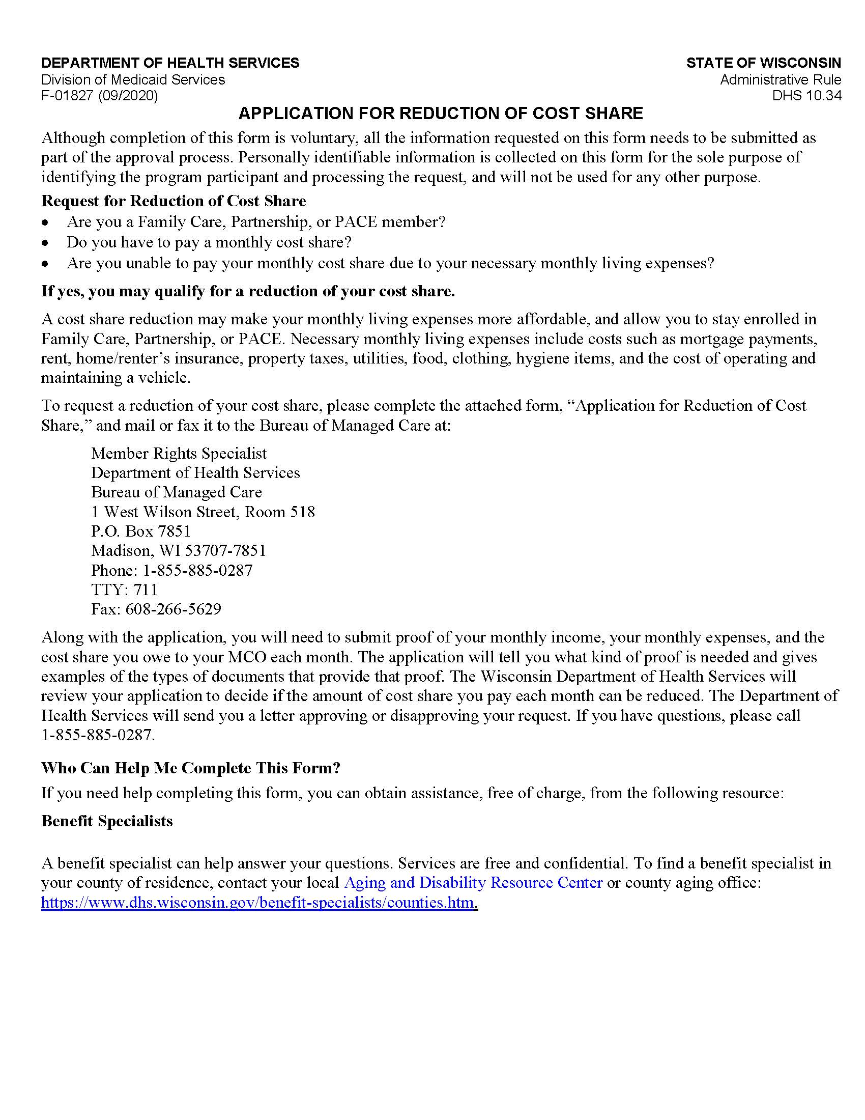

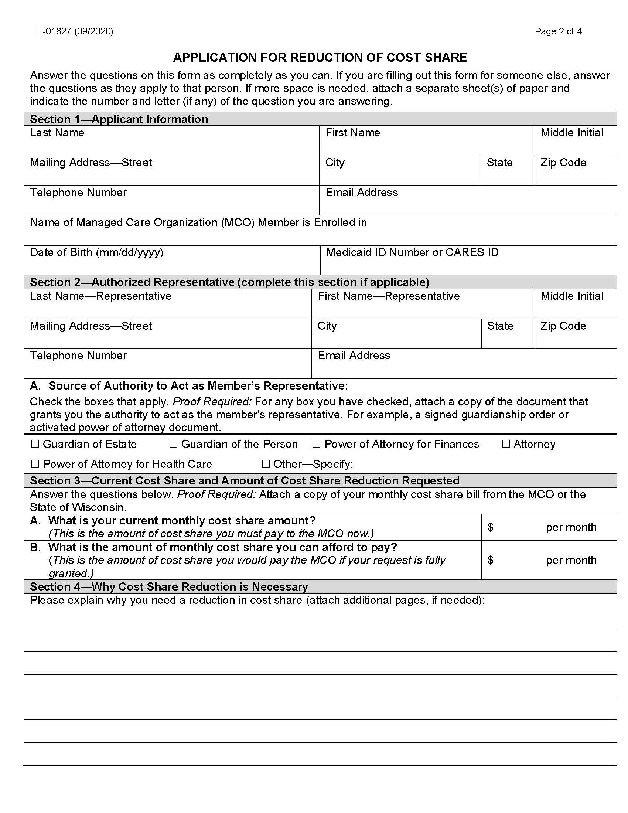

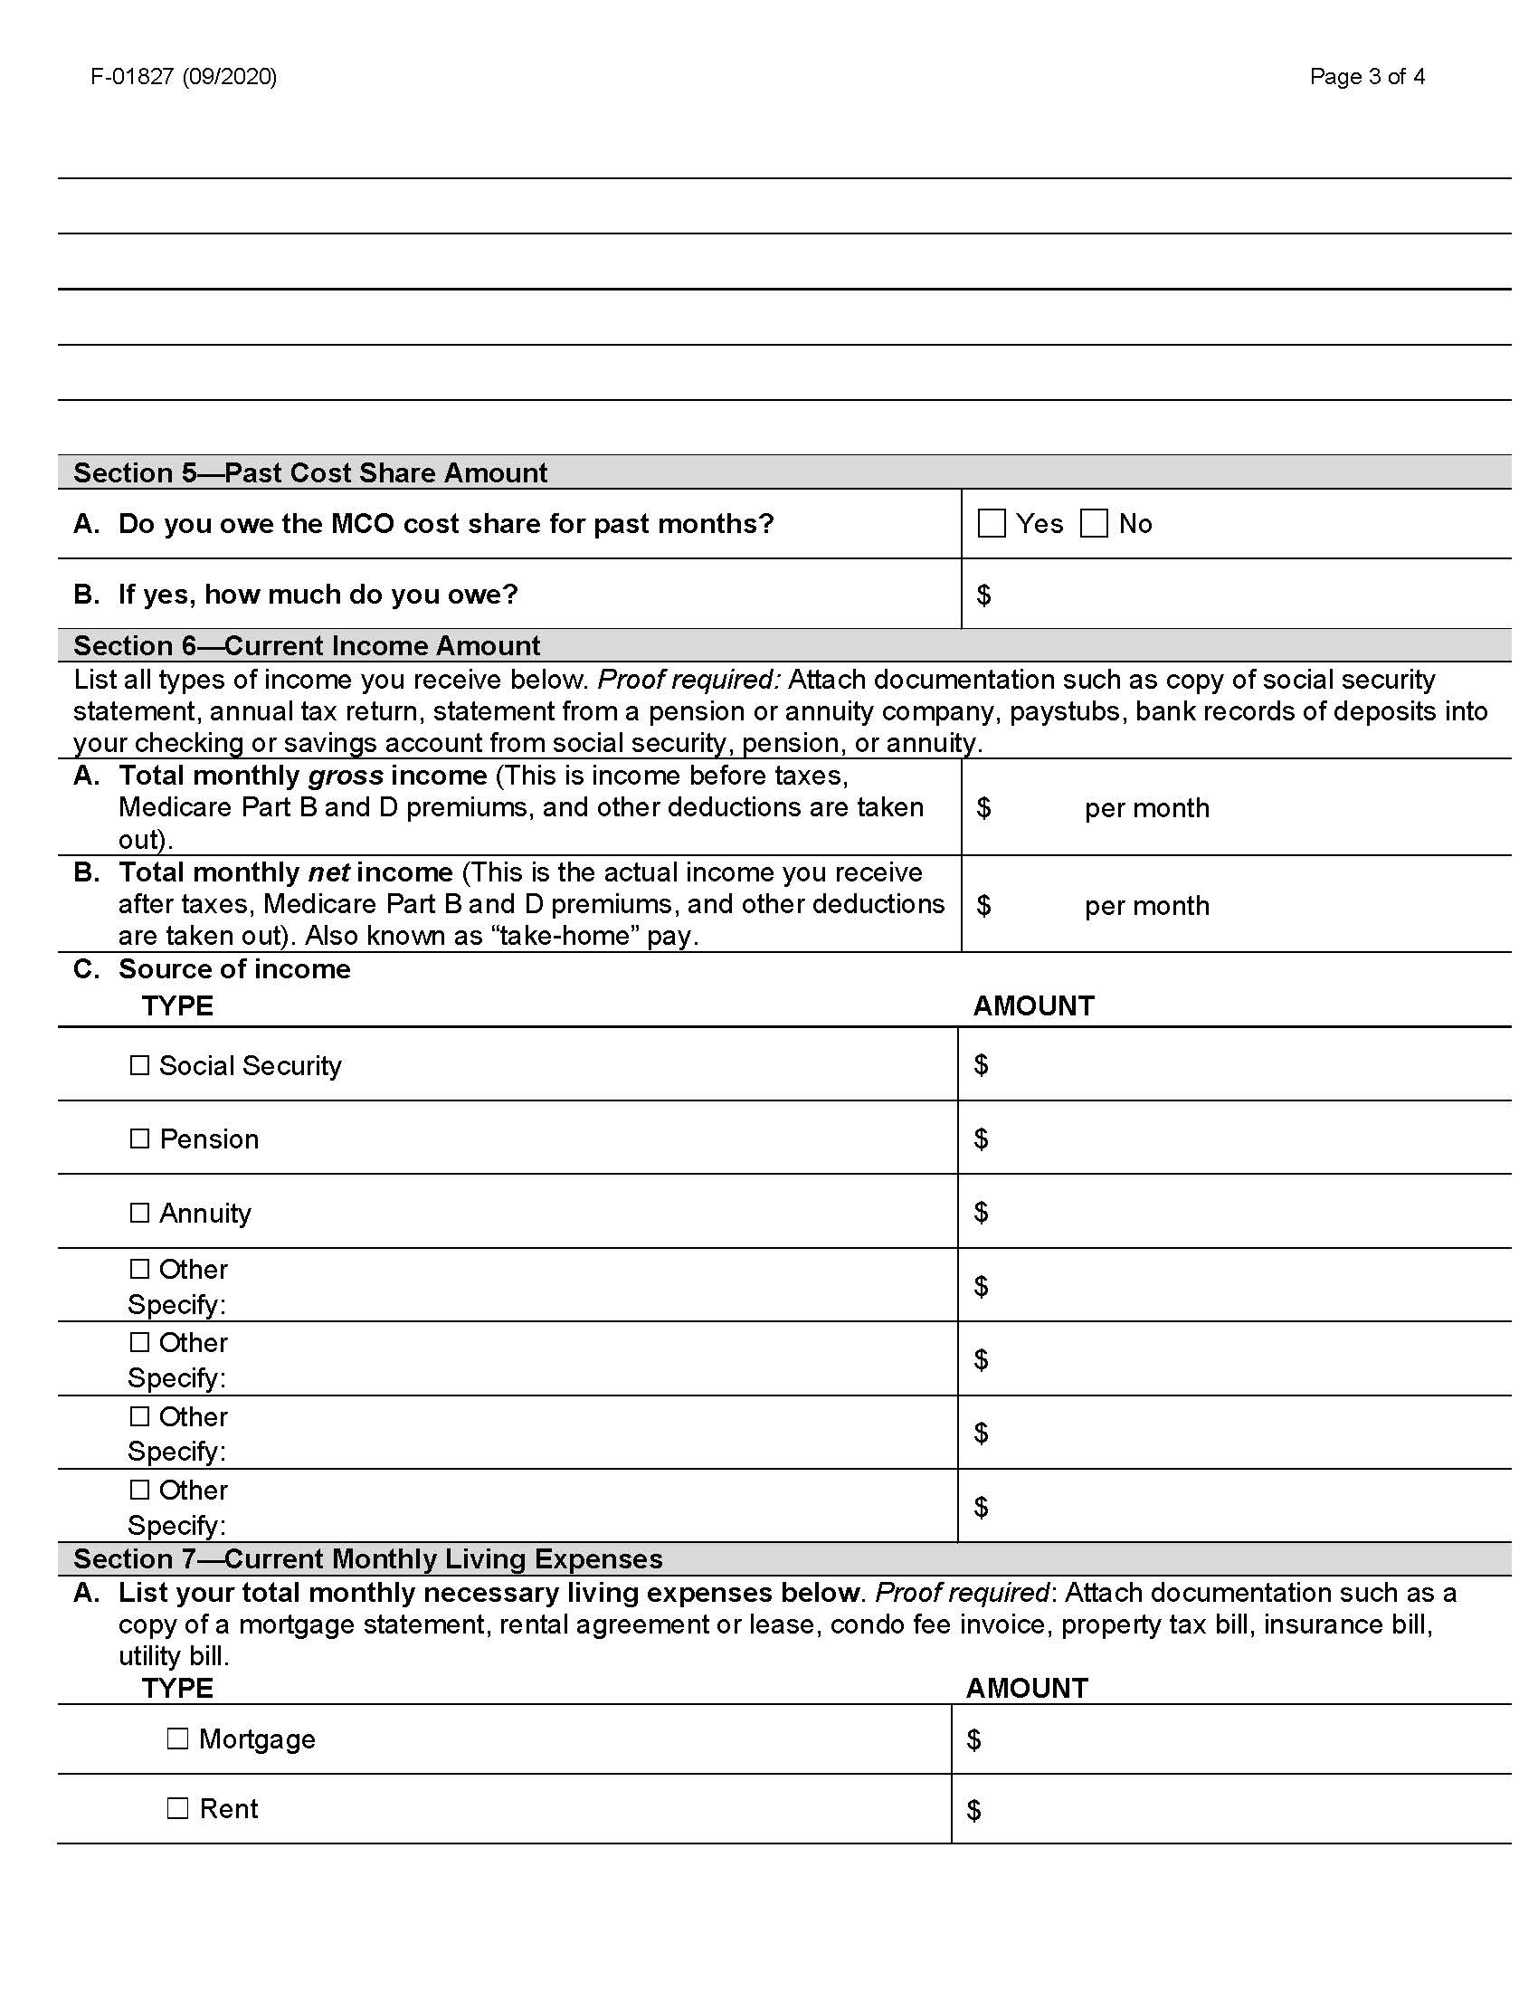

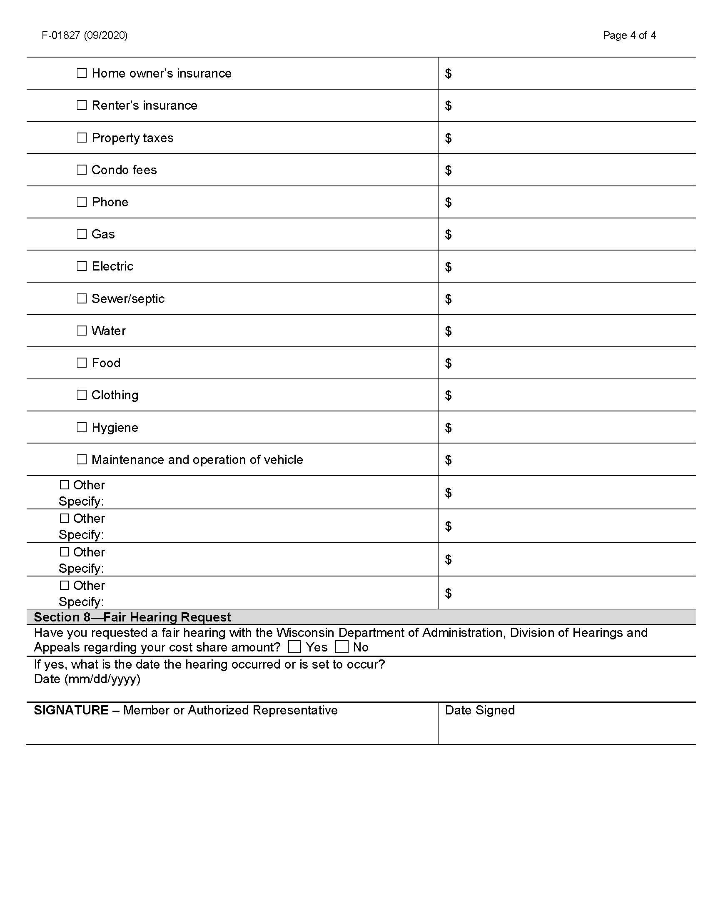

4. Tusaale Notice of Adverse Benefit Determination (Ogeysiis Go’aanka Beddelka Manaafacaadka)

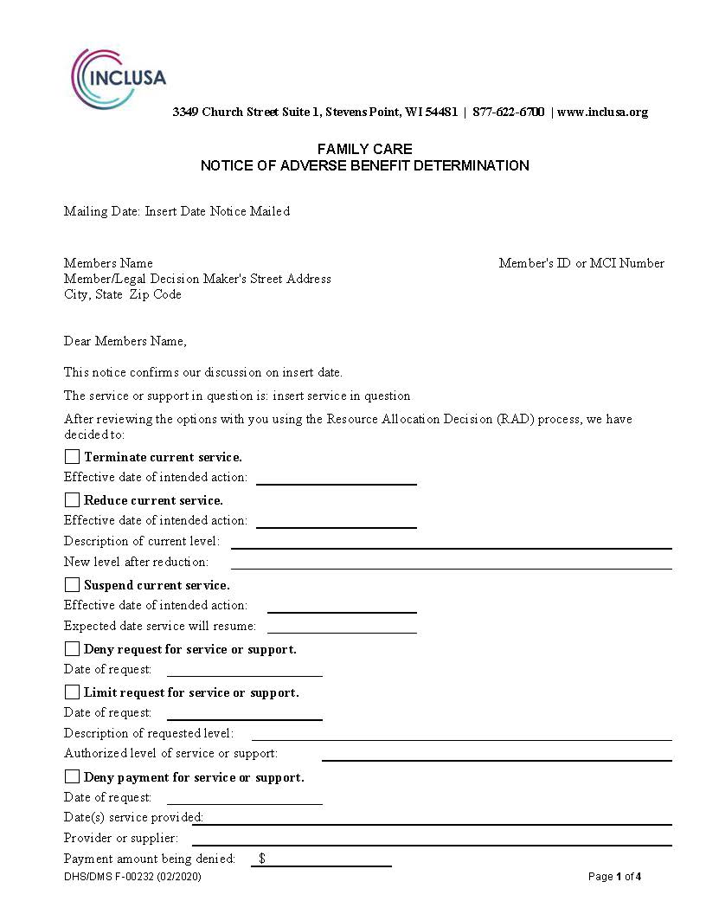
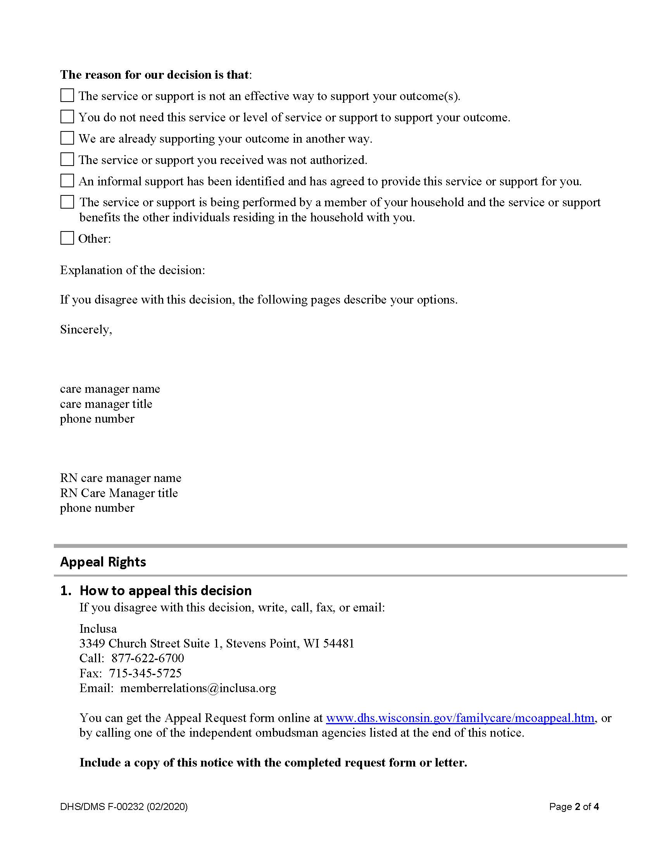
[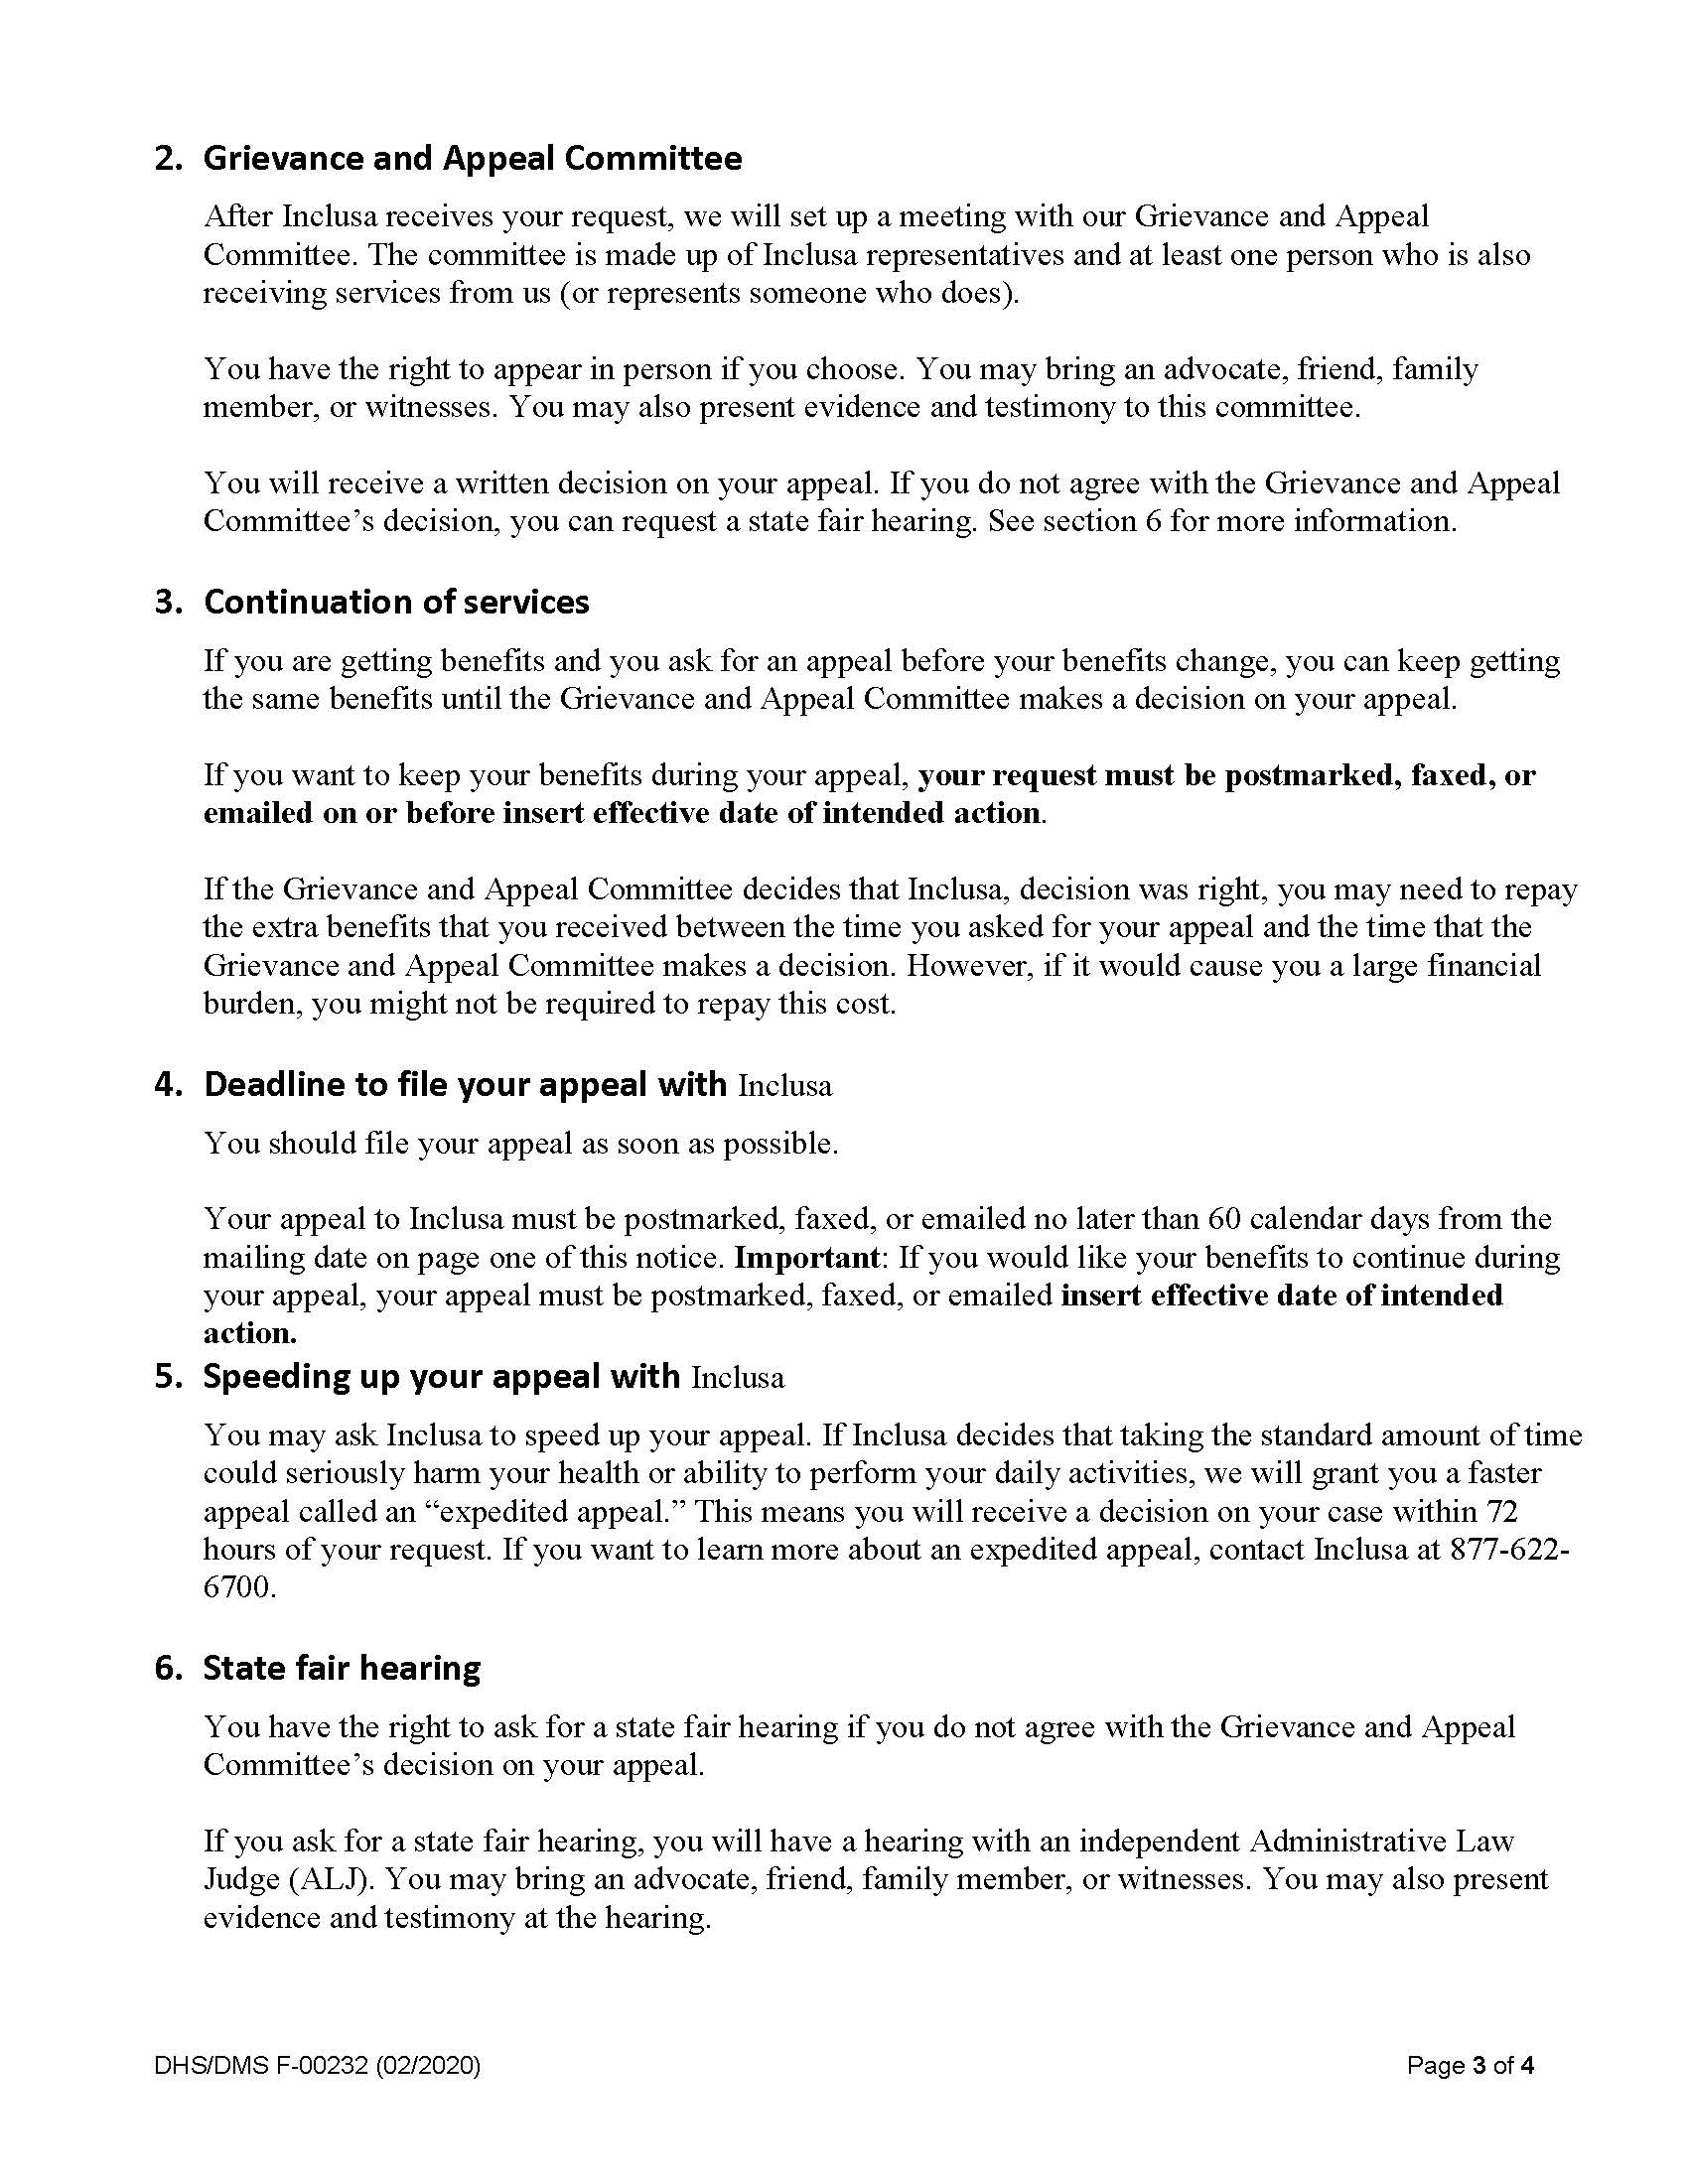

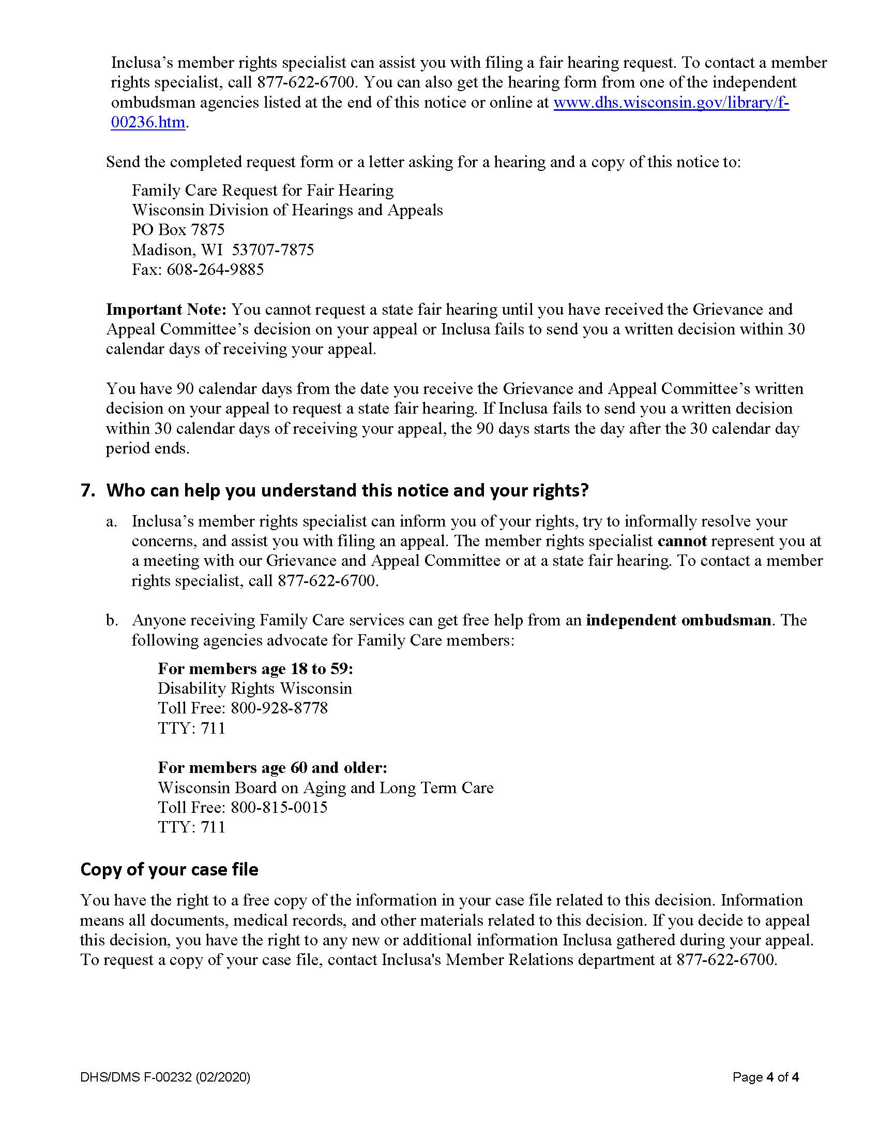

5. Inclusa foomka codsiga racfaanka

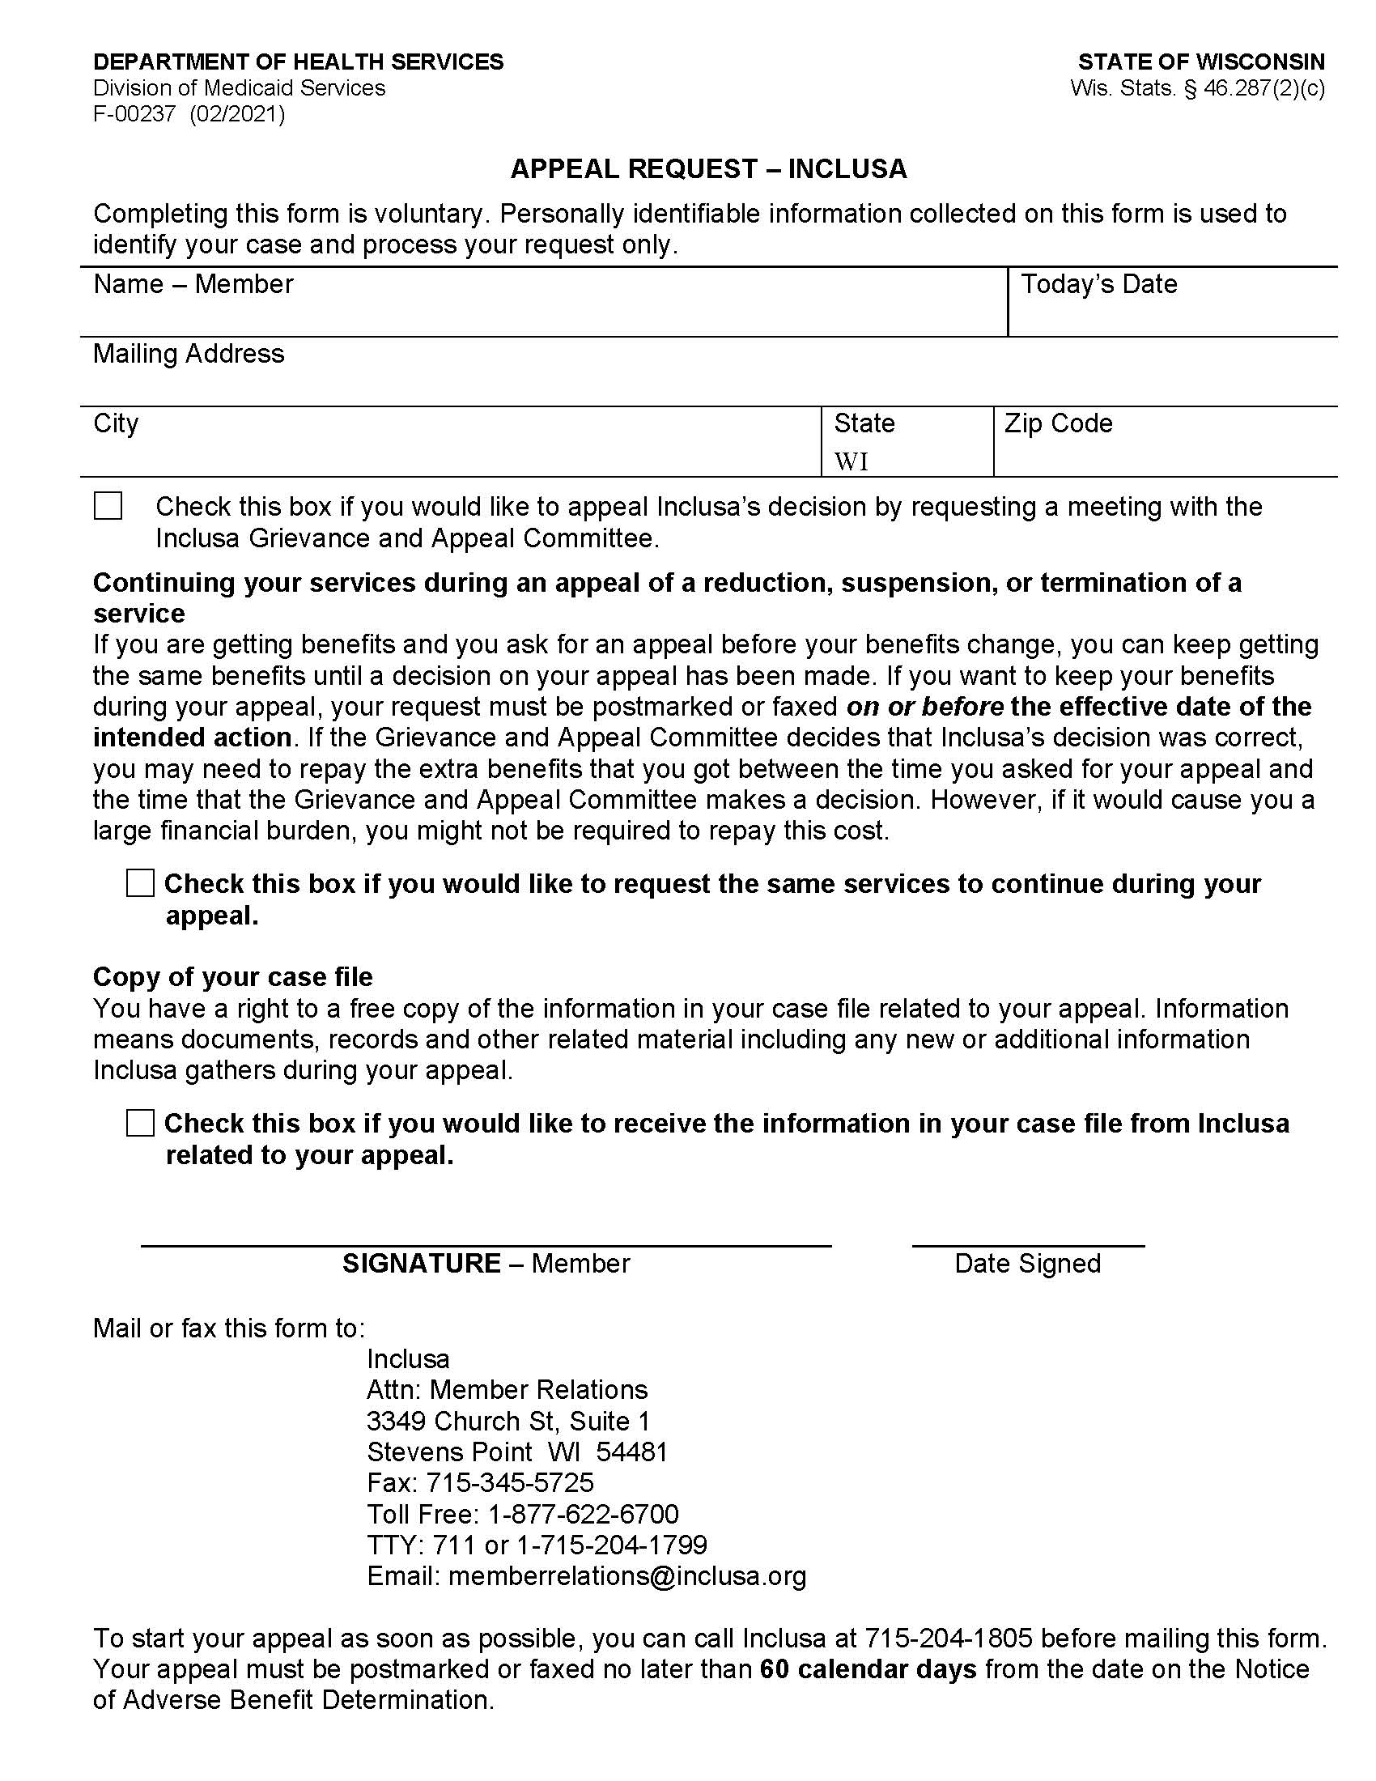

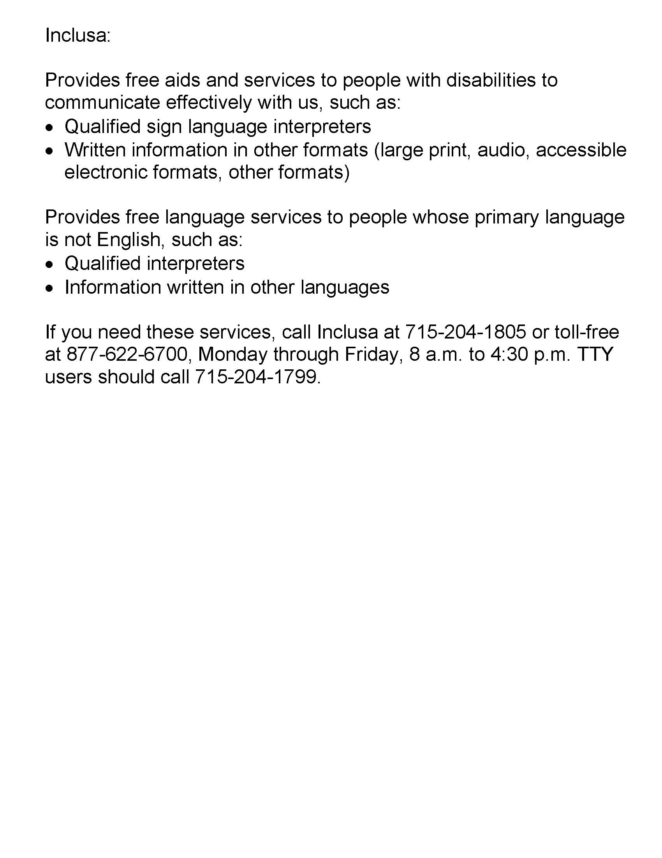

6. Foomka codsiga Dacwad-dhageysiga Gobolka

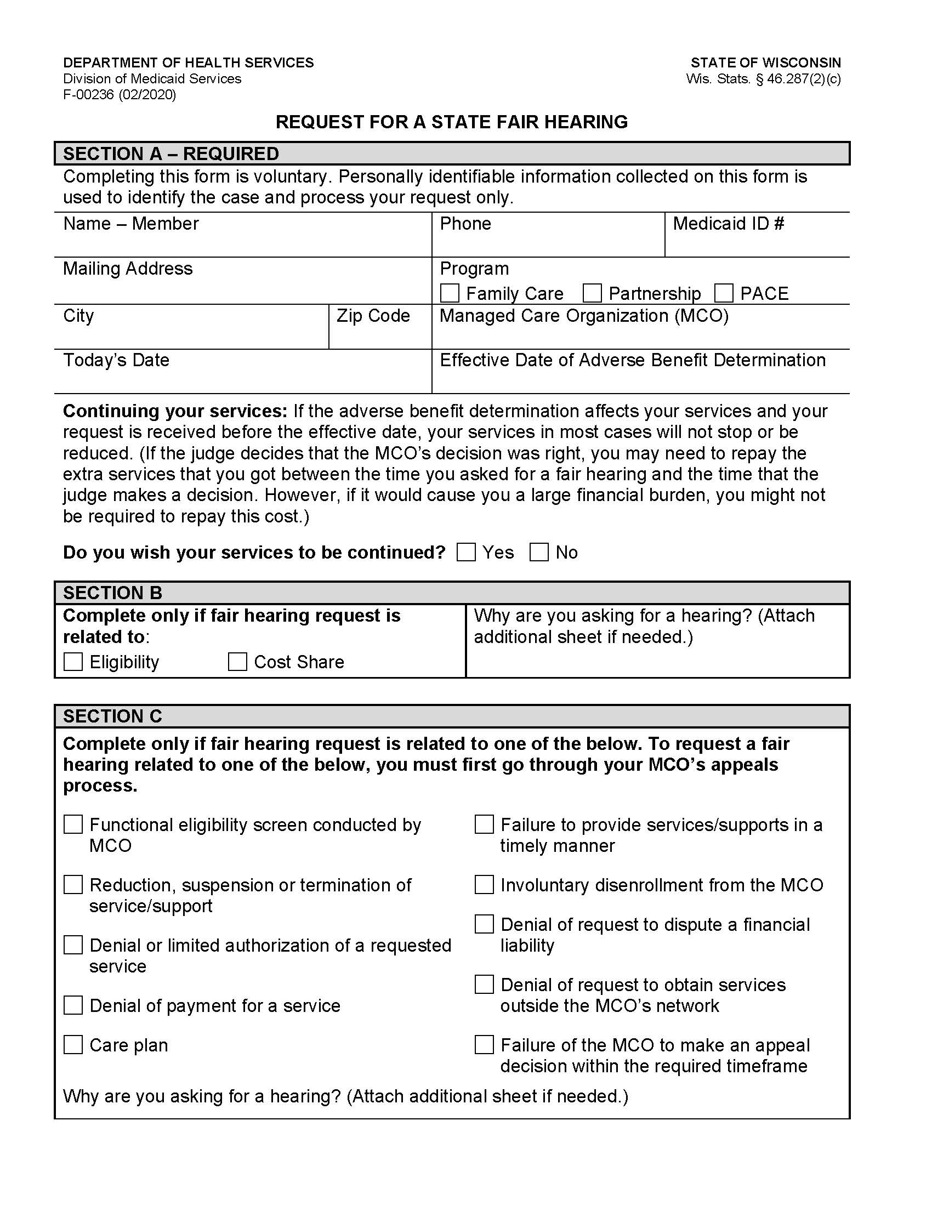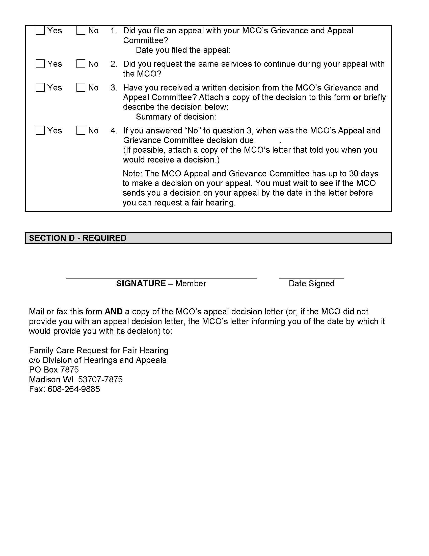
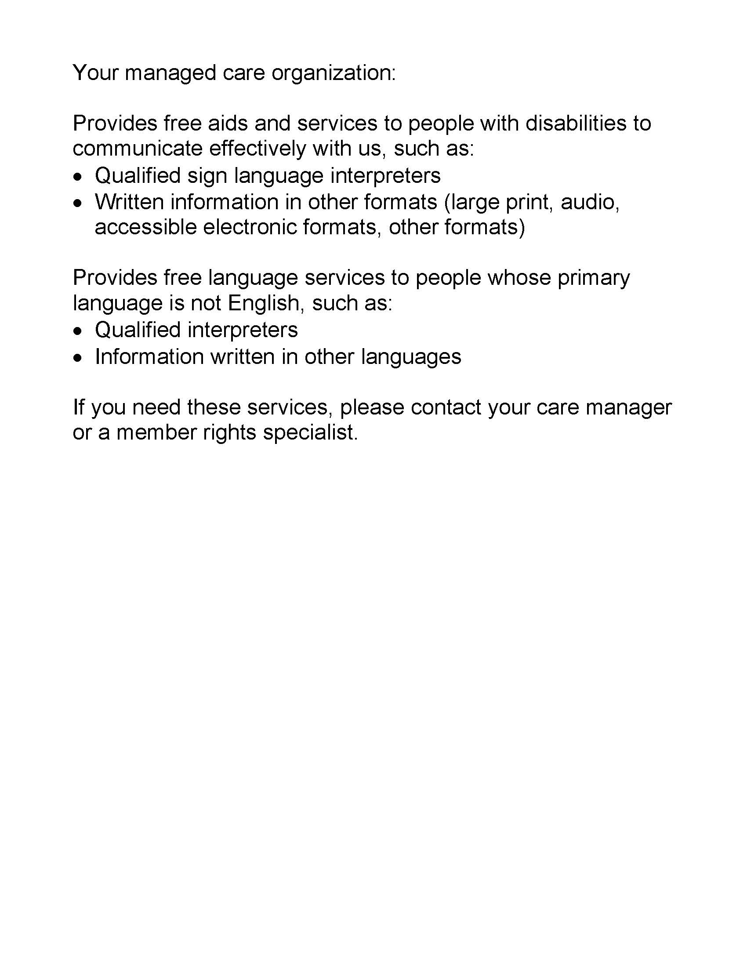

7. Ogeysiiska arrimaha shakhsiga ah

Notice of Privacy Practices
Inclusa
This Privacy Practices Notice describes how health care
information about you may be used and disclosed, and
how you can get access to this information.
Please read the notice carefully.

We are required to protect the privacy of health care information about you, to notify you of our legal duties and privacy practices with respect to your protected health information, and to notify you following a breach of unsecured protected health information. This Privacy Notice tells you about your rights regarding information about you that is kept in health care records. You can look at this anytime to see how your health care records are used by Inclusa as part of your care, and who gets to see them.
This Privacy Notice includes answers to the following questions:
- What is health care information?
- Who can see health care information about you without your written authorization?
- Who cannot see health care information about you unless you give written authorization?
- What are your rights regarding health information about you?

Changes to this Privacy Notice.
We are required to abide by the terms of this notice currently in effect. We reserve the right to change this Privacy Notice. We reserve the right to make the changed Privacy Notice apply to the health care records we already have about you in addition to any information we receive in the future. The Member Handbook will contain the most current Privacy Notice available. You will be offered an updated Member Handbook each year. We will also post a copy of the current Privacy Notice on Inclusa’s website. The effective date of the notice can be found in the lower left-hand corner of the first page.

1. What is Health Care Information?
Any information that can identify you and relates to your past, present, or future physical or mental health or condition; the provision of health care to you; or the past, present, or future payment for the provision of health care to you, is considered your protected health care information. Inclusa may have health care information regarding services we provide to you or payment for services provided to you or information about your past, present, or future health condition. We are required by law to protect health care information about you. We are required to follow the policies in the most current Privacy Notice available.

Health care information about you is kept in a health care record. This health care record contains your assessments, your member-centered plan, and other information related to your care. Each time you visit or are visited by your Community Resource Coordinator, Health & Wellness Coordinator, or other professionals on behalf of Inclusa, a record of the visit is made. This health care record serves as:
- a starting point for planning your care, treatment and any needed follow-up care;
- a means of communication among your care team and the many professionals who contribute to your care;
- a means by which you or a third-party payer (for example, insurance carriers, Medicare, Medicaid) can verify that services billed were actually provided; and
- a tool that can be used to evaluate and continually improve the care given and progress made.

Understanding what is in your health care record and how your health care information is used helps you to:
- make sure health care information about you in the record is correct;
- better understand who, what, when, where, and why others may access health care information about you; and
- make better-informed decisions when you authorize health care information about you to be shared with others in situations where your consent is required to share the information.

2. Who Can Access Health Care Information About You Without Your Written Authorization?
Listed below are reasons why we use and may share your health information without your written authorization:
- For Treatment: We are permitted to use and share health care information about you with health care individuals involved in your care. We are also permitted to share information about you with your health care providers. For example, your Health & Wellness Coordinator may call your pharmacist to reorder medications for you. We are permitted to use and share health information about you with providers of service under contract with Inclusa. For example, a Community Resource Coordinator may need to speak with a transportation provider to arrange transportation for you.
- For Payment: We are permitted to use and share your health care information so that the services you receive through Inclusa may be billed to, and payment collected from, your insurance company, Medicare, and/or Medical Assistance. For example, Inclusa may use health care information about you to pay a provider who has provided long-term care services to you, or Inclusa, or your care team may work with your Income Maintenance Worker to make sure you maintain financial eligibility for Family Care.

- For Health Care Operations: We can use and share your health care information for our operations. We may use health care records to review our treatment and services and to evaluate the performance of our staff in caring for you. We also may remove all information that identifies you from a set of health care information so that others may use that information to study health care and the health care delivery without learning who the specific people are. For example, health care information may be collected and analyzed to improve the quality of our services.

- To Business Associates for Treatment, Payment and Quality Assurance: We may use and share your health care information for our business operations. This using and sharing is necessary to run Inclusa and to make sure that all members receive quality care. We have written agreements with our business associates for administrative purposes, including payment of claims for your services or management of our member-related software system. For example, Inclusa has a contract with WPS to pay claims on our behalf. WPS is considered a business associate to Inclusa We have a formal written agreement with WPS to protect your health care information.

Special Situations
- Individuals Involved in Your Care or Payment of Your Care: We may use or disclose health care information to a family member, other relative, a close personal friend, or any other person identified by you when you are present and you, based on your participation, do not object to the sharing of health care information. If you are not present, or you are not able to agree because you are hurt or experiencing an emergency, we may use our professional judgment to determine whether sharing your health care information is in your best interest. We may also share health care information about you in order to notify your family member, other relative, a close, personal friend, or an agency involved in disaster relief efforts of your location, general condition, or death.

- As Required By Law: We will share your health care record when required to do so by federal, state, or local law. For example, state law requires us to report abuse and neglect. If we believe you are a victim of abuse or neglect, we may share health care information about you to governmental authorities, including protective services as authorized by law to receive such reports. Another example would be during an officially declared disaster or crisis if it is necessary to help ensure your safety or your community’s safety or to prevent disease. However, if you have specific preferences on how we disclose this information under these circumstances, or if you wish to opt out of any disclosure, please let us know and if we agree with the limitations, we will follow your instructions unless there is a specific legal prohibition against it.

- Health Oversight Activities: We will share your health care information with a health oversight agency as authorized by the law for audits, investigations, inspections, and licensure. These activities are necessary to monitor the health care system, government programs, and compliance with civil rights laws. For example, the State of Wisconsin’s Department of Health Services contracts with an agency to provide quality oversight of Inclusa. The oversight agency may conduct file reviews of records to assure compliance with contract requirements.

- Lawsuits and Disputes: If you are involved in a lawsuit or a dispute, we will share your health care information in response to a court or administrative order. We may also share your health care information in response to a subpoena or other lawful process. For example, a subpoena may require disclosure, or a judge may order us to disclose health care information about you.

- If You Dis-enroll and go to Another Family Care Agency: Should you leave Inclusa and sign up for Family Care through another agency, we may be asked to provide a copy of your most recent Long Term Care Functional Screen. Once the request has been verified as a legitimate request, Inclusa will release the screen to them without requesting your permission.

- Other: If you have given someone medical power of attorney, or if someone is your legal guardian, that person can exercise your rights and make choices about your health information. We will make sure the person has this authority and can act for you before we take any action. Another exception includes organ transplants; we can also share health information about you with organ procurement organizations.

In addition, under some circumstances, we may share your health care information permitted or as required by law:
- to report and/or investigate a death (including sharing information with the coroner, medical examiners, or funeral directors)
- Worker’s Compensation claims;
- for judicial and administrative proceedings;
- with protection agencies, advocacy agencies, and ombudsmen programs;
      - to a facility to which you may be involuntarily committed;
      - to avert a serious threat to health or safety; and
      - to a law enforcement or correction agency.

Uses or disclosures of your health care information for other purposes or activities not listed above will be made only with your written permission. If you give us permission to use or share your health care information, you may cancel your permission in writing at any time. If you cancel your permission, we will no longer use or share your health care information for the reasons covered by your written permission. However, we are unable to take back anything we had given already with your permission.

    - Who Cannot See Health Care Information About You Unless You Give Written Authorization?
Other than the uses and disclosures described generally above, we will not use or disclose health care information about you without authorization, or signed permission, from you or your legal decision maker. We would get authorization or signed permission from you, or your legal decision maker, by having you sign an Release of Information for Use and Disclosure of Confidential Information form.

Most uses and disclosures of psychotherapy notes, uses and disclosures of protected health information for marketing purposes, and disclosures that constitute a sale of protected health information, require your written authorization.

Inclusa does not conduct any fundraising, marketing, or medical research. We do not sell any of your information. We do ask members to respond to a survey, provided annually, on their satisfaction with care provided by Inclusa Participation in the survey is always voluntary and you always have the option to say no.

Inclusa is prohibited from the use or disclosure of protected health information for underwriting purposes, including your genetic information. This is required by the Genetic Information Nondiscrimination Act (GINA) of 2008.

    - What Are Your Rights Regarding Health Care Information about You?
You have the following rights regarding the health care information we maintain about you:
- The Right to Ask for Limitations: You have the right to ask for a limitation on the health care information we use or share about you for treatment, payment, or health care operations. You also have the right to ask for a limit on the health care information we share about you to someone who is involved in your care, or the payment for your care, such as a family member or friend. Inclusa must comply with your request to restrict disclosure of your health information to a health plan if:
(A) The disclosure is for the purpose of carrying out payment or health care operations and is not otherwise required by law; and
(B) The protected health information pertains solely to a health care item or service for which you or a person on your behalf has paid Inclusa in full.

In your request, you must tell us:
- what information you want to limit;
- whether you want to limit Inclusa’s use and/or disclosure of the information;
- to whom you want the limits to apply (for example, sharing information with your spouse); and
- your contact address and daytime phone number.

We are not required to agree with your request, especially in those situations where your consent is not required before disclosing the information as described above. If we do agree, we will honor your request unless the information is needed to provide you with emergency treatment. Inclusa will notify you in writing with our decision.

- The Right to Request Confidential Communications: You have the right to request that we speak with you about your services in a certain way or at a certain location. Your request must specify how or where you wish to be contacted. We will accommodate all reasonable requests. For example, you can ask that we only contact you by telephone at work or that we only contact you by mail at home.

- The Right to Inspect and Receive a Copy: You have the right to inspect and receive a copy of your health care information that may be used to make decisions about your care. Usually, this includes case notes and billing records. Psychotherapy notes may not be seen by others or copied. We will provide you a copy or summary of your health information, usually within thirty (30) days; however, under unique circumstances we do have an option of taking a thirty (30) day extension. If there is a delay, we must notify you in writing why we need the extra time and when we think we will be able to fulfill your request. All requests for information must be in writing. Your care team can provide you with a request form and help you fill out the request.

If you request a copy of your health care information, we may charge a fee for the costs of copying, mailing, or other supplies associated with your request. We may deny your request to see or receive a copy in certain very limited circumstances. If you are denied access to your health care information, we will notify you in writing. You may request that the denial be reviewed. The person conducting the review will not be the person who denied your request. We will follow through with the outcome of the review.

- The Right to Amend: If you think there is something wrong or missing in your health care information, you may ask that it be changed. You have the right to request a change to your Inclusa member file. You must include a reason that supports your request. We may say no to your request, but we will tell you why in writing within sixty (60) days.

We may deny your request for a change if it is not in writing or does not include a reason to support the request. In addition, we may deny your request if you ask us to change information that:
- was not created by Inclusa;
- the person or entity that created the information is no longer available to make the amendment;
- is not part of the health care information kept by or for Inclusa; or
- is accurate and complete.

Inclusa will notify you in writing whether we agree or do not agree with your amendment request.

Additionally, if we grant the request, we will make the correction and distribute it to all necessary recipients as well as those you ask to receive the corrected information. If we deny your request for a change to your health care information, we will notify you how you may file a complaint with Inclusa
  - The Right to be Notified of a Breach of your Personal Health Information: With the exceptions outlined under HIPAA Regulations, you have a right to be notified if your information is ever mishandled and a breach (loss) of your personal health information has occurred or has likely occurred.

- The Right to an Accounting of Disclosures: You have the right to request an accounting of disclosures that has been made by Inclusa in the past six (6) years. We will include all the disclosures except for those about treatment, payment, and health care operations and certain other disclosures, such as any you asked us to make.

Your request must state a time period not longer than six (6) years and may not include dates before July 1, 2008. The first list you request within a twelve (12) month period will be free of charge. For additional lists, we may charge you for the costs of providing the list. We will also notify you of the cost involved before any costs are incurred.

  - The Right to a Paper Copy of This Notice: You have the right to receive a paper copy of this Privacy Notice. To obtain a paper copy of this Privacy Notice, contact the Inclusa Privacy Officer at 1-877-622-6700..

